REPORT ON THE INTERNSHIP TRAINING PROGRAMME
A Report on the Internship Training Programme submitted
to the Department of Computer Science,
St. Joseph’s College (Autonomous),
(Affiliated to Bharathidasan University), Tiruchirappalli – 620 002
in partial fulfilment of the requirements for the award of the degree of

BACHELOR OF SCIENCE IN COMPUTER SCIENCE
Submitted by
JOHN DIVINE MATHEW J
23UCS508
Under the guidance of
Dr. S. SATHYAPRIYA


DEPARTMENT OF COMPUTER SCIENCE
ST. JOSEPH’S COLLEGE (AUTONOMOUS)
Accredited at A++ (Cycle IV) by NAAC
Special Heritage Status Awarded by UGC
TIRUCHIRAPPALLI – 620 002

DEPARTMENT OF COMPUTER SCIENCE
ST. JOSEPH’S COLLEGE (AUTONOMOUS)
Accredited at A++ (Cycle IV) by NAAC
Special Heritage Status Awarded by UGC
25th Position in NIRF -2025
TIRUCHIRAPPALLI – 620 002
DATE:
CERTIFICATE

This is to certify that the Report on the Internship Training Programme submitted to the Department of Computer science, St. Joseph’s College (Autonomous), Tiruchirappalli, in partial fulfilment for the award of the Degree of BACHELOR OF COMPUTER SCIENCE, is a bona-fide record of the work done by JOHN DIVINE MATHEW J (23UCS508) under my guidance during the academic year 2025-2026.

Dr. B. REX CYRIL Dr. S. SATHYAPRIYA
CO-ORDINATOR GUIDE

Submitted for the viva-voce examination held on ----------------------

INTERNAL EXAMINER EXTERNAL EXAMINER

DECLARATION

I hereby, declare that the Report on the Internship Training Programme titled BILLING SOFTWARE DEVELOPMENT AND KIOSK APPLICATION TESTING is an independent work done by me, JOHN DIVINE MATHEW J (D. No: 23UCS508) under the guidance of Dr. S. SATHYAPRIYA, Assistant Professor of Computer Science, St. Joseph’s College (Autonomous), Tiruchirappalli in partial fulfillment for the award of the degree Bachelor of Science in Computer Science, during the academic year 2025-2026, and that the work has not formed the basis for the recognition of any other degree at any other College/University.

Place: Tiruchirappalli Signature of the Student
Date: JOHN DIVINE MATHEW J

ACKNOWLEDGEMENT

I would like to express my deepest gratitude to all those who provided me with the opportunity to complete this Internship Programme

First and foremost, I thank God for giving me the strength, knowledge, and ability to undertake this internship and to persevere and complete it satisfactorily.

I am profoundly grateful to Rev. Dr.S. Mariadoss SJ, Principal, and Dr.D. Kumar, Deputy principal St. Joseph’s College (Autonomous), Tiruchirappalli, whose leadership and vision have always been a source of inspiration and guidance.

In a special manner I thank to Dr. B. Rex Cyril, MSc., B.Ed., M.Phil., SET.,Ph.D., Coordinator (Shift-II), Department of Computer Science, St. Joseph’s College (Autonomous), Tiruchirappalli-2, for encouraging me in every step.

I wish to extend my heartfelt thanks to my internal guide, Dr. S. Sathyapriya M.Sc., MPhil., Ph.D., for her constant support, invaluable feedback, and expert guidance, which have been crucial in completing this report.

Special thanks to my Class In-charge Dr.J. Antony John Prabu MCA,MCTS,M.Phil.,Ph.D., M.Sc., M.Phil, for her encouragement and support during the course of this internship.
Finally, I express my deepest gratitude to my parents for their unwavering support, understanding, and encouragement throughout my academic journey and this internship.

JOHN DIVINE MATHEW J
23UCS508
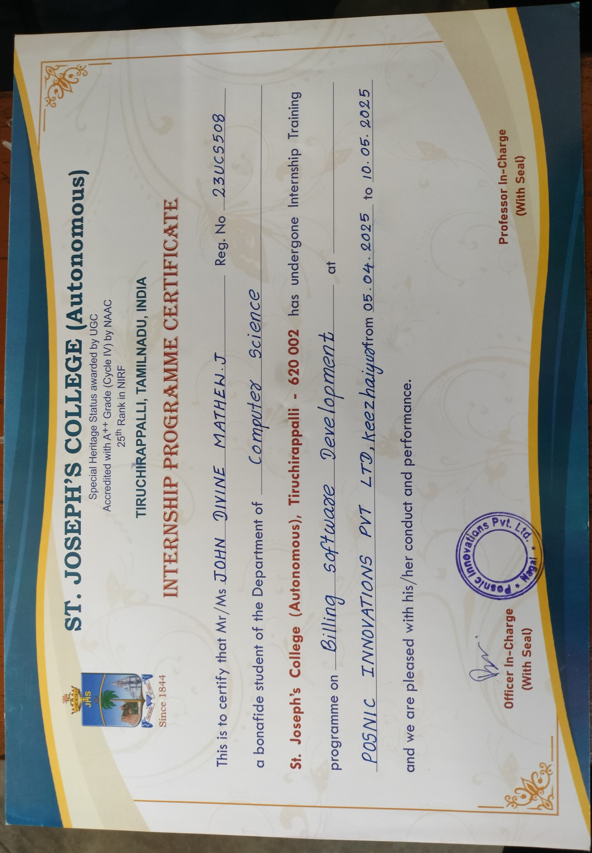

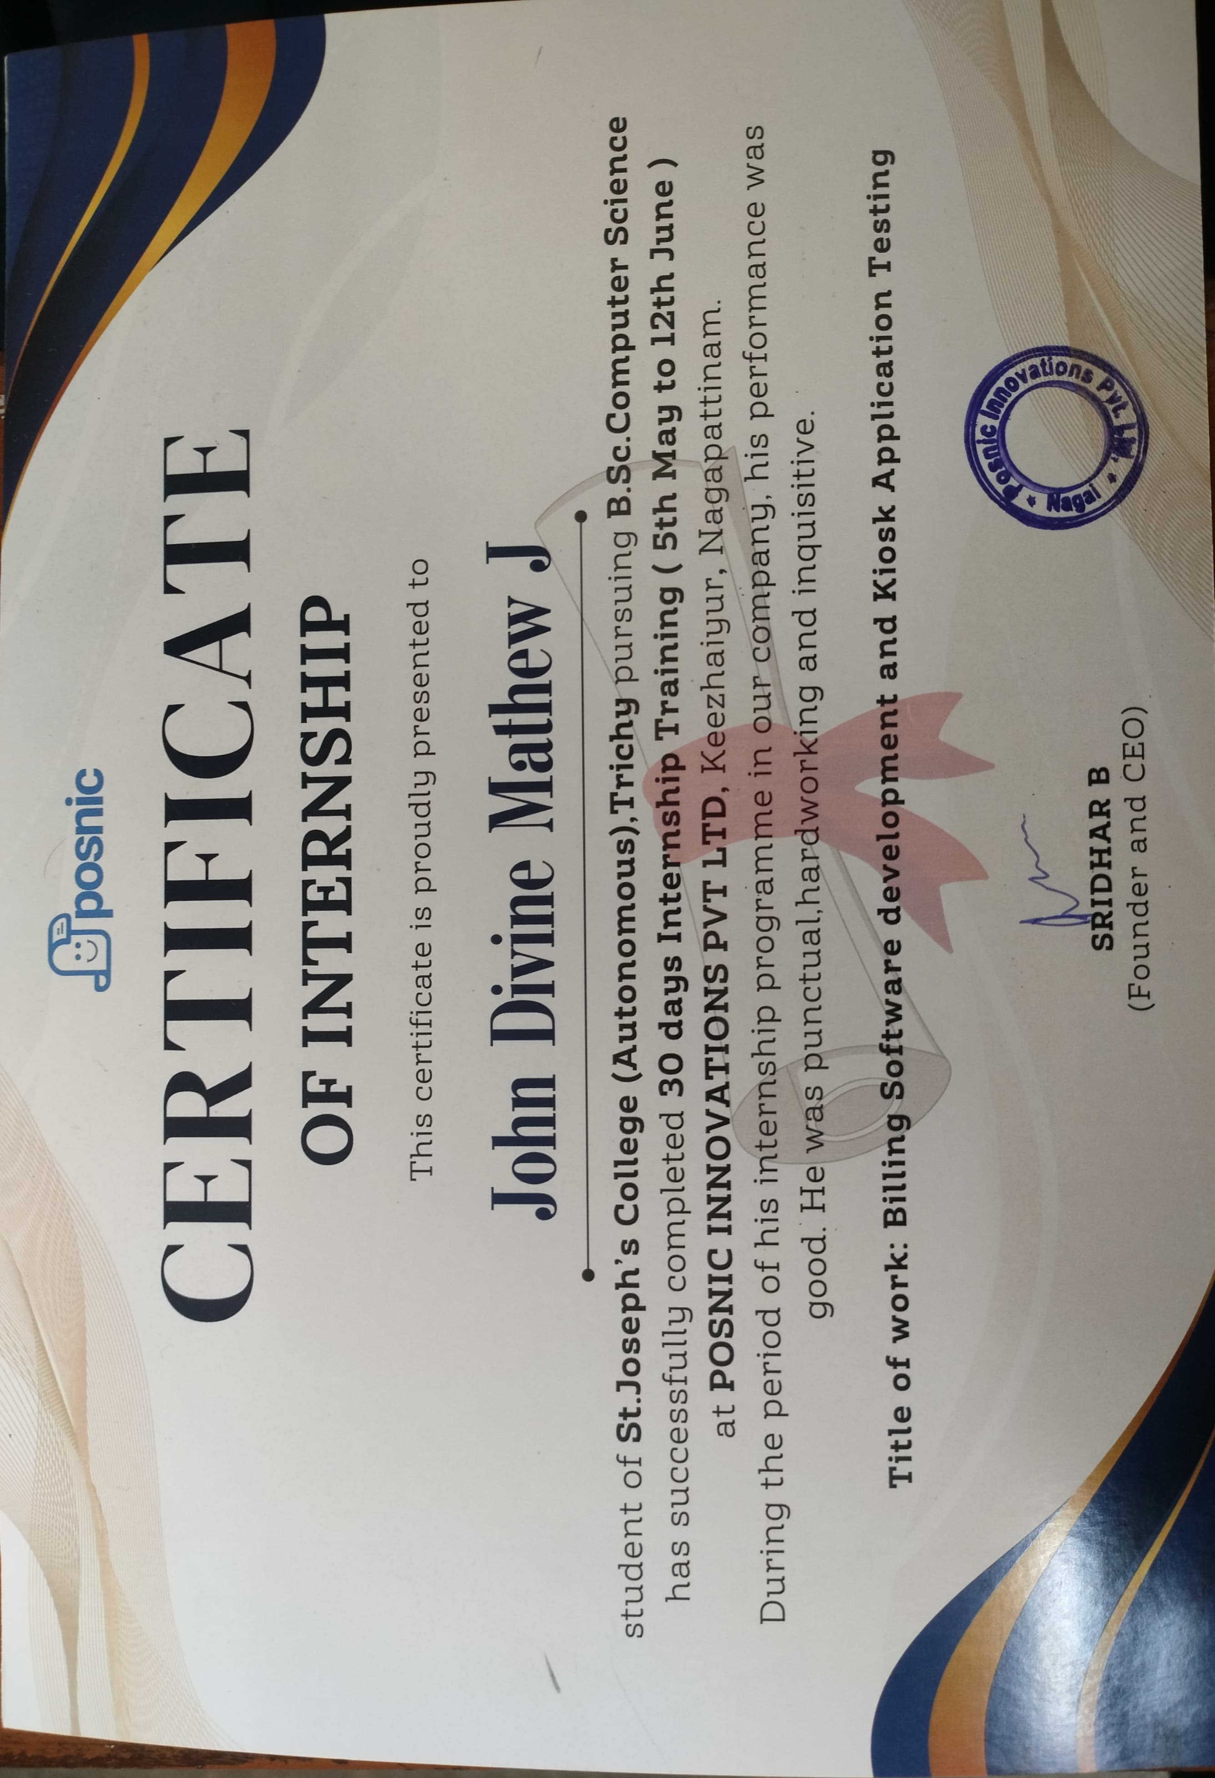

S. No | CONTENTS | Page
1 | INTRODUCTION
2 | ORGANIZATION PROFILE
3 | ROLES AND RESPONSIBILITIES
4 | ACTUAL WORK DONE
5 | LEARNING OUTCOME
6 | CONCLUSION
APPENDIX
 | PHOTOS TAKEN IN THE COMPANY
 | DAILY WORK SHEET

INTRODUCTION

The purpose of this report is to document my 30-day internship experience at POSNIC INNOVATIONS PVT LTD, a firm specializing in billing software development and kiosk system integration. This internship, conducted as part of my academic curriculum, provided an opportunity to gain practical exposure to real-time software development environments, particularly in the domains of retail billing systems, point-of-sale (POS) applications, and hardware integration.
Throughout the internship, I was involved in various phases of the development lifecycle—from understanding the system architecture to identifying and resolving software bugs, customizing user interfaces, and testing hardware components like printers and QR scanners. I had the chance to work closely with experienced developers, UI/UX designers, and testers, which helped improve my technical skills and broaden my understanding of collaborative software development practices.
The primary goal of the internship was to understand the functionality of the billing software and assist in testing and improving the kiosk system used in outlets such as KFC. I contributed by testing features, identifying bugs, performing compatibility checks, and suggesting improvements, all while learning key industry practices.

ORGANISATION PROFILE
COMPANY NAME : POSNIC INNOVATIONS PVT LTD
INTERNSHIP DURATION : [05/05/2025] – [12/06/2025]
PROJECT FOCUS : BILLING SOFTWARE & KIOSK APPLICATION TESTING
FOUNDER and CEO : SRIDHAR B
PHONE NO : +91 90084 27482
COMPANY WEBSITE : www.posnic.com
EMAIL :info@posnic.com

ROLES AND RESPONSIBILITIES
During the internship, my primary role was to assist the development and QA teams in testing, analysing, and improving the billing and kiosk software systems. I was actively involved in identifying bugs, reporting issues, and verifying functionality across various modules such as item ordering, payment processing, inventory management, and admin control panels.
I also contributed to customizing the kiosk interface by updating logos, banners, and advertisements based on project requirements. Additionally, I tested hardware integrations, including printers and QR scanners, ensuring seamless performance between the software and physical devices.
Through continuous coordination with developers and testers, I played a supporting role in enhancing the software’s reliability, user experience, and deployment readiness.
Key Responsibilities:
- Testing and Validation: I conducted extensive testing of the kiosk interface and billing software, including functionality like order placement, payment processing (QR & COD), and admin-side operations. I performed both manual and device-based tests (using printers, QR scanners, and mobile devices).
- Bug Identification and Reporting: My primary responsibility was to identify, document, and report bugs found during different stages of the software. I worked closely with developers and submitted detailed reports with screenshots, steps to reproduce, and suggested fixes.
- Customization and UI Enhancements: I handled the customization of visual elements on the kiosk such as logos, banners, and advertisements, based on instructions from the project manager. This included verifying visibility across admin and user modes and maintaining proof of changes made.
- Hardware Integration Testing: I tested various hardware components with the kiosk system including ESC POS printers and QR code scanners. I verified compatibility, conducted sample printing, and reported errors in device communication.
- Documentation and Communication: I maintained a detailed daily log of activities, testing outcomes, screenshots of bugs, and version change confirmations. I also took part in team discussions, knowledge-sharing sessions, and final presentation reviews.

ACTUAL WORK DONE
Day 1: Company and Software Analysis
- Met with team members to understand their roles and responsibilities.
- Explored the company’s website and product details.
- Learned that PHP and JavaScript are used for software development.
- Analyzed billing software features: sales, inventory, reports.
- Noted key functions for future testing.

Day 2–3: Software Setup and Guidance
- Received login credentials and the kiosk application.
- Installed the application on the provided system.
- Logged in and navigated through billing functions.
- Learned basic usage from team members.
- Reviewed the structure of the codebase.

Day 4: Project Involvement and Bug Analysis
- Accessed the KFC billing project.
- Assigned to identify software bugs.
- Documented issues found during testing.
- Suggested improvements to the team.
- Received appreciation from the project manager.
Day 5: Customization and Bug Reporting
- Analyzed the POSNIC.IO kiosk interface.
- Customized kiosk visuals: logo, banners, ads.
- Reported any visual or functional bugs.
- Coordinated changes with the design team.
- Saved screenshots of all visual updates.

Day 6: In-depth Testing and Reporting
- Tested various order and payment flows.
- Checked parcel and dine-in processes.
- Found a scanner-related bug in the payment module.
- Communicated bug details to the dev team.
- Ensured testing documentation was complete.

Day 7: Post-Update Testing & Logo Replacement
- Re-tested after new software updates.
- Replaced the default logo with a college logo.
- Verified changes in admin and user modes.
- Consulted the manager for validation.
- Captured photo proof of updates.

Day 8: Printer Testing
- Installed the ESC POS Printer app.
- Connected the printer to multiple devices.
- Printed sample KFC receipts successfully.
- Verified alignment and text clarity.
- Took printout photos for proof.

Day 9: QR Code Scanner & Mobile Testing
- Tested QR scanning using a mobile phone.
- Checked redirection to KFC billing portal.
- Simulated a customer order via phone.
- Identified and fixed mobile interface bugs.
- Documented test results with screenshots.

Day 10: Logo Update & Node FS Testing
- Updated the KFC logo in the admin panel.
- Verified logo build updates on user side.
- Installed Node FS for advanced testing.
- Found and reported a critical bug.
- Confirmed fix and revalidated both apps.

Day 11: Payment Method Update & Bug Report
- Tested new payment options: COD & QR.
- Found bugs in both payment flows.
- Reported bugs to the development team.
- Took error screenshots as proof.
- Validated payment screen updates.

Day 12: Admin Panel Walkthrough
- Explored all admin panel features.
- Studied order management and reporting tools.
- Tested add/edit item functionalities.
- Found UI inconsistencies and reported them.
- Suggested better labeling for user clarity.

Day 13: Kiosk Database Connectivity Testing
- Verified the database connection between the kiosk and server.
- Simulated order placement and checked database entries.
- Cross-checked real-time update reflection in admin panel.
- Found a mismatch in order status and reported the issue.
- Received confirmation after the issue was resolved.

Day 14: Cross-Device Compatibility Check
- Tested the kiosk software on different screen sizes.
- Ensured mobile responsiveness on Android and tablets.
- Identified layout breakpoints in the order summary section.
- Communicated bugs with screenshots to UI team.
- Suggested using media queries for better layout.

Day 15: Inventory Update Module Testing
- Explored the inventory management module.
- Simulated stock addition, deduction, and item deletion.
- Found an error in updating stock count post-sale.
- Documented the error and escalated to the dev team.
- Verified fix after patch deployment.

Day 16: Testing with Low Bandwidth Network
- Simulated kiosk usage on a slow internet connection.
- Noted slow image loading and timeout issues.
- Observed delay in payment processing.
- Recommended image compression to the design team.
- Team agreed to optimize assets in future builds.

Day 17: UI/UX Feedback and Improvement Suggestions
- Analyzed user flow in the kiosk interface.
- Listed confusing labels and suggested renaming.
- Proposed a restructured home layout for easier navigation.
- Prepared a feedback report and submitted to design lead.
- Some suggestions were approved for next version.

Day 18: Testing Admin User Restrictions
- Created multiple test users with different roles.
- Verified access controls for admin and staff users.
- Found that staff could access restricted reports.
- Reported the access control bug.
- Verified role-based restrictions after fix.

Day 19: Customer Feedback Module Testing
- Opened the customer feedback page post-order.
- Entered feedback and submitted test comments.
- Found that negative feedback didn’t trigger alerts.
- Shared issue with backend team.
- Bug fixed and auto-alert email was verified.

Day 20: Testing Offline Functionality
- Disabled internet and tried to use the kiosk.
- Found that orders were not cached locally.
- Suggested implementing IndexedDB for offline orders.
- Shared browser console logs with the dev team.
- Fix was planned for future update.

Day 21: Payment Gateway Integration Testing
- Tested the integration with UPI and card payment.
- Simulated a failed transaction scenario.
- Observed missing error message on failed UPI.
- Logged the issue with payment team.
- Verified the updated error notification post-fix.

Day 22: Security Review – Admin Panel
- Checked for unsecured URLs in the admin panel.
- Verified session logout and password reset functionality.
- Found insecure API call with token exposed.
- Reported it to the backend lead.
- They migrated to secure headers and resolved the issue.

Day 23: Backup and Recovery Test
- Triggered manual data backup from admin.
- Simulated a data loss scenario and restored backup.
- Verified all records were accurately restored.
- Found UI bug in the restore status display.
- Bug fixed by the team and functionality confirmed.

Day 24: Final Testing of Kiosk Interface
- Re-tested complete order process end-to-end.
- Checked all visual assets and navigation flows.
- Verified bug fixes from previous reports.
- Confirmed logo, banners, and text accuracy.
- Logged successful report in QA tracker.

Day 25: Deployment Environment Walkthrough
- Discussed development, staging, and production flows.
- Observed how code moves from dev to live server.
- Learned about Git workflows and version control.
- Assisted in pushing a test build to staging.
- Documented the steps for reference.

Day 26: Code Review Participation
- Joined the team during a live code review session.
- Understood how linting, code readability, and structure are checked.
- Noted common improvement suggestions made by the team.
- Asked questions and got clarifications from developers.
- Wrote a summary of learning from the session.

Day 27: Final Presentation Preparation
- Collected all screenshots, logs, and documents.
- Created a summary presentation of my 4-week experience.
- Highlighted key contributions and bug fixes.
- Practiced presenting to a small internal group.
- Received feedback to improve flow and clarity.

Day 28: Final Review and Internship Closure
- Gave my final presentation to the manager and team.
- Received positive feedback and a certificate of completion.
- Completed all pending documentation and submitted proof.
- Thanked team members for support and mentorship.
- Reflected on the technical and professional growth achieved.

Day 29 – Final Round of Testing and Feedback Integration
- Conducted a final round of end-to-end testing for all modules—order placement, payment processing, inventory updates, and admin reports.
- Rechecked previously fixed bugs to ensure they did not reoccur after the latest deployment.
- Collected feedback from the QA and development team on remaining minor issues and usability improvements.
- Assisted in applying final UI touch-ups such as text alignment, button color consistency, and responsiveness across screens.
- Submitted a detailed testing checklist and bug resolution summary as part of final documentation.

Day 30 – Internship Wrap-up and Knowledge Transfer
- Compiled all technical notes, screenshots, testing logs, and documentation into a single organized folder.
- Participated in a knowledge transfer session, sharing what I learned and how others can continue from my work.
- Completed an internship feedback form provided by the company and shared my own feedback about the experience.
- Attended a closing meeting with the manager, who appreciated my consistency and contributions to the team.
- Received the official internship certificate and expressed gratitude to all mentors and co-workers for their support and guidance.

LEARNING OUTCOME
Key Learning Outcomes:
- Technical Skills: Gained practical knowledge in software testing, bug reporting, kiosk system navigation, and working with real-time applications using technologies like PHP, JavaScript, and Node.js.
- Hardware-Software Integration: Learned how billing software interacts with physical devices such as ESC POS printers and QR code scanners.
- UI/UX Understanding: Developed an eye for interface design by customizing the kiosk's visual elements and understanding user flow improvements.
- Problem-Solving Abilities: Improved my ability to identify issues, analyze causes, and communicate fixes effectively within a development team.
- Team Collaboration: Learned how to coordinate with different departments, understand project roles, and engage in productive discussions with mentors and developers.

CONCLUSION
This 30-day internship has been a valuable and enriching experience that bridged the gap between academic knowledge and industry practice. By working on real-time projects like the KFC billing software and kiosk system, I gained insight into the complete software development and testing process, from deployment to maintenance and final delivery.
I had the opportunity to contribute meaningfully to the project by identifying bugs, testing features, suggesting UI improvements, and ensuring hardware compatibility. The guidance and support provided by my mentors and team members played a crucial role in shaping this experience into a successful and impactful learning journey.
Overall, this internship has strengthened my confidence, sharpened my technical and communication skills, and given me a clearer perspective on the roles and responsibilities involved in a professional software development environment.

PHOTOS TAKEN IN THE COMPANY
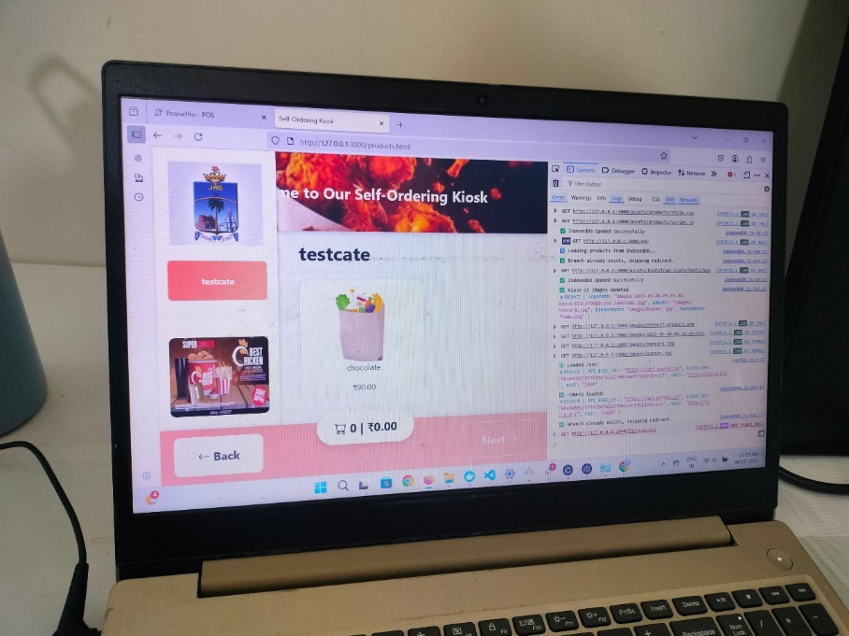
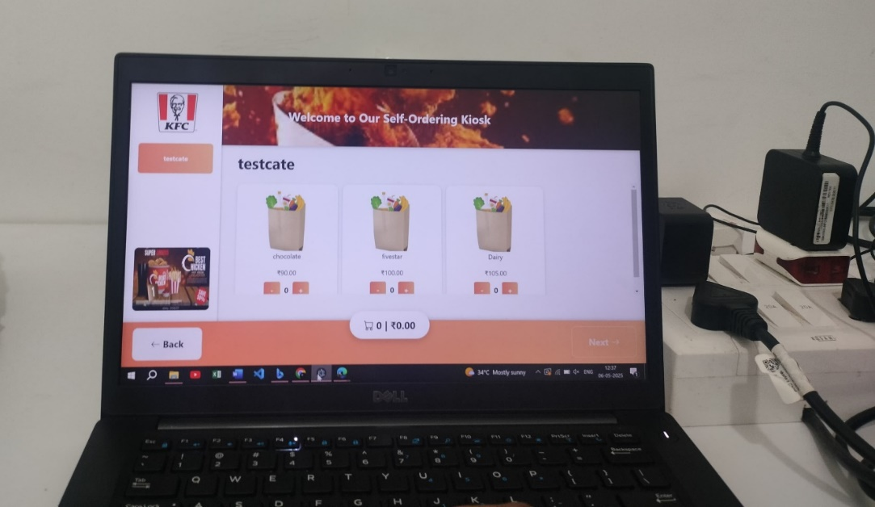
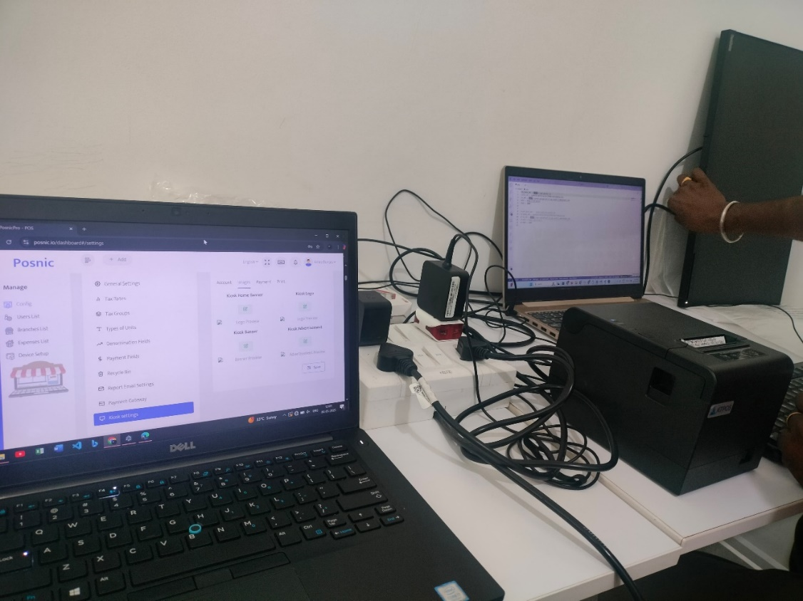
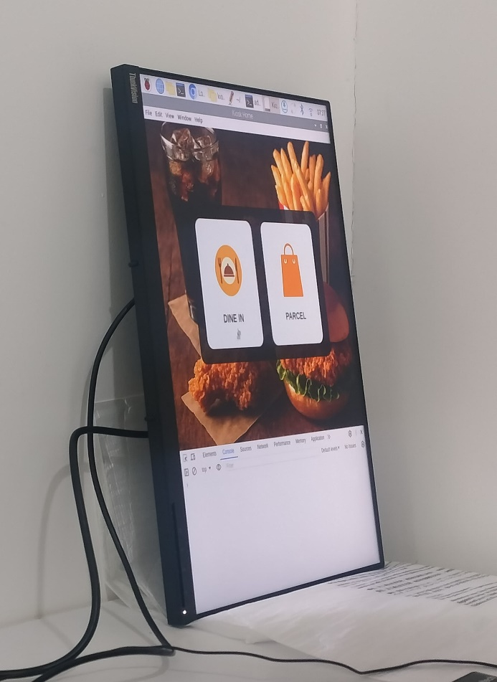

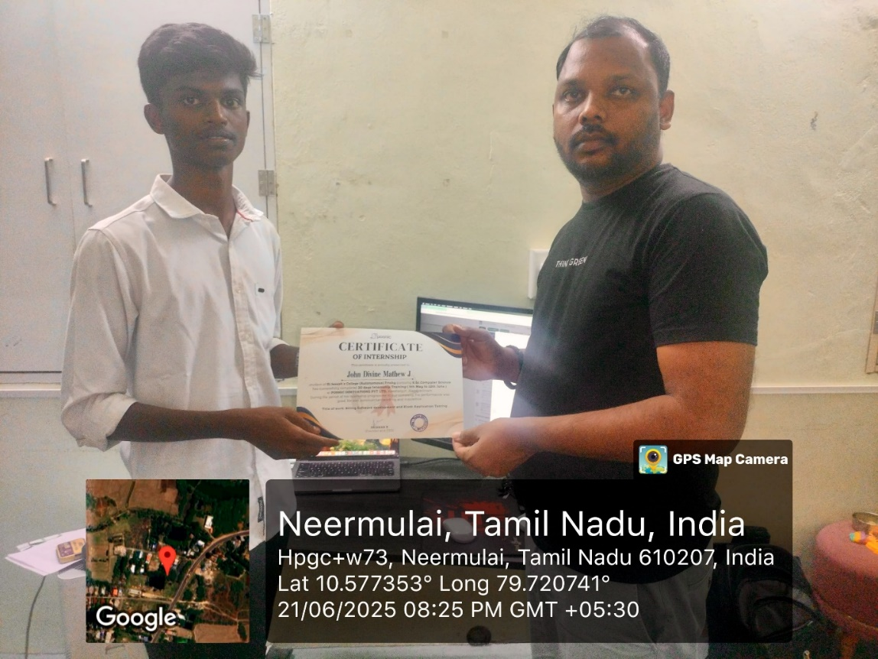

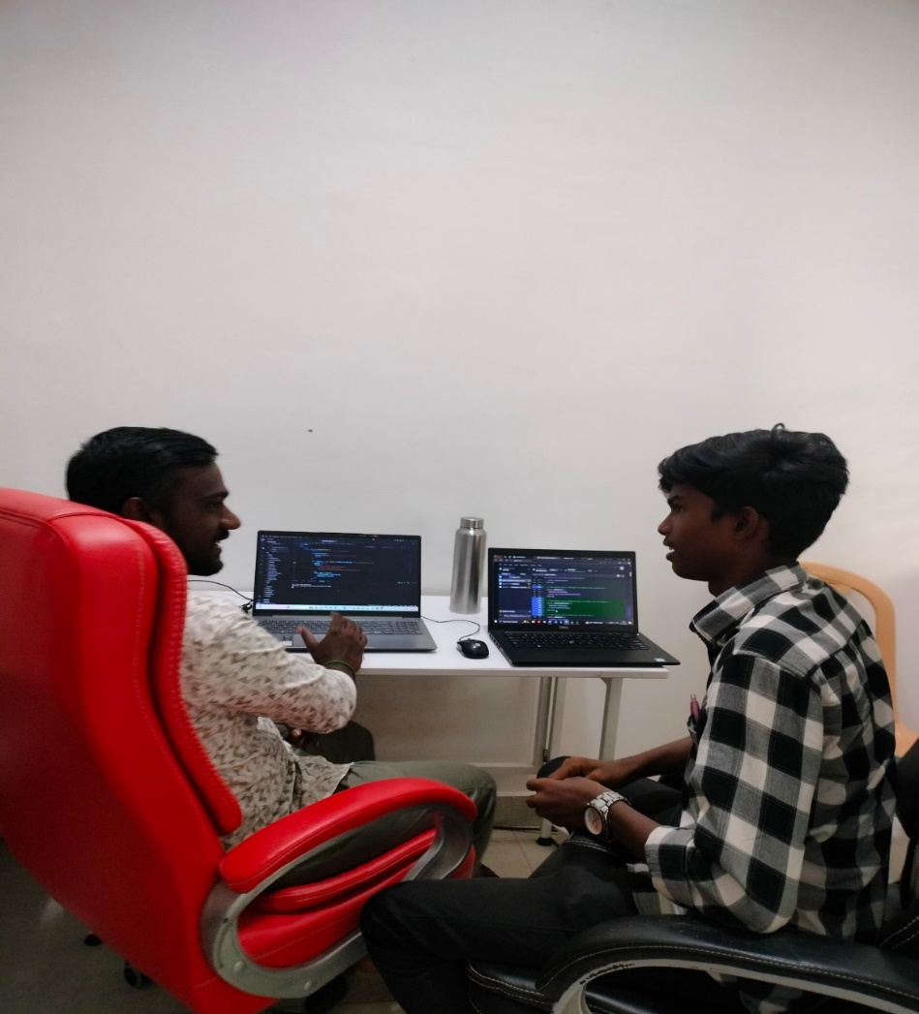

DAILY WORK SHEET

