John Wilson

CSCI 3287-310 Database Systems

Homework 4 SQL

-- 1)

SELECT CompanyName, Country

FROM hwsuppliers

WHERE Country='Japan' OR Country='Germany'

;

-- 2)

SELECT ProductName, QuantityPerUnit, UnitPrice

FROM hwproducts

WHERE UnitPrice<7 AND UnitPrice>4

;

-- 3)

SELECT CompanyName, City, Country

FROM hwcustomers

WHERE (Country='USA' AND City='Portland') OR (Country='Canada' AND City='Vancouver')

;

-- 4)

SELECT ContactName, ContactTitle

FROM hwsuppliers

WHERE SupplierID >= 5 AND SupplierID <= 8

ORDER BY ContactName DESC

;

-- 5)

SELECT ProductName, UnitPrice

FROM hwproducts

WHERE UnitPrice IN

(SELECT MIN(UnitPrice) FROM hwproducts)

;

-- 6)

SELECT COUNT(OrderID), ShipCountry

FROM hworders

WHERE NOT (ShipCountry='USA' AND ShippedDate >= '2015-05-04' AND ShippedDate <= '2015-05-10')

GROUP BY ShipCountry

HAVING COUNT(OrderID) > 3

;

-- 7)

SELECT FirstName, LastName, DATE_FORMAT(HireDate, "%m-%d-%Y") as HireDate

FROM hwemployees

WHERE DATEDIFF(CURRENT_DATE, HireDate) >= 1826 AND Country<>'USA'

;

-- 8)

SELECT ProductName, (UnitPrice * UnitsInStock) AS InventoryValue

FROM hwproducts

WHERE (UnitPrice * UnitsInStock) > 3000 AND (UnitPrice * UnitsInStock) < 4000

;

-- 9)

SELECT ProductName, UnitsInStock, ReorderLevel

FROM hwproducts

WHERE ProductName LIKE 'S%' AND UnitsInStock >= 1 AND UnitsInStock <= ReorderLevel

;

-- 10)

SELECT ProductName, UnitPrice

FROM hwProducts

WHERE QuantityPerUnit LIKE '%box%' AND Discontinued = 1

;

-- 11)

SELECT ProductName, SUM(UnitPrice * UnitsInStock) AS InventoryValue

FROM hwProducts, hwsuppliers

WHERE hwsuppliers.Country = 'Japan'

GROUP BY hwsuppliers.Country

;

-- 12)

SELECT Country, COUNT(CustomerID)

FROM hwCustomers

GROUP BY Country

HAVING COUNT(CustomerID) > 8

;

-- 13)

SELECT ShipCountry, ShipCity, COUNT(OrderID)

FROM hwOrders

GROUP BY ShipCountry

HAVING ShipCountry = 'Austria' OR ShipCountry = 'Argentina'

;

-- 14)

SELECT CompanyName, ProductName

FROM hwSuppliers

INNER JOIN hwProducts

ON hwSuppliers.SupplierID = hwProducts.SupplierID

WHERE hwSuppliers.Country = 'Spain'

;

-- 15)

SELECT ROUND(AVG(UnitPrice), 2) AS AverageUnitPrice

FROM hwProducts

WHERE ProductName LIKE '%T'

;

-- 16)

SELECT CONCAT( hwEmployees.FirstName, ' ', hwEmployees.LastName) AS FullName, hwEmployees.Title, COUNT(hwOrders.OrderID) AS OrderCount

FROM hwEmployees

LEFT JOIN hwOrders on hwEmployees.EmployeeID = hwOrders.EmployeeID

GROUP BY FullName

HAVING COUNT(hwOrders.OrderID > 120)

;

-- 17)

SELECT hwCustomers.CompanyName, hwCustomers.Country

FROM hwCustomers

LEFT JOIN hwOrders ON hwCustomers.CustomerID = hwOrders.CustomerID

WHERE hwOrders.CustomerID IS NULL

;

-- 18)

SELECT hwCategories.CategoryName, hwProducts.ProductName

FROM hwCategories

RIGHT JOIN hwProducts ON hwCategories.CategoryID = hwProducts.CategoryID

WHERE hwProducts.UnitsInStock = 0

;

-- 19)

SELECT hwProducts.ProductName, hwProducts.QuantityPerUnit

FROM hwProducts

LEFT JOIN hwSuppliers on hwProducts.SupplierID = hwSuppliers.SupplierID

WHERE hwSuppliers.Country = 'Japan' AND (hwProducts.QuantityPerUnit LIKE '%pkg%' OR hwProducts.QuantityPerUnit LIKE '%pkgs%' OR hwProducts.QuantityPerUnit LIKE '%jars%')

;

-- 20)

SELECT hwCustomers.CompanyName, hwOrders.ShipName, ROUND(((hwOrderDetails.UnitPrice * hwOrderDetails.Quantity) * (1 + hwOrderDetails.Discount)),2) AS OrderValue

FROM hwOrders

JOIN hwCustomers ON hwOrders.CustomerID = hwCustomers.CustomerID

JOIN hwOrderDetails ON hwOrders.OrderId = hwOrderDetails.OrderID

WHERE hwCustomers.Country = 'Mexico'

GROUP BY hwOrders.ShipName

;

-- 21)

SELECT hwProducts.ProductName, hwSuppliers.Region

FROM hwProducts

INNER JOIN hwSuppliers ON hwProducts.SupplierID = hwSuppliers.SupplierID

WHERE hwProducts.ProductName LIKE 'L%' AND hwSuppliers.Region <> ''

;

-- 22)

SELECT ShipCountry, ShipName

FROM hwOrders

WHERE ShipCity = 'Versailles' AND CustomerID NOT IN

(SELECT DISTINCT customerID FROM hwCustomers)

GROUP BY ShipCountry

;

-- 23)

SELECT ProductName, UnitsInStock, RANK()

OVER (ORDER BY UnitsInStock DESC)

AS 'Rank'

FROM hwProducts

WHERE ProductName Like 'F%'

;

-- 24)

SELECT ProductName, UnitPrice, RANK()

OVER (ORDER BY UnitPrice ASC)

AS 'Rank'

FROM hwProducts

WHERE ProductID >= 1 AND ProductID <= 5

;

-- 25)

SELECT FirstName, LastName, Country, DATE_FORMAT(BirthDate, "%m-%d-%Y") AS BirthDate, RANK()

OVER (PARTITION BY Country ORDER BY BirthDate DESC)

AS 'Rank'

FROM hwEmployees

WHERE EXTRACT(YEAR FROM BirthDate) > '1984'

;

1. 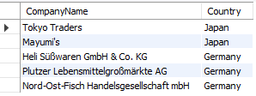
2. 
3. 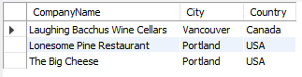
4. 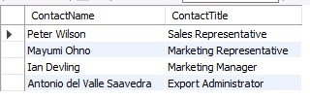
5. 
6. 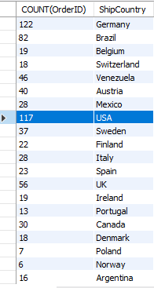
7. 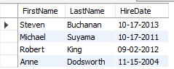
8. 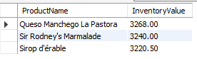
9. 
10. 
11. 
12. 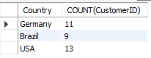
13. 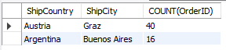
14. 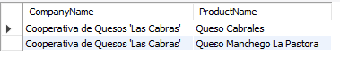
15. 
16. 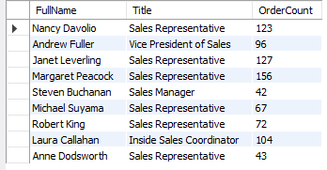
17. 
18. 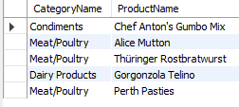
19. 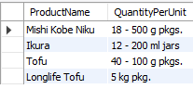
20. 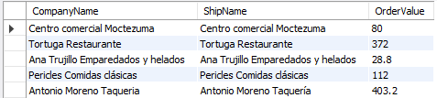
21. 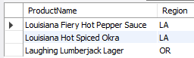
22. 
23. 
24. 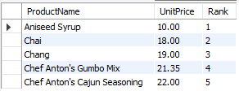
25. 