John Wilson

CSCI 3287-310 Database Systems

Homework 5 Data Warehouse

-- 1)

SELECT c.customername, c.gender, s.salespersonname, s.city

FROM dim_customer c

JOIN fact_productsales f

ON c.customerid = f.customerid

JOIN dim_salesperson s

ON s.salespersonid = f.salespersonid

JOIN dim_date d

ON d.datekey = f.salesdatekey

WHERE d.YEAR = '2015' AND d.MONTHNAME = 'September' AND f.salesprice > 20 AND f.quantity > 8

;

-- 2)

SELECT s.storename, s.city, p.productname

FROM dim_store s

JOIN fact_productsales f

ON s.storeid = f.storeid

JOIN dim_product p

ON f.productid = p.productkey

JOIN dim_date d

ON d.datekey = f.salesdatekey

WHERE d.YEAR = '2017' AND d.MONTHNAME = 'March' AND f.productcost < 50 AND s.city = 'Boulder'

;

-- 3)

SELECT s.salespersonname, SUM(f.SalesPrice * f.Quantity) AS revenue

FROM dim_salesperson s

JOIN fact_productsales f

ON s.salespersonid = f.salespersonid

GROUP BY s.salespersonname

ORDER BY revenue DESC

LIMIT 2

;

-- 4)

SELECT c.customername, SUM(f.SalesPrice * f.Quantity) AS totalrevenue

FROM dim_customer c

JOIN fact_productsales f

ON c.customerid = f.customerid

JOIN dim_date d

ON d.datekey = f.salesdatekey

WHERE d.YEAR = '2017'

GROUP BY c.customername

ORDER BY totalrevenue ASC

LIMIT 1

;

-- 5)

SELECT s.storename, SUM(f.salesprice) AS totalsalesprice

FROM dim_store s

JOIN fact_productsales f

ON s.storeid = f.storeid

JOIN dim_date d

ON d.datekey = f.salesdatekey

WHERE d.YEAR BETWEEN 2010 AND 2017

GROUP BY s.storename

ORDER BY s.storename ASC

;

-- 6)

SELECT s.storename, p.productname, SUM((f.salesprice * f.quantity)-(f.productcost * f.quantity)) AS totalprofits

FROM dim_store s

JOIN fact_productsales f

ON s.storeid = f.storeid

JOIN dim_product p

ON f.productid = p.productkey

JOIN dim_date d

ON d.datekey = f.salesdatekey

WHERE d.YEAR = '2017' AND p.productname LIKE '%Jasmine Rice%'

GROUP BY s.storename

;

-- 7)

SELECT SUM(f.salesprice * f.quantity) AS totalrevenue, d.quarter

FROM fact_productsales f

JOIN dim_store s

ON s.storeid = f.storeid

JOIN dim_date d

ON d.datekey = f.salesdatekey

WHERE d.YEAR = '2016' AND s.storename = 'ValueMart Boulder'

GROUP BY d.quarter

ORDER BY d.quarter ASC

;

-- 8)

SELECT c.customername, SUM(f.salesprice) AS totalsalesprice

FROM dim_customer c

JOIN fact_productsales f

ON c.customerid = f.customerid

WHERE c.customername = 'Melinda Gates' OR c.customername = 'Harrison Ford'

GROUP BY c.customername

;

-- 9)

SELECT s.storename, f.salesprice, f.quantity

FROM dim_store s

JOIN fact_productsales f

ON s.storeid = f.storeid

JOIN dim_date d

ON d.datekey = f.salesdatekey

WHERE d.DAYOFMONTH = '12' AND d.MONTHNAME = 'March' AND d.YEAR = '2017'

;

-- 10)

SELECT s.salespersonname, SUM(f.salesprice * f.quantity) AS totalrevenue

FROM dim_salesperson s

JOIN fact_productsales f

ON s.salespersonid = f.salespersonid

GROUP BY s.salespersonname

ORDER BY totalrevenue DESC

LIMIT 1

;

-- 11)

SELECT p.productname, SUM((f.salesprice * f.quantity)-(f.productcost * f.quantity)) AS totalprofits

FROM dim_product p

JOIN fact_productsales f

ON p.productkey = f.productid

GROUP BY p.productname

ORDER BY totalprofits DESC

LIMIT 3

;

-- 12)

SELECT d.year, d.monthname, SUM(f.salesprice * f.quantity) AS totalrevenue

FROM dim_date d

JOIN fact_productsales f

ON d.datekey = f.salesdatekey

WHERE d.YEAR = '2017' AND (d.MONTHNAME = 'January' OR d.MONTHNAME = 'February' OR d.MONTHNAME ='March')

GROUP BY d.monthname

;

-- 13. Display Product Name, average product cost and average sales price for the products sold in

-- 2017. Show averages rounded to 2 decimal places.

-- 13)

SELECT p.productname, ROUND(AVG(f.productcost),2) AS avgcost, ROUND(AVG(f.salesprice),2) AS avgprice

FROM dim_product p

JOIN fact_productsales f

ON p.productkey = f.productid

JOIN dim_date d

ON d.datekey = f.salesdatekey

WHERE d.YEAR = '2017'

GROUP BY p.productname

;

-- 14)

SELECT c.customername, ROUND(AVG(f.salesprice),2) AS avgprice, ROUND(AVG(f.quantity),2) AS avgquantity

FROM dim_customer c

JOIN fact_productsales f

ON c.customerid = f.customerid

WHERE c.customername = 'Melinda Gates'

GROUP BY c.customername

;

-- 15)

SELECT s.storename, ROUND(MAX(f.salesprice),2) AS maxsalesprice, ROUND(MIN(salesprice),2) AS minsalesprice

FROM dim_store s

JOIN fact_productsales f

ON s.storeid = f.storeid

WHERE s.city = 'Boulder'

GROUP BY s.storename

;

1. 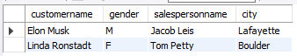
2. 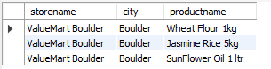
3. 
4. 
5. 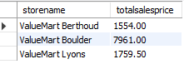
6. 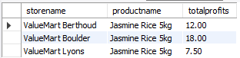
7. 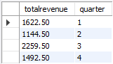
8. 
9. 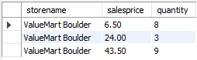
10. 
11. 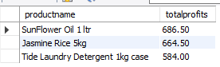
12. 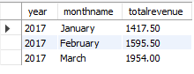
13. 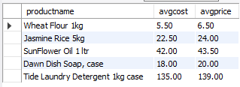
14. 
15. 