[](https://www.genmymodel.com/)

# CS321UML

Author: John Ingram

Date: 2021-03-27

# CS321UML (Model)

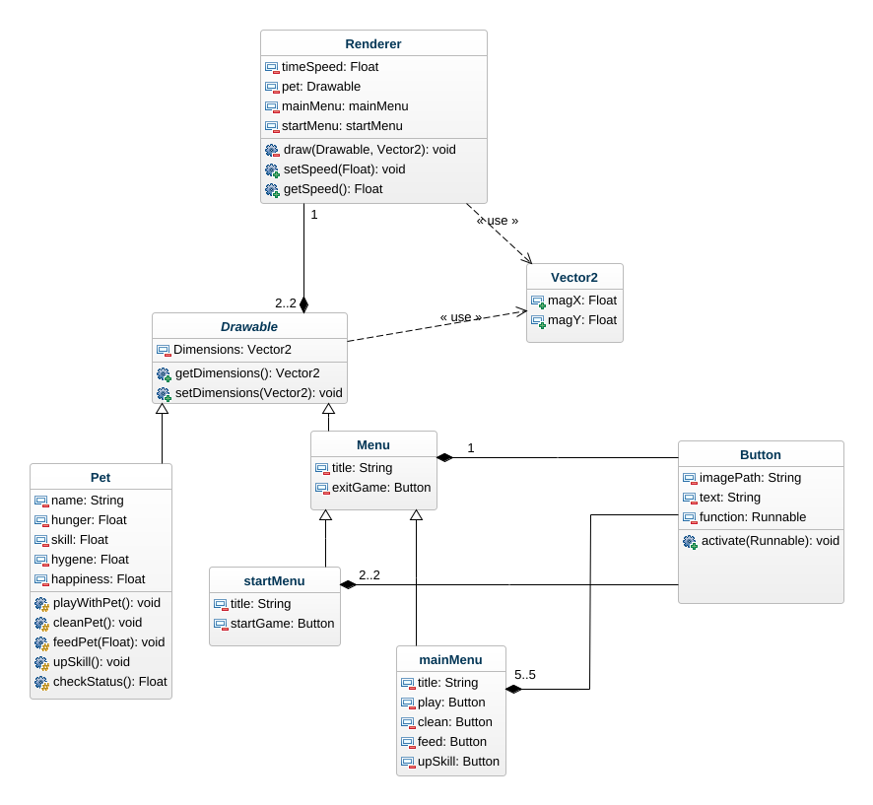

class-diagram

## 1. Button (Class)

In CS321UML

| Attributes |
| --- |
| imagePath : String [1] |
| text : String [1] |
| function : Runnable [1] |

| Operations |
| --- |
| activate : void  - parameter: Runnable[1] |

| Associations |
| --- |
| startMenu_Button - startMenu : startMenu [2..2] - see definition |
| mainMenu_Button - mainMenu : mainMenu [5..5] - see definition |
| Menu_Button - menu : Menu [1] - see definition |

## 2. Drawable (Class)

In CS321UML

| Attributes |
| --- |
| Dimensions : Vector2 [1] |

| Operations |
| --- |
| getDimensions : Vector2 |
| setDimensions : void  - parameter: Vector2[1] |

| Associations |
| --- |
| Drawable_Renderer - renderer : Renderer [1] - see definition |

## 3. Float (DataType)

In CS321UML

## 4. Menu (Class)

In CS321UML

Extends

* Drawable - see definition

| Attributes |
| --- |
| title : String [1] |
| exitGame : Button [1] |

| Associations |
| --- |
| Menu_Button - button : Button [0..1] - see definition |

## 5. Pet (Class)

In CS321UML

Extends

* Drawable - see definition

| Attributes |
| --- |
| name : String [1] |
| hunger : Float [1] |
| skill : Float [1] |
| hygene : Float [1] |
| happiness : Float [1] |

| Operations |
| --- |
| playWithPet : void |
| cleanPet : void |
| feedPet : void  - parameter: Float[1] |
| upSkill : void |
| checkStatus : Float |

## 6. Renderer (Class)

In CS321UML

| Attributes |
| --- |
| timeSpeed : Float [1] |
| pet : Drawable [1] |
| mainMenu : mainMenu [1] |
| startMenu : startMenu [1] |

| Operations |
| --- |
| draw : void  - Parameter: Drawable[1] - parameter: Vector2[1] |
| setSpeed : void  - parameter: Float[1] |
| getSpeed : Float |

| Associations |
| --- |
| Drawable_Renderer - drawable : Drawable [2..2] - see definition |

## 7. Runnable (DataType)

In CS321UML

## 8. Vector2 (Class)

In CS321UML

| Attributes |
| --- |
| magX : Float [1] |
| magY : Float [1] |

## 9. mainMenu (Class)

In CS321UML

Extends

* Menu - see definition

| Attributes |
| --- |
| title : String [1] |
| play : Button [1] |
| clean : Button [1] |
| feed : Button [1] |
| upSkill : Button [1] |

| Associations |
| --- |
| mainMenu_Button - button : Button [0..1] - see definition |

## 10. startMenu (Class)

In CS321UML

Extends

* Menu - see definition

| Attributes |
| --- |
| title : String [1] |
| startGame : Button [1] |

| Associations |
| --- |
| startMenu_Button - button : Button [1] - see definition |

## 11. void (Class)

In CS321UML