Q1

1. mystery(4, 9) returns 4 + mystery (8, 4) = 4 + 32 + 0 =36
2. mystery (8, 4) returns mystery(16, 2)
3. mystery(16, 2) returns mystery(32, 1)
4. mystery(32, 1) returns 32 + mystery(64, 0)
5. mystery(64, 0) returns 0

This code returns the product of a and b (it multiplies them)

Q2

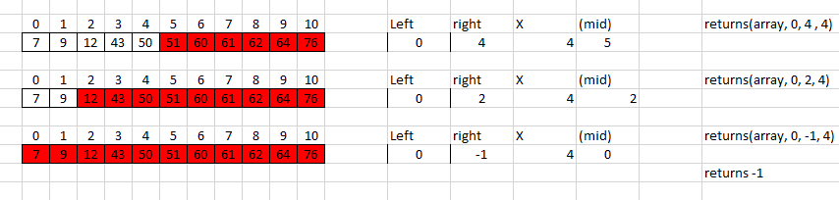

Q3

Binary search is better because it is much faster. Instead of having to check each element of the array, a very large number of checks can be skipped.

Q4

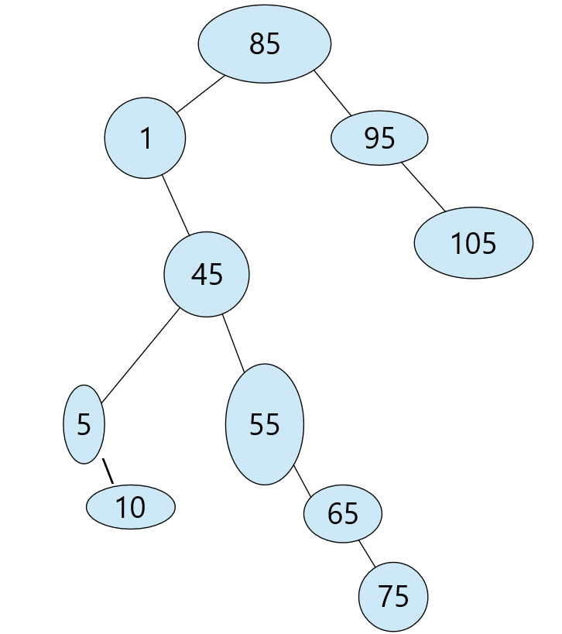

Q5

int getDepth(Node \*root)

    {

        if (root == NULL) return 0;

        int leftResult, rightResult;

        leftResult = getDepth(root->left);

        rightResult = getDepth(root->right);

        if (leftResult >= rightResult)

        {

            return 1+leftResult;

        } else

        {

            return 1+rightResult;

        }

    }

Q6

The tree is not a Max Heap, because heaps are populated from left to right.

Q7

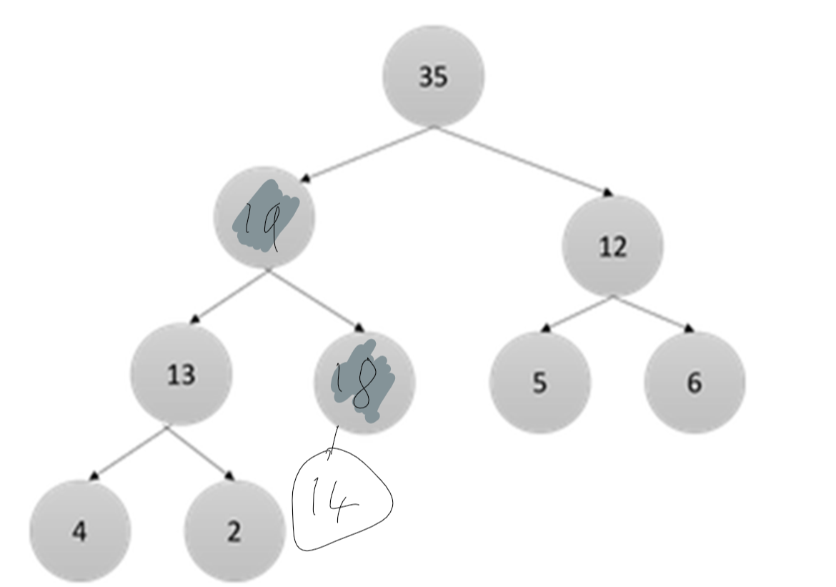

Q8

