Created a repository for project:

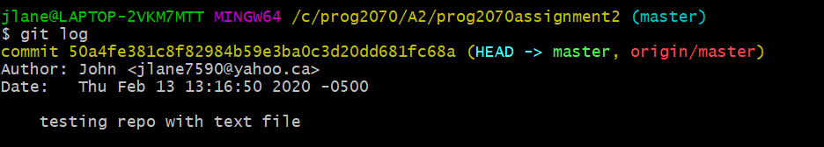

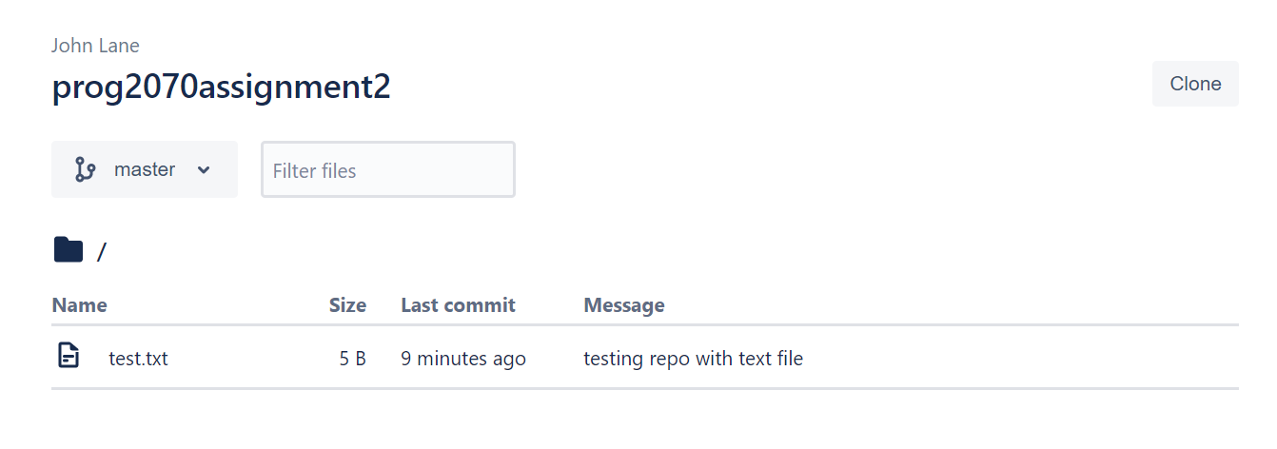

Created Console Application:

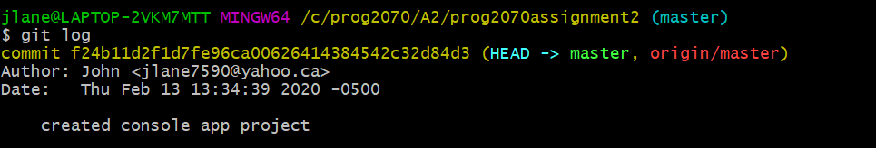

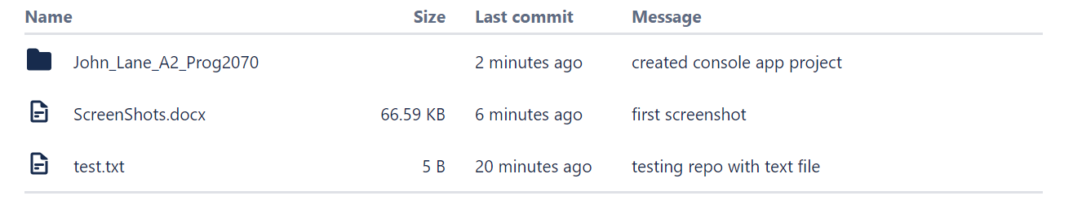

Completed Console Application:

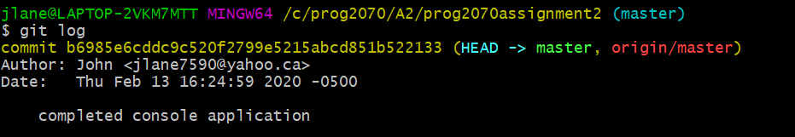

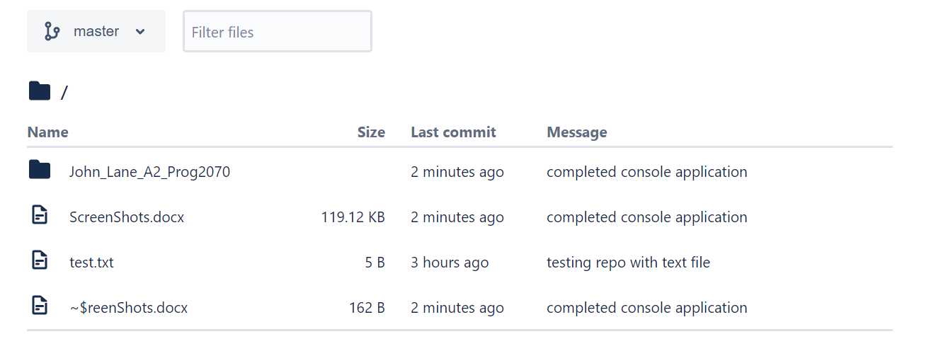

All tests run successfully:

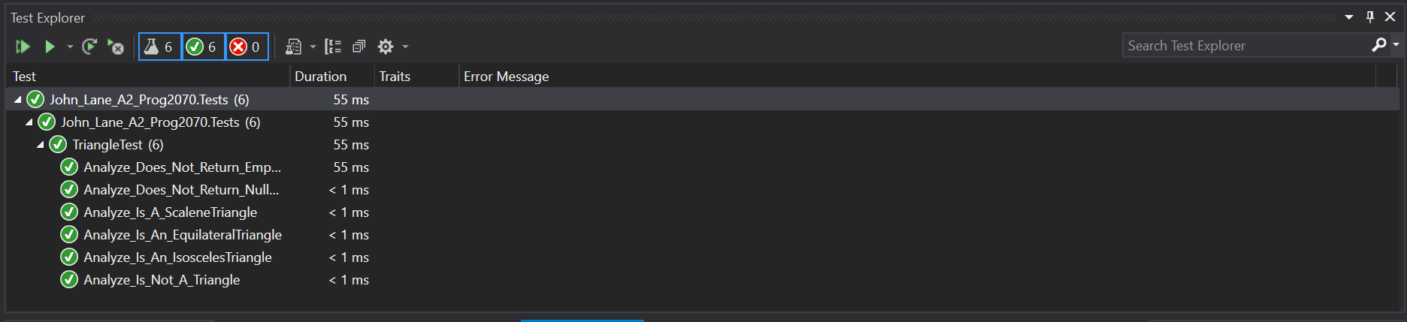

Completed Console Application with comments:

