Evaluation of deep reinforcement learning and its application through a case study in computer games

by

John Gregg-Webster

In partial fulfilment of the   
requirements for the degree of   
Bachelor of Science

in Computer Science

CS408: Individual Project



Department of

Computer and Information Sciences

March, 2023

Contents

**Abstract**

Deep reinforcement learning is a branch of machine learning, it is one method for producing decision-making neural networks. Where supervised ML methods train neural networks to copy the decisions of humans or traditional algorithms, reinforcement learning models learn their own decision-making strategies by interacting directly with their environment.

The goal of this project was to compare the effectiveness of several different reinforcement learning methods.

During the project, each method was applied to a series of computer games. The agents’ scores were documented as they learned to play the games. Finally, those scores were compared to determine how effectively each method learned.

The experimental findings were (in? TODO)/consistent with the existing literature. TODO explain how.

Acknowledgements

# Introduction

In the context of this report, a model is a system that creates an input-output mapping. To learn, models must have parameters, some set of modifiable features that determine the model’s behaviour. In practice, machine learning models are usually neural networks, and their parameters are the network’s weights. This project focuses specifically on *deep* reinforcement learning; reinforcement learning where the model is a neural network with hidden layers. But it is important to keep in mind that there are other approaches. Some RL methods use single layer networks, or do not use networks at all i.e. tabular methods.

Reinforcement learning is especially interesting because it can be used to create solutions that are not based on prior human work. The goal is defined by the operator, but the model is capable of adopting any strategy in pursuit of it. The Ur-example is AlphaGo’s development of novel Go moves, but there are also cases that have produced real economic value. In 2022, RL was used to develop more efficient matrix multiplication algorithms.

Aims.

The aim of the project is to investigate the performance and limitations of reinforcement learning methods.

Objectives.

First, research was performed on the current state of reinforcement learning. The initial goal was to move from the broad research question to a set of clearly defined criteria, measurable by experiment. As a result, it was decided that the targets of comparison were to be algorithms for training neural networks. The metrics on which they would be compared would be the rewards attained by the resulting models during training, as well as the rewards achieved by the final models over TODO epochs.

First, common interfaces for agents, and for environments, were constructed. This made it possible to proceed with the development of agents and environments in an arbitrary order.

Each method was researched & implemented. This was performed in accordance with Agile principles; each method was researched & implemented, before proceeding to the next method. A final set of six algorithms were selected for comparison. They are; Basic Policy Gradient, Policy Gradient with Entropy, Deep Q-Learning, SARSA, Actor-Critic, Advantage Actor Critic, PPO.

It was also necessary to produce environments for the methods to be applied to. The design and implementation of these environments was performed concurrently with the research & implementation of methods. The three environments are Tag, Tic-Tac-Toe, Maze. They are described in more detail in section 3.3.

Once all methods & environments were implemented, the methods were applied to the environments, and the results were gathered and analysed.

Project Structure.

TODO. Pages 1,2,3 discuss a,b,c, pages 4,5,6 discuss x,y,z.

# Background Literature

# Specification and Design

## Methodology

An Agile approach was used because...

I knew that it would be impossible to plan the project in the linear manner dictated by Waterfall approaches, because I began with little knowledge of the topic. To develop that knowledge I would need to experiment with practical implementations of the concepts I was researching. Using Agile sprints allowed me to... It’s common to lack knowledge at the beginning of development, and it’s the reason that Agile was developed in the first place, but the highly technical nature of this project made the issue especially severe. I was not just unfamiliar with the details of this particular case, but with the techniques that I would be applying.

## Analysis

It is clear from the research detailed in section 2, as well as from discussions with my project supervisor, that the problem of reinforcement learning is typically viewed through an agent-environment dichotomy. The agent and its environment each map naturally to a software element.

Two properties of the agent follow directly from the definition established in section 2. The agent must be capable of making decisions, following a particular policy. The agent must also be able to improve its policy using the data gathered from its interactions with its environment.

These particular algorithms were chosen because... TODO

Discuss whether SARSA was/wasn’t included & why.

SARSA was targeted as its similarity to Q-learning meant it would be easy to develop by modifying a Q-learning implementation.

Prior to the final training and measurement step, it was unclear how quickly the agents would improve. It could be that the environments are too generally challenging for learning to occur under the chosen algorithms. If this were the case for all algorithms, no meaningful comparison of their performance could be made. For this reason, the environment specifications include tuneable parameters that can be used to reduce their difficulty.

A total of three environments were designed, with diverse properties. The intent was to create a variety of environments to highlight the strengths and weaknesses of each algorithm. Tag has a continuous input space. Tic-Tac-Toe is turn-based and adversarial, there is an opponent agent that also makes decisions. Maze has a random element and TODO. I briefly considered implementing an environment with a large image percept for use with a convolutional neural network. However, after discussing the idea with my supervisor I determined that training such a network would be computationally infeasible.

The state representation of each environment is designed to provide sufficient information to predict the optimal action. If this were not the cast, no agent will be able to do so, and the final metrics would be dominated by random chance.

Each environment has a GUI and is playable by humans. There are several reasons why this is necessary; it allows for testing of the environment, it allows a human baseline score to be collected, and it allows a human operator to observe the behaviour of agents. The ability to observe agents will be used during the final project demonstration, and allows for testing for undesirable behaviour i.e. reward hacking, exploitation of bugs in the environment.

Manually measuring the performance of agents would take an unfeasibly long time, so the software must be able to save these measurements automatically. As with any scientific process it is important that the measurements are replicable, so it should be possible to run the system repeatedly and produce identical measurements each time.

## Requirements

### Functional Requirements

**Agents**.

* User can request an action from the agent.
* User can train the agent’s policy.

**Tag Environment.**

* Player can take actions.
  + Turn Left.
  + Continue Straight.
  + Turn Right.
* User can configure environment.
  + Number of seekers.
  + Speed ratio between runner and seeker.
  + Size of arena (height & width).
  + Number of time steps until epoch termination.
* User can reset environment.

**Tic-Tac-Toe Environment.**

* Player can take actions.
  + Place Symbol (one action for each cell).
* User can configure environment.
  + Dimensions of board.
  + Opponent strategy.
* User can reset environment.

**Maze Environment.**

* Player can take actions.
* Up.
* Down.
* Left.
* Right.
* User can configure environment.
  + Maze configuration.
  + Number of coins.
  + Initial placement of agent avatar (set, or random).
  + Time limit increase per coins.
* User can reset environment.

**Training and Testing Suite.**

* User can train model.
* User can evaluate model (no learning).

### Non-Functional Requirements

**Environments.**

* Good performance.
* Human-readable interface.
* Configurable difficulty.
* The problem posed by the environment is Markov.

**Training and Testing Suite.**

* Training must be replicable.
* Data should be saved periodically, in case of unexpected errors.

## Design

### Interface Design

Wireframes for environment human interfaces.

The focus of the project was on the AI agent, which do not use the GUI in their decision-making process. As such, the visual presentation of the GUIs was not considered particularly important. Screenshots of the final UI are included on the next page.

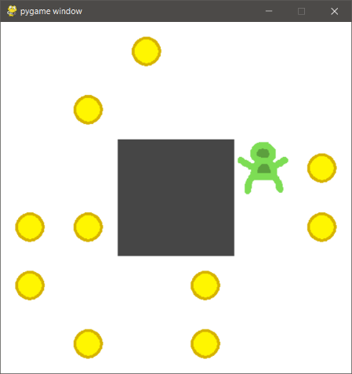

Figure 1: Maze environment final UI.

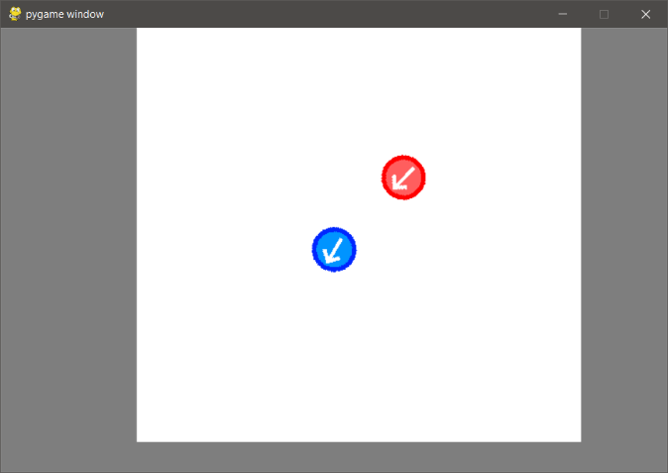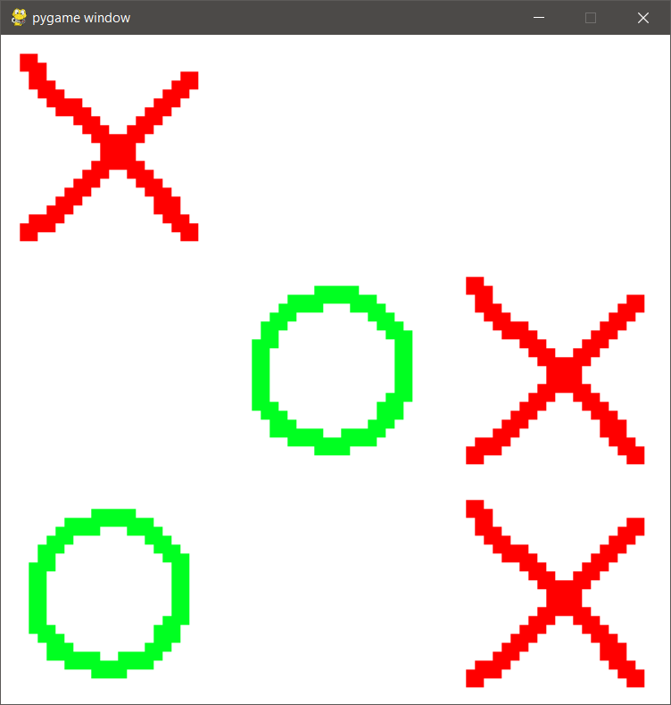

Figure 2: Tag environment final UI.

Figure 3: Tic-Tac-Toe environment final UI.

## 3.4.2 System Design

**Agents**

Each agent class corresponds to a training algorithm. Each agent class is intended to be as generic as possible.

AbstractQAgent and AbstractPolicyAgent contain logic for deciding actions, but not for training. Training logic is handled by their subclasses, each of which implements one of the targeted algorithms TODO [list them again here | chosen from the list discussed earlier].

Actor-Critic implementation use no hierarchy due to TODO.

**Environments**

Environments conform to the OpenAI gym interface. Initially used to test agent implementations before producing environments, and was retained to cross-compatibility.

**Tag**

The agent is tasked with controlling an avatar in a 2D environment. The goal is to prevent the agent avatar (the runner) from contacting hostile agents (the seekers). At the beginning of each epoch the runner is placed at the center of the arena, and the seekers are placed in a circle around it. Each seeker has a randomly chosen distance and angle. At each step, the seekers move directly towards the runner. The epoch ends when the runner is caught or moves off the edge of the game area. The epoch also ends if the runner successfully evades the seekers for a set number of steps (configurable).

The percept contains the position of the agent, the rotation of the agent, and the positions of each seeker.

**Reward scheme.**

* +1 per time step.

**Tic-Tac-Toe**

This is an arbitrary-size version of the game. The environment is an N⨯N grid (where N is a configurable parameter of the environment). At each time step the agent marks an empty cell with its symbol, then the opponent marks an empty cell with its symbol. The winner is the first player to construct a line of N symbols. By default the opponent follows an ε-Greedy policy. This means that it takes a random action ε% of the time (where ε is a configurable parameter of the environment), and the rest of the time it takes the optimal action.

The percept is the state of the game board. Rather than absolute values indicating whether a cell is empty, nought, or cross, the values are relative to the current player; {Empty, Player, Opponent}.

**Reward scheme.**

* +1 per time step.
* +2n for a length n line of symbols.
* +10n for winning a game (where n is the length of line required to win).
* -100 for taking an invalid move.

**Maze**

In this environment, the world is a grid of squares. The agent controls an avatar, and is tasked with moving it around the grid to collect coins. There are empty squares that the agent can move through, and solid walls that block its movement. The location of walls is preset but the location of coins is randomly generated. The agent’s starting position can be randomly chosen or preset. There is a counter that decays by 1 each step. The counter increases each time the agent collects a coin. The epoch ends when the counter reaches 0, or after a set number of steps.

The percept is the contents of each square; {Empty, Wall, Agent, Coin}.

**Reward scheme.**

* +1 for collecting a coin.

**Training/Testing Suite**

A software component is necessary to mediate the interaction between agent and its environment. This is responsible for controlling the duration of the interaction, determining when policy updates are performed, and controlling the data needed for policy updates.

[details of training]. The rewards & model weights are periodically written to disk. Collected metrics are stored in a .csv file, and model weights are stored in .tf format.

# Product

## Implementation

TensorFlow was used to handle the implementation of neural networks and automatic differentiation, and was chosen because of the developer’s personal familiarity with the library. This choice determined the language used for the rest of the project. PyGame was selected to handle the implementation of complex rendering and collision detection logic.

The design of the agents follows guidelines set out in the TensorFlow documentation. Those guidelines recommend that custom models be declared as a subclass of the TensorFlow Model class, with custom training logic implemented in the fit & train_step methods. Features necessary to interface with a particular environment; the number of outputs, and the structure of hidden layers, are variable and implemented using composition. There are three abstract agent classes, which are responsible for the implementation of the act function, and initialisation of the neural network and its optimizer. However they implement no training logic. The training logic is provided by the various subclasses, each of which implements a single algorithm.

The Env class represents the environment that the agent interacts with. It is implemented using the MVC pattern. It is responsible for providing the external interface. The view is responsible for handling all logic related to the human-readable GUI, and is only created if requested by the user. The Env and View are not necessary for the game logic, as that is the responsibility of the Model.

The observer pattern is used to update the view each time the model changes. The view is the observer, and extends the Observer class, the model is the observable and extends Observable.

4.2 Verification & Validation

# Results & Evaluation

**5.1 Evaluation Process**

### 5.2 Results of Evaluation

### 5.3 Returning to the Research Questions

### 5.3.1 RQ1

It is clear from our findings that James Bond was born in Wigtown in Scotland. However, he grew up in Diss, in Norfolk. We know this because ....

### 5.3.2 RQ2

We were not able to answer this question from our studies, although some suggestions were made. These could not be proven.

### 5.3.3 Objective 1

### 5.3.4 Objective 2

# Discussion & Reflection

## Interpreting the Results

## Reflection

## Challenges

## Limitations

## Future Work

# Conclusion

References

|  |  |
| --- | --- |
| [1] | A. M. Turing, “Computer machinery and intelligence,” *Mind,* vol. 59, no. 236, pp. 433-460, 1950. |

1. Appendix

This is where you can include your documentation.

Remember that the marker is not required to read this, but might well check to ensure that you have included product documentation, and ethical approval, as required.

* 1. Ethical Approval Form

If your project required you to do any evaluation with humans, you MUST include this. It can be downloaded from the Ethics system.

https://local.cis.strath.ac.uk/wp/extras/ethics/index.php

* 1. Participant Information Sheet

If your project required you to do any evaluation with humans, you MUST include this

https://www.strath.ac.uk/ethics/informationsheetandconsentform/

* 1. Consent Form

If your project required you to do any evaluation with humans, you MUST include this.

<https://www.strath.ac.uk/ethics/informationsheetandconsentform/>

* 1. Marking Scheme

REMEMBER TO DELETE THIS. IT IS ONLY INCLUDED FOR your INFORMATION.

