Money Hub

Software Engineering Project

Software Design Documentation

Created by:

John Neis & Sam Dressler

CSCI 463- Software Engineering

4/29/2020

# Table of Contents

**Revision History**

1. **Introduction**
   1. *Document Purpose*
   2. *Product Scope*
   3. *Intended Audience*
2. **Design Considerations**
   1. *Assumptions and Dependencies*
   2. *General Constraints*
   3. *Goals and Guidelines*
   4. *Development Methods*
3. **Architectural Strategies**
   1. *Programming Language*
   2. *Component Reuse*
   3. *Further Work*
   4. *User Interface*
   5. *Software Interface*
   6. *Error Detection and Recovery*
4. **Software Architecture**
   1. *System Architecture*
   2. *System Decomposition*
5. **Policies and Tactics**
   1. *Coding Guidelines and Conventions*
   2. *Plans for Testing Product*
   3. *Maintaining Product*
   4. *Organization of Source Code*
   5. *Generating System Deliverables*
6. **Detailed System Design**
   1. *Classification*
   2. *Definition*
   3. *Responsibilities*
   4. *Constraints*
   5. *Compositions*
   6. *Uses and Interactions*
   7. *Resources*
   8. *Processing*
   9. *Interface and Export*
   10. *Detailed Subsystem Design*

# Revision Summary

|  |  |  |  |  |
| --- | --- | --- | --- | --- |
| Version | Name | Description of Change | | Date |
| 1.0 | Sam Dressler | -Document structure and initial layout  -Initial complete draft of section 1. Introduction  -Initial complete draft of section 3. Architectural Strategies  -initial complete draft of section 5. Policies and Tactics | 4/29/2020 | |
|  | Sam Dressler | -added assumption to the design considerations section 2.2 | 4/30/2020 | |
|  |  |  |  | |
|  |  |  |  | |
|  |  |  |  | |
|  |  |  |  | |

# 1. Introduction

## 1.1 Document purpose

This document contains the detailed design of the Money Hub system. The design will cover the user interface, the backend server, and the SQL database. Furthermore, the document will cover limitations that affect the development of the system. System architecture, policies, developmental strategies, and preliminary talk of testing will also be included. For a general overlook of the document, consult the table of contents found at the top of this report.

## 1.2 product scope

Money Hub was launched with the ideal in mind of simplifying how people manage their finances independently. The primary goal of creating Money Hub is to give users access to a simple and easy to use application that enables tracking of expenses and savings. The tools being designed into the product will prepare customers for financial challenges that will no doubt present themselves in life.

Money Hub will provide the user with visibility to a variety of their accounts in one place. Example of the accounts that can be viewed by the user can range from savings and checking to investments and loans.

Where Money Hub goes beyond your typical personal finance application is its access to showing the user their investment portfolios being used in online investment firms. On top of that, one of our goals in creating the system is too be able to see what debts the user has in car, student, and other various loans.

Money Hub will create a comprehensive summary of this information that is visible all in one place. The project team believes that allowing users to see all this is the first step in increasing the financial intelligence of the general American population.

## 1.3 Intended Audience

Software design documentation is primarily written with the purpose of allowing developers, system architects, and software testers a document to consult when they have questions regarding specific areas of the software.

In addition to developers, the design documentation will also serve the purpose of giving the customer a view of how the product is being developed. Referred to as the customer in the previous sentence, Dr. Hassan Reza, will be the primary evaluator of the system and this document will contain the necessary information to understand how the application will be structured.

# 2. Design Considerations

## 2.1 Assumptions and Dependencies

At the current phase of development, the Money Hub system considers several assumptions that will affect the system. The first of these, is in the testing of the product. Because the product will rely on displaying information that is taken from external parties, the application will have to set these fields with pre decided information in order to display the desired results in the prototype.

Secondly, the system relies on the use of network communication to retrieve information, as well as communication between the server application and the database system. The communication between these components must be reliable to ensure unimpeded use of the system. As of the present time, the project will work on the Windows operating system. Support for other operating systems may, or may not, appear in the production release.

## 2.2 General Constraints

Hardware used to run this product must have a semi-reliable internet connection. Without this, there can be no communication between the client and the server, and thus an end user will never be able to view any relevant information.

To that end, the server must remain operational at all times. If a user needs to view their account at unusual times, for instance in a time of emergency, the user must be able to access their information. If the server needs to be made inoperable (for servicing/maintenance for example), ample warning should be provided to any and all users of the system.

Network communication will utilize a reliable protocol (TCP) in order to ensure there is no data loss or corruption when displaying user account information.

For the server, the application must be able to interface with a relational database system. The relational database system will be used to store and maintain user data.

## 2.3 Development Methods

Development of the product was conducted via the waterfall method. Small, proof of concept module prototypes were developed alongside the documentation and design of the product following a model more akin to agile development.

# 3 Architectural Strategies

## 3.1 Programming Languages

The Money Hub System Architecture is currently being developed as a desktop application. Production versions of the system will allow for downloads and installation off an external site. The prototype of the system being discussed in this report, will consist of three main components. Each of these components will be implemented using unique programming languages.

The first component is how the users will interact with the system. This part of the architecture will be discussed further in section 3.4 of the system design documentation. The language chosen to implement this will be C#. One of the main reasons C# was used was the ease in which it allows for graphical user interfaces to be developed through Microsoft visual studio. The language also offers the ability to connect to servers that are written in java.

The second component, the server, will act as a conduit for which the user will communicate to the database. Java has options that make it a prime candidate because it can communicate with clients written in other languages.

The final component of the architecture is the database. The Structured Query Language, otherwise known as SQL, was chosen in order to maintain the relative information for the system. Since Money Hub is a query-based system, SQL makes sense for the development team to use for this.

## 3.2 Component Reuse

The current design for the system does not make use of any existing external components. The system will however offer means for the system to reuse internal data structures and functions.

## 3.3 Further Work

The System architecture will eventually need to include means in which it can query information from partner banks and firms off the internet. This web API is not currently in development because of the cooperation needed from these third parties. Additionally, the system would eventually be developed for mobile and web use in order to increase the access of the system to clients.

## 3.4 User Interface

The Money Hub user interface is designed with ease of access of user information in mind. Since the client application is currently being designed for Windows, there is a lot of flexibility with how we organize and size the display. A careful balance of how much information is available on one page and application size is needed in order to make sure that the user has an enjoyable experience while using the system. The interface will need to adhere to response time requirements outlined in the SRS in order to offer responsive and interactive experience while navigating the client.

## 3.5 Software Interface

Software interfaces are how the user client, accessed through the user interface, will communicate and query the database. Requests from the user will be coded and sent via a server connection that contain the request in json or xml format.

## 3.6 Error Detection and Recovery

From the current point of development, many errors will not be discovered until product testing begins. Testing and error detection will be discussed further in future documents. The current design phase is being completed with initial proof of concept of interaction for the system components as its primary focus.

# 4 Software Architecture

## 4.1 System Architecture

The product will operate as a query-based system where the users will send requests to a server via the clients User interface. The centralized server will allow each of the unique client applications to request the information needed by the current user logged on that port. 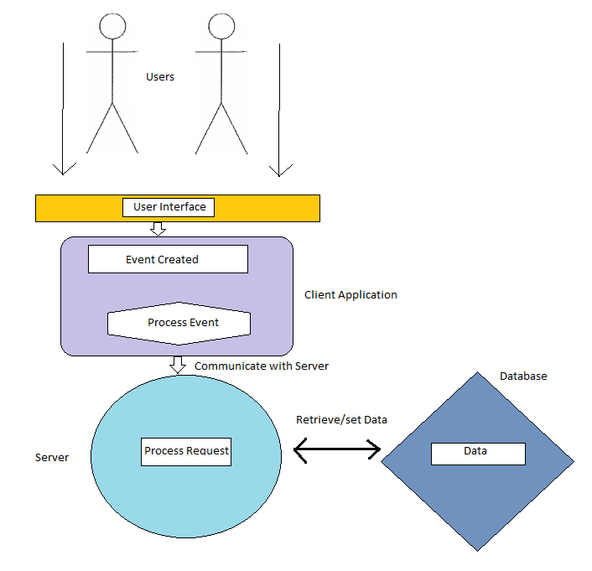

Figure 1 System Architecture Diagram

## 4.2 System Decomposition

Client: The client module will request the user provide account login information. In the final release of the product, the client will encrypt the login information before sending it to the server. Once the server responds, the client will display either the information requested by the user, or a failed login message, prompting the user to resubmit their information.

Server: The server will remain in a state of standby, listening for login requests from clients. The server will parse the information received from the client, and if the login information is valid, will build a string of data attributed to the user and send it back to the client. In the final release, this information will also be encrypted.

Database: The database will also remain in a state of standby, as its action will be paired with the server’s. The server will maintain the validity of the database.

# 5 Policies and Tactics

## 5.1 Coding Guidelines and Conventions

Strict coding guidelines will be used in the implementation of the Money Hub System. The reason being it allows for more rapid and effective development. For the development of the C# and Java components of the system, several guidelines will be followed and discussed in this section.

The coding convention and their benefits are as follows:

* Naming Conventions- create a consistent look in the code. Allows developers to focus on the content and not the layout.
* Layout Conventions – Enables better copying, changing, and maintaining of code.
* Commenting Conventions – Enables testers and developers to better understand how the code works. Enables rapid bug fixing as well as enables non-developers to understand how the code is working

Security is also a primary concern for the Money Hub Application so a few security guidelines will also be followed:

* Secure Resource Access – Use of a database to hold passwords and user account information rather than storing in a file that the client has direct access to.
* Security-Neutral Code – Means the program runs with whatever permission is allowed for that user when they register their account. No one can change their *own* permission level once they create their account.

## 5.2 Plans for Testing Product

Various testing strategies will be used at different stages of implementation in order to ensure the components are working as designed. Unit testing will be the primary method to test various cases. Since the implementation is not yet complete at this point the testing will be saved for its own report.

## 5.3 Maintaining Product

Once out of the prototyping phase with a proven application, product maintenance will be essential to keeping users’ level of contentedness high. Additionally, any bugs in the system will need to be periodically fixed once they are found. The system will have means by which the users can communicate any errors in the system that they encounter.

## 5.4 Organization of code

Organization of the source code shall be in a project files directory. Within that directory, there will be additional directories for the user interface as well as one for both the server and database file. This organization strategy keeps the components and dependencies for the system all in one place which allows for quicker development.

## 5.5 Generating system deliverables

In order to ensure the application and each of its components are compiled correctly, a batch script seems like a valid option to set up the various dependencies in the system. A detailed user manual will be developed prior to the final delivery to ensure the evaluator can correctly use the system.

# 6 Detailed System Design

## 6.1 Classification

6.1.1 – Client Component

- accountCreator class

- AccountTypeEnum enumeration

- AdminAccount class

- Login class

- MoneyHub class

- Navigator class

- UserAccount class

6.1.2 – Server Component

- ServerDriver class

- MySQL JDBC library

6.1.3 – Database Component

- MySQL server

## 6.2 Definition

## 6.3 Responsibilities

## 6.4 Constraints

## 6.5 Compositions

## 6.6 Uses and Interactions

## 6.7 Resources

## 6.8 Processing

## 6.9 Interface and Export

## 6.10 Detailed Subsystem Design