Money Hub

Modest Software Engineering Project

Software Requirement Specification

Created by:

Sam Dressler & John Neis

CSCI 463- Software Engineering

3/30/2020

# Table of Contents

**Table of Contents**

**Revision History**

1. **Introduction** 
   1. Document Purpose
   2. Product Scope
   3. Intended Audience and Document Overview
2. **Project Description**
   1. Product Perspective
   2. Product Functionality
   3. Users and Characteristics
   4. Operating Environments
   5. Design and Implementation Constraints
   6. User Documentation
   7. Assumptions and Dependencies
      1. Assumptions
      2. Constraints
      3. Dependencies
3. **Project Requirement Specification**
   1. Client User Interface Requirements
   2. Server Requirements
   3. Other Requirements
      1. API Requirements
      2. Database Requirements
      3. Security Requirements
      4. Availability Requirements
4. **System Specification**
   1. Data Modeling
      1. Data Flow Diagram
   2. Behavioral Modeling
      1. State Chart
      2. Use Case Diagram

# Revision Summary

|  |  |  |  |  |  |  |
| --- | --- | --- | --- | --- | --- | --- |
| Revision | | Name | Description of Change | | | Date |
| 1.0 | Sam Dressler | | | Initial report design and layout  Introduction sections: 1.1, 1.2, 1.3  Report Description sections: 2.1,2.2,2.3,2.4,2.5,2.6  2.7  Project Requirement Specification 3.1, | 3/29/2020 | |
|  |  | | |  |  | |
|  |  | | |  |  | |

# Introduction

## 1.1 DocumeNT pURPOSE

*\*\*Identify the product whose software requirements are specified in this document, including the revision or release number., Describe the scope of the product that is covered by this SRS, particularly if this SRS describes only part of a the system or a single subsystem.\*\**

Money Hub, henceforth known as the *project*, is the product whose requirements will be specified in this document. The requirement specification shall cover all functional and non-functional requirements as well as any design or process constraints.

The product is split into two main partitions, the Money Hub Client, henceforth known as the *client*, and the Money Hub Server, henceforth known as the *server*. The four specifications noted in the above paragraph will be specified for each of the partitions.

In addition to the specifications, this document will contain detailed models that specify certain use cases as data flows throughout the system. Finally, the document will contain a formal method of modeling the system that will be captured using a finite state machine.

## 1.2 Product scope

*\*\*Provide a short description of the software being specified and its purpose, including relevant benefits, objectives, and goals. \*\**

Money Hub was launched with the goal in mind of simplifying the user’s financial situation. The goal of creating Money Hub was to give users access to a product that allows them to improve their financial competency.

Money Hub will provide the user with access to a variety of there accounts in one place. Having a mirror of their checking, and savings accounts, allow the user the benefit of being able to track their spending and saving.

Where Money Hub goes beyond your typical banking website, is its access to showing the user their investment portfolios being used in online investment firms. On top of that, one of our goals in creating the system, is too be able to see what debts the user has in car, student, and other various loans.

Creating a comprehensive summary of this information in one place will surely achieve the objective of making the population of the United States more financially intelligent.

## 1.3 Intended Audience and Document Overview

*\*\*Describe the different types of reader that the document is intended for, such as developers, project managers, marketing staff, users, testers, customers, and documentation writers. Describe what the rest of this SRS contains and how it is organized. Suggest a sequence for reading the document, beginning with the overview sections and proceeding through the sections that are pertinent to each reader type. \*\**

The rest of this document contains a further description of the project and its environment as well as limiting factors such as constraints and dependencies. Additionally, this document will provide requirement specifications and certain models detailing the usage of the system.

The main purpose of this document is to present the customer (Dr. Hassan Reza Ph.D.), with the contents summarized in the previous paragraph. This document shall be considered a living document throughout the development phase as the requirements shall be influenced and modified based on feedback from the customer.

While the customer is the main motivator for writing this document, the contents can also be used by various other parties. The next important of these will be the people who are charged with the actual development of the system such as the software developers and testers. For those parties, the critical sections to read are found in section three. Readers in those categories can jump to that section to begin learning the specific specifications of the system as well as to begin studying the information and data flow in the models.

For readers in the categories of customer, project managers, marketing staff, or documentation writers, continue reading into section two. This section will give a broader description of the project that will help in further work that will help in marketing, planning risk, or writing insightful documentation. Lastly, the information from section two will make understanding the final section easier to comprehend.

# Project Description

## 2.1 Product perspective

*\*\*Describe the context and origin of the product being specified in this SRS. For example, state whether this product is a follow-on member of a product family, a replacement for certain existing systems, or a new, self-contained product. If the SRS defines a component of a larger system, relate the requirements of the larger system to the functionality of this software and identify interfaces between the two, In this part, make sure to include a simple diagram that shows the major components of the overall system, subsystem interconnections, and external interfaces. In this section it is crucial that you will be creative and provide as much information as possible \*\**

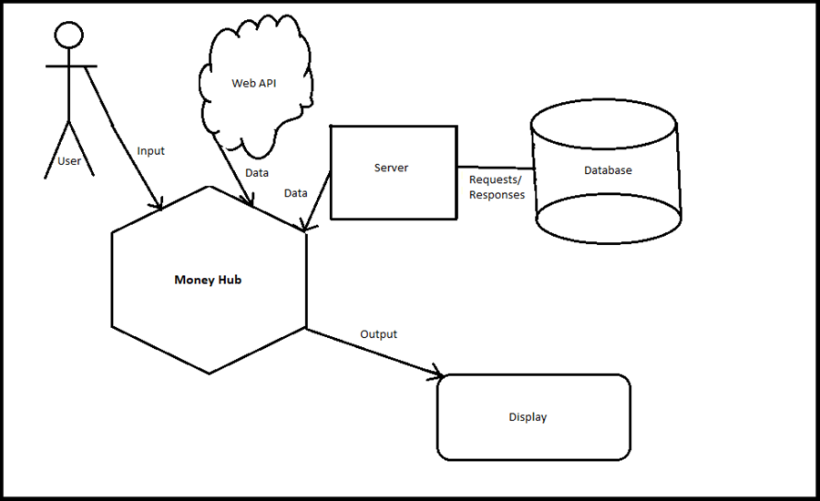Money Hub is a product that was envisioned as an entirely new system. In the information age, nothing is more important than having the facts. This is especially true in our own lives. Opening an app and seeing all the important financial information is something that our team believes is crucial to survive in today’s fast-moving world.

<INCLUDE Product Perspective HERE>

## 2.2 Product functionallity

*\*\*Summarize the major functions the product must perform or must let the user perform. Details will be provided in Clause 3, so only a high-level summary is needed here. Organize the functions to make them understandable to any reader of the SRS. A picture of the major groups or related requirements and how they relate, such as a top-level data flow diagram or object class diagram, will be effective \*\**

This system runs concurrently by connecting to a server through client applications. Additionally, there will be multiple web-based API’s that allow our third-party software to extract account information from banks and lenders and feed it into the client.

First time users will create an account that is then stored on the server before being logged onto the Money Hub “Home” page. Here the user will see what the web APIs return to the client. This information will include the amounts for the accounts that the user has connected. At the same time, the information loaded from the web is then stored into that user’s account information on the server.

For users to have the balance of an account show up in the client, they will need to log into the respective company’s website through the client. Connecting to the accounts this way ensures that Money Hub never directly sees the user’s password for an account but still has access to the amounts they are trying to see inside of client application.

Returning users will log into the client and have their credentials validated through the server. Once into the client, the application will begin updating the balances shown in the application.

Users will be able to sync their Money Hub account with accounts from other firms by logging into the respected accounts through the client.

## 2.3 users and characteristics

*\*\* Identify the various users that you anticipate will use this product. Users may be differentiated based on frequency of use, subset of product functions uses, technical expertise, security or privilege levels, educational level, or experience. \*\**

The usability of the system will be heavily considered when designing the user interface. The reason for this is so that whether the user is a recent college grad just gaining a real income for the first time, or a Millennial looking to get their finances in check, the experience will be one of ease.

Our team wanted the characteristics of the program to be one that is attractive and clean. Many times, applications are cluttered or difficult to follow from page to page. In designing a page like this, it will make sure that you don’t need to be a computer expert to use the system.

Reading the financial information will also be a breeze because all the amounts will be visible on a single page. Additionally, analytics performed on the account information will make it clear as to what the user’s financial situation is so that they can decide what their next correct step is.

## 2.4 Operating environment

*\*\* Describe the environment in which the software will operate, including the hardware platform, operating system and versions, and any other software components of applications with which it must peacefully coexist. In this part, make sure to include a simple diagram that shows the major components of the overall system, subsystem interconnections, and external interface. \*\**

We live in a world where we are constantly on the move. In order to keep up with the pace of our lives, we need to develop a product that can be accessed on the go. To achieve this goal, The Money Hub application will eventually be developed to be used on the web, by browsers such as Google Chrome, Microsoft Edge, or Mozilla Firefox.

Currently the system will be a simple desktop application due to the short-handed development phase length and the lack of knowledge in our team in the area of web-based development. The limitations will be elaborated further on in clause 2.7.2. The operating system that the prototype will be able to operate on will be Windows 10.

## 2.5 Design and implementation constraints

*\*\* Describe any items or issues that will limit the options available to the developers. These might include hardware limitations, interfaces to other applications, specific technologies, tools, and databases to be used, parallel operations, language requirements, communications protocols, security considerations, design conventions or programming standards. \*\**

During the development process of a prototype for Money Hub, there are a few challenge areas that would need to be overcame in the development of a full fledge system.

1. **External Data Availability**

Access to external accounts takes time and permission. For the development of a prototype like this we have neither, so the data being fed into the system is non-existent. To develop the project fully, time and energy would need to be invested into getting firms such as banks and lenders to allow us access to their data through an API. Another constraint that comes from volatile data availability is the time it takes to access the data from the external firm.

While this process may seem daunting, there are already proofs of the concept out there. Many personal financial management tools are out there that implement the connections to firms that would be needed in this product.

1. **Data Security**

There are a few different levels of security that will be necessary. For example, the client will need to log in but where will the data used in validating the account be stored? In order to provide security for the user’s information, that validating information will need to be stored in a database on a server rather than on the client.

1. **Portability**

Currently, Money Hub is a desktop application. Since we have a limited time frame to develop the prototype, we had to choose an operating system to develop on. For us we chose Windows 10, which means we won’t have time to make sure that all the functionality works on another host running Linux or MacOS.

1. **Internet Access**

Because the client sync’s new financial data from the web and validates its logins via a server, if a user is trying to log into the client with out internet access, then they will not be able to access their account.

## 2.6 User documentation

*\*\* List the user documentation components (such as user manuals, online help, and tutorials) that will be delivered along with the software. Identify any known user documentation deliver formats or standards. \*\**

Utilization of the application and the service held within were designed so that the user would have minimal issues when learning to use the system. The user interface will be designed such that it is self-explanatory. However, one area where problems may arise is syncing an external account. To account for this, help will be available to the user via an internal help button near the option to add an account.

## 2.7 assumptions and dependencies

*\*\*List any assumed factors (as opposed to known facts) that could affect the requirements stated in the SRS. These could include third-party or commercial components that you plan to use, issues around the development or operating environment, or constraints. The project could be affected if these assumptions are correct, are not shared, or change, Also Identify any dependencies the project has on external factors, such as software components that you intend to reuse from another project. \*\**

## 2.7.1 assumptions

During the planning for the development of this system, certain assumptions had to be made. These assumptions are those came during the preliminary brainstorming of the system and more may be added further into development.

1. The account information for all the user’s that are added during the prototyping phase will be the same. These amounts will need to be hard coded into the prototype so that they can be loaded into the client once they log in.
2. The instance “web API” means all the API’s that would be required to retrieve account information from banks, investment firms, and loan venders.
3. In the prototype, the web API will return the hard-coded values for a few accounts that will be decided during the design phase.
4. The application will be build using Java, C#, and an SQL database with the interface being designed using Visual Studio.

## 2.7.2 Constraints

The development process for the project will also face constraints on its development.

1. Time and effort to complete the prototype is limited. The entirety of the development process will take place over just a couple of months so complexity of the system will consider such constraints.
2. The system prototype will not be able to interface via an API with online firms. While this concept is possible, there must be a period of communication and development between organizations in order to ensure the security, legality, and feasibility of such ventures.
3. The money being displayed in the system for a given user will have not actually exist in the real world.

## 2.7.3 Dependencies

The development and implementation of the full Money Hub system will depend on the cooperation of partner firms in order to give the user access to the information that they desire. Additionally, once the system is fully operational, it will depend on these firms giving access to account information on a regular basis with low downtimes.

# Specific Requirements

### Requirement Specification Key

|  |  |
| --- | --- |
| Token | Description |
| FR | Functional Requirement |
| NFR | Non-Functional Requirement |
| <#ID> | three-digit number indicating the ID of the requirement |
| <#ID>C | Indicates the requirement involves the Client |
| <#ID>S | Indicates the requirement involves the server component |
| <#ID>A | Indicates the requirement involves the API |
| <#ID>O | Indicates the requirement involves some other aspect of the system |

## 3.1 Client User Interface Requirements

*\*Describe the logical characteristics of each interface between the software product and the users. This may include sample screen images, any GUI standards or product family style guides that are to be followed, screen layout constraints, standard buttons and functions that will appear on every screen, error message display standards, and so on. Define the software components for which a user interface is needed. \*\**

The user interface is one of if not the most crucial components of the system. This interface will contain multiple pages that allow for the user to access the remainder of the system and its functionality.

|  |  |  |
| --- | --- | --- |
| ID | Component | Description |
| FR001C | User Interface | The client shall validate credentials and log a user into the system in less than five seconds. |
| FR002C | User Interface | The client shall display the options to exit and minimize the program on every page, including the login page. |
| FR003C | User Interface | The client shall display the option to log out after a user has been logged in successfully. |
| FR004C | User Interface | The client shall correctly navigate to a new page when a button is clicked. |
| FR005C | Client-Server Communication | The client shall send a user account login ID and a password, ideally encrypted, to the server. |
| FR006C | Client-Server Communication | The client shall receive and display account information from the server. |
| NFR007C |  |  |

## 3.2 Server Requirements

The Server will be the means by which the client will communicate to access the database.

|  |  |  |
| --- | --- | --- |
| ID | Component | Description |
| FR001S | Database | The database shall record user account login IDs, password, a list of accounts and balances, and ages of the respective accounts. |
| FR002S | Client-Server Communication | The server shall query the database using login information received from clients in order to generate a login token. |
| FR003S | Server | The server shall sanitize any data received from the client, in order to avoid SQL injections. |

# System Specification

## 4.1 Data modeling

### 4.1.1 – Entity Relationship Diagram

Fig. 4.1.1 – Shows how the data of relevant to the database is structured

## 4.2 Behavioral Modeling

### 4.2.1 State Chart

Fig 4.2.1 – The state chart diagram demonstrates the flow of control and data throughout the execution of the program. Here, the client and server are treated as separate states, as one is active while the other is inactive. This, however, can be extended to include multiple concurrent sessions between multiple clients and the server.

### 4.2.2 Use Case Diagram

Fig 4.2.2 – The Use Case Diagram demonstrates the various uses the system will provide. Throughout the development process, more use cases may be discovered, so this may not be a totally comprehensive visual.