Motion of the Earth, Moon & Sun

1

2

4

3

*The Earth, Sun, and Moon are constantly rotating. The Earth and Moon are also revolving.*

# Rotation

*Next*

When the Earth, Sun, and Moon spin on their own axes, they are performing a motion called *rotation*. It takes one day, or 24 hours, for the Earth to make one complete rotation on its axis.

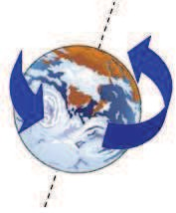

Rotation of the Earth on its axis

The rotation of the Earth is responsible for the change between night and day. When one part of the Earth is rotated toward the Sun, it is daytime there. When the same part of Earth is rotated away from the Sun, it is nighttime there.

The Sun and Moon appear to rise in the East and set in the West each day. At midday, the Sun appears to be almost directly overhead. But this apparent motion of the Sun and Moon is a result of the rotation of the Earth on its axis. Similarly, the stars appear to move across the sky each night. This is also because the Earth is rotating.

The video below shows how the Earth's rotation results in the change from day to night and back again. To start the video, click on the arrow.



*Clip provided by Education Clip Library with permission from ITN Source*

The Sun also rotates on its axis. The Moon rotates on its axis as well. But we only ever see one side of the Moon, because it rotates at the same speed at which it *revolves* around the Earth.

# Revolution

When the Earth *revolves*, it moves in an orbit around the Sun. The orbit is

*elliptical*, which means that it is similar to an oval in shape.

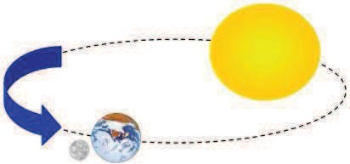

Revolution of the Earth-Moon system around the Sun

The revolution of the Earth around the Sun and the tilt of Earth's axis are responsible for the changing seasons. It takes the Earth one year, or 365 1/4 days, to make one complete revolution around the Sun. Because the Earth's axis is tilted, different parts of the Earth will be tilted toward or away from the Sun at different times of the year. Watch the video below to learn how the Earth's tilted axis causes seasons.



*Clip provided by Education Clip Library with permission from ITN Source*

It is winter where the Earth tilts away from the Sun. The days are short, and the Sun is low in the sky, even at noon. It is summer where the Earth tilts toward the Sun. The days are long, and the Sun is high in the sky at noon.

In December, it is summer in the South Hemisphere and winter in the North Hemisphere.

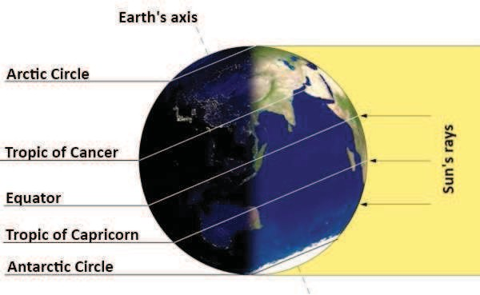

*Image courtesy of SciJinks/NASA and NOAA*

In June, it is summer in the North Hemisphere and winter in the South Hemisphere.

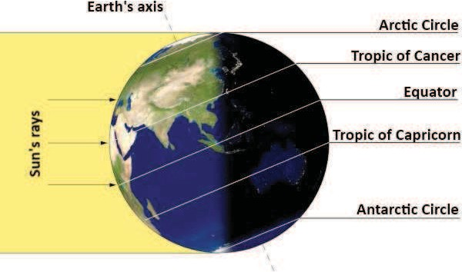

*Image courtesy of SciJinks/NASA and NOAA*

The white lines in the images above show the paths taken by different parts of the Earth as it revolves on its axis. Notice how the Arctic circle stays in the sun almost all day in June and in the dark almost all day in December. Days are shortest in the winter and longest in the summer. There are two days each year when the day and the night are the same length. These are the **spring** and **fall** *equinoxes*.

The Moon *orbits*, or revolves around, the Earth, and it also revolves around the Sun as part of the Earth-Moon system. It takes the Moon about one month to revolve once around the Earth.