**Performance Analysis on Feature Extraction and Matching Techniques**

**Objective**

This activity aims to evaluate and compare three feature extraction techniques (SIFT, SURF, and ORB) and two matching techniques (Brute-Force Matcher and FLANN Matcher) for feature matching between two images. The task includes analyzing the performance of each feature extraction and matching method in terms of keypoint detection accuracy, speed, and effectiveness in real-world image matching tasks.

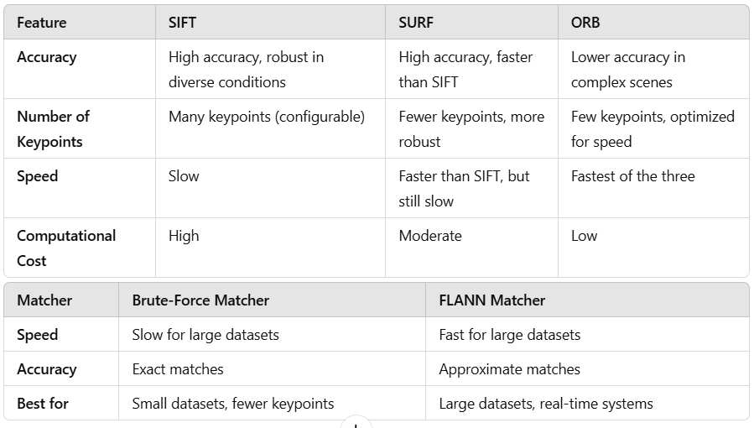

In terms of keypoint detection accuracy, SIFT is known for its precision and ability to handle transformations like scale, rotation, and noise, though it is computationally expensive and slow. SURF, while offering similar accuracy, is faster due to optimizations like integral images, making it more efficient but still resource-heavy. ORB, designed for real-time applications, is the fastest of the three but sacrifices some accuracy and keypoint detection for speed, making it ideal for applications where efficiency is prioritized over precision.

When comparing the number of keypoints detected, SIFT generally identifies the most keypoints, followed by SURF and then ORB, which detects fewer keypoints due to its focus on speed. In terms of speed, ORB outperforms both SIFT and SURF, making it suitable for real-time applications. SIFT is the slowest, with SURF providing a balance between speed and accuracy.

Regarding feature matching, the Brute-Force Matcher is more accurate but slower, as it exhaustively compares all descriptors, making it less suitable for large datasets. On the other hand, FLANN is faster as it uses approximate nearest neighbor search techniques, sacrificing some accuracy for speed. FLANN is particularly effective for large datasets and real-time applications, where speed is crucial. While Brute-Force is ideal for applications requiring high precision, FLANN is better for performance-sensitive scenarios where a slight accuracy trade-off is acceptable.

**Short Report on Feature Extraction and Matching Techniques**

In my opinion, when it comes to feature extraction and matching, each method (SIFT, SURF, ORB) has its unique strengths and weaknesses. SIFT provides highly accurate keypoint detection, especially for images with significant transformations like rotation or scaling. However, it tends to be slower, making it less optimal for real-time applications. SURF, while faster than SIFT, offers similarly robust keypoint detection but is also computationally expensive. ORB strikes a balance between speed and accuracy, making it a great choice for real-time applications, though it may not be as robust under extreme transformations.

Regarding feature matching, both the Brute-Force Matcher and FLANN Matcher have their roles. The Brute-Force Matcher is simple and effective when you have fewer keypoints to match. It works well for smaller datasets but can be slow for larger ones due to its exhaustive search. On the other hand, FLANN (Fast Library for Approximate Nearest Neighbors) is more efficient for large datasets and provides faster matching. It uses approximate search techniques that sacrifice some accuracy for speed but is significantly faster, especially in real-time applications.

In conclusion, ORB offers a good balance of performance and speed, making it ideal for real-time scenarios. For smaller datasets, Brute-Force Matcher can be sufficient, but for larger datasets, FLANN Matcher offers a faster and more scalable solution. Thus, the choice of feature extraction and matching technique depends largely on the application requirements, with a trade-off between accuracy, speed, and computational resources.