**Team Name:**

**The Pirates**

**Team Website:**

<https://github.com/John-Stovall/ThePirates>

**Team Contacts:**

Ryan Hasen ryanchansen@hotmail.com

Rand Almaroof Rand3@uw.edu

Robert Cordingly robertcordingly@gmail.com

Reagan Stovall reaganstovall@gmail.com

**GUI:**

Currently the app opens to the Create Account Page if no user is saved, but gives the option for known users as seen below. The menu bar displays the current User and dropdown is used to navigate.

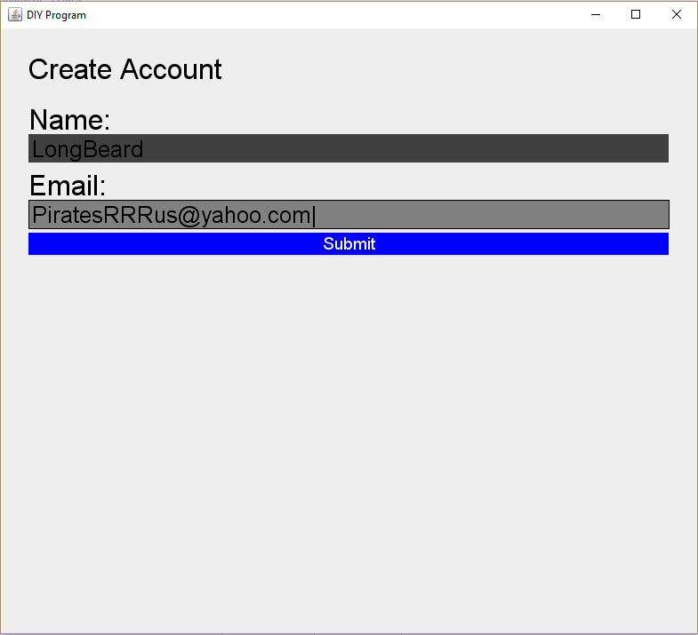 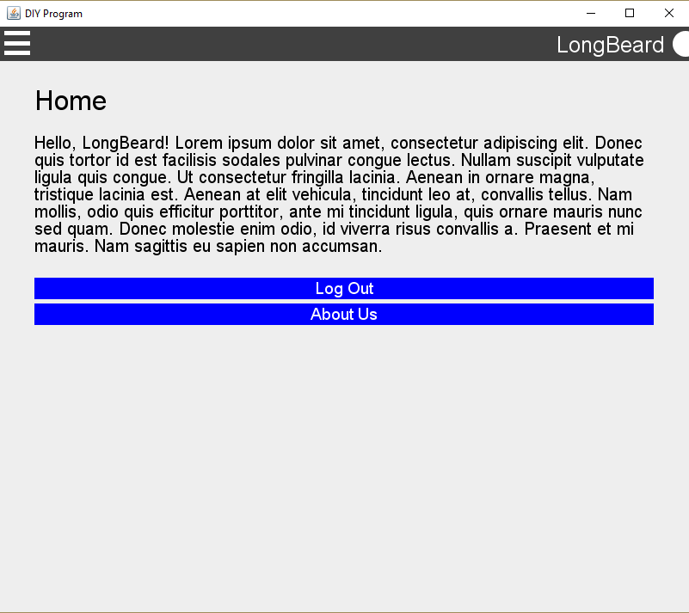 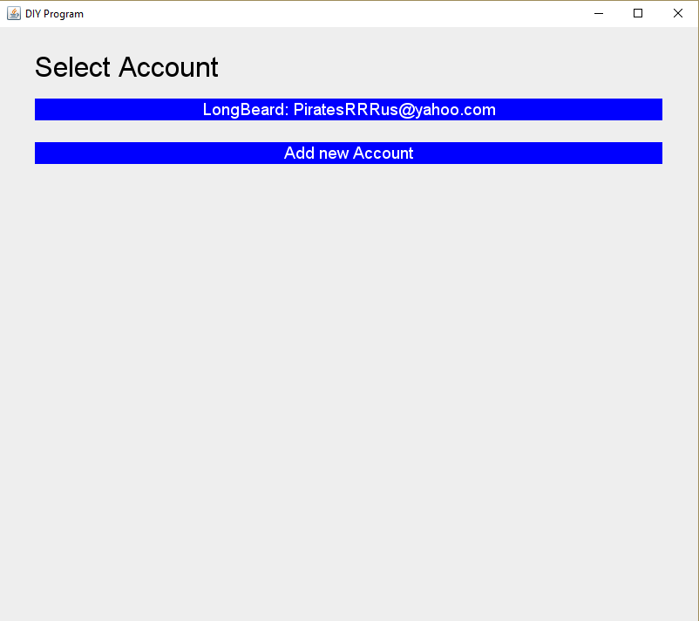 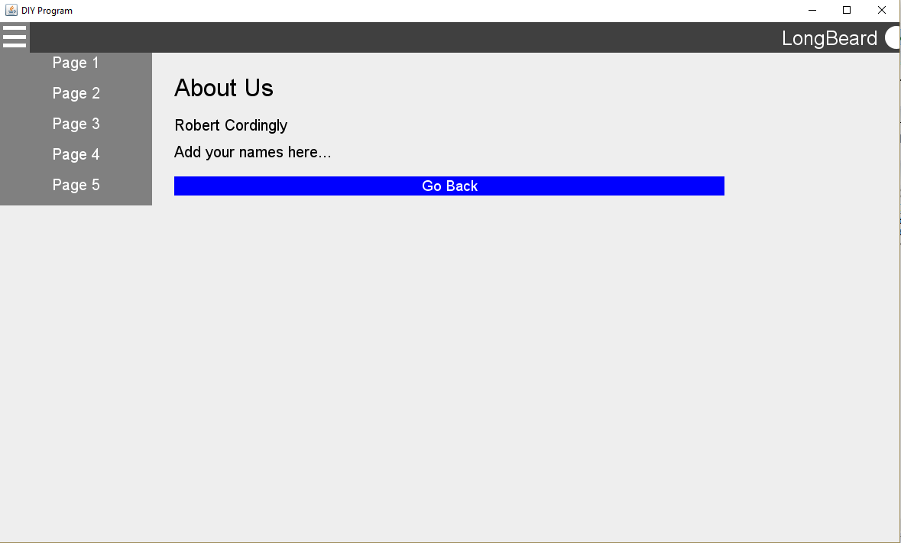

**Junit Tests:**

* That the user name was at least 4 characters long, excluding leading and trailing spaces.
* The email provided contained at least one @ sign.
* The email provided contained a “.com” as we are somewhat exclusive.
* Built the Check methods to easily accommodate future tests if needed.

