Inspection Findings

Finding 1: BASEBOARD SEPARATION FROM WALL
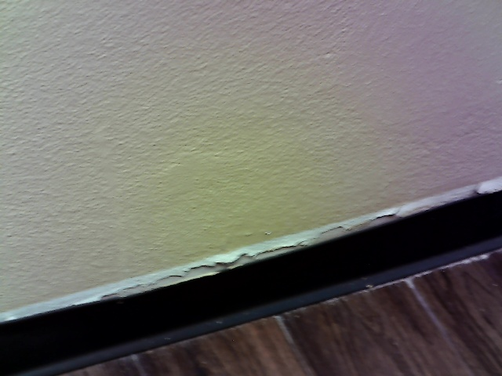
A visible gap was observed between the baseboard and the adjacent wall surface. The sealant applied to this joint has failed, exhibiting cracking and peeling along the upper edge of the trim. This condition is commonly caused by the natural expansion and contraction of building materials due to temperature and humidity changes, or minor building settlement. While primarily a cosmetic issue, the gap can collect dust and debris. If left unaddressed, the paint and caulk will continue to deteriorate, further detracting from the interior finish. The opening could also create a pathway for insects into the wall cavity.

Finding 2: EXPOSED ELECTRICAL WIRING [Significant Defect]
Left side of the hallway
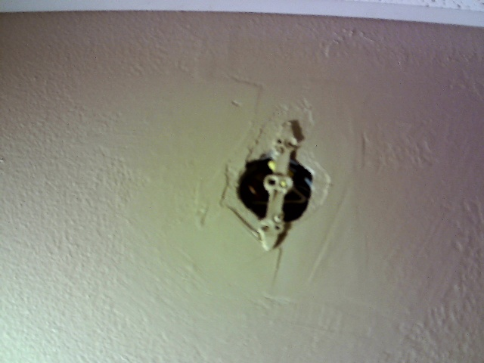
An uncovered opening in the wall reveals an electrical box with exposed wiring. No fixture or protective cover plate was installed over the box at the time of the inspection. This condition typically occurs when a fixture is removed and not properly terminated with a blank cover. Exposed, potentially live electrical conductors present a serious risk of accidental contact, which can lead to severe electrical shock or electrocution. Furthermore, the open box allows combustible materials like dust to accumulate near the wiring, creating a significant fire hazard. This is a major safety deficiency requiring immediate attention.

Finding 3: INOPERABLE CEILING LIGHT [Marginal Defect]
Hallway Ceiling
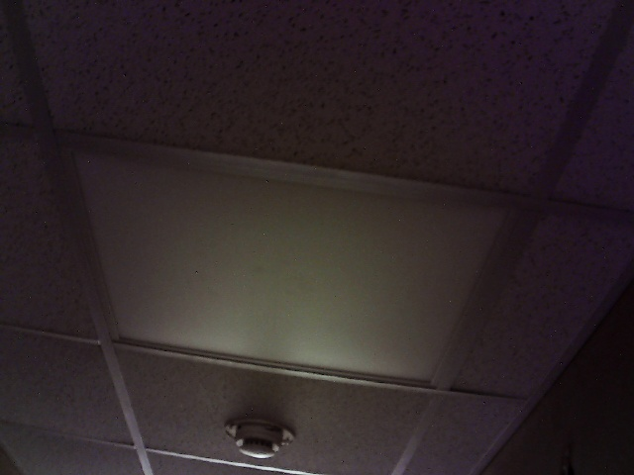
The overhead light fixture located in the middle of the hallway was not operational during the inspection. The lamp failed to illuminate when the corresponding wall switch was activated. The cause for this functional failure is unknown but could range from a simple burnt-out bulb to a more complex issue like a faulty ballast, defective switch, or wiring problem. This lack of illumination results in inadequate lighting for the area, creating a potential trip-and-fall hazard for occupants navigating the hallway. The condition represents a loss of intended function for the installed fixture.

Finding 4: DAMAGED HVAC VENT COVER
Hallway Ceiling
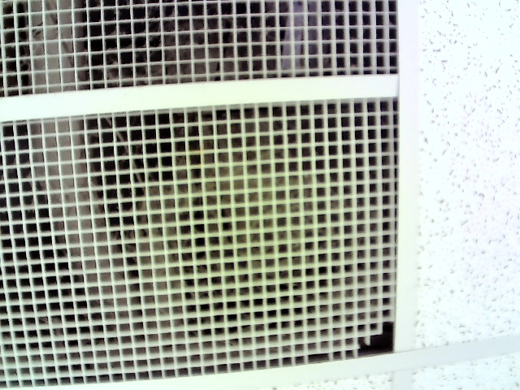
The HVAC return air vent cover installed in the ceiling grid was observed to be damaged. A section of the plastic grille is broken and not seated correctly within its supporting frame. An accumulation of dust was also noted on the grille and within the visible ductwork. Damage to such components can result from accidental impact or material degradation over time. A broken grille can potentially impede airflow, which may slightly reduce the efficiency of the HVAC system. The dust buildup can negatively impact indoor air quality as particles are circulated by the system.

Finding 5: BASEBOARD GAP WITH EXPOSED CABLE [Marginal Defect]
End of hallway
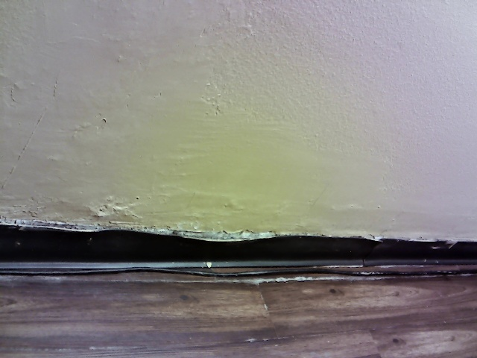
A significant gap is present where the baseboard has pulled away from the wall surface. Visible within this opening is an electrical cable that has been routed outside of the protected wall cavity. This condition likely stems from improper fastening of the trim combined with the improper installation of the low-voltage cabling. The exposed cable is vulnerable to physical damage from cleaning equipment, furniture, or pests. Damage to the cable's insulation could create a short circuit or a potential shock hazard. This represents a deficiency in workmanship and a potential safety concern.

Finding 6: EVIDENCE OF MOISTURE INTRUSION [Significant Defect]
Hallway Ceiling
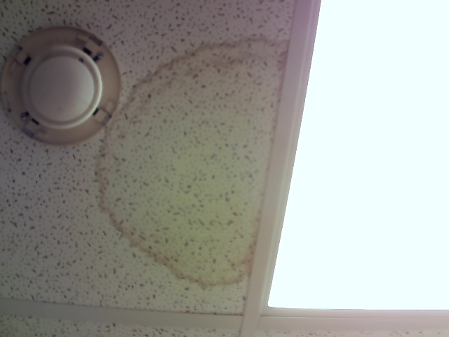
A prominent, discolored stain was observed on an acoustic ceiling tile, which is characteristic of water damage. The tile was dry to the touch at the time of the inspection, suggesting the leak may be intermittent or has been resolved without replacing the tile. Such stains are evidence of a leak from a plumbing pipe, HVAC condensate line, or roof component located above the ceiling. If the source of moisture has not been corrected, recurring leaks can lead to significant damage to structural components, deterioration of ceiling materials, and the potential for microbial growth. The integrity of the stained tile is compromised.

Finding 7: UNCOVERED JUNCTION BOX [Significant Defect]
Right side of the hallway
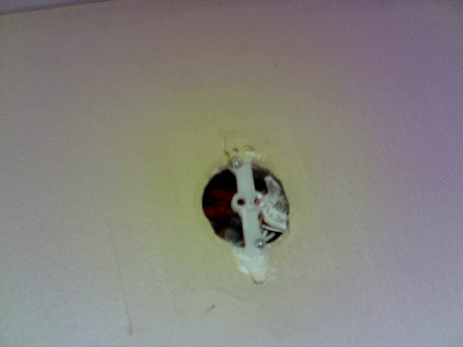
An electrical junction box recessed in the wall was found to be open and uncovered. The wiring inside the box is exposed, lacking the protection of a fixture or a blank cover plate. This hazardous condition is typically the result of an incomplete electrical project or the improper removal of a wall-mounted device. Exposed electrical components create a severe risk of electric shock from accidental contact. The opening also allows dust and other combustible materials to enter the box, which can accumulate and create a substantial fire hazard. This is a serious safety violation that needs to be addressed.

Finding 8: WALL SURFACE DAMAGE AT DOOR [Marginal Defect]
Wall at door frame
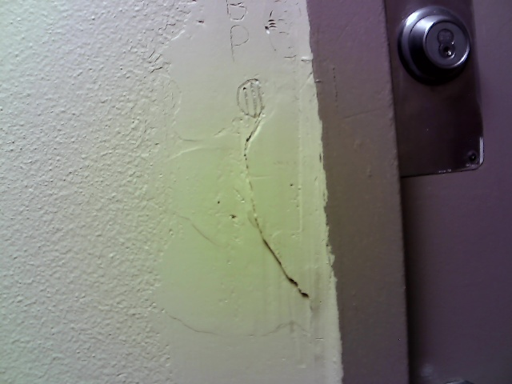
A vertical crack was noted in the wall finish immediately adjacent to a door frame. The area appears to have been subject to a previous, poorly finished repair, and is further marred by cosmetic damage from inscriptions. Cracks in this location can be caused by the repeated impact of the door closing, or from minor building settlement causing stress at the opening. While currently a cosmetic defect, the crack could worsen over time with continued vibration and movement. It may also be an early indicator of ongoing settlement that could affect the door's operation in the future.

Finding 9: NON-STANDARD ELECTRICAL RECEPTACLE [Marginal Defect]
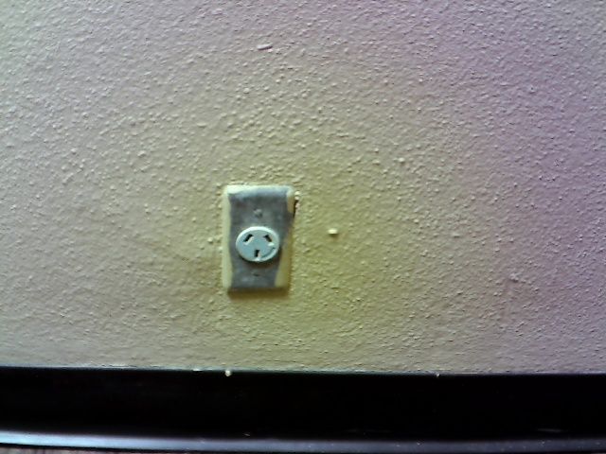
An electrical receptacle installed in the wall has a non-standard configuration that is not compatible with common North American (NEMA) plugs. This outlet may have been installed for a specific piece of foreign or specialized equipment that is no longer present. As a result, this outlet is non-functional for general use, limiting the electrical access in the area. It is unknown if the voltage and wiring connected to this outlet are standard for the building. Using an adapter without confirming the circuit's specifications could result in damage to connected equipment.

Finding 10: DISPLACED SUSPENDED CEILING TILE
Hallway Ceiling
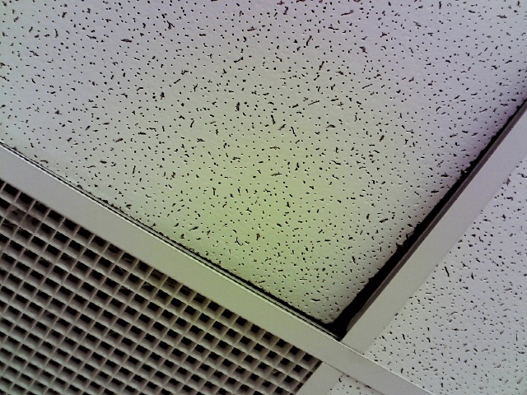
A tile within the suspended ceiling grid system was observed to be misaligned and not properly seated in its frame. This condition creates a visible gap between the tile and the supporting metal grid. Such displacement often occurs after maintenance work is performed in the ceiling plenum and the tile is not reinstalled correctly. It can also be caused by building vibrations. Although primarily a cosmetic issue, a loose tile could become fully dislodged and pose a minor falling hazard. The gap also compromises the finished appearance of the ceiling.

