image_1.jpeg captured at Mon 01 Dec 2025 01:31:23 PM
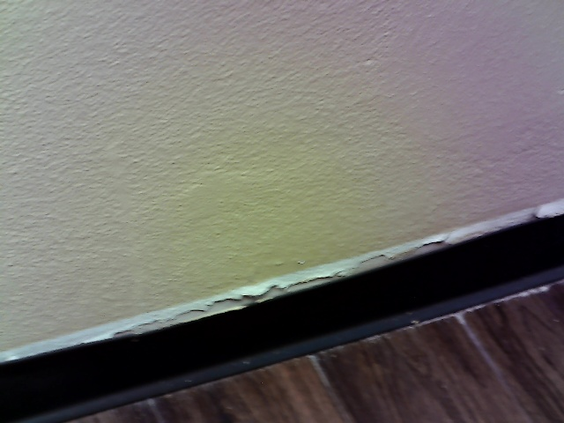
[Mon 01 Dec 2025 01:31:25 PM → 01:31:27 PM] Okay, so this is our demo.
[Mon 01 Dec 2025 01:31:30 PM → 01:31:34 PM] The first picture we took is the base board.
[Mon 01 Dec 2025 01:31:34 PM → 01:31:37 PM] It seemed to be coming apart from the wall.
[Mon 01 Dec 2025 01:31:43 PM → 01:31:48 PM] And this one either needs to be caulked or repainted in order to repair the issue.

image_2.jpeg captured at Mon 01 Dec 2025 01:33:01 PM
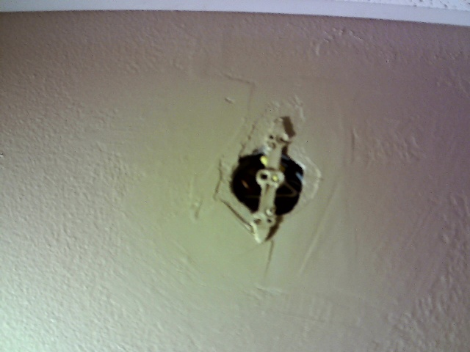
[Mon 01 Dec 2025 01:33:03 PM → 01:33:09 PM] Okay, so that is another image from the left side of the hallway.
[Mon 01 Dec 2025 01:33:09 PM → 01:33:12 PM] There's a hole in the wall with exposed wiring behind it.
[Mon 01 Dec 2025 01:33:12 PM → 01:33:19 PM] This is a safety hazard and will need to be repaired.

image_3.jpeg captured at Mon 01 Dec 2025 01:33:29 PM
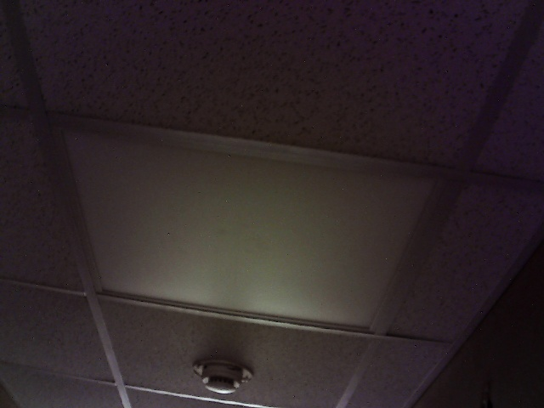
[Mon 01 Dec 2025 01:33:31 PM → 01:33:34 PM] Okay, so this is on the same area.
[Mon 01 Dec 2025 01:33:34 PM → 01:33:36 PM] The left side of the hall.
[Mon 01 Dec 2025 01:33:36 PM → 01:33:38 PM] The middle light is not working.
[Mon 01 Dec 2025 01:33:38 PM → 01:33:39 PM] It's not functioning.
[Mon 01 Dec 2025 01:33:39 PM → 01:33:45 PM] This leaves the middle of the hallway dimmer than the other parts and may result in someone tripping.
[Mon 01 Dec 2025 01:33:45 PM → 01:33:48 PM] They don't see something on the floor.

image_4.jpeg captured at Mon 01 Dec 2025 01:34:06 PM
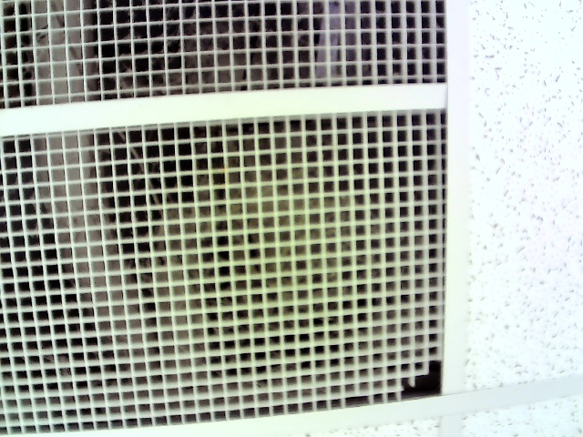
[Mon 01 Dec 2025 01:34:07 PM → 01:34:12 PM] Okay, so now we're on the end of the left side of the hallway.
[Mon 01 Dec 2025 01:34:12 PM → 01:34:17 PM] The vent is broken and it's also dusty.
[Mon 01 Dec 2025 01:34:17 PM → 01:34:23 PM] And the best solution would be to replace this in the future.

image_5.jpeg captured at Mon 01 Dec 2025 01:34:34 PM
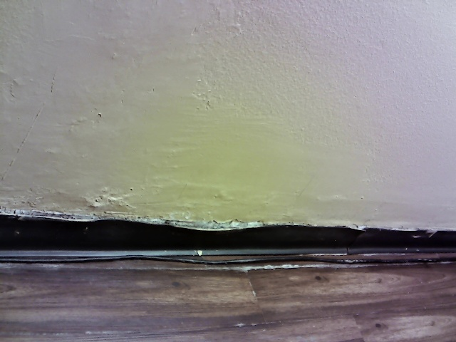
[Mon 01 Dec 2025 01:34:37 PM → 01:34:45 PM] So this is the kind of theme in this hall is that the baseboards are coming apart from the wall.
[Mon 01 Dec 2025 01:34:45 PM → 01:34:59 PM] It will need just need to be called repainted all around the floor for it to be on the wall.

image_6.jpeg captured at Mon 01 Dec 2025 01:35:12 PM
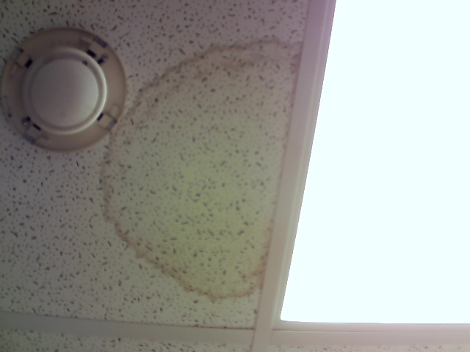
[Mon 01 Dec 2025 01:35:14 PM → 01:35:23 PM] Okay, so now we're in the middle of the end of the hallway.
[Mon 01 Dec 2025 01:35:23 PM → 01:35:26 PM] There is a water stain on one of the tiles.
[Mon 01 Dec 2025 01:35:26 PM → 01:35:33 PM] This can indicate a AC leak that will need to be repaired in the future.

image_7.jpeg captured at Mon 01 Dec 2025 01:36:03 PM
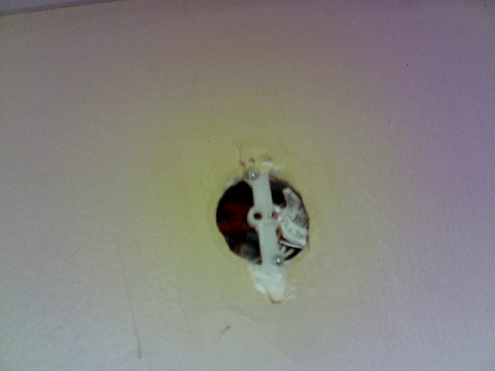
[Mon 01 Dec 2025 01:36:05 PM → 01:36:08 PM] Okay, so now we are on the end of the right side of the hallway.
[Mon 01 Dec 2025 01:36:08 PM → 01:36:13 PM] Again, as is the last time, there's a whole wall with exposed wiring.
[Mon 01 Dec 2025 01:36:13 PM → 01:36:20 PM] This can prove to be a safety hazard and will need to be replaced or repaired as soon as possible.

image_8.jpeg captured at Mon 01 Dec 2025 01:36:52 PM
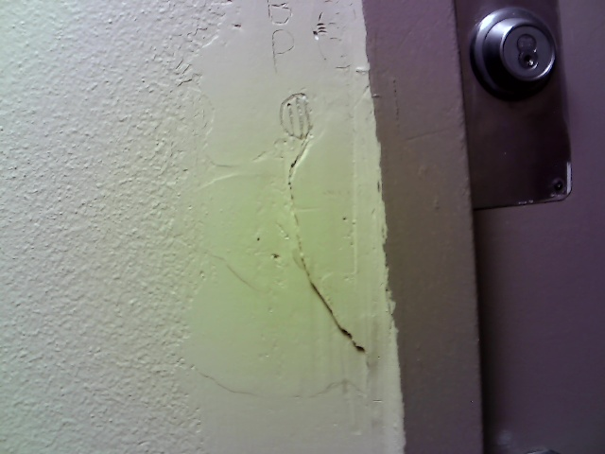
[Mon 01 Dec 2025 01:36:48 PM → 01:36:58 PM] Okay, so now we're in the middle of the left side of the hole.
[Mon 01 Dec 2025 01:36:58 PM → 01:37:02 PM] There appears to be a crack in the wall, right next to the door, among us, someone having
[Mon 01 Dec 2025 01:37:02 PM → 01:37:06 PM] carved letters inside of the paint.
[Mon 01 Dec 2025 01:37:06 PM → 01:37:11 PM] This will need to be repainted and replaced because this crack can lead to eventual structural
[Mon 01 Dec 2025 01:37:11 PM → 01:37:12 PM] integrity issues.

image_9.jpeg captured at Mon 01 Dec 2025 01:37:30 PM
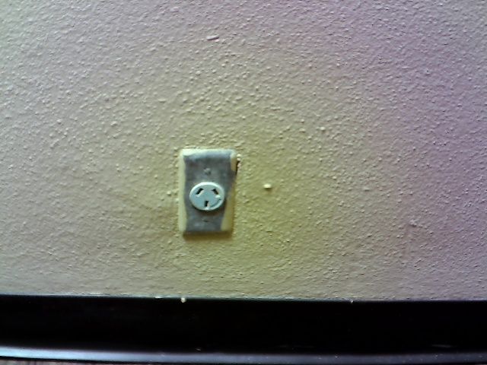
[Mon 01 Dec 2025 01:37:12 PM → 01:37:39 PM] Okay, so on both sides of the hole there is an outlet and it would be useful but it has
[Mon 01 Dec 2025 01:37:39 PM → 01:37:46 PM] a European cover so that means it cannot be used in appliances or electronics that we have
[Mon 01 Dec 2025 01:37:46 PM → 01:37:47 PM] here in Arkansas.
[Mon 01 Dec 2025 01:37:47 PM → 01:37:53 PM] This one needs to be replaced for functionality purposes.

image_10.jpeg captured at Mon 01 Dec 2025 01:38:24 PM
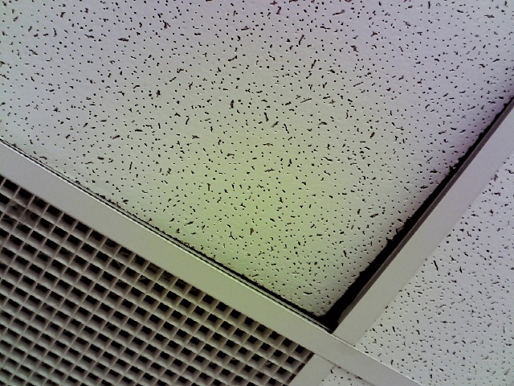
[Mon 01 Dec 2025 01:38:15 PM → 01:38:29 PM] Okay, so this is now we're on the end of the left side of the hole.
[Mon 01 Dec 2025 01:38:29 PM → 01:38:39 PM] One of the tiles needs to be out of place whether because of someone who moved it or whatnot.
[Mon 01 Dec 2025 01:38:39 PM → 01:38:45 PM] This can prove to I guess this is just more of a aesthetics issue but this is something
[Mon 01 Dec 2025 01:38:45 PM → 01:38:49 PM] that will need to be fixed.

