Co.Labs is an online, open-source collaboration tool designed for businesses in need of a secure communications application on a custom web domain where employees can collaborate in real-time across multiple remote offices. From the Co.Labs website, company administrators can download the program files and follow and quick and easy setup process to establish their own instance of the Co.Labs platform. Administrators will be prompted to enter basic company information, and will have the ability to manually add users to the system or create a custom authentication key which will allow employees to create their own profiles. Once logged in, users will see a news feed displaying company stories and updates uploaded by administrators, Labs through which they can communicate cross-departmentally and across multiple offices, and a list of online users. Within the Labs, users will participate in real-time chat sessions to work together on anything from projects or upcoming tasks, or even just bringing the concept of gathering around the water cooler into the modern world.

**Tasks**

* Build file structure
* Build out user interface—admin and users
* Database logistics—decide between MySQL or MongoDB
* Set up server and routing
* Set up ORM files
* MVC–Determine best framework to use
  + If none are applicable, create my own MVC format
* Set up web socket
* Build simple site for product description, documentation and download
* Testing
* Deployment

**User Interface**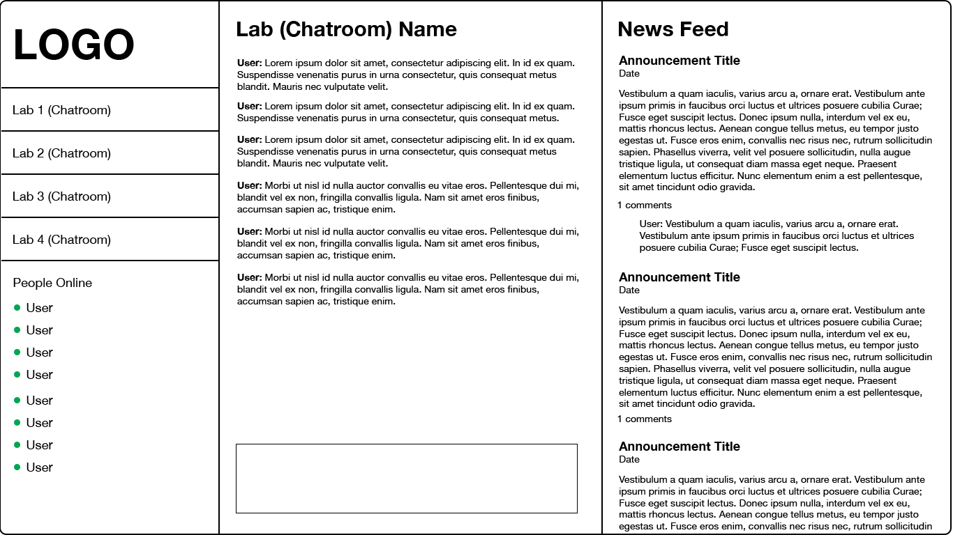

**Admin Interface**

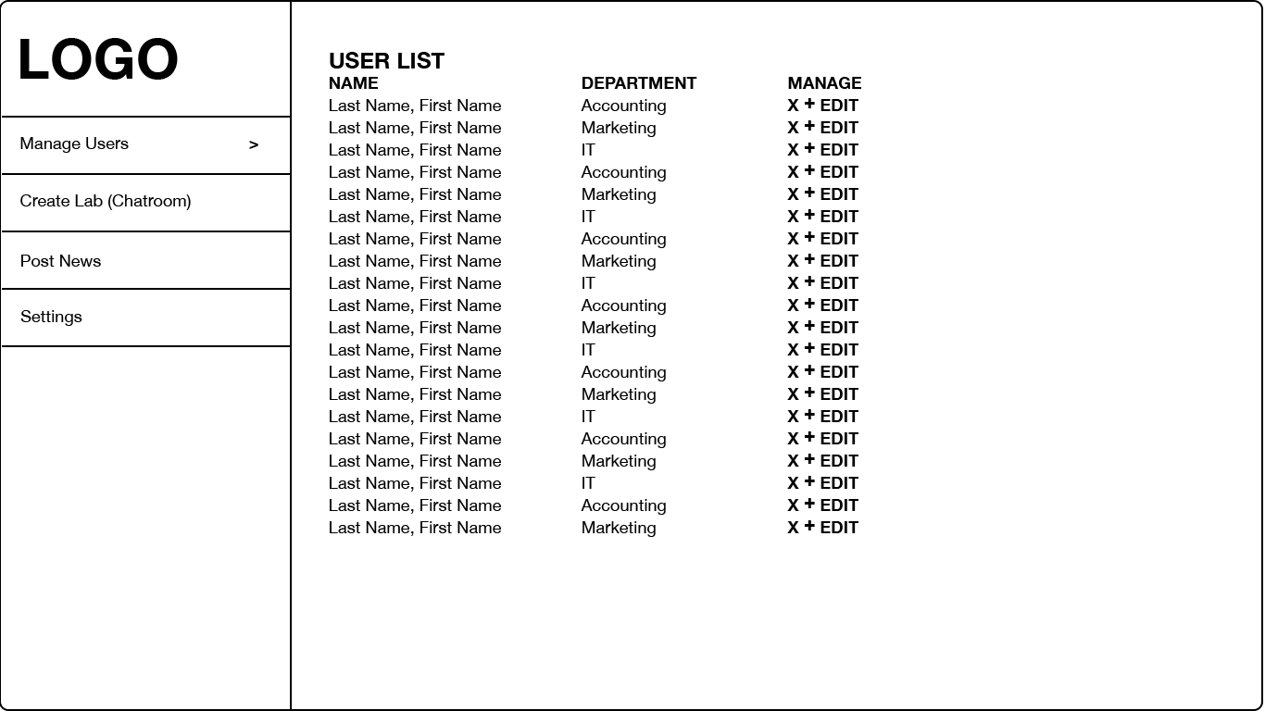Admin Interface