How to Create an Email Signature in Gmail

In Gmail email you may create and save multiple email signatures.

## Create Signature

1. Log into your Gmail email account.
2. Open Gmail configuration:
   1. Open settings by clicking on the configuration icon in the top right-hand corner 
   2. Select the See all settings button
3. Create and name a new signature:
4. Scroll down to Signatures
5. Click on the + Create new button.
6. Enter a signature name in the pop-up box, for example “Default Signature”.
7. Write the body of the signature:
   1. In the text entry box, write your email signature.

|  |
| --- |
| **Note:** You have options other than plain text to customize your signature. The edit box includes formatting tools such as: bulleted and numbered lists, links, indents, and images. |

* 1. Choose the drop-down list under ‘Signature defaults’ to select the ‘Default Signature’ to include this signature in new emails.
  2. Choose the drop-down list under ‘ON REPLY/FORWARD USE’ to select the ‘Default Signature’ to include this signature in email replies and forwards.

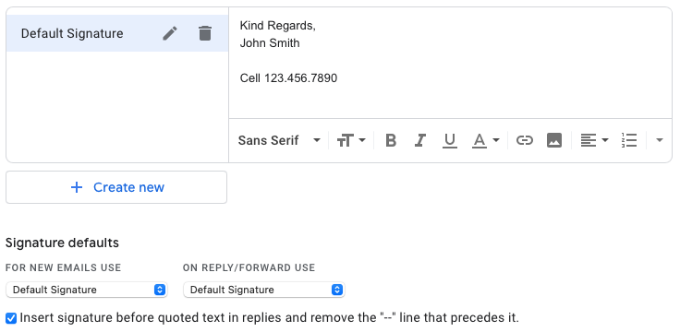

1. Save the new signature:

To save your changes, scroll to the bottom of the page and choose Save Changes.

## Test Signature

1. From the main Gmail page, select the compose button to create a new email.



1. If successful you will see a new email with your signature.