5/21/2021

Traditional Wood Stove vs. Pellet Stove for Home Heating

John Van Hook

Table of Contents

Objective: 2

Audience: 2

Wood Stove Explained 3

Pellet Stove Explained 3

Purchase cost 4

Low End Wood Stove: 4

High End Wood Stove: 4

Low End Pellet Stove: 4

High End Pellet Stove: 4

Conclusion 4

Installation Requirements 5

Wood Stove 5

Pellet Stove 5

Conclusion 5

Ease of Use 6

Purchase and Store Fuel 6

Carry Fuel to the Stove 6

Tend the Fire 6

Conclusion 7

Maintenance 8

Wood Stoves 8

Pellet Stoves 8

Conclusion 8

Ambiance and Aesthetics 9

Wood Stove 9

Pellet Stove 9

Conclusion 9

Safety 10

Wood Stove 10

Pellet Stove 10

Conclusion 10

Emergency Use 10

Wood Stove 10

Pellet Stove 10

Conclusion 10

Summary 11

Recommendation 11

## Objective:

The objective of this report is to compare two common wood-fuel home-heating options, wood burning stoves and pellet stoves. This report will conclude with a recommendation based on the following metrics:

* Up front cost
* Installation requirements
* Effort of use
* Effort of maintenance
* Ambiance and Aesthetics
* Safety
* Emergency use

## Audience:

The audience for this document is the average home owner. Education expectations are middle school and above; reading and simple arithmetic.

If you are interested in heating, or supplementing an existing heating system in your home with a wood burning option, there are many factors to consider. But first, look at this graphic and video that explains the technology of both.

## Wood Stove Explained

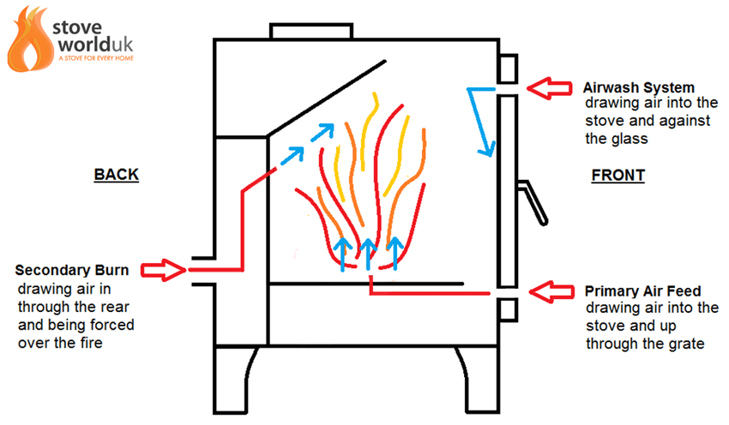

<https://www.stoveworlduk.co.uk/what-is-secondary-burn-on-a-wood-burning-stove>

A traditional wood stove does not have any moving parts.

## Pellet Stove Explained

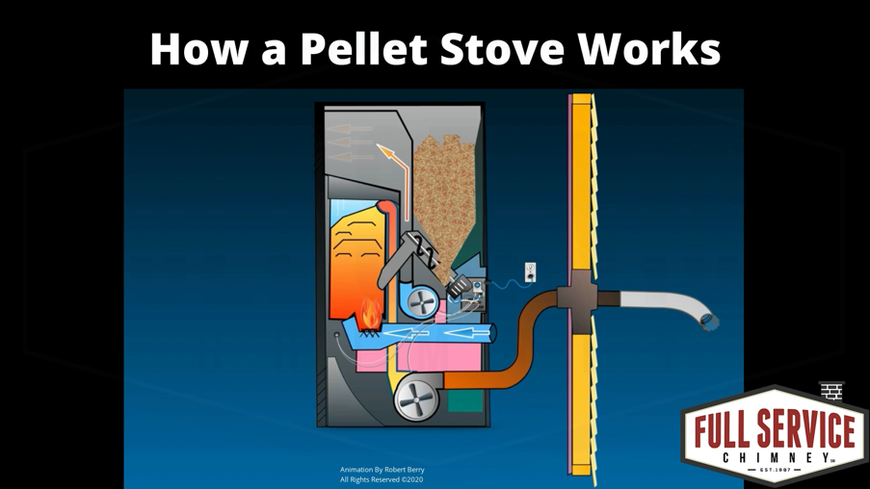

<https://vimeo.com/437266353>

Animation Created by Robert Berry  
All Rights Reserved © 2020   
Website: [fullservicechimney.com/](https://fullservicechimney.com/)

A pellet stove uses three electric motors to power two fans and one auger that lifts the pellets into the burn pot. There is a control board and some number of wires and sensors.

## Purchase cost

There are many different options and levels of quality.

For 2000 square foot heating capability, in 2021 dollars:

### Low End Wood Stove:

$900

<https://www.homedepot.com/p/Englander-2-000-sq-ft-EPA-Certified-Wood-Burning-Stove-15-W03/312643309?irgwc=1&cm_mmc=afl-ir-1347687-456723-&clickid=Vbe0PYTJ2xyLTsUwUx0Mo37FUkB2ajS5RzYNTE0>

### High End Wood Stove:

$3,549

<https://www.hearthstonestoves.com/product/heritage/>

### Low End Pellet Stove:

$1,522

<https://www.homedepot.com/p/US-Stove-2200-sq-ft-Golden-Eagle-Pellet-Stove-with-Igniter-5520/203393027?MERCH=REC-_-pnf-_-202398329-_-203393027-_-N&>

### High End Pellet Stove:

$4,469

<https://www.fireplaces.com/products/p68-pellet-stove?page=Specifications>

### Conclusion

The wood stove is a little less expensive, but this difference amortized over decades is of little consequence. The user will have to consider: style, features, aesthetics, and reputation for quality when considering which stove to purchase.

## Installation Requirements

Depending on several factors, a wood stove installation can be easy and inexpensive, or difficult and expensive. A pellet stove install is usually very easy.

**Caution:**

Your intention here is to light a fire, inside your house. Always hire professionals to inspect your chimney or stove pipe, and to install chimney or stove.

### Wood Stove

If you have an existing chimney in perfect working order the installation may be simple. The installers simply place the stove on the hearth and install stove pipe to the existing chimney.

If the chimney in condition is unknown, you will need to have it inspected and possibly repaired by a qualified mason. This can get expensive.

If you do not have a chimney at all, here are two possible options:

* Hire an architect, a contractor, a mason, and a carpenter to build a chimney. This will be very expensive.
* Have a stove pipe installed through the roof, or out a wall and up the side of the building.

### Pellet Stove

A pellet stove installation is usually much easier. Because a pellet stove’s electric fan pushes the exhaust out the stove pipe, the pipe does not need to go up high to create a draft like a wood stove. The pipe can just stick out the side of the house by a couple of feet. Local laws will determine the exact restrictions, but in general, the pipe may not be too close to doors, windows, or other places where the exhaust may be drawn back into the house.

*Note:* The stove will require a 110v electrical outlet.

### Conclusion

Pellet stove installation requirements are typically easier and less expensive than a wood stove.

## Ease of Use

With either option you will need to carry fuel into the house and put it in the stove. You will then have to start and tend the fire.

### Purchase and Store Fuel

For either choice you will need to purchase, move, and store a large amount of fuel. When storing the fuel, consider that you must carry the fuel to the stove, every day, and perhaps through deep snow.

* Wood is typically sold by the cord. A cord of wood is 4 feet x 4 feet x 8 feet. Wood storage requires space outside with easy access to the house. You may store the wood outside with nothing more than a tarp covering it.

**Caution:** It is not advisable to store a large amount of wood inside your home (in the basement for example) because of the possibility of bringing in destructive insects.

* Pellets are sold by the ton on pallets. Fifty, forty-pound bags to make a ton. Pellet storage requirements are more difficult because pellets are sensitive to moisture. If they get wet, they are ruined. If your basement is dry, storing the pellets there can be a storage solution.

A pallet of pellets is approximately equal in heat output in BTUs to a cord of wood.

*Note:* In New England, in 2021: A cord of cut-split-seasoned-hard wood costs ~$250. A pallet of premium pellets costs ~$275. If this is your primary heat, expect to purchase 3-5 or more (cords or tons) per season. Pellets are slightly more expensive.

### Carry Fuel to the Stove

Wood stoves and pellet stoves require you to carry the fuel to the stove.

* Logs are a few pounds each depending on size, moisture content and type (hard-wood vs soft-wood). Depending on different factors you should expect to carry in several large armfuls of logs per day.
* Pellet bags are 40 pounds. Depending on different factors you should expect to carry in on average one 40-pound bag per day.

You will likely carry more weight in logs than in pellets, and make more trips with logs.

### Tend the Fire

An important consideration when choosing a stove type is how often must you tend the fire.

#### Wood Stove

With most wood stoves you must add fuel every few of hours. If you do not add logs, the fire will burn out and the house will begin to cool.

#### Pellet Stove

The pellet stove hopper will typically hold a full day’s worth of fuel. Many modern pellet stoves have a feature that wood stoves do not. The pellet stove has an automatic self-lighting feature. When the temperature in the room drops below a preset temperature, the stove will light. This is ideal in the scenario where you leave for the day but want stove to continue running.

* Wood stoves require more effort to bring in fuel.
* Wood may be stored outside in the weather.
* Pellets require a dry storage place.
* Pellet stoves can operate with attention only once per day.
* Wood stoves require attention every few hours.

|  |  |
| --- | --- |
| Carry in | Pellet Stove Easier |
| Storage | Wood Stove Easier |
| Attention | Pellet Stove Easier |

### Conclusion

The pellet stove is easier to use.

## Maintenance

As with any appliance in your home, you will incur maintenance and repair costs.

### Wood Stoves

Check with your chimney sweep professional as to how often you should have your chimney cleaned and inspected. At least once per season is advisable. If you are burning many cords of wood per season, consider multiple cleanings. Cleaning the ash out of the wood stove is a regular chore. This must be done once or twice a week. There are seals around the doors that need replacing every few years. There are fire bricks inside that need replacing. The typical life span of fire bricks is measured in decades.

### Pellet Stoves

Pellet stoves require more maintenance simply because they have more moving and sensitive parts. There are three electric motors, several sensors, wires, and a control circuit board. You should have the pellet stove and chimney professionally cleaned and inspected once per year. Expect some parts, such as the electric motors, to fail every few seasons. Cleaning out the ash is a is a weekly chore.

### Conclusion

**Pellet stoves, with more moving parts, are typically more expensive to maintain.**

## Ambiance and Aesthetics

A wood stove or pellet stove will take up a sizable area in your living space. Considering how it will look and feel in your living space is prudent.

### Wood Stove

Wood stoves come in many shapes and sizes. You may even consider an antique.

#### Style

There are many styles to choose from to fit any decor.

#### Light

Shutting off the lights and sitting in front a fire is a part of the experience. A wood stove with a glass door is aesthetically pleasing and will light up a dark room.

#### Sound

The only sound is the wood crackling and popping.

### Pellet Stove

Pellet stoves come in many shapes and sizes. As parts are known to wear out, a new pellet stove is a more prudent choice.

#### Style

There are many styles to choose from to fit any decor.

#### Light

Shutting off the lights and sitting in front a pretty fire is a part of the experience. A pellet stove has a small glass door that will light up a dark room, but it is a much smaller flame than a wood stove.

#### Sound

Pellet stoves are loud. There is always one fan blowing, sometimes two fans blowing and every few minutes the auger runs putting more pellets into the burn pot.

### Conclusion

Because the pellet stove has a smaller window, smaller flame, and is noisy, the wood stove has a more pleasing ambiance.

## Safety

Both stoves have excellent safety records if they have been properly installed and maintained. It is also up to the user to follow good safety practices to stay safe.

### Wood Stove

* The side of a wood stove may become hot enough to cause a sever burn. A children and pets must be kept away.
* When adding wood to a wood stove there is the opportunity for a mistake to be made where a user could get burned or a burning log could roll out.

### Pellet Stove

* While most pellet stoves do not get so hot to the touch on the outside that a severe burn would occur, the front glass does get hot enough to cause injury.
* There is no risk of fire escaping while refilling a pellet stove even while it is running.

### Conclusion

A pellet stove is safer.

## Emergency Use

If you lose electrical service during a storm, you will still need to heat you r home.

### Wood Stove

When the electrical power goes out you can still use a wood stove for heat, light, and cooking.

### Pellet Stove

While a pellet stove will not function without power, it does not need a lot of power to run. A small battery backup can power the pellet stove for a short duration. The pellet stove flame will still provide some light. A pellet stove top does not get hot enough to cook on.

### Conclusion

A wood stove is more useful in an emergency.

## Summary

|  |  |  |
| --- | --- | --- |
| Metric | Comment | Conclusion |
| Up front cost | The wood stove is a little less expensive, but this tiny difference amortized over decades is of little consequence. | Tie |
| Installation requirements | Unless a healthy chimney/stove pipe is already in place, the Pellet stove is easier and less expensive to install. | Pellet Stove |
| Effort of use | Wood is easier to store, but the pellet stove requires less effort tending the fire. | Pellet Stove |
| Effort of maintenance | A pellet stove has many moving parts that will need replacing or repairing. | Wood Stove |
| Ambiance and Aesthetics | Wood stove is quiet with an aesthetically pleasing view of the fire. A pellet stove is noisy with a small flame. | Wood stove |
| Safety | An accident is more likely when loading logs into a wood stove. | Pellet stove |
| Emergency use | A pellet stove needs electricity to run, and even if you have that it does not have a surface to cook on. | Wood stove |

Wood stove 3

Pellet stove 3

Tie 1

### Recommendation

It is this authors conclusion that there is no clear winner. Both options are safe and effective in their own way. It all depends on your circumstances, personal taste, and what is important to you. Answer the following questions to decide what is best for your situation.

* How often does your electrical power go out? (back-up generator?)
* Will you ever want to cook on the stove?
* Do you have existing chimney/stove pipe?
* Do you need it leave the stove unattended all day?
* Will the noise of the pellet fan motors bother you?
* Do you have dry storage for pellets?
* Do you have pets or small children who could get a burn touching a hot stove?
* Is the aesthetic of a fire important?
* Is this your supplemental, backup, or primary source of heat?