Tent Seam Sealing Instructions

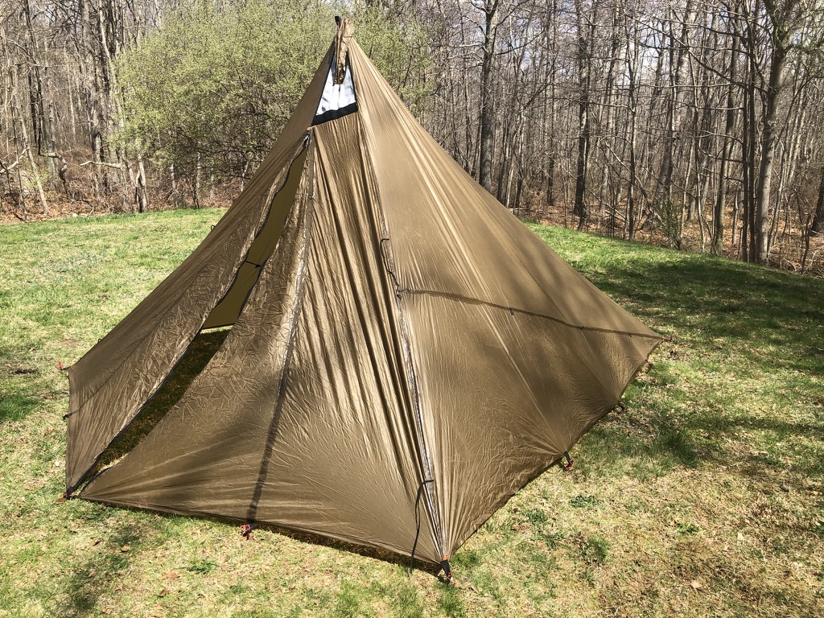

Brand: Kifaru. Model: Sawtooth. Shown with optional stove jack for portable wood stoves.

Tent sold by: https://kifaru.net/store/shelters/tipis-sawtooth/sawtooth/

Image Source: Home movie/pictures, John Van Hook, April, 2021

Author: John R. Van Hook

April 21, 2021

Table of Contents

Introduction 3

Terms 4

Acquire Tools and Supplies 4

Tools and Supplies 4

Choose a Time with Appropriate Environmental Conditions 5

Range of environmental conditions. 5

Prepare to Apply Silicone Slurry 5

Verify you can reach seams. 5

Mix the Silicone Slurry 6

Mix a batch of silicone slurry. 6

Begin Seam Sealing Your Tent 6

Applying the Slurry 6

Wait for the Silicone Slurry to Dry Before Testing 8

Test the Seams 8

## Introduction

This guide will instruct you in the process of seam-sealing a new or used tent. You will learn how to mix sealant and thinner to make a silicone slurry, and how to apply it to a tent.

Most tents are made of silnylon because it is strong, light, and waterproof. However, stitching the tent pieces together puts tiny little holes all along the stitching seam. Sealing these holes will keep your tent from leaking during rain storms.

Some tent manufactures sell tents with unsealed seams because it saves the customer money. To get the best experience, the customer must seal the tent’s seams themselves. In other cases, the seams on a used tent may have begun to leak. You can apply the same techniques for a new or used tent.

No special tools or experience required, but having an assistant may be helpful. These instructions are for elementary school level and above.

## Terms

Mineral Spirits: A type of paint thinner that is petroleum-based, similar in usage to the vegetable based thinner turpentine.

Silicone: A non-toxic, colorless, odorless, rubber-like substance

Silnylon: Nylon infused with silicone for waterproofing

Slurry: This describes the mixture of silicone and mineral spirits

## Acquire Tools and Supplies

You can get all the tools and supplies you need from a general hardware store. See Figure 1. for a picture of a sample of the supplies needed.

### Tools and Supplies

* Odorless mineral spirits: Typically, the smallest quantity you may purchase is a quart.
* 1 small (disposable) ½ inch to 1 inch paint brush, per application
* Disposable cup, for example a large unused coffee cup
* Stirring stick, a popsicle stick for example
* 2.8 Fluid Oz tube of clear, odorless silicone. One tube will do a three-man or smaller tent. For tent sizes four-man and up, or tall tipi style tents, you will need more than one tube of silicone.

**Caution:**

Do not use previously opened silicone tubes. Some people have reported that the silicone never completely dries when using previously opened silicone. If the slurry fails to dry, this will be a big mess to clean up. If you have a supply of silicone on hand that you wish to use up, try mixing a small batch to see if it will set before applying to the tent. To test, mix a small batch of slurry and apply a thin coat to a piece of tent like material or cardboard. Wait one hour to see if silicone slurry dries.

*Note:* You can use mineral spirits from a previously opened container

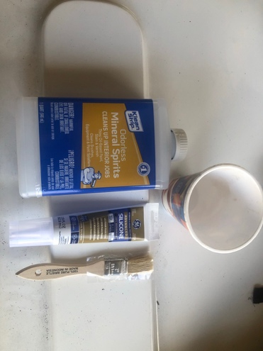

Figure 1. A sample of the supplies needed to seal tent seams

Image Source: Home movie/pictures, John Van Hook, April, 2021

## Choose a Time with Appropriate Environmental Conditions

Very low temperature will cause the silicone slurry to dry very slowly, if at all. Very high temperatures may cause the slurry to be too runny, or may cause the slurry to dry too quickly. If it rains on the tent while the silicone slurry is still wet, it will wash off the slurry and you will need to re-apply

Range of environmental conditions. See the usage label on the silicone to verify these conditions are suitable.

* Temperatures between 32° F and 120° F (As per the directions on the silicone)
* Light or no wind
* No rain or snow predicted

Prepare to Apply Silicone Slurry

Careful preparation will help make the job go smoother.

1. Pitch the tent taut. A loose floppy tent wall will make it difficult to paint the slurry on uniformly.
2. Make sure the tent is clean on all the seams. The slurry will not bond well with a dirty tent. If any seam or stitching areas are dirty, either wipe the dirt off, or if necessary, wash the tent with a hose. Let dry thoroughly.
3. With the paint brush, perform a dry run. To perform a dry run: Take the paint brush and see if you can reach all the tent seams on the outside of the tent. If you cannot reach the higher seams, you will need to devise a method of reaching them.

*Note:* Check that you can reach all the seams before you mix the slurry.

Verify you can reach seams. Reaching the top of the tent to get all the seams can be hard, especially for tents designed to allow the camper to stand up inside. Here are some suggestions to help reach those spots:

* + With very tall tipi tents you may be able to pitch the tent outside in, then use a step ladder to reach the seams up high.
  + Tape the paint brush to the end of a yard stick
  + A tall step ladder straddled over the tent
  + Enlist the help of a tall assistant

Mix the Silicone Slurry

Mix the silicone/mineral spirits slurry in a cup using a 50/50 ratio.

Mix a batch of silicone slurry. You are trying to achieve the consistency of pancake batter or maple syrup. Make sure you mix the ingredients thoroughly.

1. Squeeze all the contents the tube of silicone into the cup (2.8 oz)
2. Pour in 2.8 oz of mineral spirits
3. Mix with popsicle stick

Begin Seam Sealing Your Tent

Once the slurry is mixed, you are on the clock. You will want to get to work.

### Applying the Slurry

Using the paintbrush, apply a thin layer of the slurry everywhere there is stitching. Start from the top and work downward. Only apply to stitching on the outside areas. Make sure you cover all the stitching. Do not worry about a little bit of excess slurry over the edges of the seams, it is better to go a little over than a little under. You want full seam coverage. See video 1. to view video clip of silicone slurry application.

*Note:* Double-click to activate video.

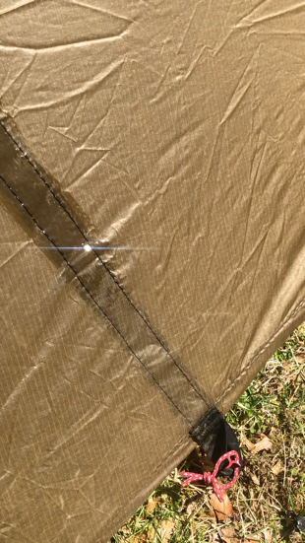

Video 1. Applying Silicone slurry to a sample of stitches seams.

Video Source: Home movie/pictures, John Van Hook, April, 2021

## Wait for the Silicone Slurry to Dry Before Testing

After about one hour, the slurry will be dry to the touch. The dried silicone will feel like rubber. Letting it set all day is the safest approach. Once the slurry has completely dried, you can pack the tent away as you normally would.

### Test the Seams

Before testing the seams, wait a full day to allow the silicone to dry completely. Start by setting newspaper on the floor of the tent. Spray the tent with a hose. Look inside at the paper for leaks. In a floorless tent you need the paper to see the water. In a tent with a floor, the paper will help determine exactly where the water is leaking in, but is not necessary. Or, you could sit inside while an assistant runs the hose.