**CubeRover**

I led a team of students designing and engineering the teleoperation system for a lunar rover. Our system is planned to fly to the moon in 2020.

**OffBeat**

A service my group designed from the concept and business model to the practical details like the website, app and even job descriptions.

**Business Casual**

An app my group designed to help bring university groups together with industry representatives for training, info sessions and career opportunities.

**RadPiper**

A robot developed for the DOE I helped design user interfaces and a system of labels that helped users track all parts of the RadPiper system.

**Concept Design**

3D rendering and animation to communicate a vision for anything from architecture to missions to the moon.

**Hyperloop**

Designing and developing virtual reality simulators and leading a team doing research into how the hyperloop could be integrated into existing cities.

**Project Drafter**

Designing an Augmented Reality based cad program built on unity.

**About Me**

I am a User Experience and Interface Designer specializing in robotics and space ready systems. A founding member of the CubeRover team, I helped launch a robotics startup dedicated to revolutionizing robotic missions to other planets through our standardized and modular rover. Before that I spent two years as Carnegie Mellon Hyperloop’s design lead and worked on robotics projects for the department of energy.

When I first arrived at Carnegie Mellon I was planning to study Scenic Design, the design of sets for theatre, film and tv. While I was there however, I fell in love with user experience design and realized I wanted to be a part of the revolution happening in the commercial space industry. Along the way I have developed a wide variety of skills from animation to web development.

Most importantly in my time working for CubeRover, the Hyperloop Team and most of all in the theatre I learned how to work as a part of a team. I have put these lessons to good use leading teams of students and friends on a variety of projects and look forward to bringing my experience to your team.

**Off Beat**

Off-Beat was the culmination of a semester long Service Design project. Service design is a framework of design thinking which is unique in that it considers all parts of an organization as part of the design. For example, a service designer working for a restaurant chain would consider far more than normal customer experiences and touchpoints (waitstaff, menu’s, ect.). Their design would include the backstage processes, from how food is delivered to how the kitchen staff receives the orders in order to provide the best experience to all stakeholders.

*For this project we were tasked with designing a music related service that targeted an audience other than the mass market.*

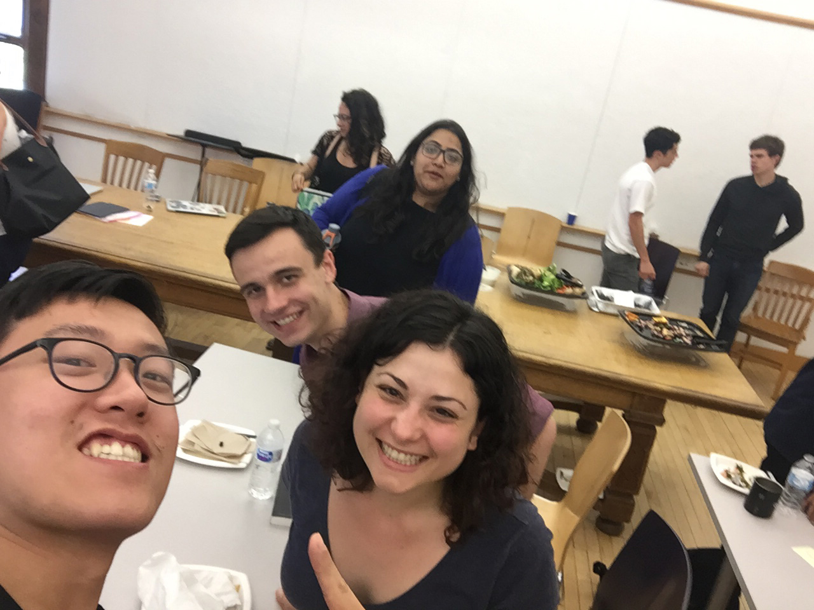

This is the one photo of the whole team we took during the entire process, right after the final presentation. From front to back: Steven Ji, Emma Zelenko, me and Devika Khowala.

OPPORTUNITY

“I’d love to go to a place where there are a bunch of music enthusiasts. It would be great to connect with people who like all sorts of music and are game to explore it all.” - Brad Frost, web designer & amateur musician, Pittsburgh

Music is more fun and compelling with other people, but amateur musicians often struggle to find a local community of musicians they can connect with.

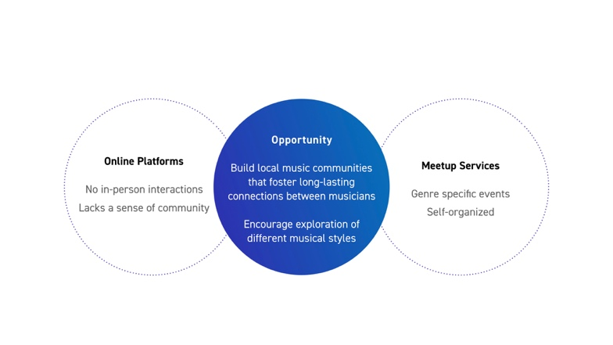

VIDEO

Offbeat helps to build local music communities of amateur musicians through its hosted events and digital platform.

STAKEHOLDERS

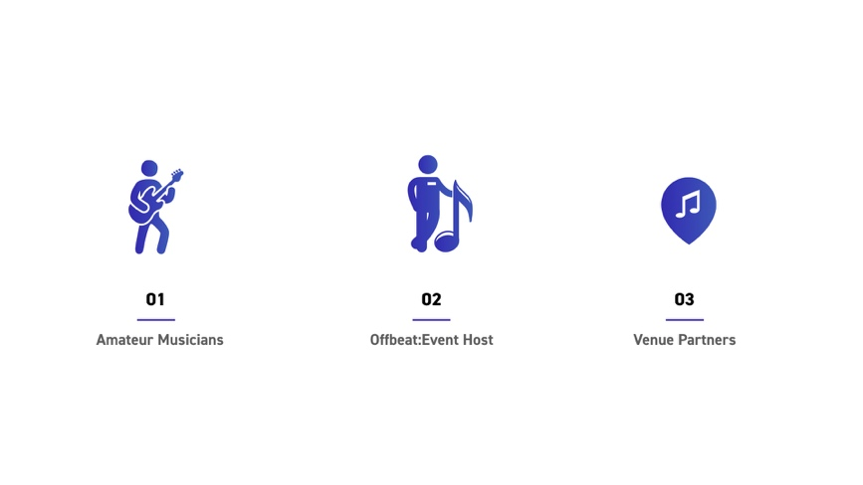

1. Amateur musicians are the heart of OffBeat, everything we do is about integrating ourselves with this community and building it up.
2. The OffBeat Event Host is the face of our service, they are responsible for coordinating and running our events.
3. Our venue partners are invaluable partners to the service they provide key parts of the service from space to entrees.

VALUE FLOW

The value flow map is a key document that describes where OffBeat gets value from others what we give them in exchange. In our case Offbeat’s service brings together Venues, Equipment and local music experts to give our customers an experience and community like no other.

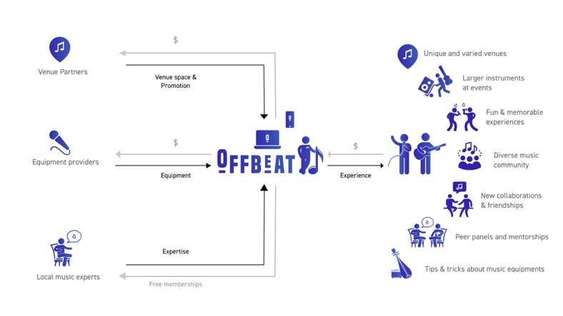

EVENTS

When thinking about what kinds of events OffBeat should host we noticed our ideas tended to fall somewhere on the axis between a performance and a networking event. One of the big questions we had to answer through user testing, which we did through speed dating storyboards, was how structured those events should be.

What we found was that there wasn’t a perfect solution for every event but rather that people tended to prefer their performance opportunities to be more casual and their networking or learning opportunities to be more structured.

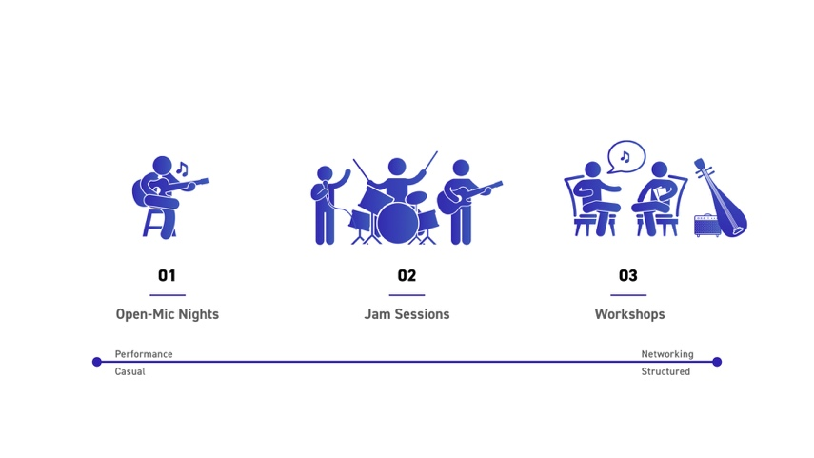

Our findings in our speed dating led us to select three primary types of events. Open-Mic nights would provide musicians an opportunity to perform and share their music with others. Jam Sessions would bring together groups of musicians to find new kinds of sounds and more importantly new friends. Finally, workshops would allow musicians to learn more about their or other’s instruments and improve their craft.

SERVICE BLUEPRINT

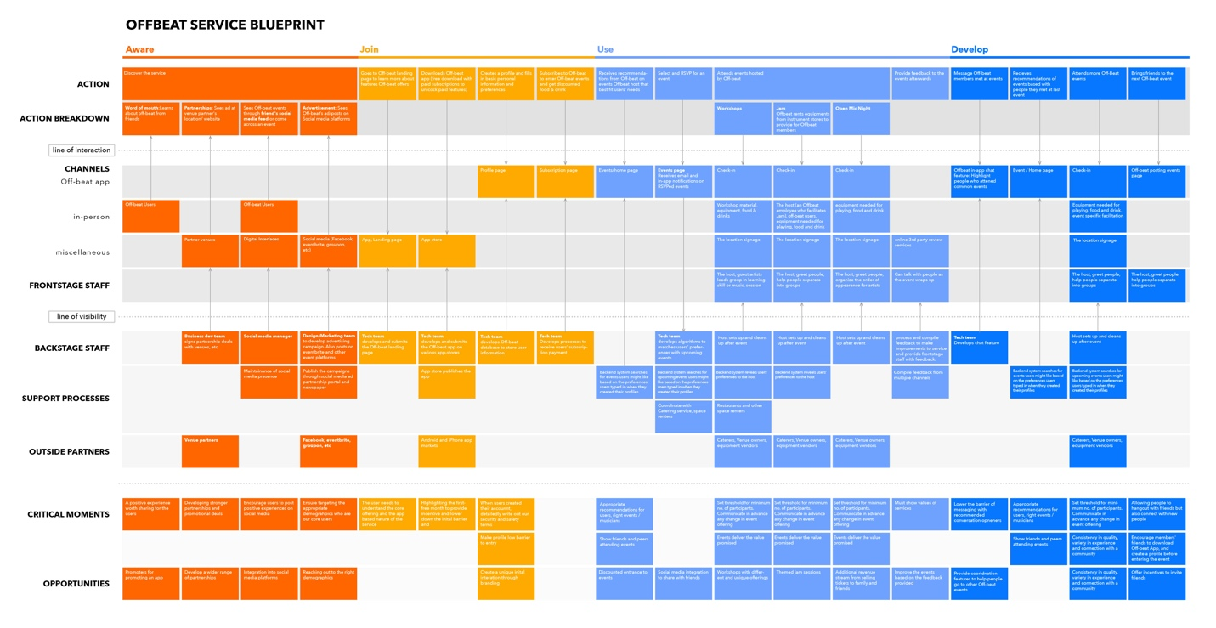

Once we determined what OffBeat would be providing and to whom we developed this service blueprint to describe what frontstage and backstage elements we would need to support that service. This allowed us to create a list of touchpoints which the user would interact with throughout the service. Designing those touchpoints would become our next focus.

LANDING PAGE

The goal of our landing page is to inform users about what the service is, show them upcoming events and encourage them to download our app which will be their window into the service.

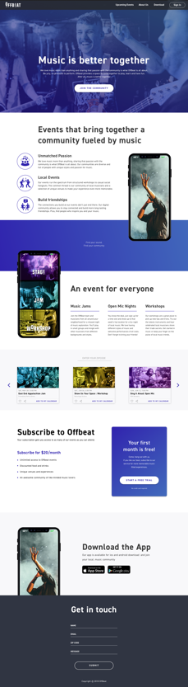

OFFBEAT APP

The app is the heart of OffBeat, it lets users know when our events are and helps them build a community as well as handling a variety of administrative tasks such as payment.

The onboarding sequence of the app is all about getting to know the user and having them set up OffBeat to work best for them. We wanted to make the process simple but interesting to the user, so it didn’t feel like a chore.

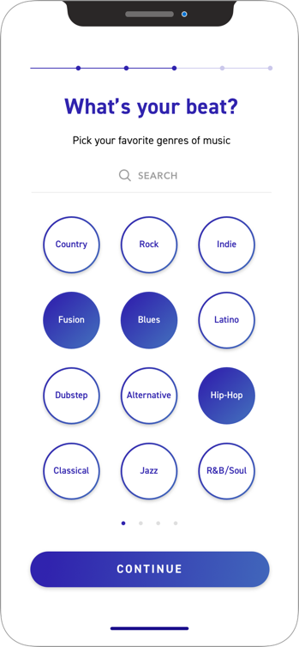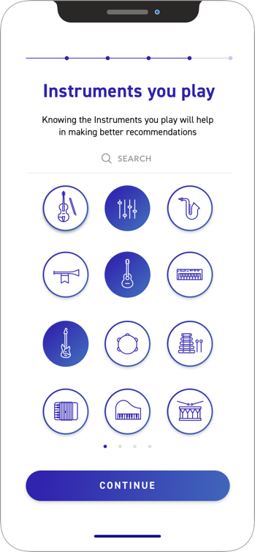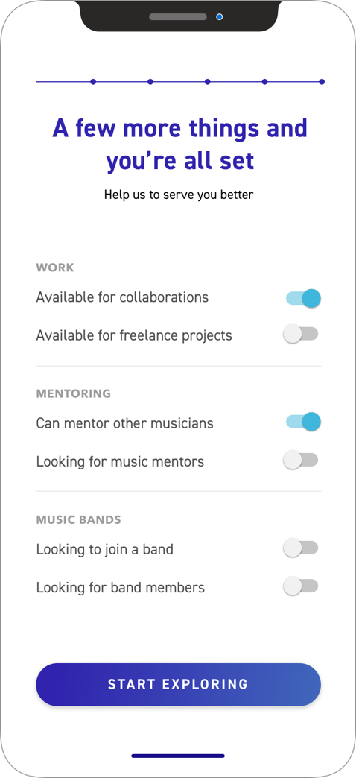

The app also functions to inform users about upcoming events in their area and tries to make getting information about them as easy as possible.

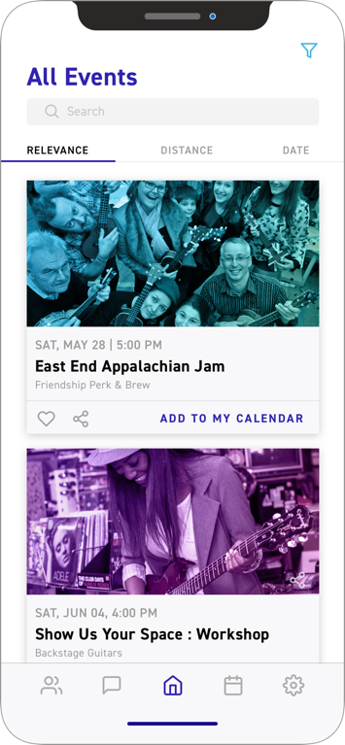

Finally, the app helps musicians connect with other members of the OffBeat community which attend similar events. This helps people continue the connections they make with us, beyond us.

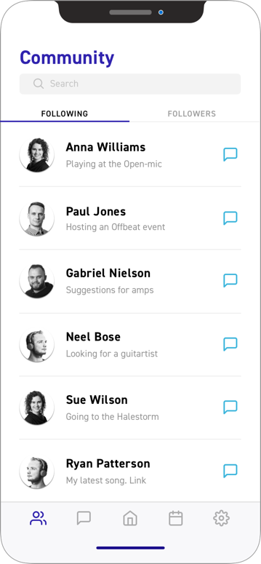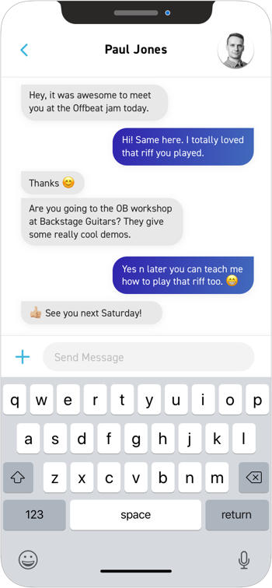

OFFBEAT HOST

The final touchpoint we designed was the OffBeat host. The host is responsible for coordinating our events and we wanted to make sure we hired the right kind of person.

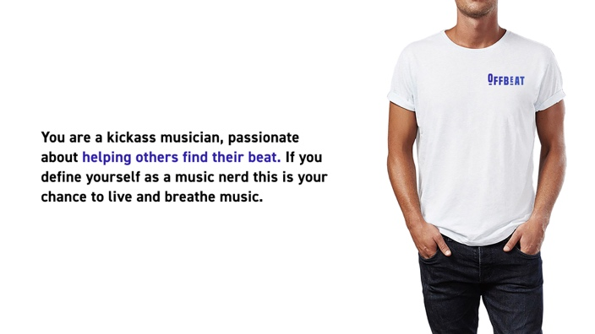

The OffBeat host has three primary roles, most importantly however they should be a relaxed friendly presence in the room who can bring their passion and help grow that passion in others.

**Community Building**

Introduces musicians and helps to build groups for jams, introduces performances at open mic nights and facilitates workshops.

**Check In**

Greets and checks-in arriving musicians.

**Set up & Clean up**

Facilitates the logistics of the event. Making sure the space is clean and functional.

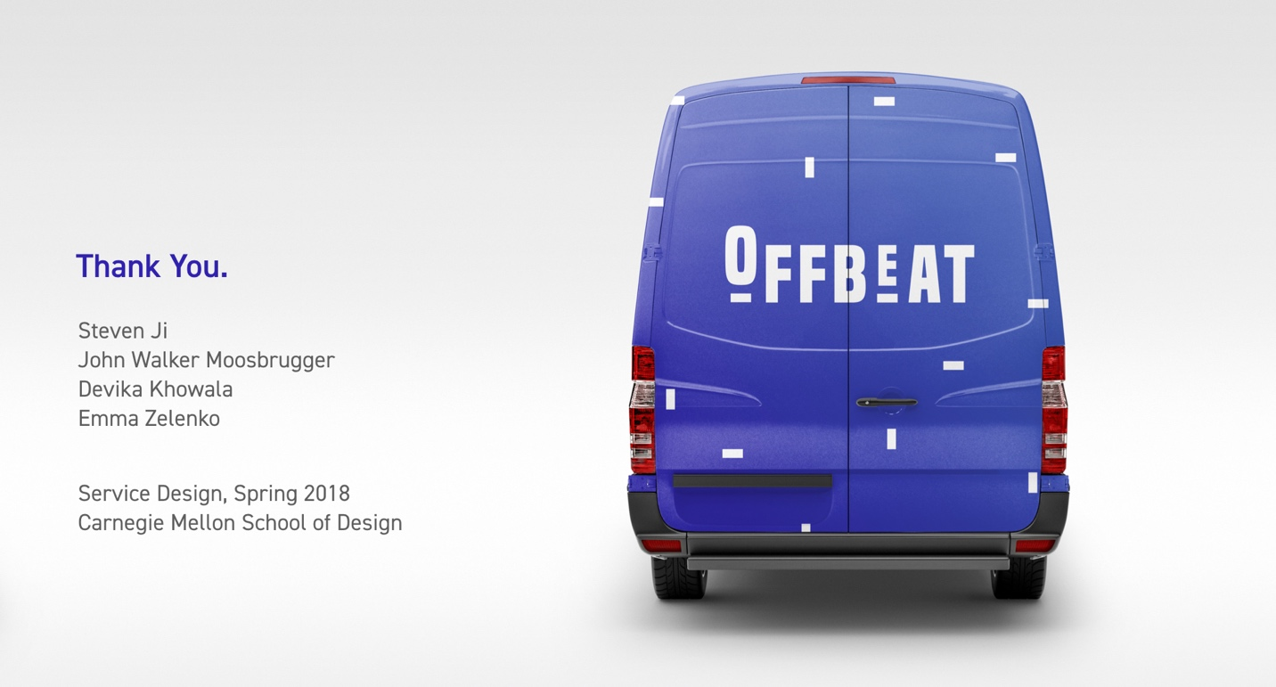

**Concept Design**

From robotics to architecture images have the power sell a vision. A self-taught 3D artist and animator, my renderings have been used for marketing and in successful proposals for projects to NASA and Private investors.

All of the projects on this page were modeled and rendered in Blender.