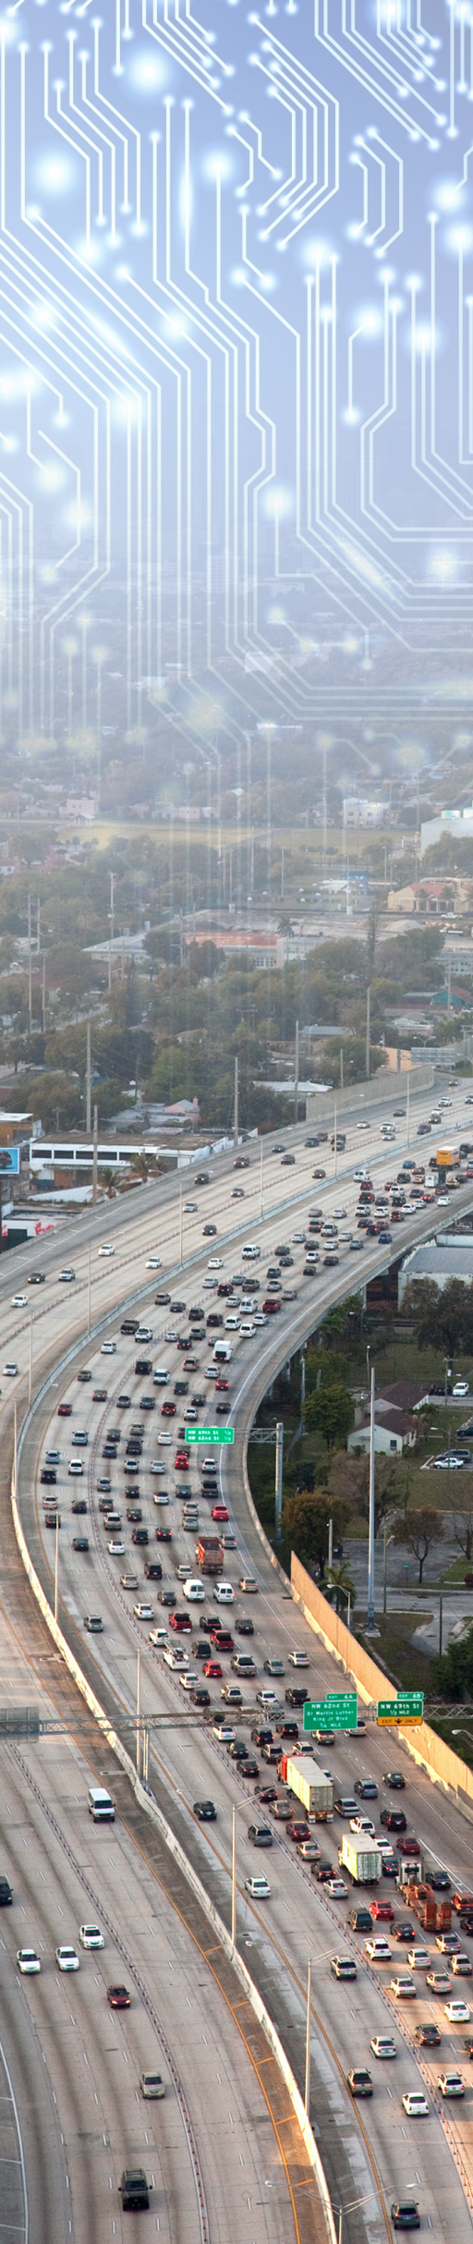

ODE User Guide Document has been MOVED:

Please see the online version [here](https://github.com/usdot-jpo-ode/jpo-ode/blob/master/docs/UserGuide.md)

<https://github.com/usdot-jpo-ode/jpo-ode/blob/master/docs/UserGuide.md>