**john adeyemi**

**WEB DEVELOPMENT**

HTML tags

* Heading tags goes on to 6. There are only 6 heading tags. <h1> through <h6>
* You find a specific info you want by inputting the right search terms on google
* Mdn, w3schools, <https://www.devdocs.io> ,
* Anatomy of HTML tags

Tags that don’t need closing are called self-closing tags e.g. <br>,

<hr **size=”3”**> The other things enclosed in the apart from hr are called attributes and what they do is that they give more information to the browser to specify modifications to the html element.

<center>

<hr size="3" noshade>

<h1>The Adventures of Sherlock Holmes</h1>

<br>

<h3>by</h3>

<br>

<h2>Arthur Conan Doyle<h2/>

<hr size="3" noshade>

</center>

* HTML boiler plate code is like a code template
* The meta element i.e. **<meta charset="utf-8">** gives extra metadata to your html document. So, it’s telling the browser that all the data on the html date is encoded using the **utf-8** encoding system.
* <https://www.fileformat.info>
* <https://www.unicode-table.com>
* Tru-Choice Primary School, Heyward Gate Primary School, Apostolic Church Grammar School, Antioch Royal College and City of Westminster College.
* Git-hub CV link 🡪 <https://harlex-art.github.io/CV/>

**CSS**

You add background colours by using background-colour in the opening body tag.

Everything in a webpage is a bunch of boxes and their properties can be affected by changing their CSS code

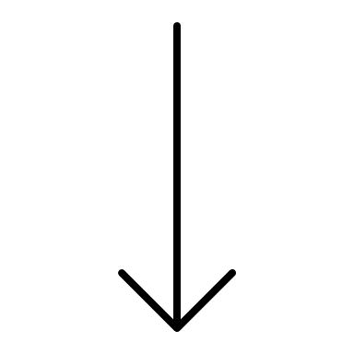 **Hierarchy in order of priority**

Inline CSS 🡪 Internal CSS 🡪 External CSS

**Anatomy of CSS Syntax**

* The selector comes at the beginning of a CSS rule
* Then the curly brackets which the CSS rules resides in
* The CSS rule changes the appearance of a property and gives it a new value and it ends with a semi colon
* Use class selectors when you want to apply changes to a group of related elements
* Use IDs when you want to apply changes to a single element on your webpage.
* IDs and Class selectors will override tag selectors.
* An ID name can only be used once on a page
* Any HTML element can have more than one class but can only have one ID.
* Pseudo class

<span> tag is used to make changes to a set of letters of a word in a line. The tag is an in-line element. The width of span can’t be changed. The display value of block elements can be changed to inline using **display: inline;** The display value of in-line elements can be changed to block using **display: block;**

In-line Block is a display value that combines block and in-line property so it will have the value of a block element but it’s width can be changed.

The image element by default has an in-line block value

CSS positioning 🡪

Relative positioning which is top, bottom, left right by number of pixels

Absolute positioning is positioning the element relative to it’s parent. It affects the layout of the website and when used, it’s as if the space that one was occupied is occupied by elements that follow it.