IT Infrastructure Upgrade for NextGen Tech Works

Table of Contents
Introduction 1
Objectives 1
Methodology 1
Weekly Task Summaries 2
Week 1: PC Components 2
Week 2: System Unit Components 2
Week 3: Storage Devices and Power Supplies 3
Week 4: Peripherals and External Devices 3
Week 5: Networking Concepts 3
Week 6: Network Protocols and Services 4
Week 7: Project Management 4
Week 8: Cyber Security Concepts and Best Practices 4
Week 9: Troubleshooting Hardware and Software Issues 5
Week 10: Operating Systems 5
Week 11: Mobile Devices and IDEs 6
Week 12: Cloud Computing and Virtualisation 6
Key Findings 6
Conclusion 7
References 8
Appendices 10
Appendix A. Charts and Tables 10
Appendix B. Project Artifacts 12

Introduction
NextGen TechWorks is a small-to-medium organization which offers gaming stations to professionals and hobbyists. The period covered in this Personal Learning Record is Weeks 1-12, between the selection of the components and assembling the system to the networking, security, troubleshooting, operating system setup, mobile tooling, and the decision regarding the cloud and virtualisation. The quality of experience of gaming on a workstation and a mobile platform was compared in Laghari et al. (2020), which led to the choice of latency, stability, and user experience as the targets. The report will enhance hardware, software, and cloud performance without making solutions impractical regarding their costs and support capacity to SMEs. Table 1 in the Appendix A summaries core workstation decisions and expenditure, the further evidence is in the form of specifications lists, configuration logs and diagrams. Images and URLs of the peripherals picked such as a keyboard are shown, and performance within the network and container are aided with graphs and tabular representation in the appendices.

Objectives
The project will focus on designing an upgrade which will provide responsive gaming and professional workloads based on compatible CPU, GPU, memory, storage, and power options, backed up by maintainable peripherals and scalable SME network. It aims at trusted DHCP and DNS protocols, packet-based traffic segmentation, and control of security that minimize phishing and ransomware attacks and patching and maintain system operation. The discussion on the benefits and challenges of Devops adoption by Grande et al. (2023) facilitated the aim of harmonizing tooling, changes, and monitoring with controlled changes. The learning outcomes are the use of specification comparison, performance checks and cost-benefit reasoning, the creation of evidence in an articulated form in the form of tables, screenshots, logs and diagrams, and the creation of a justified budget that is applicable within an SME procurement cycle.

Methodology
The PLR is a weekly, task-based process comprising of desk-based research and practical configuration and validation of an SME gaming-station setting. Every week documents actions, justification of choices, and artefacts generated and updates an ongoing budget of hardware, software, and services.
The data will be collected based on SOL teaching resources, laboratory instructions, documentation of the vendor, standards books and peer-reviewed articles and product comparison websites utilized as the component selection photographs. Data is recorded in the form of specifications tables, compatibility notes, benchmark summaries (where available), system tests and network tests screenshots, configuration logs and systems, and diagrams.
Specification comparison and compatibility and power sizing checks, basic performance verification, security risk identification, and cost-benefit review are used to evaluate the options. The results are summarised in brief weekly stories that make connections between practical decisions and computing concepts and document constraints, trade-offs, and the results of implementation. To track the traceability, both throughput and container performance charts and selections summary tables are referenced in weekly text, with the help of the Appendix items.

Weekly Task Summaries

Week 1: PC Components
Week 1 was dedicated to the task of choosing PC components that would be used in NextGen gaming stations to represent a balance of performance, efficiency, and compatibility. Comparison of CPU, GPU and motherboard was conducted on the basis of manufacturer specifications, benchmarks summary, and platform support document. A shortlist including indicative prices and selection notes has been prepared and is listed as Table 1 in Appendix A. Checking of compatibility was done between socket, chipset, memory standard and PCIe generation to avoid the use of incompatible parts. Yang et al. (2024) tested the accuracy of NVIDIA GPU built-in power sensing which was used to base power estimates on budgeting and PSU planning. A non-redesigned upgradeable path was observed as to support expansion of the graphical and storage memory. In the case of images being used in selected components, the figure will be contained within this week with the source website URL.

Week 2: System Unit Components
Week 2 discussed the units of the system that influence the operating cost and reliability. A cooling solution was determined based on an evaluation of airflow demand, noise levels to expect, and thermal load of the shortlist of components in Week 1. PSU size was based on the estimated peak draw and headroom and paralleled to efficiency ratings which could be used in continuous SME operation. Checking Cable and connector availability was verified against the requirements of the GPU and motherboard to eliminate the risks of building. The layout of the chosen case was tested on the basis of the fan placing and maintenance access and the evidence was saved as a list of components and setup notes that will be verified later to the NextGen operations.

Week 3: Storage Devices and Power Supplies
Week 3 made a comparison between storage devices and power supply considerations that affect performance, resilience and data management. NVMe SSDs features were compared with SATA SSDs and HDDs based on capacity, endurance ratings and interface bandwidth to facilitate quick loading of games and workstation operations. The ability to use NVMe to achieve sustained performance I/O as described by Haas and Leis (2023) justified the focus on NVMe as the new primary drive. A three-level scheme was designed which isolates operating system and applications, active project files, and archival data to control the cost. Week 2 PSU options were revisited to ensure connector and storage expansion. Results were captured in a comparison chart and suggestions were made on their future inclusion in the Appendix.

Week 4: Peripherals and External Devices
Week 4 was about peripherals and external devices required to work and experience. Monitor options were checked in resolution to ergonomic features that support extended working hours, refresh rate, and resolution. The durability and usability of keyboards and mice were evaluated and the chosen picture of the keyboard and the URL of the source site are located in the section of this week. Li et al. (2024) investigated the influence of mechanical switch type and backlight condition on typing performance and user experience, which were used in selecting the keyboard. Maintenance schedule was written including cleaning, firmware updates and replacement rates and documented and set up procedures were maintained in case of later Appendix assistance.

Week 5: Networking Concepts
Week 5 resulted in a network design that would best fit an SME gaming station provider, and is well segmented and supportable. Figure 3 in Appendix B was used to map the site layout, switching, routing and Wi-Fi positioning, and the trade-offs were summarised in Table 2 in Appendix A to choose access points and airtime efficiency functionality. Figure 1 in Appendix A is the throughput trends of the mixed 802.11ax networks of the 5 GHz band and the analysis carried out by Natkaniec and Bieryt (2023) justifies capacity planning. Gaming, administration and guest access VLAN groupings were defined and list of hardware was drafted with indicative cost to enable budgeting. Cabling notes and IP addressing on the notes were noted accurately.

Week 6: Network Protocols and Services
The Week 6 recorded the settings of DHCP and DNS services needed to be able to manage devices predictably in the SME setting. An IPv4 addressing plan was established followed by the setting of DHCP scopes, exclusions and reservations to separate gaming stations, administration and guest devices. DNS forwarders and local records were configured and the name resolution had been tested with nslookup and ping tests and the screenshots were stored as evidence. The Wi-Fi 6 design assumptions were supported in fig. 1 of Appendix A and they were used to plan the address capacity. Jerabek et al. (2024) had a comparison of detectors of DNS over HTTPS that informed a control in order to check the use of encrypted DNS and to make the DNS policy to reflect security needs. Table 2 (Appendix A) summarised the choices of protocols.

Week 7: Project Management
The project plan created during week 7 synchronized the weekly build, configuration, and validation activities into a workable SME schedule. Some of the core functions were assigned to procurement, assembling, network configuration, security testing and documentation and dependencies were drawn in such a way that the network services and hardware readiness came after each other. Milestones, control points and evidence checkpoints were captured in Table 3 in Appendix B with reference to the PLR structure. Dong et al. (2024) synthesised the definitions of agile project management that favoured a weekly review and iterative planning. The adoption problems encountered in small organisations were reported by Putrianasari et al. (2024), which underpinned simple governance and minimal ceremony.

Week 8: Cyber Security Concepts and Best Practices
Week 8 formulated security plan that aligned NextGen operational risks with practicable controls in the SME environment. A risk matrix was prepared followed by the selection of baseline controls on identity, endpoint protection, backups and network segmentation with the implementation evidence being recorded in checklists and screen shots. Bekkers et al. (2023) simulated the reasons behind taking measures to protect against ransomware, and the model advocated the priority of immutable backups, recovery testing and minimal administrative account privilege. Bhavani et al. (2022) examined machine learning systems used to detect phishing information that served user awareness directions and email filtering necessities. Rose et al. (2020) defined a zero-trust architecture model, according to which the definition of trust boundaries between groups of devices and services was specified. The research conducted by Fernandez and Brazhuk (2024) assessed constraints of zero trust adoption that influenced the documentation of assumptions, tracking of the needs, and gradual implementation. The completed security controls were aligned to Week 5 VLAN design and documented to become audit ready.

Week 9: Troubleshooting Hardware and Software Issues
Week 9 kept a troubleshooting journal to store problems, diagnostic actions, and confirmed solutions on hardware and software configuration in normal configuration. Issues were classified based on symptoms, probable causes, tools to fix them and remedies that would assist in repeat fixes. System logs were used to trace driver conflicts and failure of updates, network connectivity failures were isolated by use of ping, ipconfig and DNS tools with results being saved as evidence. Jenkins et al. (2024) surveyed patching behaviours and obstacles, which informed documenting rollback options, maintenance windows, and update sequencing. The final state after correction was put in each entry along with the command output or setting that indicated resolution. The summary highlighted lessons to practice in the support of multiple gaming stations in an SME.

Week 10: Operating Systems
The installation and configuration of the operating system to NextGen security and performance requirements were recorded in week 10. A target OS version was chosen on manageability features, after which installation media was made and base drivers installed. Updates were made, device status was monitored, and recovery options were turned on to do troubleshooting. Errors in event logs were examined. The settings were modified to include password rules as well as least privilege and screenshots were made of the local accounts and administrator policies. To stabilize the work station behaviour, power profiles and storage settings were adjusted. Firewall defaults and remote management option were checked out to be the same across stations. Evidence was stored as OS configuration exports and OS setup notes.

Week 11: Mobile Devices and IDEs
Week 11 defined guidelines of using mobile devices and IDE in the business network. The policies of the devices were to have a screen lock, encryption, and MFA of work accounts and the process of onboarding was recorded in the access of emails and collaboration. One of the standard IDE sets was chosen to work with and configuration notes were made on the extensions, version control preferences and secure credential storage. The support of edge computing in mobile augmented reality games as shown by Schwaiger et al. (2023) informed the needs to have stable wireless connection and secure management of devices concerning gaming related processes. The evidence was provided in the form of policy summaries and screenshots of important security settings.

Week 12: Cloud Computing and Virtualisation
Week 12 tested cloud computing and virtualisation alternatives in order to enhance scalability and flexibility. Containerisation was checked against consistency and evidence was mentioned in the Figure 2 of Appendix A to summarize the time difference between Docker and local host executions. Performance of Docker on MPI workloads was measured by Kononowicz and Czarnul (2022), and it was needed to record overhead concerns in compute intensive tasks. Potdar et al. (2020) contrasted containers and virtual machines which were useful in the choice of containers in lightweight services and VMs in heavier isolation requirements. The analysis of container engines conducted by Baresi et al. (2024) influenced the choice of an engine depending on the features, maturity, and management tooling. Dakić et al. (2024) tested the Kubernetes network interfaces, which led to the selection of networks interfaces by CNI parameters to be used in latency sensitive gaming services. Table 2 (Appendix A) was used to map the selected cloud options.

Key Findings
The weekly deliverables established a progressive upgrading process of an SME gaming station provider. The choice of components equated performance goals with power and compatibility tests where core selection was condensed into Table 1 (Appendix A). Storage planning gave fast NVMe first action to active workloads and maintained the expansion with the choice of the tiered capacity. Segmented traffic was specified by network design, recorded service configuration with support of Table 2 (Appendix A) and verified on the basis of protocol testing evidence. Identified risks were connected to security planning controls implemented such as backups, least privilege, and artefacts of audits were kept. Cloud and virtualisation assessment recorded engine and platform trade-offs and taken performance context on container execution on Figure 2 (Appendix A). Lee et al. (2023) simulated the quality of experience of gamers in a testbed of cloud gaming, which supported the emphasis on quantifiable latency, stability, and throughput limits.

Conclusion
This Personal Learning Record was a record of the planning, selection, and configuration decisions which are needed to increase the NextGen TechWorks IT capability in hardware and peripherals, networking, and security, troubleshooting, operating systems, mobile tooling, and cloud services. The work has utilized concepts of computing by using evidence-based comparison, compatibility tests, checking of configuration and organised budget. The artefacts present in Appendix support the decision-making process with traceable information such as component mapping and network mapping tables and performance charts. The exercise enhanced real world knowledge of the art of documenting technical decisions, the translation of requirements into deployable configurations, and keeping control with progressive planning. The future work is based on the continued verification of performance under peak load, the enhancement of security monitoring, and the analysis of costs against the procurement cycles to ensure the long-term sustainability.

References
BARESI, L., G. QUATTROCCHI and N. RASI, 2024. A qualitative and quantitative analysis of container engines. Journal of Systems and Software, 210, 111965
BEKKERS, L. et al., 2023. Protecting your business against ransomware attacks? Explaining the motivations of entrepreneurs to take future protective measures against cybercrimes using an extended protection motivation theory model. Computers & Security, 127, 103099
BHAVANI, P.A. et al., 2022. Phishing websites detection using machine learning. SSRN Electronic Journal
DAKIĆ, V. et al., 2024. Performance and Latency efficiency Evaluation of Kubernetes container network interfaces for Built-In and Custom tuned profiles. Electronics, 13(19), 3972
DONG, H. et al., 2024. What is Agile Project Management? Developing a New Definition Following a Systematic Literature Review. Project Management Journal, 55(6), 668-688
FERNANDEZ, E.B. and A. BRAZHUK, 2024. A critical analysis of Zero Trust Architecture (ZTA). Computer Standards & Interfaces, 89, 103832
GRANDE, R., A. VIZCAÍNO and F.O. GARCÍA, 2023. Is it worth adopting DevOps practices in Global Software Engineering? Possible challenges and benefits. Computer Standards & Interfaces, 87, 103767
HAAS, G. and V. LEIS, 2023. What Modern NVMe Storage Can Do, and How to Exploit it: High-Performance I/O for High-Performance Storage Engines. Proceedings of the VLDB Endowment, 16(9), 2090-2102
JENKINS, J., WOODS, M. et al., 2024. Not as easy as just update: Survey of System Administrators and Patching Behaviours. In Proceedings of the 2024 CHI Conference on Human Factors in Computing Systems,1-17
JERABEK, K., K. HYNEK and O. RYSAVY, 2024. Comparative analysis of DNS over HTTPS detectors. Computer Networks, 247, 110452
KONONOWICZ, T. and P. CZARNUL, 2022. Performance assessment of using Docker for selected MPI applications in a parallel environment based on commodity hardware. Applied Sciences, 12(16), 8305
LAGHARI, A.A. et al., 2020. Quality of experience (QoE) assessment of games on workstations and mobile. Entertainment Computing, 34, 100362
LEE, Y. et al., 2023. Modeling gamer quality-of-experience using a real cloud gaming testbed. Proceedings of the 14th ACM Multimedia Systems Conference, 12-17
LI, J., J. WANG and Y. HUANG, 2024. Effect of mechanical keyboard switch and backlight status on typing performance and user experience. Electronics, 13(21), 4205
MOZAFFARIAHRAR, E., F. THEOLEYRE and M. MENTH, 2022. A survey of Wi-Fi 6: Technologies, Advances, and Challenges. Future Internet, 14(10), 293
NATKANIEC, M. and N. BIERYT, 2023. An analysis of the mixed IEEE 802.11AX wireless networks in the 5 GHz band. Sensors, 23(10), 4964
POTDAR, A.M. et al., 2020. Performance evaluation of docker container and virtual machine. Procedia Computer Science, 171, 1419-1428
PUTRIANASARI, R. et al., 2024. Problems in the adoption of Agile-Scrum software development process in small Organization: A systematic literature review. SinkrOn, 9(1), 495-504
ROSE, S., BORCHERT, O., MITCHELL, S. and CONNELLY, S., 2020. Zero trust architecture (NIST Special Publication 800-207). National Institute of Standards and Technology.
ROY, B. and KANT, K., 2020. Enhancing endurance of ssd based high-performance storage systems using emerging nvm technologies. In 2020 IEEE International Parallel and Distributed Processing Symposium Workshops (IPDPSW), 1070-1079, IEEE
SCHWAIGER, A. et al., 2023. V-light: leveraging edge computing for the design of mobile augmented reality games. In Proceedings of the 18th International Conference on the Foundations of Digital Games, 1-10
YANG, X. et al., 2024. Accurate and convenient energy measurements for gpus: A detailed study of nvidia gpu’s built-in power sensor. In SC24: International Conference for High Performance Computing, Networking, Storage and Analysis, 1-17, IEEE

Appendices

Appendix A. Charts and Tables
Figure 1
Throughput versus offered load in mixed IEEE 802.11ax and IEEE 802.11ac networks, with and without BSS coloring (Natkaniec and Bieryt, 2023).
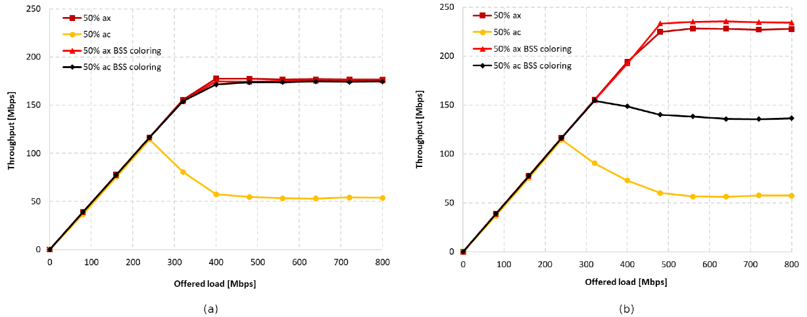
Figure 2
Docker versus host execution time comparison for parallel computing workloads across increasing numbers of processes (Kononowicz and Czarnul, 2022).
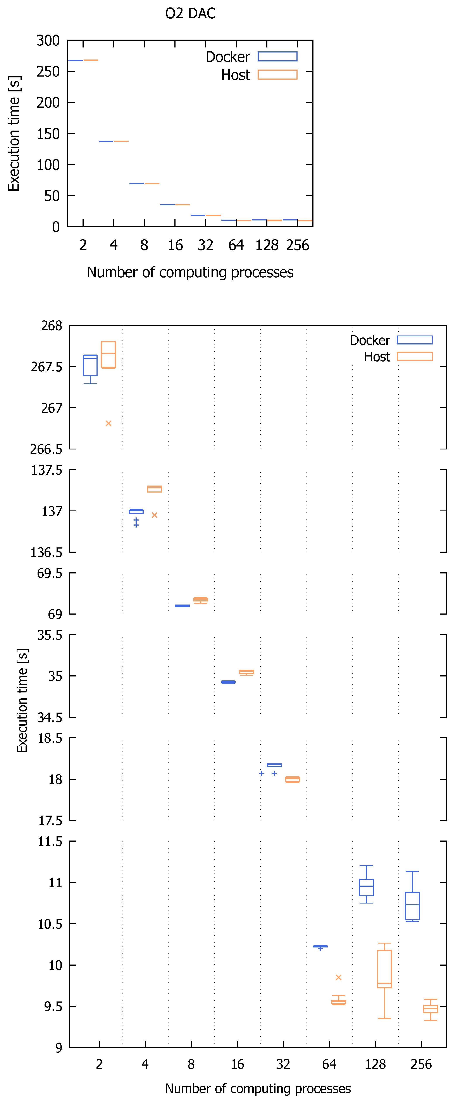
Table 1
Key gaming-station component shortlist and selection rationale.
Component | SME gaming-ready specification | Why it is selected | Budget note
CPU | 8-16 cores, high single-thread boost | Supports high FPS plus streaming/creation workloads | Mid-high cost driver
GPU | Current gen, 12-16 GB VRAM (or higher) | Enables high-resolution gaming and pro graphics tasks | Highest cost item
RAM | 32-64 GB DDR4/DDR5 | Stable multitasking, IDEs, streaming tools | Scale with users
Storage | 1-2 TB NVMe SSD + optional HDD/NAS | Fast load times plus capacity for media/projects | Tiered spend

Table 2
Network and cloud options mapped to NextGen operational needs and cost control approach.
Area | Selected solution | Business value for NextGen SME | Cost control approach
LAN core | Managed switch + VLANs | Separates admin, guest, and gaming traffic | Buy once, multi-year use
Wi-Fi | Wi-Fi 6 (802.11ax) APs | Better throughput under load, improved efficiency | Right-size AP count
Core services | DHCP/DNS on server or firewall | Reliable addressing + name resolution | Use existing licences
Cloud | Cloud backup or hybrid storage | Scalability and resilience | Pay only for usage

Appendix B. Project Artifacts
Figure 3
NextGen TechWorks (SME) site network and cloud integration diagram.
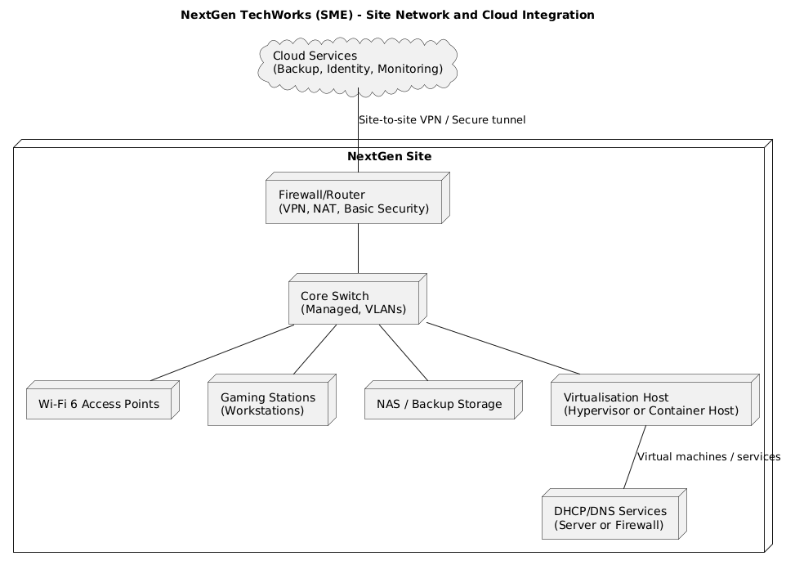

Table 3
Project plan: Timeline and deliverables (by week).
Week(s) | Work package | Key activities | Outputs for PLR evidence
1 | PC components | Research CPU, GPU, motherboard options; compare benchmarks/specs; check compatibility and upgrade paths | Component shortlist table + justification notes + cost estimates
2 | System unit components | Select cooling and PSU; validate power draw and efficiency; confirm case airflow assumptions | Compatibility checklist + PSU sizing notes + updated cost table
3 | Storage and power strategy | Compare NVMe SSD vs SATA SSD vs HDD; define storage tiers for gaming rigs and shared files; confirm backup approach | Comparison chart + recommendation table + budget update
4 | Peripherals and external devices | Select monitor, keyboard, mouse, headset, printer; define maintenance and replacement schedule | Images with sources + setup/maintenance notes + peripheral cost table
5 | Networking design | Design SME network layout; select switch/AP/router; define VLANs for gaming, admin, guest | Network diagram (PlantUML) + hardware quotes + design rationale
6 | Protocols and services | Plan and document DHCP/DNS; define IP scheme; test connectivity and name resolution | Configuration screenshots/logs + simple performance checks
7 | Project management | Confirm roles, timeline, dependencies; introduce change control and risk tracking | Short Gantt-style schedule + roles list + risk register summary
8 | Cyber security | Define baseline security controls (accounts, MFA, patching, backups, endpoint protection, firewall rules); perform risk assessment | Risk matrix + security checklist + audit evidence screenshots
9 | Troubleshooting | Record issues encountered and fixes (hardware, drivers, network, latency, updates) | Troubleshooting diary table + resolution summaries + tool outputs
10 | Operating systems | Select OS edition; document install, updates, drivers, policies; apply security hardening | OS setup evidence + configuration screenshots + verification outputs
11 | Mobile devices and IDEs | Define mobile management rules; enforce lock screen and MFA; document IDE setup for productivity workflows | Policy notes + setup steps + screenshots showing configurations
12 | Cloud and virtualisation | Choose cloud service model for backup/monitoring; document virtualisation or container plan; evaluate impact | Cloud plan summary + performance notes + final budget totals

