Software Requirements Specification (SRS)
Luxebyness Salon Booking Web Application
Deliverable D2 — DCIT 208 Software Engineering, 2026 Session
Client: Ms. Vanessa, Luxebyness Salon
Prepared by: Anobea (Project Manager) and Team
Date: 2 July 2026
Client-validated (interview completed 2 July 2026). A small number of items remain open for D3/D4 — see section F.3.

A. Requirements Overview

A.1 Purpose, Scope and System Boundary
This document specifies the functional and non-functional requirements for the Luxebyness Salon Booking Web Application. The purpose of the system is to allow clients to discover salon services and book appointments online, while giving salon staff and administration a digital way to manage bookings, services and schedules, replacing manual/phone-based booking.
Scope: the system covers client-facing booking (registration, service browsing, appointment booking, rescheduling, cancellation, history, reviews) and staff/admin-facing management (calendar view, service catalog management, staff schedule management). Scope excludes point-of-sale/inventory management and in-app payment processing unless confirmed otherwise by the client (see A.4).
System boundary: the web application (client-facing site and admin/staff dashboard) and its database are within scope. External SMS/email providers and any payment gateway are external systems the application integrates with but does not own.

A.2 Stakeholder Map and User Roles
Stakeholder | Role | Interest
Ms. Vanessa | Salon owner / Admin | Overall salon operations, service catalog, staff schedules, business reporting
Salon staff / stylists | Service provider | View and manage their own appointment calendar
Salon clients | End user / customer | Discover services, book, reschedule, cancel, review appointments
Project team (7 members) | Developers | Build, test and deliver the system
Course instructor | Evaluator | Assess deliverable quality against rubric

A.3 High-Level Narrative of Functional Requirements
Clients create an account, browse services and stylists, and book an appointment for an available time slot. The system prevents double-booking and sends confirmation notifications. Clients can view booking history, reschedule or cancel within policy, and rate completed visits. Staff view their own calendar of assigned bookings and receive notifications for new assignments. The salon admin manages the service catalog, pricing, and staff availability, and has an overview dashboard of all bookings.

A.4 Assumptions, Constraints and Dependencies
- The system is a responsive web application (mobile + desktop browser); no native mobile app is in scope for this academic project.
- The salon currently operates one location. Client-confirmed: the system should be architected so multiple branches can be supported in future without a full rebuild, though multi-branch is not required for this project's scope.
- Development constrained to the DCIT 208 course timeline (single semester, 7-person team, defined sprint plan from D1).
- Client-confirmed: a deposit is required to secure every booking (via Mobile Money or bank card); the remaining balance is paid in person at the salon after service.
- Client-confirmed: the salon currently has 4 stylists. Some specialize in specific services while others perform most services, so the system must support assigning bookings by stylist skill and availability.
- The system depends on a WhatsApp/SMS/email gateway for notifications (WhatsApp is clients' primary channel, SMS is backup, email is supplementary) and a payment gateway supporting Mobile Money and card for deposits.

B. Use Case Model

B.1 UML Use Case Diagram
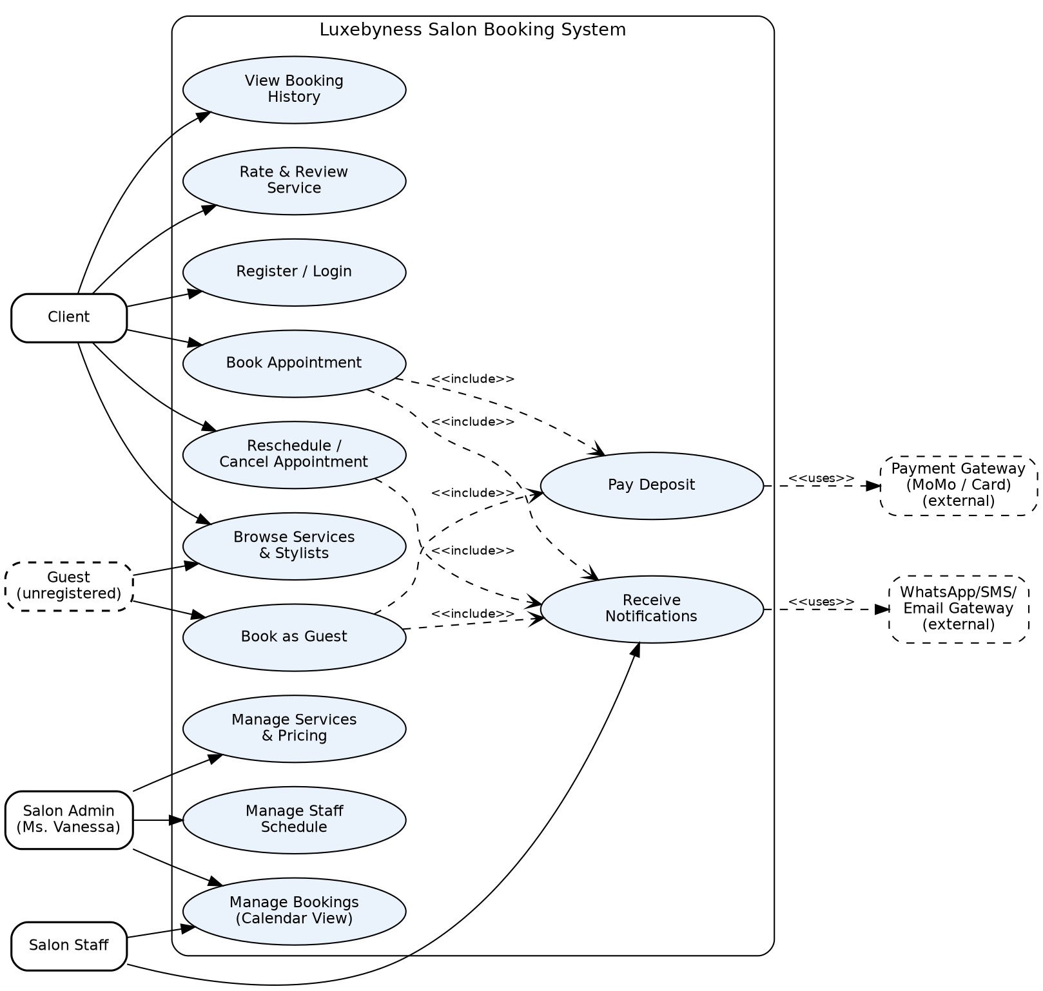
Diagram source file: docs/02_requirements/diagrams/usecase.dot (Graphviz), exported as usecase.png. See repository evidence.

B.2 Actors
Actor | Type | Description
Client | Primary | A registered customer who books, manages and reviews salon appointments
Guest (unregistered) | Primary | A visitor who books an appointment without creating an account
Salon Staff | Primary | A stylist who fulfils appointments and views their calendar
Salon Admin (Ms. Vanessa) | Primary | Owns and manages the service catalog, staff schedules, and overall bookings
WhatsApp/SMS/Email Gateway | Secondary (external) | Delivers booking confirmations and reminders — WhatsApp primary, SMS backup, email supplementary
Payment Gateway (MoMo/Card) | Secondary (external) | Processes online deposit payments via Mobile Money or bank card

B.3 Use Case Descriptions

UC-01: Register / Login
Primary actor: Client
Preconditions: The client has internet access and a valid phone number or email.
Main success scenario:
- Client opens the registration/login page.
- Client enters name, phone/email and password (registration) or credentials (login).
- System validates input and creates/authenticates the account.
- System redirects the client to their dashboard.
Alternative / exception flows: If credentials are invalid, the system shows an error and allows retry (max 5 attempts before temporary lockout). If the phone/email is already registered, registration is rejected with guidance to log in instead.
Postconditions: Client has an authenticated session and can access booking features.

UC-02: Browse Services & Stylists
Primary actor: Client
Preconditions: Client is on the booking site (logged in or as guest, per client confirmation).
Main success scenario:
- Client opens the services page.
- System displays active services with price, duration and description.
- Client optionally filters by stylist to view specialties and availability.
Alternative / exception flows: If no services are active, the system shows an empty-state message to the client.
Postconditions: Client has enough information to proceed to booking.

UC-03: Book Appointment
Primary actor: Client | Secondary actor(s): WhatsApp/SMS/Email Gateway, Payment Gateway
Preconditions: Client is logged in and has selected a service.
Main success scenario:
- Client views available time slots per stylist to avoid clashes.
- Client selects a preferred stylist, date and an open time slot.
- Client confirms the booking and pays the required deposit (includes UC-12).
- System checks the slot is still free and creates the appointment.
- System (includes UC-10) sends a confirmation notification to the client and an assignment notification to the stylist.
Alternative / exception flows: If the slot was taken by another client in the meantime, the system blocks the booking and prompts the client to choose another slot. If deposit payment fails, the booking is held as Pending and the client is prompted to retry.
Postconditions: A new appointment record exists with status Confirmed once the deposit is paid; client and staff are notified.

UC-11: Book as Guest
Primary actor: Guest (unregistered) | Secondary actor(s): WhatsApp/SMS/Email Gateway, Payment Gateway
Preconditions: A visitor has not created an account but wants to book.
Main success scenario:
- Guest browses services and stylists (UC-02).
- Guest selects service, stylist and an available time slot.
- Guest provides name and phone number (email optional).
- Guest pays the deposit (includes UC-12).
- System creates the appointment linked to the guest's contact details and sends confirmation (includes UC-10).
Alternative / exception flows: If the guest later wants to track bookings, they may register (UC-01) and the system can link the booking to the new account by matching phone number.
Postconditions: A confirmed appointment exists without requiring a registered account.

UC-12: Pay Deposit
Primary actor: Client / Guest | Secondary actor(s): Payment Gateway
Preconditions: A booking is ready to be confirmed and a deposit amount has been calculated.
Main success scenario:
- Client/Guest selects Mobile Money or bank card as the payment method.
- System redirects to or embeds the payment gateway.
- Client/Guest completes payment.
- Payment gateway confirms success and system marks the deposit as Paid.
Alternative / exception flows: If payment fails or is cancelled, the booking remains Pending and is released after a timeout so the slot does not stay blocked indefinitely.
Postconditions: Deposit is recorded as Paid and the appointment is Confirmed.

UC-04: Reschedule / Cancel Appointment
Primary actor: Client | Secondary actor(s): SMS/Email Gateway
Preconditions: Client has an existing upcoming appointment.
Main success scenario:
- Client opens the appointment from their booking list.
- Client chooses to reschedule (select a new slot) or cancel.
- System updates the appointment status and releases/reassigns the original slot.
- System notifies the assigned stylist of the change.
Alternative / exception flows: If the request falls within the salon's late-cancellation window, the system displays the policy and may still allow the action per client-confirmed policy.
Postconditions: Appointment status is updated to Rescheduled or Cancelled; stylist calendar reflects the change.

UC-05: View Booking History
Primary actor: Client
Preconditions: Client is logged in and has at least one appointment on record.
Main success scenario:
- Client opens 'My Bookings'.
- System lists past and upcoming appointments with status, service and stylist.
Alternative / exception flows: If the client has no bookings, the system shows an empty state with a prompt to book.
Postconditions: Client can review their appointment history.

UC-06: Rate & Review Service
Primary actor: Client
Preconditions: The appointment status is Completed.
Main success scenario:
- Client opens a completed appointment.
- Client submits a star rating (1–5) and optional comment.
- System stores the review against the stylist/service.
Alternative / exception flows: If a review already exists for that appointment, the system prevents duplicate submission.
Postconditions: The review is stored and may be visible on the stylist/service profile.

UC-07: Manage Bookings (Calendar View)
Primary actor: Salon Staff
Preconditions: Staff member is logged in with an assigned role.
Main success scenario:
- Staff opens their calendar.
- System displays bookings assigned to that staff member by day/week.
- Staff may mark a booking as completed or no-show.
Alternative / exception flows: If a staff member has no bookings for the period, the calendar shows an empty state.
Postconditions: Staff has an up-to-date view of their schedule; booking status may be updated.

UC-08: Manage Services & Pricing
Primary actor: Salon Admin
Preconditions: Admin is logged in with admin privileges.
Main success scenario:
- Admin opens the service catalog management page.
- Admin adds, edits or deactivates a service (name, price, duration, description).
- System validates and saves the change.
Alternative / exception flows: If a service is referenced by future bookings, deactivation is blocked or requires confirmation, per client-confirmed policy.
Postconditions: The service catalog reflects the admin's changes immediately for clients.

UC-09: Manage Staff Schedule
Primary actor: Salon Admin
Preconditions: Admin is logged in with admin privileges.
Main success scenario:
- Admin opens staff schedule management.
- Admin sets or edits a staff member's working hours/days off.
- System updates available booking slots accordingly.
Alternative / exception flows: If existing bookings conflict with a new schedule, the system flags the conflict for admin review.
Postconditions: Booking availability reflects the updated staff schedule.

UC-10: Receive Notifications
Primary actor: Client / Salon Staff | Secondary actor(s): SMS/Email Gateway
Preconditions: A triggering event has occurred (booking created, changed or cancelled).
Main success scenario:
- System composes a notification message.
- System sends the notification via SMS and/or email through the external gateway.
- Recipient receives the notification.
Alternative / exception flows: If the external gateway is unavailable, the system logs the failure and retries or flags it for manual follow-up.
Postconditions: The relevant client and/or staff member is informed of the booking event.

C. User Stories

C.1 User Story List
ID | User Story | Traces to Use Case(s)
US-01 | As a client, I want to register an account with my name, phone number and email, so that I can book appointments and receive confirmations. | UC-01
US-02 | As a client, I want to log in securely, so that my bookings and profile are protected. | UC-01
US-03 | As a client, I want to browse available services with prices and duration, so that I can decide what to book. | UC-02
US-04 | As a client, I want to view stylist profiles and availability, so that I can choose who serves me. | UC-02
US-05 | As a client, I want to select a service, stylist, date and time slot, so that I can book an appointment that fits my schedule. | UC-03
US-06 | As a client, I want to receive a confirmation notification after booking, so that I know my appointment is secured. | UC-03, UC-10
US-07 | As a client, I want to reschedule an upcoming appointment, so that I can adjust my plans without losing my slot. | UC-04
US-08 | As a client, I want to cancel an appointment within a set window, so that I am not charged for a visit I cannot make. | UC-04
US-09 | As a client, I want to view my past and upcoming bookings, so that I can track my salon visit history. | UC-05
US-10 | As a client, I want to leave a rating and review after a completed visit, so that I can share feedback on the service. | UC-06
US-11 | As a salon staff, I want to view a daily/weekly calendar of my bookings, so that I can prepare for each client. | UC-07
US-12 | As a salon staff, I want to receive a notification when a new booking is assigned to me, so that I stay updated in real time. | UC-07, UC-10
US-13 | As a salon admin, I want to add, edit or remove services and prices, so that the catalog stays accurate. | UC-08
US-14 | As a salon admin, I want to manage staff working hours and availability, so that bookings only happen during valid hours. | UC-09
US-15 | As a salon admin, I want to view all bookings across staff in one dashboard, so that I can oversee daily salon operations. | UC-07
US-16 | As a guest (unregistered visitor), I want to book an appointment without creating an account, so that I can secure a slot quickly. | UC-11
US-17 | As a client or guest, I want to pay a deposit via Mobile Money or card when booking, so that my appointment is secured and the slot is held for me. | UC-12
US-18 | As a client, I want to see each stylist's real-time available time slots before booking, so that I avoid double-booked or clashing appointments. | UC-02, UC-03

C.2 Acceptance Criteria (Given/When/Then)

US-01
- Given a new visitor, when they submit valid name, phone and email, then an account is created and a welcome message is sent.
- Given a duplicate phone/email, when they try to register, then the system rejects it with a clear error.

US-02
- Given a registered client, when they enter correct credentials, then they are logged in and redirected to their dashboard.
- Given 5 failed attempts, when the client tries again, then the account is temporarily locked.

US-03
- Given the service catalog, when a client opens the booking page, then all active services show name, price and duration.

US-04
- Given a selected service, when a client views stylists, then only stylists qualified for that service are listed with next available slot.

US-05
- Given a chosen service and stylist, when a client selects an open time slot and confirms, then the appointment is created with status Pending/Confirmed.
- Given a slot already taken, when a client selects it, then the system blocks the double-booking.

US-06
- Given a successful booking, when it is saved, then an SMS/email confirmation is sent within 1 minute.

US-07
- Given a booking more than 24 hours away, when a client requests reschedule, then they can pick a new open slot and the old slot is released.

US-08
- Given a booking outside the cancellation window, when a client cancels, then status changes to Cancelled and staff are notified.
- Given a booking inside the cancellation window, when a client tries to cancel, then the system shows the salon's late-cancellation policy.

US-09
- Given a logged-in client, when they open 'My Bookings', then upcoming and past appointments are listed with status.

US-10
- Given a completed appointment, when the client opens it, then they can submit a 1–5 star rating and comment, once only.

US-11
- Given a logged-in staff member, when they open their calendar, then only their own assigned bookings are shown by day/week.

US-12
- Given a new booking assigned to a staff member, when it is confirmed, then the staff member receives a push/SMS notification.

US-13
- Given an admin session, when a service is added/edited/removed, then the change reflects immediately in the client-facing catalog.

US-14
- Given an admin session, when staff hours are updated, then the booking calendar only offers slots within those hours.

US-15
- Given an admin session, when the dashboard is opened, then bookings for all staff are visible and filterable by date/staff/status.

US-16
- Given a visitor with no account, when they select a service, stylist and slot and provide name + phone, then a booking is created without requiring registration.
- Given a guest booking exists, when the guest later registers with the same phone number, then the system offers to link the past booking to the new account.

US-17
- Given a booking in progress, when the client/guest selects Mobile Money or card and completes payment, then the deposit is marked Paid and the appointment status becomes Confirmed.
- Given payment fails or times out, when this happens, then the booking is marked Pending and the slot is released after a timeout so it does not block other clients.

US-18
- Given a client has selected a service, when they view a stylist's calendar, then only genuinely open slots are shown.
- Given a slot is booked by someone else while the client is viewing it, then it is removed from availability before they can select it.

C.3 Preconditions and Postconditions Linked to Story Numbers
Preconditions and postconditions for each story follow directly from the use case they trace to (see section B.3). For example, US-05's preconditions/postconditions match UC-03; US-07/US-08's match UC-04. This avoids duplicating the same conditions twice in the document.

C.4 Initial Epics
Epic | Stories included | Notes for D3 decomposition
Account & Access | US-01, US-02 | Split into registration, login, password reset, session/security tasks
Discovery | US-03, US-04 | Split into service listing, filtering, stylist profile tasks
Booking Lifecycle | US-05, US-06, US-07, US-08 | Split into slot selection, conflict handling, notification, reschedule, cancellation-policy tasks
Client History & Feedback | US-09, US-10 | Split into history view and review submission tasks
Staff Operations | US-11, US-12 | Split into calendar UI and notification tasks
Admin Management | US-13, US-14, US-15 | Split into catalog CRUD, schedule CRUD, and dashboard/reporting tasks
Guest Booking & Payments | US-16, US-17, US-18 | Split into guest checkout flow, MoMo/card payment integration, deposit-timeout logic, and real-time slot availability tasks

C.5 Traceability: Use Cases → User Stories
Use Case | User Stories
UC-01 Register/Login | US-01, US-02
UC-02 Browse Services & Stylists | US-03, US-04
UC-03 Book Appointment | US-05, US-06
UC-04 Reschedule/Cancel | US-07, US-08
UC-05 View Booking History | US-09
UC-06 Rate & Review | US-10
UC-07 Manage Bookings (Calendar) | US-11, US-15
UC-08 Manage Services | US-13
UC-09 Manage Staff Schedule | US-14
UC-10 Receive Notifications | US-06, US-12
UC-11 Book as Guest | US-16
UC-12 Pay Deposit | US-17

D. Non-Functional Requirements

D.1 Usability
- A first-time client should be able to complete a booking in 5 or fewer steps without assistance.
- The interface follows a consistent design system across client and admin views (see D1 System Components).

D.2 Performance and Availability
- Core pages (service list, booking calendar) load in under 3 seconds on a typical mobile connection.
- The system should support at least 50 concurrent users without noticeable degradation, sufficient for a single-salon academic deployment.
- Target availability of 99% during business hours; scheduled maintenance communicated in advance.

D.3 Security, Privacy and Access Control
- Passwords are stored hashed (never in plain text).
- Role-based access control restricts admin and staff functions from unauthenticated or client-role users.
- All data in transit is encrypted via HTTPS.
- Client personal data (name, phone, email) is only accessible to authorized staff/admin, not to other clients.

D.4 Maintainability, Portability and Deployment
- Code follows the team's agreed style/branching conventions (see repository CONTRIBUTING notes) to support handover and grading.
- The application is deployable to a standard web hosting environment without proprietary dependencies, consistent with the D1 system components plan.
- Client-confirmed: although the salon currently has one location, the data model (e.g. branch/location field on services, staff and appointments) should not hard-code a single location, so multi-branch support can be added later with minimal rework.

D.5 Accessibility and Inclusive Use
- Pages use sufficient colour contrast and readable font sizes for low-vision users.
- Forms are keyboard-navigable and labelled for screen readers where feasible within project scope.

D.6 Data Backup, Audit and Logging
- Booking data is backed up on a regular schedule (frequency to be set based on hosting environment used).
- Key actions (booking created/changed/cancelled, service/schedule edits) are logged with timestamp and actor for audit purposes.

E. Data and External Interface Requirements

E.1 Key Data Entities
Entity | Key fields (conceptual) | Sensitivity
Client / Guest | full name, phone (required), email (optional), password hash (registered clients only) | Personal
Staff | name, role, specialty/skills, working hours, contact | Internal
Service | name, description, price, duration | Public
Appointment | client/guest ref, staff, service, preferred stylist, date/time, notes/special requests, status | Confidential
Payment | appointment ref, amount, method (MoMo/card), status, transaction reference | Confidential
Review | appointment ref, rating, comment | Internal
Notification log | recipient, channel (WhatsApp/SMS/email), message, status, timestamp | Internal

E.2 External Systems and Interfaces
- Client-confirmed: WhatsApp is clients' primary channel for confirmations/reminders, with SMS as backup and email as a supplementary channel. Provider/API for each to be selected by the dev team.
- Client-confirmed: a payment gateway supporting Mobile Money and bank card is required to process deposits at booking time (provider e.g. Paystack/Hubtel-class service to be selected by the dev team).
- Client-confirmed: authentication is phone/email + password only; social login (e.g. Google) is not required.

E.3 Data Sensitivity Classification
Public: service catalog and pricing. Internal: staff schedules, reviews, notification logs. Confidential: appointment records linking clients to specific times/services. Personal: client name, phone number, email address.

E.4 Data Retention and Deletion (initial expectations)
- Client accounts and booking history are retained while the account is active.
- Client-confirmed: on a deletion request, the client is first asked to state their reason via an in-app form, then, once confirmed, their personal data is deleted promptly — except records the salon is legally required to retain, such as completed payment/transaction records.

F. Glossary and Validation Evidence

F.1 Glossary
Term | Meaning
Client | A customer of Luxebyness Salon who books appointments through the system
Slot | A discrete bookable unit of time for a given stylist and service
No-show | A booked client who does not attend their appointment
Epic | A large user need that is broken down into smaller user stories in D3
Stylist / Staff | A salon employee who performs services and manages their own booking calendar

F.2 Client Validation Notes
Interview conducted via WhatsApp with Ms. Vanessa on 2 July 2026, with a brief follow-up the same evening (transcripts retained in docs/02_requirements as evidence).
Confirmed: the overall use case diagram and system flow accurately reflect how the salon operates. The client confirmed: 24-hour cancellation policy with non-refundable deposit inside that window; rescheduling allowed subject to availability; deposit required to secure every booking with balance paid in-salon; 4 stylists with mixed specialization; only the owner/admin can edit services and prices; single location today; WhatsApp as the primary notification channel; authentication by phone/email + password only (no social login); and, on data deletion requests, the client first states a reason via an in-app form, after which personal data is deleted promptly except records the salon is legally required to keep (e.g. completed payment/transaction records).
Changed from the initial draft: the client requested four additions that were not in the original draft and have now been incorporated — (1) guest booking without registration (UC-11, US-16), (2) online deposit payment via Mobile Money and card (UC-12, US-17), (3) client-visible real-time slot availability to prevent double-booking (US-18), and (4) stylist selection at the time of booking (reflected in UC-03).
Still unknown: the exact deposit amount/percentage, and whether a grace/timeout period applies before an unpaid pending booking's slot is released — neither was covered in the interview rounds and is logged below for D3/D4.

F.3 Open Questions for D3/D4
- What is the deposit amount or percentage — fixed fee or a percentage of service price?
- Is there a grace/timeout period before an unpaid pending booking's slot is released back to availability?
- Should multi-branch support be built into the MVP data model now, or deferred entirely to a future phase?
- What specific record types is the salon legally required to retain after a data deletion request (beyond payment/transaction records), and for how long?

Quality Checklist (self-assessment before submission)
- Every functional requirement is understandable and testable — Yes, expressed as use cases + Given/When/Then acceptance criteria.
- Every user story has a real user role and benefit — Yes, all 15 stories follow the As a/I want/so that format.
- No duplicate or conflicting stories remain unresolved — Yes, reviewed for overlap.
- Non-functional requirements are measurable where possible — Yes (load time, concurrency, uptime targets stated).
- The client has seen or validated the requirements baseline — Yes, validated via WhatsApp interview on 2 July 2026 (see F.2); remaining open items are logged in F.3 for D3/D4.

