**How to Find your Windows 10 Product Key**

By [Andre Da Costa](https://www.groovypost.com/howto/author/andre/)

Last Updated on January 8, 2019

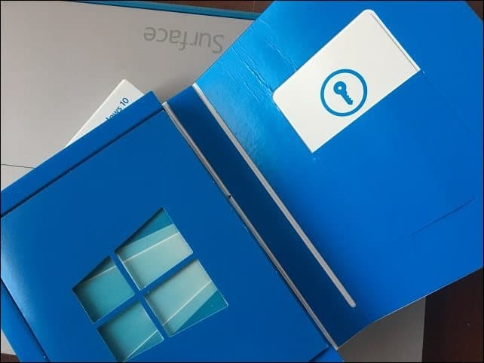

[Share](https://www.groovypost.com/howto/find-your-windows-10-product-key/" \o "Share on Facebook)

[Tweet](https://www.groovypost.com/howto/find-your-windows-10-product-key/" \o "Tweet This Post)

[Share](https://www.groovypost.com/howto/find-your-windows-10-product-key/" \o "Pin This Post)

[Email](mailto:?subject=How%20to%20Find%20your%20Windows%2010%20Product%20Key&BODY=I%20found%20this%20article%20interesting%20and%20thought%20of%20sharing%20it%20with%20you.%20Check%20it%20out:%20https://www.groovypost.com/howto/find-your-windows-10-product-key/)

[Comments](https://www.groovypost.com/howto/find-your-windows-10-product-key/" \l "comments)

Microsoft has made every effort to make Windows 10 licensing convenient. That said, there are times where product [activation might not work](https://www.groovypost.com/howto/fix-windows-10-product-key-activation/) according to plan. Whether you want to perform a new install or [transfer your Windows 10 license to a new computer](https://www.groovypost.com/howto/transfer-windows-10-license-new-pc/); your product key is an important asset you need to have. Depending on how you acquired Windows 10, you might not have a Windows 10 product key, in some cases you do, here is how you find it.

**Locate Your Windows 10 Product Key**

First, let’s start with a purchased Windows product key or license as it is officially known. Windows 10 is licensed as a digital download or a full packaged product you can purchase at a physical store. Both Microsoft and Amazon.com are the **only** authorized online merchants from whom you can purchase a digital copy of Windows 10. Any other retailer selling you just a product key is likely not genuine; so, make sure you purchase a license only from Amazon or Microsoft if you decide to go the digital download route.

Another tip, if you [buy a license from Amazon, use this link](https://amzn.to/2i59ECx). Some have tried to save a few bucks by purchasing a license from the Amazon marketplace only to later find the license is an MSDN key and not valid.

When you purchase your [Windows 10 license from the Microsoft Store](https://www.microsoftstore.com/store/msusa/en_US/pdp/Windows-10-Pro/productID.319935900), a copy of the product key is stored in your Microsoft Account. Microsoft will also send you a copy of the product key in a confirmation email. If you don’t see the confirmation email, check your junk mail folder. If you still don’t find it, log into the Microsoft Store > Downloads > Product Keys > Subscription page. Then click the [Digital Content tab](https://www.microsoftstore.com/store/msusa/en_US/DisplayDownloadHistoryPage/) to see your previous purchases along with your product key.

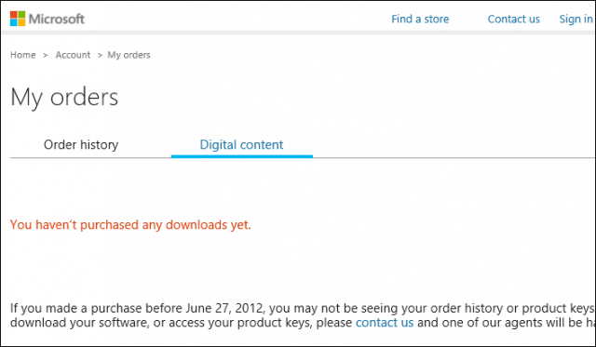

Amazon customers can visit the [Your Games and Software Library](https://www.amazon.com/YourGamesandSoftware)section of the website to find your product key.

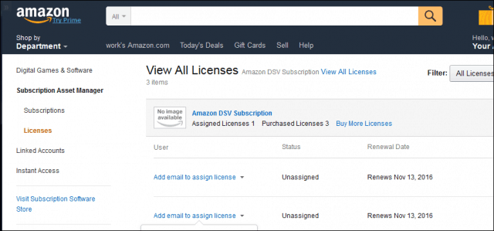

**Windows 10 Pro Pack key**

When you purchase a Windows 10 Pro Pack using the [Easy Upgrade](https://www.groovypost.com/howto/upgrade-windows-10-using-easy-upgrade-feature/) option in Windows 10 Home, you don’t receive a product key. Instead, the [digital license is attached to your Microsoft Account](https://www.groovypost.com/how-to-use-digital-license-to-manage-and-activate-windows-10-anniversary-update-licenses/); used to make the purchase. If you decide to transfer the Windows 10 Pro Pack to another computer, you can do so using the [Activation Troubleshooter](https://www.groovypost.com/how-to-use-digital-license-to-manage-and-activate-windows-10-anniversary-update-licenses/).

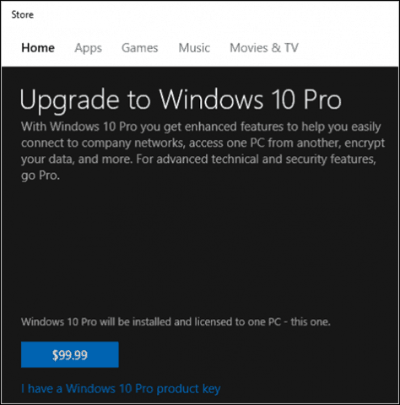

**Transfer Windows 10 Pro Pack Key to a new Computer**

1. Open *Settings > Update & security > Activation > Troubleshooter*.
2. Sign in with your Microsoft Account used to purchase the Pro Pack license.
3. After troubleshooting is completed, Windows 10 will indicate a digital license for Windows 10 Pro has been found.
4. Click *Activate Windows* then follow the on-screen wizard.

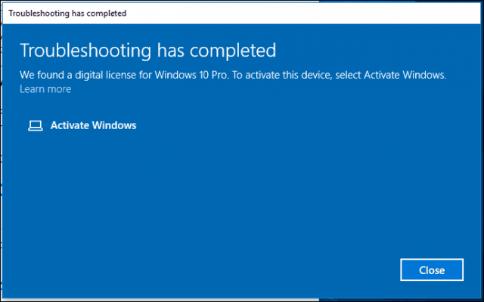

**Retail Full Packaged Product**

Windows 10 is also available as a [retail full packaged product](https://amzn.to/2iqQGTz) you can buy at a store. Inside the Windows 10 product box, you will find your product key on a small business card at the back. Users should make sure they store the product key in a safe place or have a backup copy. I also recommend you [use our trick to take a photo of the key and store it online](https://www.groovypost.com/howto/backup-photos-videos-onedrive-android-ios-windows-phone/) for safe keeping.

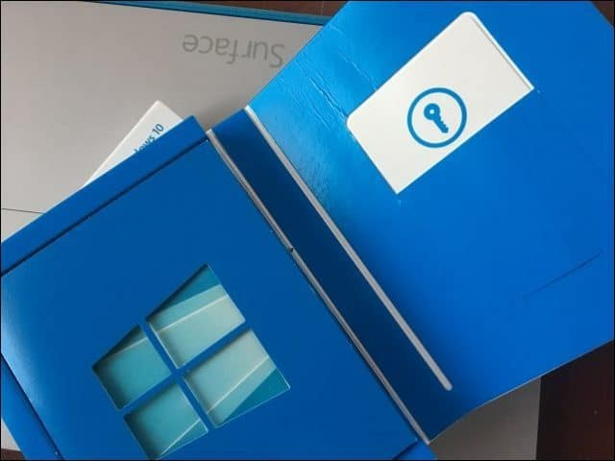

**OEM System Builder License**

The Windows 10 product key is normally found on the outside of the package; on the Certificate of Authenticity. If you purchased your PC from a white box vendor, the sticker might be attached to the chassis of the machine; so, look at the top or side to find it. Again, snap a photo of the key for safekeeping. After several years, I’ve found these keys like to rub off with normal wear-and-tear.

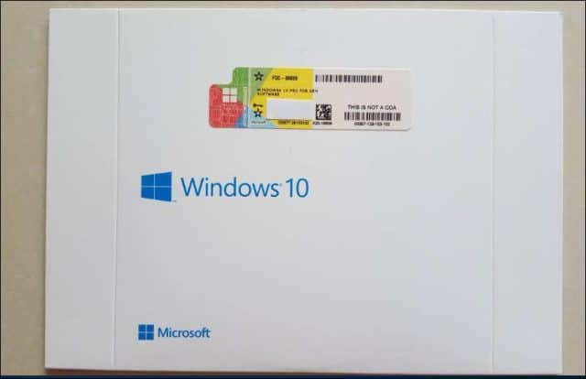

**Find Windows 10 Product Key on a New Computer**

The product key for new computers that come preinstalled with Windows 10 has the product key stored within the motherboard firmware. Users can retrieve it by issuing a command from the command prompt.

1. Press *Windows key + X*
2. Click *Command Prompt (Admin)*
3. At the command prompt, type:

wmic path SoftwareLicensingService get OA3xOriginalProductKey

This will reveal the product key.

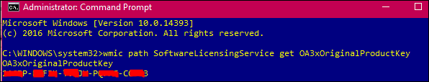

**Volume License Product Key Activation**

If you’re using Windows 10 in a business environment, editions such as Windows 10 Pro, Enterprise and Education don’t use normal product keys. Instead, Domain Administrators set up special KMS (Key Management Service) servers which manage activation across the business network. This eliminates the need for computers to connect to Microsoft for activation.  System Administrators responsible for deploying Windows 10 in an organization can find the product key from the [Volume License Service Center portal](https://www.microsoft.com/Licensing/servicecenter/home.aspx); click the *Licenses* tab, then click the Key tab for your Windows product.

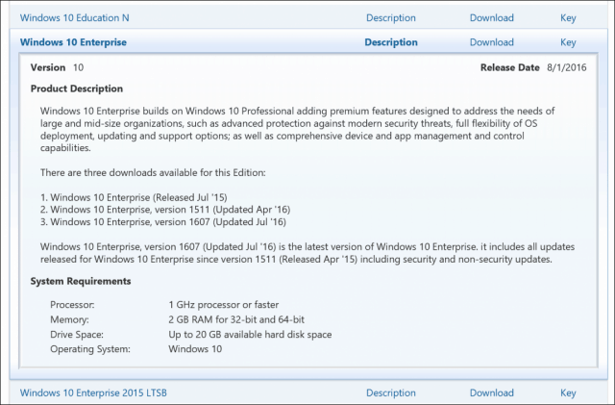

**Imagine or Microsoft Campus Agreement**

If you received your Windows 10 license through a Microsoft Campus Agreement or service such as [Imagine](https://imagine.microsoft.com/), formerly called Dreamspark, the product key should be available from the download page after purchase. A purchase confirmation email should also contain a copy of your product key. Some Universities might also use volume licensing. If your University utilizes KMS for handling product activation, then you will not receive a key. Instead, when you join the campus network or VPN in, KMS will activate your system automatically. This also means, when you graduate or end enrolment, you will lose access to the license.

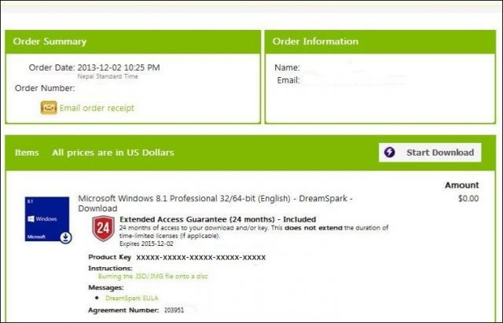

**Microsoft Software Developer Network**

Subscribers to MSDN, can find their product keys by [logging into their subscription](https://msdn.microsoft.com/en-us/subscriptions/hh442898.aspx), choose the product you would like to view click the product key button.

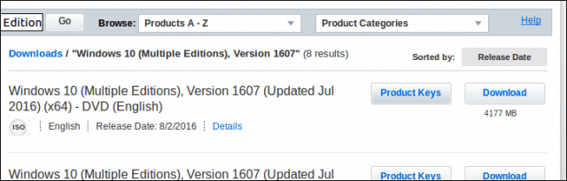

**Lost or Damaged Product Key**

Microsoft doesn’t provide much sympathy for customers who lose their product key. In some cases, you might be able to recover your product key using a [key finder utility](https://www.groovypost.com/howto/find-windows-product-key-after-upgrading-windows-10). Otherwise, if you lose it, your only option is to purchase a new one. That is why you should always make a backup copy and don’t throw away the box.

Users who took advantage of the free upgrade offer don’t have a unique Windows 10 key. This is because of the way Windows 10 handles activation; called [Digital License](https://www.groovypost.com/how-to-use-digital-license-to-manage-and-activate-windows-10-anniversary-update-licenses/). Users who need to transfer their Windows 10 free upgrade to another computer are entitled to a [one-time transfer right](https://www.groovypost.com/howto/transfer-windows-10-license-new-pc/). There are third-party utilities we have covered in the past for finding your product key; solutions such as [Show Key Plus](https://www.groovypost.com/howto/find-windows-product-key-after-upgrading-windows-10) can help if you have difficulty finding the key after upgrading from a previous version of Windows.

**Get Help From Microsoft on Windows 10 Activation**

Sometimes, after transferring a license or reinstalling Windows 10, you might have trouble reactivating the software. Windows 10 includes a handy [chat option you can use to contact a Microsoft support](https://www.groovypost.com/howto/activate-windows-10-license-microsoft-support/) agent, who can help with getting the software reactivated. If you prefer speaking to live person, you can also use phone activation.

* 1. Press *Windows key + R*
  2. **Type**: *slui.exe 4* then hit Enter
  3. Select your country from the list menu
  4. choose the option phone activation, the wait for an agent to assist you.

Tell us what you think. Was this article helpful with finding your Windows 10 product key?