Source:

<https://www.learncax.com/knowledge-base/blog/by-category/cfd/recirculation-boundary-conditions-in-ansys-fluent>

How to implement this boundary condition in ANSYS FLUENT?

In ANSYS FLUENT, recirculation inlet, outlet boundary conditions are not available by default. You have to enable them from TUI.

Following are the commands which are required to turn ON this boundary condition.

(rpsetvar 'icepak? #t)  
(models-changed)

This boundary condition is very useful to model recirculation appliances such as heating or cooling devices. In such devices fluid is supplied from one section into the simulation domain, this section is usually referred as inlet (or supply). Fluid is extracted out from other section which is usually referred as outlet (return); this extracted fluid is returned/recirculated back to supply section. Before recirculating this fluid it could be cooled down, heated up or returned without any temperature change. This depends on the type of the device (heating/cooling device).

This boundary condition needs a pair of inlet and outlet zone. Following section gives details about the setup for inlet and outlet in the pair.

**Conditions at Inlet (Supply)**

Following inputs needs to be provided on the inlet partner of the pair

* Its outlet partner
* Temperature rise specification method
* Input for thermal conditions based on the temperature rise specification method selected
* Flow direction
* Other scalar properties bases on the models selected

Following figures shows typical setup for inlet partner of the pair.

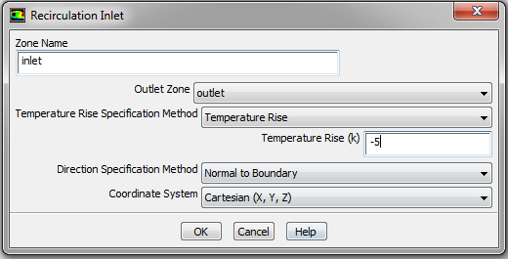

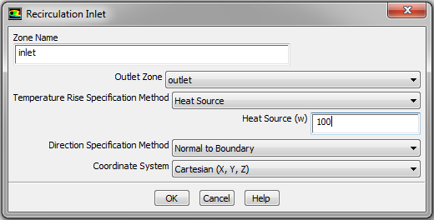

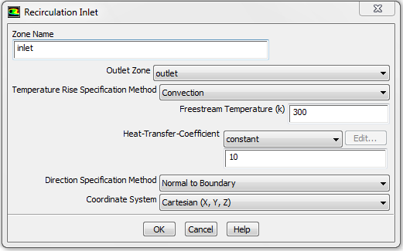

All other conditions including mass flow rate and thermal conditions are provided at outlet.

**Conditions at Outlet (Return)**

On the outlet partner of the pair, only mass flow needs to be provided. The mass flow can be provided using either mass flow rate or mass flux

**1. Mass flow rate**: We can specify total mass flow rate through supply section or extraction section. Following image shows snap shot of ANSYS FLUENT for specifying mass flow rate.

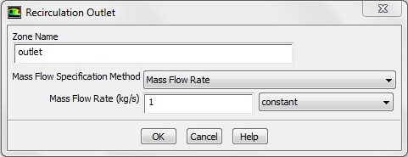

**2. Mass flow rate per unit area (mass flux)**:  Using this option we can specify mass flow rate per unit area. Following image shows snap shot of ANSYS FLUENT for specifying mass flux.

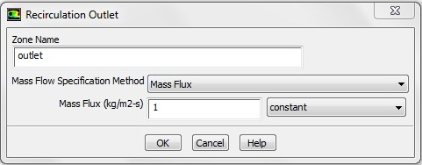

Thermal condition calculations

When the fluid re-enters in the enclosed domain, its temperature may increase or decrease. The inlet (or supply) temperature calculation depends on Temperature Rise Specification Method Selected. There are three methods by which we can specify the fluid supply temperature (TIN).

**1. Temperature change/rise**

In this method we can specify constant temperature change (ΔT) which is maintained with the help of heating or cooling device. TIN is calculated using following equation:

TIN = TOUT + ΔT



**2. Heat addition or extraction**

This method requires specifying amount of heat (ΔH) added or removed from the fluid by recirculation device. In this method TIN is calculated using following equation:

TIN = TOUT + [ ΔH / (m x CP ) ]

Where CP is specific heat of the fluid and m is mass flow rate of fluid through the device.



**3. Convection**

In this method we need to specify the external temperature (TExternal), product of heat transfer coefficient and area (h x A). Following equation shows the relation of TIN with other parameters.

TIN = TOUT - [ h x A x (TOUT – TExternal ) / (m x CP ) ]



So we have seen how to implement recirculation boundary conditions in ANSYS FLUENT. This is one custom type of boundary condition which is available in ANSYS FLUENT, but there could be some specific boundary conditions which are not available directly in ANSYS FLUENT. In such cases we can still implement those boundary conditions in ANSYS FLUENT using a User defined function (UDF). We will not go in details about creating custom boundary conditions using UDF in this blog. If you are novice to UDF then please visit our [**blog series on UDF**](https://www.learncax.com/knowledge-base/blog/by-category/cfd/blog/by-tag/udf).