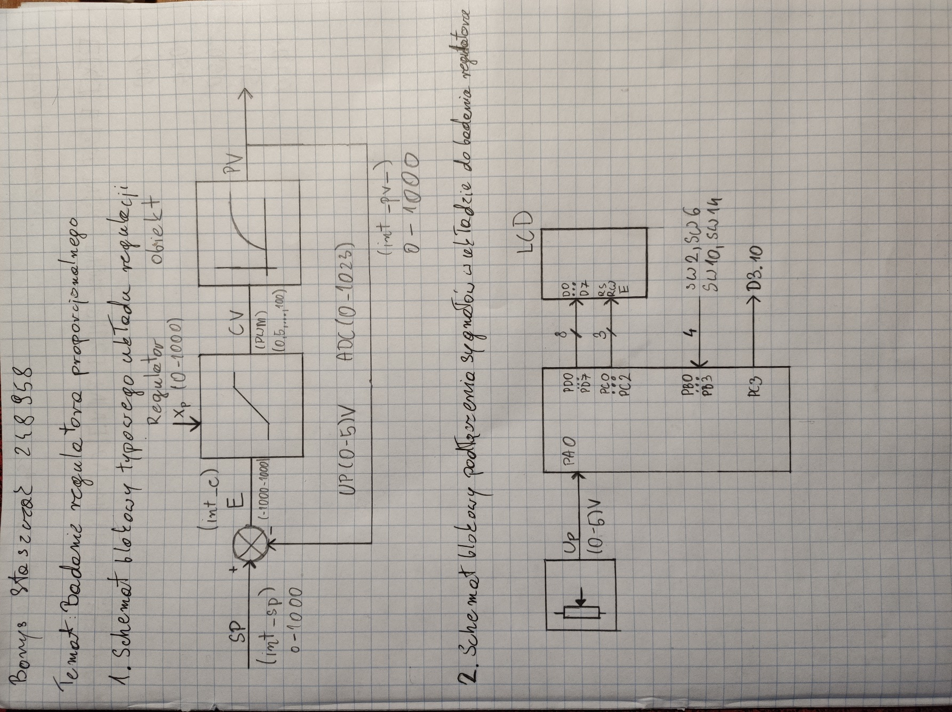

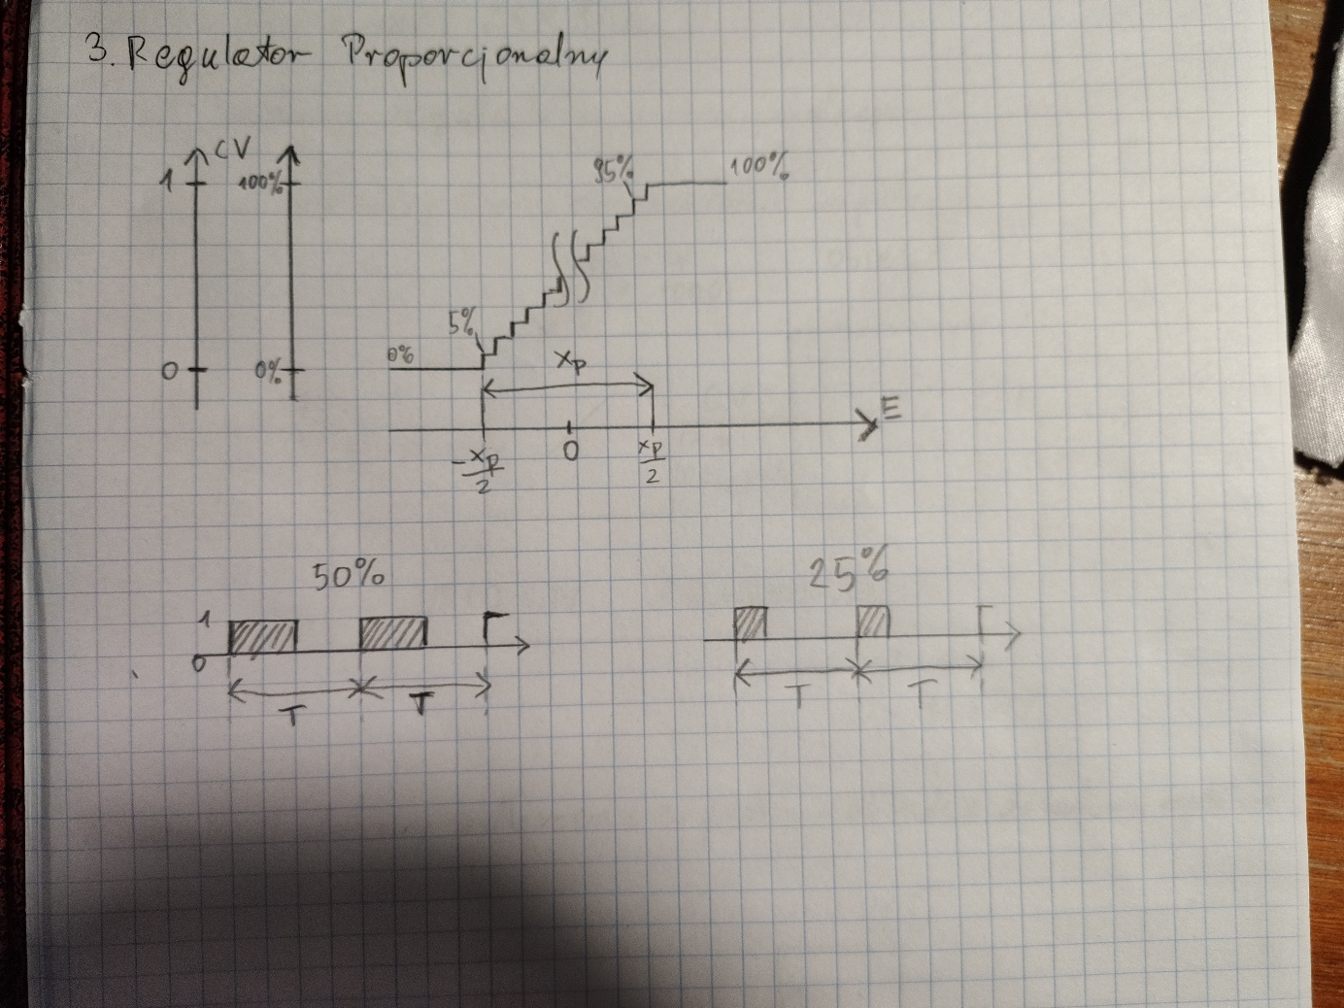

|  |  |  |  |  |  |  |  |  |
| --- | --- | --- | --- | --- | --- | --- | --- | --- |
| Sp = 40%, Xp = 30%, T0 = 20s, (0-400°C)/(0-5V) | | | | | | | | |
|
| E[Xp] | E[%] | PV[%] | PV[ADC] | PV[°C] | PV[V] | CV[%] | tH[s] | tH[s]/20[s]*100% |
| -1.00 | -30.0% | 70.0% | 716 | 280.0 | 3.5 | 0 |  |  |
| -0.55 | -16.5% | 56.5% | 578 | 226.0 | 2.825 | 0 |  |  |
| -0.50 | -15.0% | 55.0% | 563 | 220.0 | 2.75 | 0 |  |  |
| -0.45 | -13.5% | 53.5% | 547 | 214.0 | 2.675 | 5 |  |  |
| -0.40 | -12.0% | 52.0% | 532 | 208.0 | 2.6 | 10 |  |  |
| -0.20 | -6.0% | 46.0% | 471 | 184.0 | 2.3 | 30 |  |  |
| -0.10 | -3.0% | 43.0% | 440 | 172.0 | 2.15 | 40 |  |  |
| 0.00 | 0.0% | 40.0% | 409 | 160.0 | 2 | 50 |  |  |
| 0.10 | 3.0% | 37.0% | 379 | 148.0 | 1.85 | 60 |  |  |
| 0.20 | 6.0% | 34.0% | 348 | 136.0 | 1.7 | 70 |  |  |
| 0.40 | 12.0% | 28.0% | 286 | 112.0 | 1.4 | 90 |  |  |
| 0.45 | 13.5% | 26.5% | 271 | 106.0 | 1.325 | 95 |  |  |
| 0.50 | 15.0% | 25.0% | 256 | 100.0 | 1.25 | 100 |  |  |
| 0.55 | 16.5% | 23.5% | 240 | 94.0 | 1.175 | 100 |  |  |
| 1.00 | 30.0% | 10.0% | 102 | 40.0 | 0.5 | 100 |  |  |