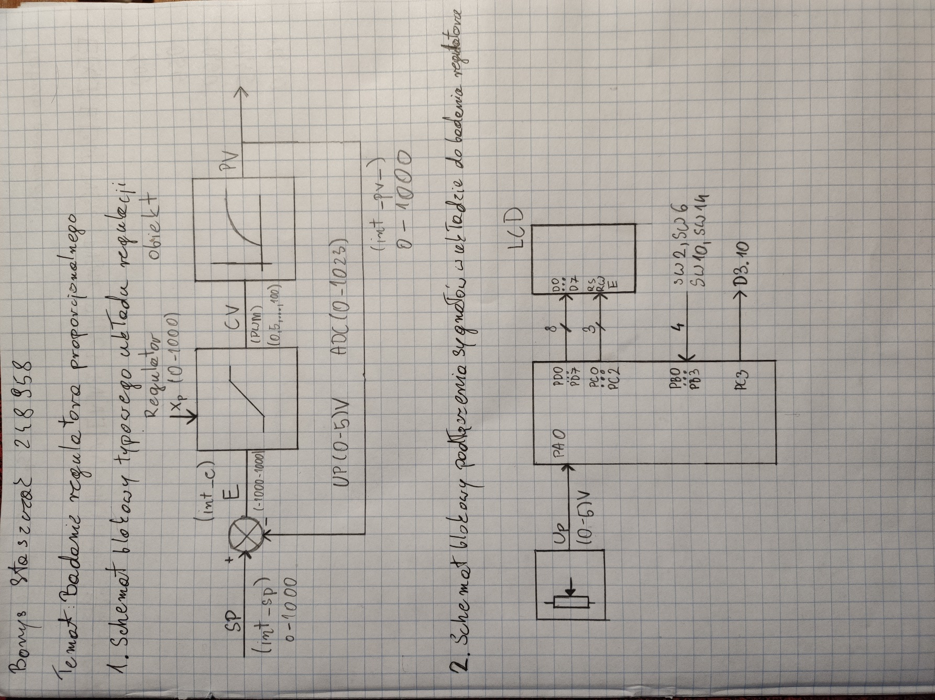

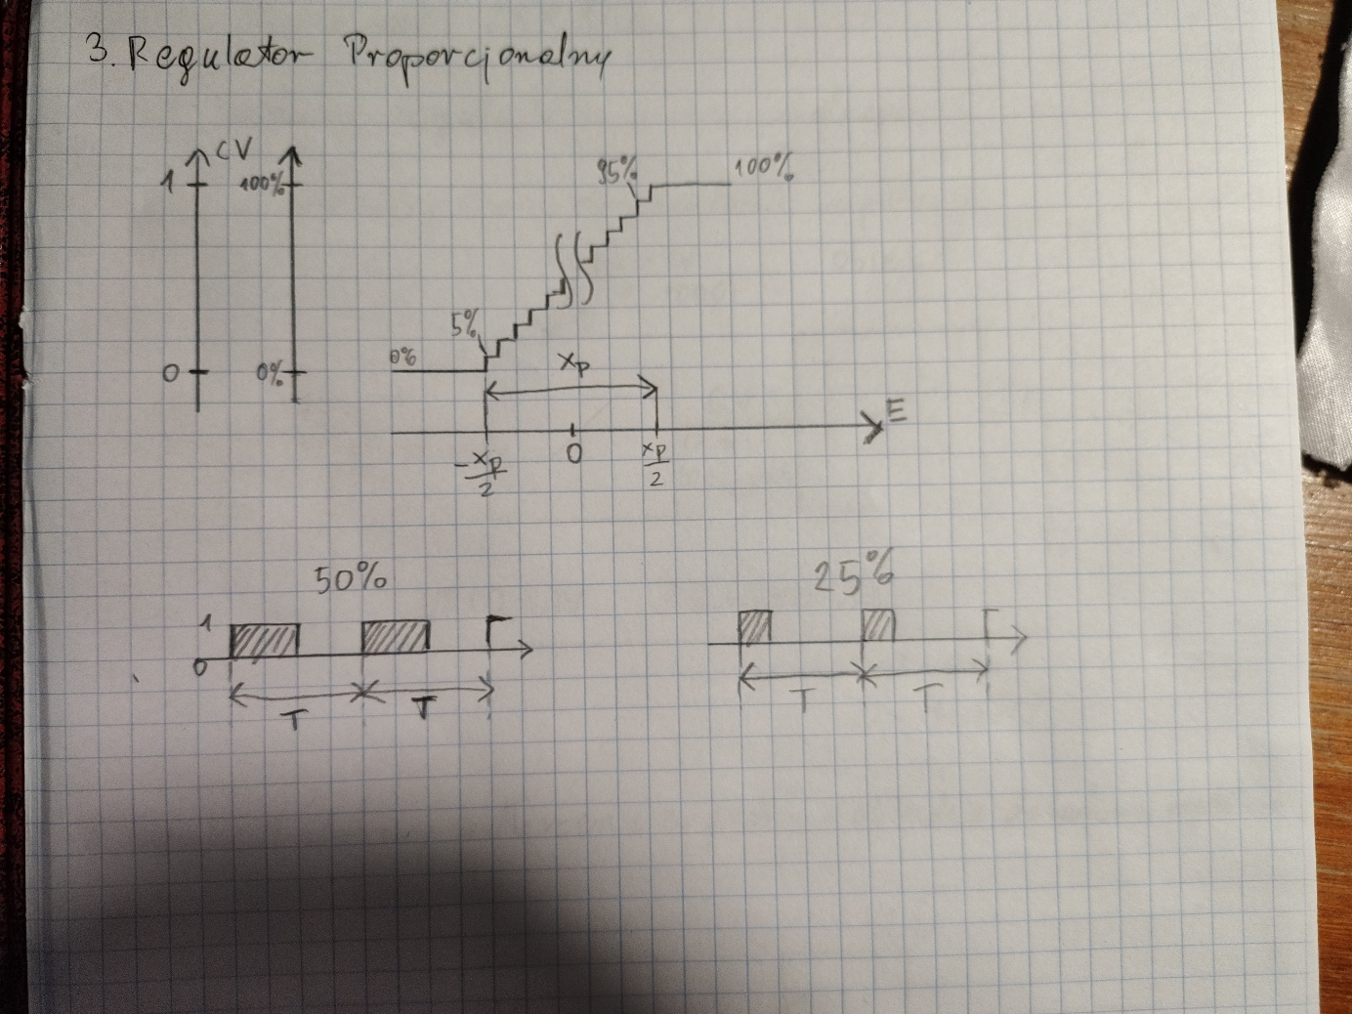

|  |  |  |  |  |  |  |  |  |
| --- | --- | --- | --- | --- | --- | --- | --- | --- |
| Sp = 40%, Xp = 30%, T0 = 20s, (0-400°C)/(0-5V) | | | | | | | | |
|
| E[Xp] | E[%] | PV[%] | PV[ADC] | PV[°C] | PV[V] | CV[%] | tH[s] | tH[s]/20[s]*100% |
| -1.00 | -30.0% | 70.0% | 716 | 280.0 | 3.5 | 0.00% | 0.00 | 0.00% |
| -0.55 | -16.5% | 56.5% | 578 | 226.0 | 2.825 | 0.00% | 0.00 | 0.00% |
| -0.50 | -15.0% | 55.0% | 563 | 220.0 | 2.75 | 0.00% | 0.00 | 0.00% |
| -0.45 | -13.5% | 53.5% | 547 | 214.0 | 2.675 | 5.00% | 0.96 | 4.80% |
| -0.40 | -12.0% | 52.0% | 532 | 208.0 | 2.6 | 10.00% | 1.60 | 8.00% |
| -0.20 | -6.0% | 46.0% | 471 | 184.0 | 2.3 | 30.00% | 6.09 | 30.45% |
| -0.10 | -3.0% | 43.0% | 440 | 172.0 | 2.15 | 40.00% | 8.54 | 42.70% |
| 0.00 | 0.0% | 40.0% | 409 | 160.0 | 2 | 50.00% | 10.32 | 51.60% |
| 0.10 | 3.0% | 37.0% | 379 | 148.0 | 1.85 | 60.00% | 12.67 | 63.35% |
| 0.20 | 6.0% | 34.0% | 348 | 136.0 | 1.7 | 70.00% | 14.03 | 70.15% |
| 0.40 | 12.0% | 28.0% | 286 | 112.0 | 1.4 | 90.00% | 16.09 | 80.45% |
| 0.45 | 13.5% | 26.5% | 271 | 106.0 | 1.325 | 95.00% | 19.14 | 95.70% |
| 0.50 | 15.0% | 25.0% | 256 | 100.0 | 1.25 | 100.00% | 20.00 | 100.00% |
| 0.55 | 16.5% | 23.5% | 240 | 94.0 | 1.175 | 100.00% | 20.00 | 100.00% |
| 1.00 | 30.0% | 10.0% | 102 | 40.0 | 0.5 | 100.00% | 20.00 | 100.00% |

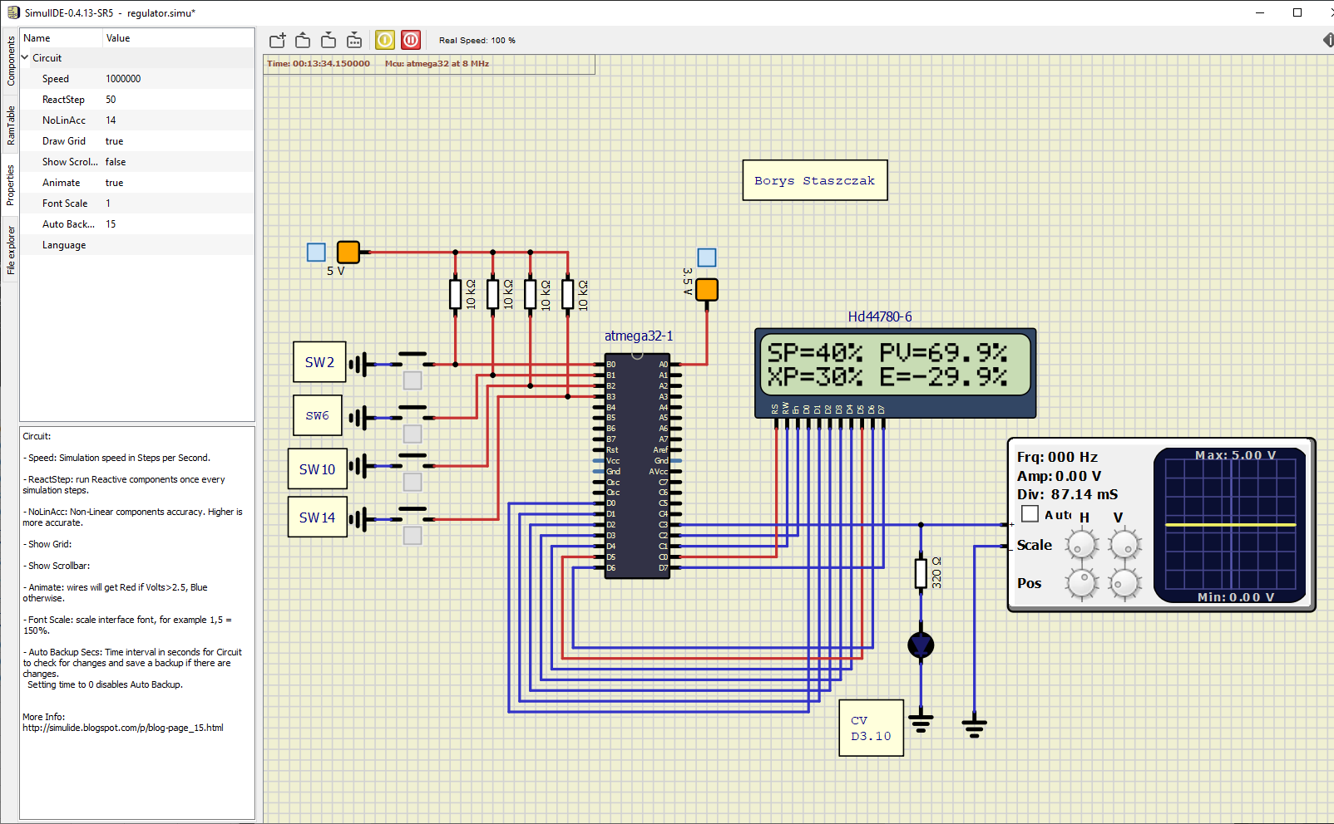

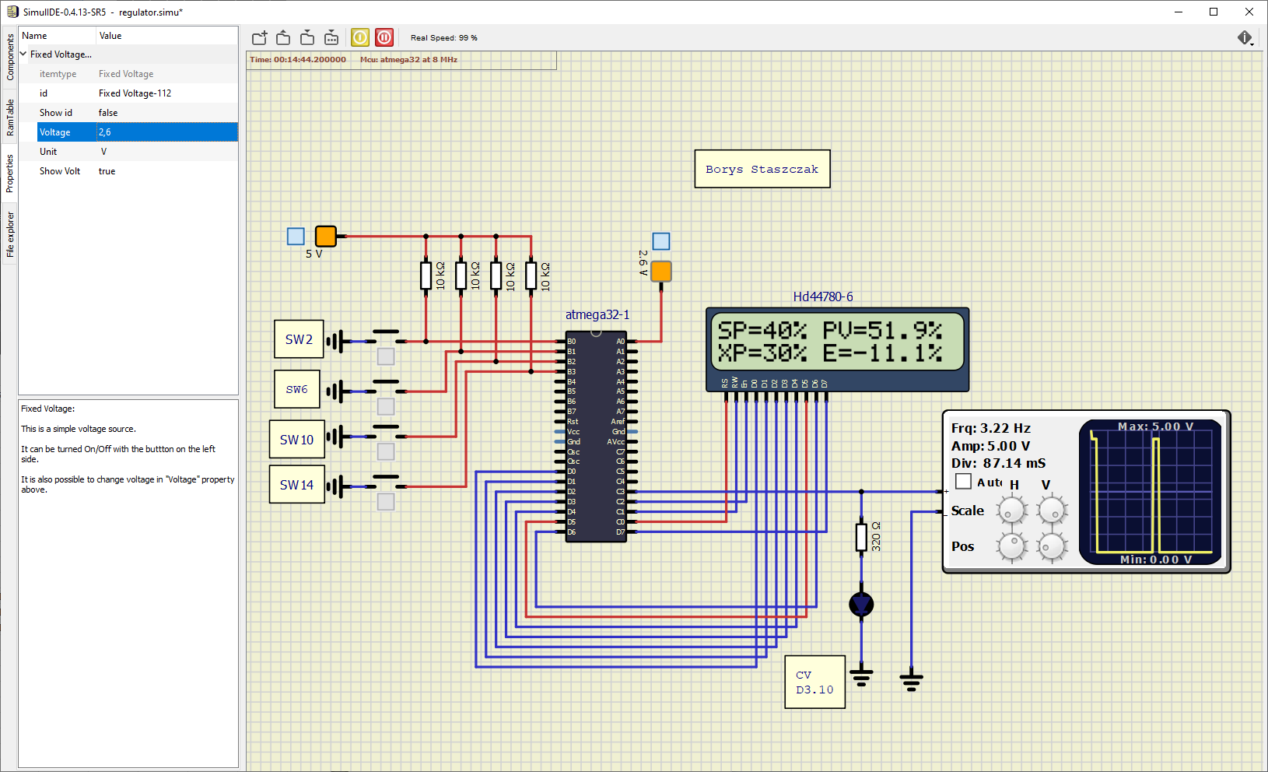

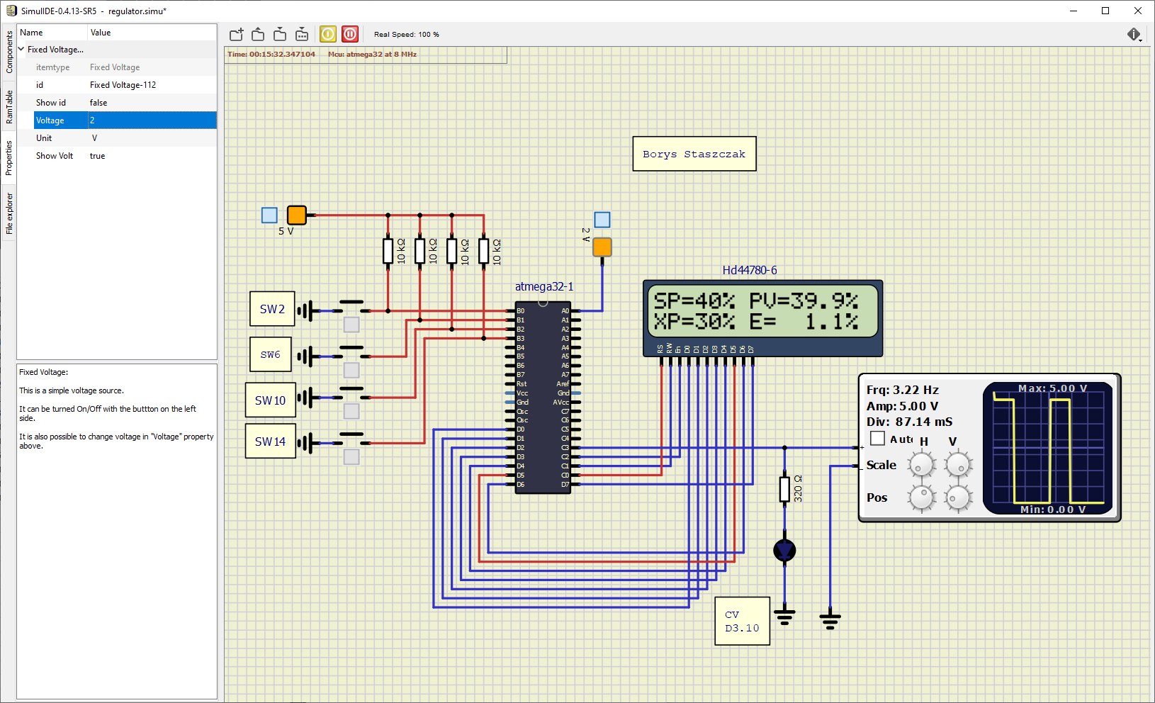

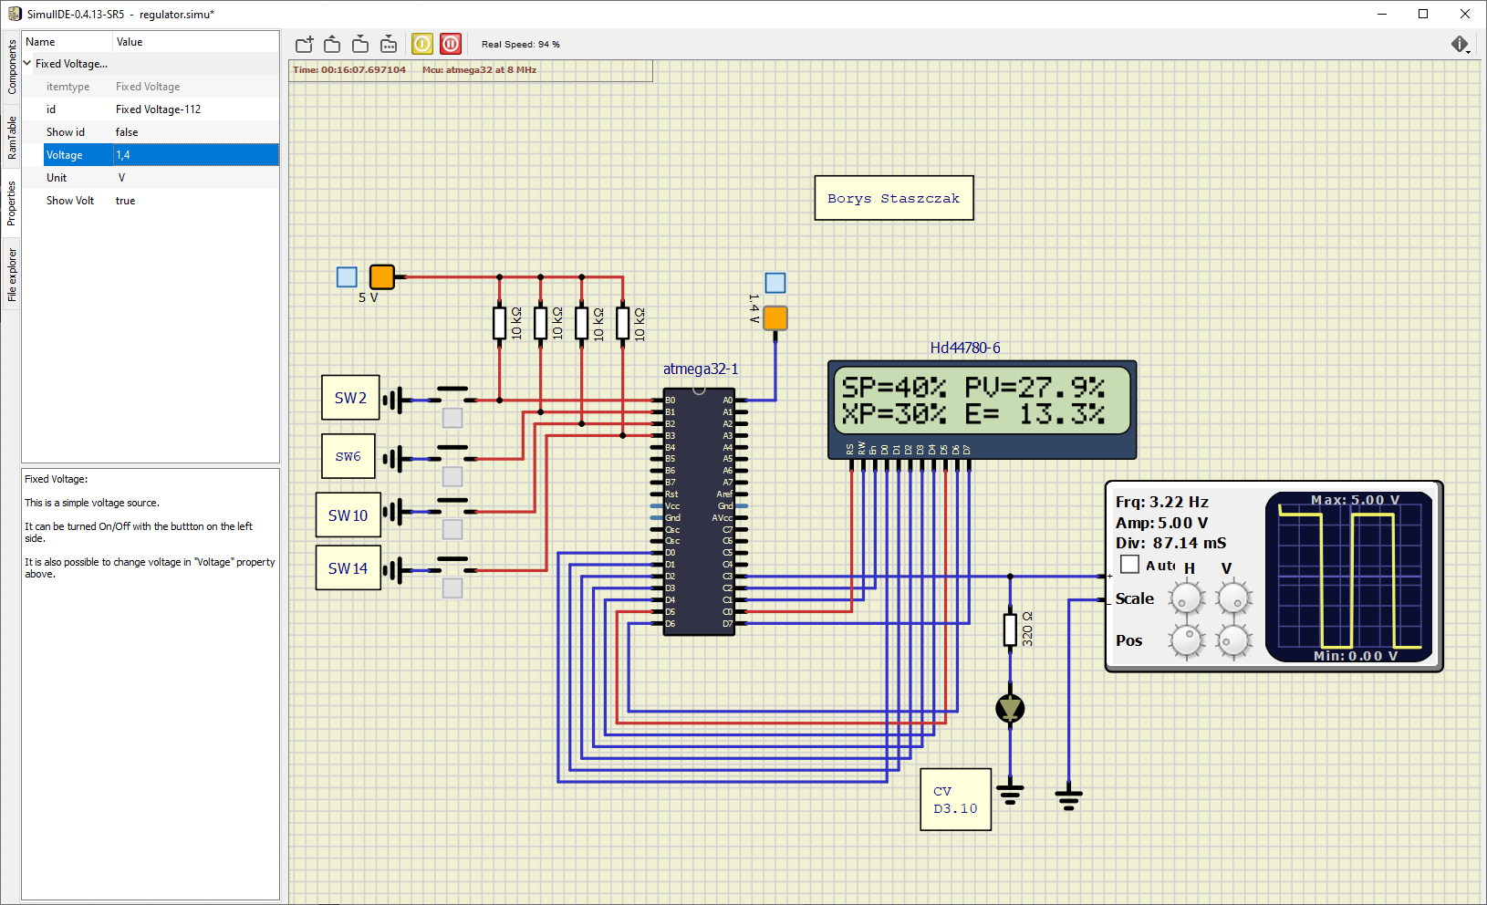

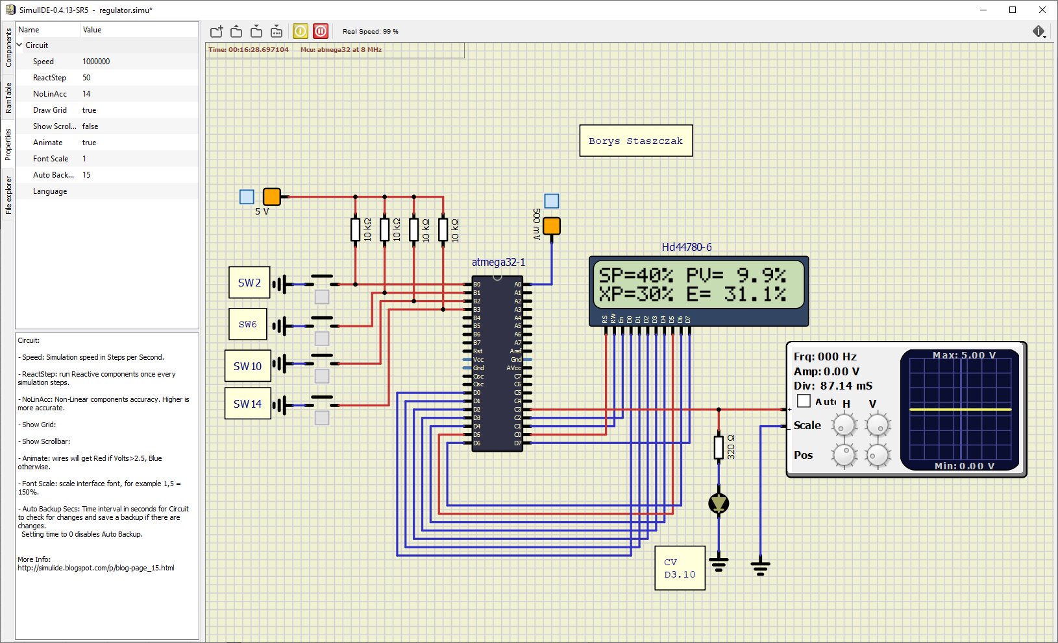

int _sp = 40;

int _xp = 30;

int _e;

int int_e;

int dec_e;

float _pv;

int full_pv;

int int_pv;

int dec_pv;

int _T = 20;

int _cv = 0;

int main(void)

{

    char tmp[16];

    int i;

    DDRD = 0xff;

    PORTD = 0x00;

    DDRC = 0xff;

    PORTC = 0x00;

    DDRB = 0x00;

    PORTB = 0xff;

    DDRC = (1 << 3) | (1 << 4);

    _delay_ms(500);

    LCD2x16_init();

    LCD2x16_clear();

    ADMUX = 0x40;

    ADCSRA = 0xe0;

*while* (1)

    {

        ADCSRA = ADCSRA | (1 << ADSC);

*while* (ADCSRA & (1 << ADSC))

            ;

        _pv = ADC;

        full_pv = (_pv / 1023.0) * 1000;

        int_pv = full_pv / 10;

        dec_pv = full_pv % 10;

        _e = _sp - int_pv;

        int_e = _e / 10;

        dec_e = _e % 10;

*if* (_e < -_xp / 2)

            _cv = 0;

*else* *if* (_e >= _xp / 2)

            _cv = 20;

*else*

            _cv = (((_e + _xp / 2) * 19 / _xp) + 1);

*for* (i = 0; i < 20; i++)

        {

*if* (i < _cv && _cv != 0)

            {

                PORTC |= 1 << PINC3; *//wlacz diode*

            }

*else*

            {

                PORTC &= ~(1 << PINC3); *//wylacz diode*

            }

            delay_ms(10);

        }

*//przyciski*

*if* (!(PINB & (1 << PB0)))

        {

            _sp = 50;

        }

*if* (!(PINB & (2 << PB0)))

        {

            _sp = 40;

        }

*if* (!(PINB & (3 << PB0)))

        {

            _xp = 30;

        }

*if* (!(PINB & (4 << PB0)))

        {

            _xp = 40;

        }

        LCD2x16_pos(1, 1);

        sprintf(tmp, "SP=%2d%% PV=%2d.%1d%% ", _sp, int_pv, abs(dec_pv));

*for* (i = 0; i < 16; i++)

        {

            LCD2x16_putchar(tmp[i]);

        }

        LCD2x16_pos(2, 1);

        sprintf(tmp, "XP=%2d%% E=%3d.%1d%%  ", _xp, _e, abs(dec_e));

*for* (i = 0; i < 16; i++)

        {

            LCD2x16_putchar(tmp[i]);

        }

        delay_ms(100);

    }

*return* 0;

}