Documentation for TeachingRatings Data
TeachingRatings contains data on course evaluations, course characteristics, and professor characteristics for 463 courses for the academic years 2000-2002 at the University of Texas at Austin. These data were provided by Professor Daniel Hamermesh of the University of Texas at Austin and were used in his paper with Amy Parker, “Beauty in the Classroom: Instructors’ Pulchritude and Putative Pedagogical Productivity,” Economics of Education Review, August 2005, Vol. 24, No. 4, pp. 369-376.

Variable Definitions

Variable | Definition
Course_eval | “Course overall” teaching evaluation score, on a scale of 1 (very unsatisfactory) to 5 (excellent)
Beauty | Rating of instructor physical appearance by a panel of six students, averaged across the six panelists, shifted to have mean zero.
Female | 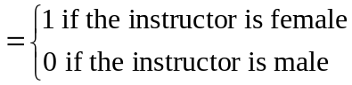
Minority | 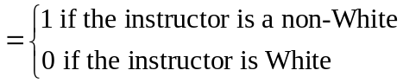
NNenglish | 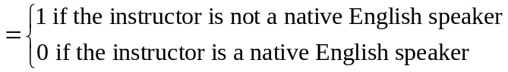
intro
onecredit
age | Professor’s age

