**Chapter I**

**INTRODUCTION**

**Background of the Study**

The attendance and monitoring of On Job Training Students in Guimaras State University, College of Science Information and Technology were recently seen as one of the most important elements or issues in monitoring and tracking their progression in their daily On Job Training service. In this study, the respondents of the Guimaras State University, College of Science Information Technology student trainee and OJT planner were identified and studied that they have difficulty in verifying and monitoring the exact hours rendered by the student. OJT Coordinator verifies the trainee’s official time entries by a traditional daily time record. The coordinator also let the trainee pass their journal written in a notebook month end report/terminal report that were stack at the office. Loss of some trainee’s file would be possible, also the OJT coordinator have to visit the trainee’s even those were far just to monitor them or check if trainees really went to their respected organization. To conclude also student trainee’s may have the possibility of losing their daily time record.

On job training is a program that students take to gain hands-on experience in the workplace and increase employability. It is a meticulously structured plan with clearly outlined phases and procedures that need to be adhered, monitor and track every day.

In conclusion, the literature available on the relationship between student attendance and attainment is inconsistent. Nevertheless, there is some empirical evidence to suggest that attendance is a determinant of academic performance and progression during there on job training service and monitor the performance, capability and self-discipline of a student.

**General Objectives**

This study aims to develop a *ON THE JOB TRAINING DOCUMENTATION SYSTEM* that will present the advantages of a paperless reports since all of the reports will be stored online and it will have a precise record of their rendered hours during the training. And will also help students and organization regarding on their daily attendance and to monitor the time consistency of a student proceeding on their respected organization.

**Specific Objectives**

The specific objectives of this study are the following:

1. To develop a system that store time and data.
2. Ability to compute time and demerits of the student trainee.
3. To generate a report of a student trainee by printing a document.
4. Allow student to store their daily time record.
5. To develop a system for the student trainee that provides the list of their information and time data where admin can view and monitor personal information.

**Figure 1: Conceptual Framework**

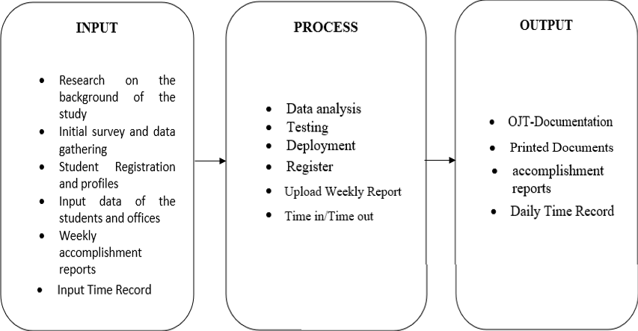

*Figure 1: Conceptual Framework*

**Input –** The researcher conducted a survey and observation for their initial data gathering. Researcher also found out that they have encountered some difficulty in verifying and monitoring the exact hours rendered of the student and loss of student weekly accomplishment reports.

**Process –** Researcher comes up of the process how they can resolve or minimize the problem.

**Data Analysis –** During this phase, the researcher analyzed the data that was obtained during their initial data gathering. The analyzed data is used towards the design and development of the system, thus making sure that all of the recommendations of the end-user will be meet.

**Testing –** The whole design and its construction are put under test to check its functionality and to see if there are some errors.

**Deployment** – In this phase, the Guimaras State University Computer and Technology Department puts in use after the system has been successfully tested.

**Register/Registration** – In this phase, Super Admin, Office admin and student will register to the system to have an access.

**Upload Weekly accomplishments report** – In this phase, Students can upload or submit their weekly accomplishment report.

**Time in / Time out** – Students will have to time in to rendered duty hours to the respective offices they are deployed.

**Scope of the Study**

This study focuses on the development of *on-the-job documentation system* that aim and have the ability to compute rendered time, remaining OJT hours, monitor and track progress of the trainee in real-time.

The admin can also generate a printed overall training hour, variation of listed student trainee, course and area. It will also function as a daily time recorder of the student.

**Limitation of this Study**

This study will be limited to the design and development of On the Job Documentation system. And it will be accessible only for four program courses of Guimaras State University Computer and Technology Department.

**Significance of the Study**

The On-the-job Training Monitoring System will help systematize the manual system operations and for the benefit of Guimaras State University Computer and Technology Department.

Specifically, this study will definitely benefit the following:

**On-the-job Training Coordinator or Super Admin.** They will not have a troublesome time confirming and observing the hours rendered and submitting the weekly accomplishment report by the students.

**On-the-job Training Supervisor as Office Admin.** They can have the chance to be associated with On-the-job Training Coordinator online. Communications and updates would be easier.

**Student/Trainees.** They will be easy handling in submitting their requirements and reports for it will be done via online. Also, they would not lose track of the hours they rendered during and after trainings.

**Researchers**. They will give the GSU-College of Science and Technology the more comprehensive guide in constructing the Capstone Project manuscript.

**Future Researchers**. The study will be a basis for researchers that may further develop and improve the current system.

**DEFENITON OF TERMS**

**User Information –** The term user information is information transferred across the functional interface between a source user and a telecommunications system for delivery to a destination user.

**Daily Time Record -** The term Daily Time Record is the process of monitoring and organizing time information. Far from just being a way to monitor the attendance of an employee, having a DTR system allows a company to effectively manage its employees by providing adequate data.

**OJT Trainee –** The term OJT Trainee is and individual who has been determined to be eligible to participate in and who is enrolled in On-The-Job Training (OJT) Trainee designation commences on the first day of on-the-job training following intake, eligibility determination, assessment, case plan development, OJT Orientation, and OJT contract execution.

**Monitor –** The term monitor is to watch, keep track of, or check usually for a special purpose.

**Administrator –** The term administrator is a person whose job involves helping to organize and supervise the way that an organization or institution function.

**Registration –** The term registration is an entry in a register form.

**Chapter II**

**REVIEW OF RELATED LITERATURE AND STUDIES**

**Theoretical Background**

Review of Related Literature is a published topic with authors and a particular study problem. It is a summary of a previous research on a topic. The proponent of On-the-Job Training Monitoring System searched some related literature and studies that is connected in our proposed study.

**Related Literature**

**Development of Internship Monitoring and Supervising Web-based System**

Industrial Training is a compulsory course that must be taken by Electrical Engineering students who follow five semesters program at Universiti Teknologi MARA (UiTM). A Web-Based System of Internship Management has been developed to computerize the whole process of the practical training and make it accessible online. The portal allows internship eligibility checking, registration, visit schedule and monitoring of industrial internship program at UiTM. This system gives advantage to the students' education process as the students can check their application status online. During their spare time, they can focus more on their lesson activities instead of checking their application status at coordinator's office. System Development Life Cycle (SDLC) is used in the development of this system. This system emphasizes online pre-registration by the student and online evaluation by industrial supervisor and faculty. This online system which is integrated with database system can help the coordinator to manage and monitor the application process that was done by the students. This system has special features as it introduces the pre-registration stage for the student to register information about the host of organization that they

would like to apply for internship program. The system also has online system assessment for industrial supervisor to evaluate the trainee. The system can be easily used to aid the process of internship program. Thus, in general aspect, this system will benefit the students, as well as every party involved in this internship program.

**Published in:**[2017 IEEE 15th Student Conference on Research and Development (SCOReD)](https://ieeexplore.ieee.org/xpl/conhome/8293873/proceeding)

**Date of Conference:**13-14 December 2017

**Date Added to IEEE *Xplore*:**01 March 2018

**ISBN Information:**

**INSPEC Accession Number:**17613647

**DOI:**[10.1109/SCORED.2017.8305395](https://doi.org/10.1109/SCORED.2017.8305395)

**Publisher:**IEEE

**Conference Location:**Wilayah Persekutuan Putrajaya, Malaysia

**Link**: <https://ieeexplore.ieee.org/document/8305395>

On-the-Job Training Monitoring System is beneficial to OJT Students and OJT Coordinator and supervisor. There are some Related of Literature and Studies that have similarity in our study. First is Development of Internship Monitoring and Supervising Web-based System. The similarities of our study are, we have the same web-based system and the system will benefit the students and every party that involved in the internship program. The difference is the coordinator will manage and monitor the application that was done by the students while in our study the coordinator will monitor the submitted accomplishment and performance of the student.

**Designing internship monitoring system web based with Laravel framework**

Today, existing information systems in the world still have some shortcomings. Disadvantages that occur, among others, namely the design, display and process of data exchange between databases that can cause errors or failures in data storage. To deal with these shortcomings before making the information system required proper design. The design of information systems that is done that consists of making Use Case Diagrams, Data Flow Diagrams, Sequence Diagrams and Entity Relationship Diagram. The results of the expected design that is able to overcome and meet these shortcomings. This paper contains about the design of web-based academic information system design using Laravel framework with case study problems on an internship monitoring information system in Telecommunication Engineering Program, Department of

Electrical Engineering, Politeknik Negeri Semarang. The purpose of writing this paper is to find out the design results or design of internship monitoring system which is believed to assist in making internship monitoring system. The construction of an internship monitoring system uses the Laravel framework to facilitate the process of making the program.

**Published in:**[2017 IEEE International Conference on Communication, Networks and Satellite (Comnetsat)](https://ieeexplore.ieee.org/xpl/conhome/8259050/proceeding)

**Date of Conference:**05-07 October 2017

**Date Added to IEEE *Xplore*:**22 January 2018

**ISBN Information:**

**INSPEC Accession Number:**17524091

**DOI:**[10.1109/COMNETSAT.2017.8263583](https://doi.org/10.1109/COMNETSAT.2017.8263583)

**Publisher:**IEEE

**Conference Location:**Semarang, Indonesia

**Link**: <https://ieeexplore.ieee.org/abstract/document/8263583>

Designing internship monitoring system web based with Laravel framework. The similarity our study, it is a web-based academic information system that designed also to overcome some shortcomings of the process of data exchange between the students, coordinator and supervisors. It is also design results or design of internship monitoring system which is believed to assist in making internship monitoring system.

**Online Practicum Monitoring System For Lyceum Of The Philippines University Batangas Campus**

The system will be capable generating reports of submitted requirements in real-time given that all data are to be stored in a database and the process is done online. This Online Practicum Monitoring System will be used as a tool to assist the students of all colleges and the college practicum Coordinators in their tasks through the use of a web-based software. The training involves the cooperation of three participants namely the Students, the Site Supervisors, and the Practicum Coordinators. The Practicum Coordinator is faced with the difficulty of monitoring the student’s performance and on-time submission of the said reports especially if the number of trainees is large and that their locations are not close proximity.

Link: <http://research.lpubatangas.edu.ph/wp-content/uploads/2014/05/IJCSE-ONLINE-PRACTICUM-MONITORING-Velasquez.pdf>

Online Practicum Monitoring System for Lyceum of the Philippines Batangas Campus. The similarities of our study are, the system will be used as a tool to assist the students and coordinator in their task through the use of a web-based system. The involve participants are Students, Supervisor and Coordinator. The difference of our study is the system will generate the reports submitted while in our study the ojt coordinator will the one who will generate the students.

**Ojt Monitoring System For Lyceum Of The Philippines University-Laguna**

The system is both windows and web-based system in which it will be used by the system Administrator and the students, respectively. It is designed and developed to improve student’s compliance to all internship requirements and for the safekeeping and documentation in the side of PCO. This system can display student profile in which there is an indication if a particular student already complies a specific requirement, receive files from students, and can send attachments. A network is needed for it to be synchronized and be functional.

Link: <https://www.behance.net/gallery/36192623/OJT-Monitoring-System-for-LPU-Laguna>

OJT Monitoring System for Lyceum of the Philippines University-Laguna. The similarity of our study is, there is an indication that there is an student already comply a specific requirement. The difference is they will using both windows and web-based while in our study we only used web-based. And lastly is Present: An Android-Based Class Attendance Monitoring System using Face Recognition Technology. The similarity of our study is to check and monitor the attendance easier, faster and reliable. The difference is, they used Android-Based and Face Recognition while in our study used web-based.

**Present: An Android-Based Class Attendance Monitoring System Using Face Recognition Technology**

As mention by Salac (2018) an Android-based Class Attendance Monitoring System using Face Recognition Technology in Batangas is an attendance checking and monitoring easier and faster. The researchers developed application was useful and it can support the needs of the instructor to make attendance checking and monitoring easier, faster and reliable.

Link: [https://www.researchgate.net/publication/346614290_PRESENT_An_Android-Based_Class_Attendance_Monitoring_System_Using_Face_Recognition_Technology#:~:text=The%20study%20aimed%20to%20develop,seventeen%20(17)%20faculty%20members%20](https://www.researchgate.net/publication/346614290_PRESENT_An_Android-Based_Class_Attendance_Monitoring_System_Using_Face_Recognition_Technology%23:~:text=The%20study%20aimed%20to%20develop,seventeen%20(17)%20faculty%20members%20)

Present: An Android-Based Class Attendance Monitoring System using Face Recognition Technology. The similarity of our study is to check and monitor the attendance easier, faster and reliable. The difference is, they used Android-Based and Face Recognition while in our study used purely web-based system.

**Chapter III**

**Technical Background**

This Chapter presents the methods and procedures that were used in the design and development of the proposed On-the-job Documentation System for Guimaras State University, College of Science and Technology students.

**Details of the technologies to be used:**

**MySQL** - is an open-source relational database management system. Its name is a combination of "My", the name of co-founder Michael Widenius's daughter My, and "SQL", the abbreviation for Structured Query Language.

**PHP: Hypertext Preprocessor -** An extremely popular scripting language that is used to create dynamic Webpages. Combining syntax from the C, Java and Perl languages, PHP code is embeddedwithin HTML pages for server-side execution.

**HTML** - The HyperText Markup Language or HTML is the standard markup language for documents designed to be displayed in a web browser. It can be assisted by technologies such as Cascading Style Sheets and scripting languages such as JavaScript.

**Libraries –** used for Bootstraps, Data Tables, Summer note, Sweet alert and jQuery.

**Apache -** is a free and open-source cross-platform web server software, released under the terms of Apache License 2.0. Apache is developed and maintained by an open community of developers under the auspices of the Apache Software Foundation.

**CSS** - Cascading Style Sheets is a style sheet language used for describing the presentation of a document written in a markup language such as HTML or XML. CSS is a cornerstone technology of the World Wide Web, alongside HTML and JavaScript.

**JavaScript -** often abbreviated as JS, is a programming language that is one of the core technologies of the World Wide Web, alongside HTML and CSS. As of 2022, 98% of websites use JavaScript on the client side for webpage behavior, often incorporating third-party libraries.

**Systems Development Life Cycle**

SDLC (System Development Life Cycle) or known as the process used by the software industries to design and develop and test high quality software. This also aims to produce high quality software to meet the user expectations. SDLC is a framework that defines tasks performed in each step in the SDLC.

The researchers decided to make use of the Waterfall Model. It is a specific usage of a Software Development Life Cycle that focuses on an introductory, simplified implementation, which at that point continuously gains more complexity and a broader feature set until the final system is completed.

Waterfall model was used because it can improve the development of the system. Iterative model has five (5) phases and each phase represents the actual activity of our system. We used this model because it is more flexible to use in our study, and the progress of our system is easy to measure.

Below is the diagram of Waterfall Model used in this study:

**Figure 2: System Development Water Fall Model**

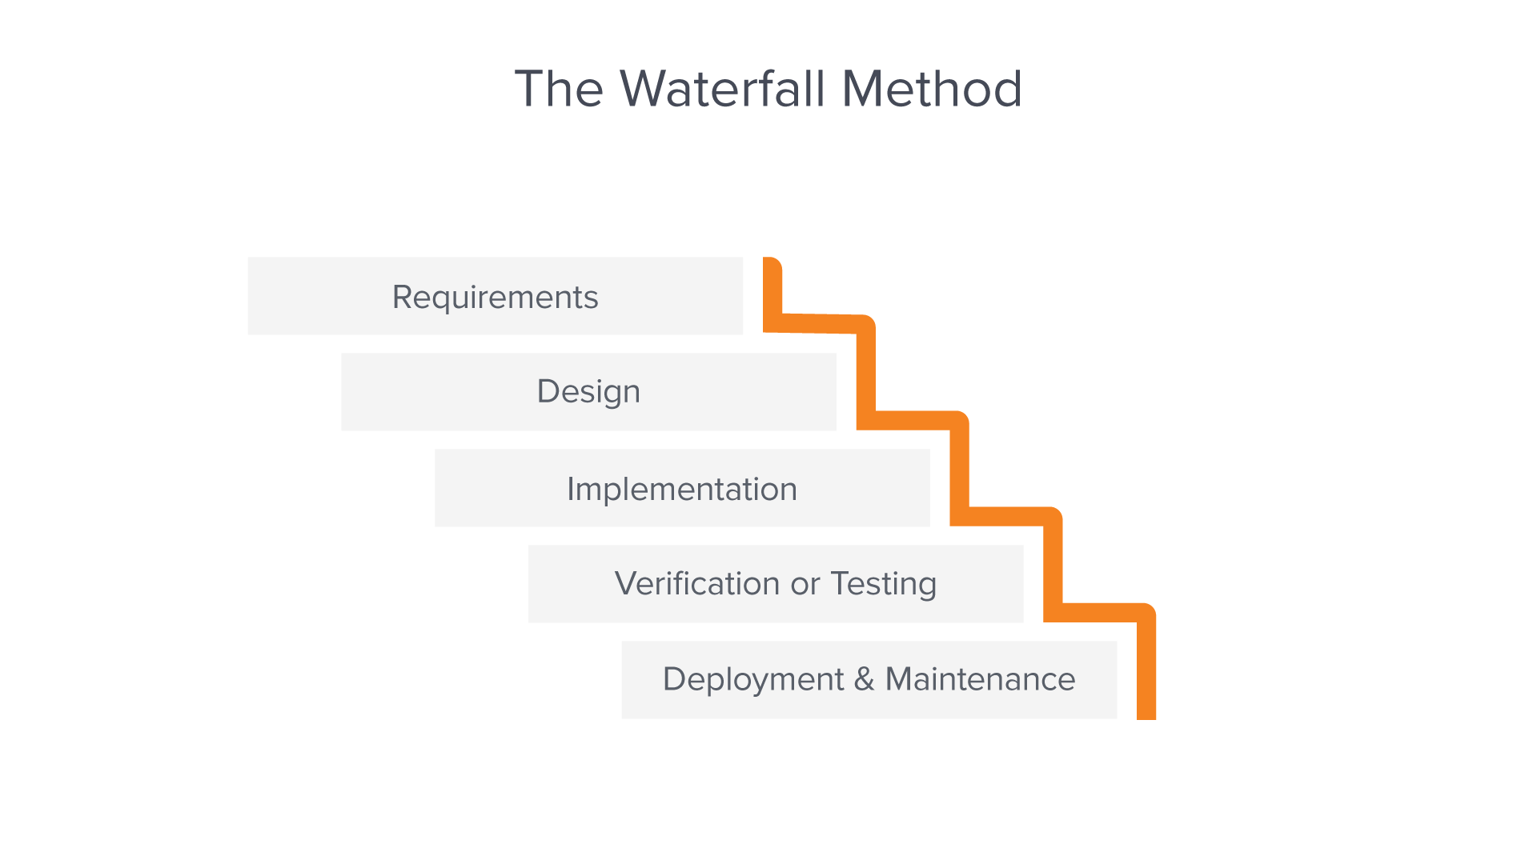

*Figure 1. Waterfall Model.*

**System Requirements**

In this phase, we identify the system requirements, gathered related literature and studying related literature and systems. The system shall employ material design in which it is adaptable system of guidelines, components and tools that support the best practices of user interface.

**System Design**

In the design phase, we define the conceptualization of system architecture, functionalities, database design and mock up design create scene setting and the realistic inclusion of the design and also to satisfy specified requirements.

**System Implementation**

In this phase, the proponents will deliver or proposed our system to Guimaras State University College of Science and Technology. In this part we will start to code and design first using HTML, JavaScript, PHP, MySQL and CSS.

**Systems Verification**

To protect our system against fraud and to make it more reliable, we test the system design's execution and system protection to prevent the access of unauthorized users and to ensure that each active programs or processes in the system uses resources only as the stated policy.

**System Maintenance**

This is the important phase because in this phase the system will be test and will be checked for any bugs and malfunctions to improve the better performance of our system. To maintain the system's performance, the system will be updated.

Table 1: The Project Development Group, their corresponding role and role description:

|  |  |
| --- | --- |
| **Role** | **Role Description** |
| Project Manager | The project manager is **responsible for planning and overseeing projects within an organization, from the initial ideation through to completion**. They coordinate to people and processes to deliver projects on time, within budget and with the desired outcomes aligned to objectives. |
| System Analyst/ Database  Designer | **The System Analyst is responsible in designing new computer systems and frameworks**. Troubleshooting technical issues. Risk mitigation planning. Collaborating with Business Analysts, Project Leads and IT team to resolve issues and ensuring solutions are viable and consistent. |
| Network Designer/User  Interface Designer | **The network designer – is responsible in designing and implementing new network solutions and/or improving the efficiency of current networks**. Installing, configuring and supporting network equipment including routers, proxy servers, switches, WAN accelerators, DNS and DHCP.  The UI UX designers is responsible to **create the user interface for an app, website, or other interactive media**. Their work includes collaborating with product managers and engineers to gather requirements from users before designing ideas that can be communicated using storyboards. They also process flows or sitemaps. |
| Software Engineer/  Programmer | The Software Engineer/Programmer is responsible in r**esearching, designing, implementing, and managing software programs**. Testing and evaluating new programs. Identifying areas for modification in existing programs and subsequently developing these modifications. Writing and implementing efficient code. |
| QA Tester/Technical Writer | The QA Tester is the one who ensures the quality of the software products and helps find and eliminate any bugs. He/She determines the functionality of every particular application. |

Figure3. Organizational Structure of the Project

**Project Manager**

**Alvin Ferrer**

**Network Designer/UI Designer**

**Vonni Dave Gabito**

**Software Engineer/**

**Programmer**

**Drazen Delgado**

**QA Tester/**

**Technical Writer**

**AL Nikko Fernandez**

**System Analyst/Database Designer**

**Christian Gallo**

**Project Proposal**

The researcher of the study proposed a *ON THE JOB TRAINING DOCUMENTATION SYSTEM* that will eliminate the problems encountered in the manual process. The advantages of this system is to eliminate paper documents since all reports will be stored online and it will have a precise record of their rendered hours during the training. And will also help students and organization regarding on their daily attendance and to monitor the time consistency of a student proceeding on their respected organization.

**Project Task and Scheduling**

Table 2: Project Development Plan

|  |  |  |  |
| --- | --- | --- | --- |
| **Task #** | **Task** | **In-Charge** | **Duration (Week)** |
| T1 | Group Organization | Group | 1 |
| T2 | Project Planning | Group | 2 |
| T3 | Project Proposal | Group | 1 |
| T4 | Data Gathering | Group | 1 |
| T5 | Project Task Scheduling | Group | 1 |
| T6 | User Requirements Analysis | System Analyst/Database Designer | 4 |
| T7 | Plan System Logical and Data Modeling | Group | 7 |
| T8 | System Logical and Data Modeling | System Analyst/Database Designer | 5 |
| T9 | System Physical Design, Interface, and Database Design | System Analyst/Database  Designer Network  Designer/ UI Designer | 7 |
| T10 | Database Coding and Development | System Analyst/  Database Designer | 10 |
| T11 | Program Coding and  Development | Software Engineer/  Programming | 14 |
| T12 | System Testing and  Debugging | QA Tester/ Technical Writer & Software  Engineer/Programming | 9 |
| T13 | Project Presentation | Group | 5 |
| T14 | Delivery and Support | Group | 4 |

Table 3: Gantt Chart

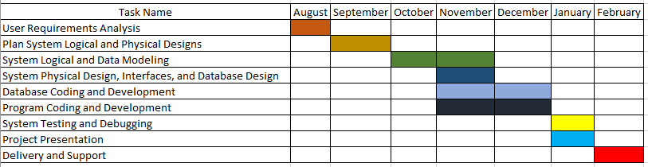

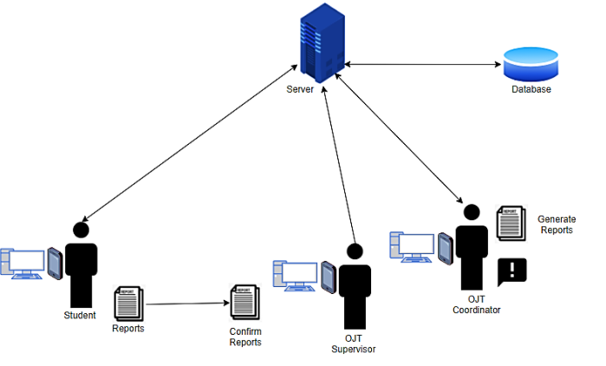

*Figure 2. Operational Framework.*