Programming/IT/Video Project

PROPOSAL

A group of Columbia volunteers create a open source multiplayer online game for Android in python. As key part of the project, the ‘world’ is invited to watch the development by publishing a large volume of YouTube videos (50+) that explore:

* Game design and planning meetings.
* IT descriptions and exactly how we got the servers set up.
* Descriptions of the coding in an almost tutorial-like fashion.

In other words, it’s not *just* an open source game. It is a practical example of how such things can be done and architected. The uses:

* provide post-analysis pointers for the package and framework designers
* provides education to those wanting to do something similar themselves

By exposing all the ‘innards’ it might end up being a useful reference for many other discussions and projects all across the Internet.

The game should be as simple as possible; but no simpler. The server architecture should be scalable but still simple enough to work, but no simpler than that.

It is completely open source so that we don’t have to worry about IP restrictions. Likely the MIT license. “Feel free to steal”. The videos should be placed into Creative Commons. The group will be a ‘Unincorporated Association’. Which is a ‘legal way’ of saying a ‘ad-hoc group of people that don’t own stuff’. The only real financial benefit is a possible boost to our individual reputations.

Some thoughts:

* Stuff to make:
  + Web site (a simple one; not actually part of the game.)
  + Android (/iOS?) App
  + Server Cloud Code (Heroku, Google, Amazon?)
  + Many many videos involving multiple developers
  + Promo and game videos for the PlayStore, etc.
* Suggestions:
  + Write the App in Python with Kivy; possible IOS version too.
    - Restricting to mobile simplifies authentication greatly
      * No password or user_id, just use the phone/tablet identity
    - Put up on GitHub
  + Write the Server Code in Python, hosted at a cloud service, in three parts:
    - The front-end servers (public facing) that the client connects to with simple TCP
    - A management server (private network)
    - The game-play servers (private network)
      * Attached to by front-ends per management server instructions
    - All three servers on a single public GitHub repository.
      * For testing purposes, all three daemons should be able to run on the same machine.
  + The game itself: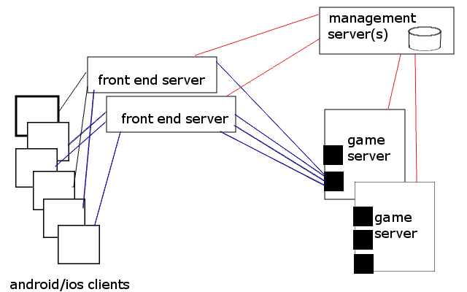
    - Strategy game; simultaneous turns
    - rather than ‘randomness’ being involved, make its mechanism similar to ‘stratego’. Not random, but not predictable either.
    - Random unnamed player selection; keeping it simple
      * no AI
      * sorts by VERY SIMPLE ranking system if there are enough players in queue
      * by not using player names, there is little value to cheating
        + no reputation reward
        + no money reward
    - 4 players at once, to make it stand out as different
    - ‘simultaneous movement’ to speed up the game play
    - Will need to ‘play testing’, possibly on paper at first, to work out bugs. Youtube videos for that as well.
* But, ultimately, limit the scope to keep our sanity. The game runs for two years: 2016 and 2017. Afterwards, we either give it to another group or we shut it down.

All of this is open of discussion. I’m not sold on any of it. This bigger picture is an ‘example project’ that the world can see and comment on.