Software Requirements Specification

for

PayRoll/PayCheck System



**Version 2.0 approved**

**Prepared by Group G**

**Enterprise Software**

**10/21/2020**

**Updated 12/1/2020**

**Table of Contents**

**Table of Contents ii**

**Revision History ii**

**1. Introduction 1**

1.1 Purpose 1

1.2 Document Conventions 1

1.3 Intended Audience and Reading Suggestions 1

1.4 Product Scope 1

1.5 References 1

**2. Overall Description 2**

2.1 Product Perspective 2

2.2 Product Functions 2

2.3 User Classes and Characteristics 3

2.4 Operating Environment 3

2.5 Design and Implementation Constraints 3

**3. External Interface Requirements 4**

3.1 User Interfaces 4

3.2 Hardware Interfaces 4

**4. System Features 5**

4.1 System Feature 1 5

4.2 System Feature 2 (and so on) 6

4.3 System Feature 3…………………………………………………………………………..6

4.4 System Feature 4…………………………………………………………………………..6

**5. Other Nonfunctional Requirements 7**

5.1 Performance Requirements 7

5.2 Safety Requirements 7

5.3 Security Requirements 7

5.4 Software Quality Attributes 8

5.5 Business Rules 8

**Revision History**

|  |  |  |  |
| --- | --- | --- | --- |
| **Name** | **Date** | **Reason For Changes** | **Version** |
| John Stendardo | 10/3 | [benefitsPackageNumber was missing in Employee.java](https://github.com/JohnAKASquib/PayrollProgram/commit/8e9b908e4a27fe0819ba6575799d0d38baf7d4b3) | beta 0.1 |
| John Stendardo | 10/4 | DBConnection.java employee login functionality | beta 0.1 |

|  |  |  |  |
| --- | --- | --- | --- |
| John Stendardo | 10/4 | Setup.sql added all necessary code to give employees passwords | beta 0.2 |
| John Stendardo | 10/5 | ConfirmDialog.java Moved all dialog boxes into their own package | beta 0.2 |
| John Stendardo | 10/5 | EleteDialog.java employee benefit panel GUI done | beta 0.3 |
| John Stendardo | 10/9 | ErrorDialog.java Moved all dialog boxes into their own package | beta 0.4 |
| John Stendardo | 10/9 | SearchDialog.java Net income UI done | beta 0.4 |
| John Stendardo | 10/11 | WarningDialog.java Gross panel UI/functionality approved | beta 0.5 |
| John Stendardo | 10/15 | HrScreen.java approved | beta 0.6 |
| John Stendardo | 10/15 | LoginScreen.java approved | beta 1.0 |

|  |  |  |  |
| --- | --- | --- | --- |
| John Stendardo | 11/25 | Error Dialog.java approved:display possible error messages. | PayCheck Beta 2.1 |
| John Stendardo | 11/25 | SearchDialog.java approved: HRscreen not show error fixed | PayCheck Beta 2.1 |
| John Stendardo | 11/28 | Deleteduakig,java approved: Fixed any User MySQL can deleted | PayCheck Beta 2.2 |
| John Stendardo | 11/28 | LoginScreen.java approved: Lock user from kept trying login | PayCheck Beta 2.2 |
| John Stendardo | 11/28 | Netpanel.java approved: able to view taxes, health status , names and infos. | PayCheck Beta 2.2 |
| John Stendardo | 12/1 | OthererEmpsPanels.java approved | PayCheck Beta 2.3 |

# Introduction

At the beginning of each month, the personnel department of a certain unit shall approve the personnel changes and salary changes of the previous month, and prepare the salary table of that month and print it according to the approved situation. Personnel changes include: newly transferred personnel, the need to establish a basic salary relationship;Internal personnel adjustment, need to adjust the personnel department;The newly increased retirees need to revise the basic salary relationship;If personnel are called out or reduced for other reasons, the corresponding contents need to be deleted. The changes of salary include: when the general salary is adjusted, the basic salary relationship shall be modified according to the position ;When the salary of an individual is changed due to the change of position (or title), it is necessary to modify the basic salary relationship of the relevant personnel;Modification of changes in wages other than basic pay, etc.

## Purpose

This software is used to manage company personnel, calculate for them after-tax salary, welfare items, as well as edit and manage the personal information of each employee

The main task is to carry out daily management of all kinds of salary information, such as input, query, modification, increase and deletion of salary information, quickly and accurately complete statistical calculation and summary of all kinds of salary information, and quickly print out statements.

## Document Conventions

The system administrator is required to be familiar with the operation of computer application software, database operation, and general network knowledge and operation management ability.The employee interface query requires that the employee can type and use the general skills of the computer

## Intended Audience and Reading Suggestions

Employee Basic Information Module Employee basic Information module has three functions:

1. employee information input, employee addition and deletion, and employee information query. 2.Employee basic information includes employee number, employee name, employee gender, department, position, length of service, salary level and other information.

3 Employee addition and deletion realize the addition and deletion of employee information in the database.Employees can query employee information by employee number or name.

Systems need to provide the following query functions:

1) the employees' attendance situation

2) employees work situation, reflect the type of work of employees, rank, position salary information such as

3) employee benefits information reflects the employees work overtime of time, work overtime category, overtime days, post subsidy etc.

4) the employee's basic information.

5) the employee's monthly salary: year, month, staff number, name, department name, basic salary, your sick leave, personal leave deductions, 3.Pay is due and paid in full

6) the employee eligibility for Health care, Dental, optical, and vision tests.

## Product Scope

This software helps the company better manage the personal information of employees, increase the efficiency of calculating after-tax wages, optimize the company’s personnel structure and improve the company’s work efficiency

## References

The salary information of employees with popup windows, and the specific information is also output/output with lists of white bars , which is displayed together with word labels. Simple interface operation.

# Overall Description

## Product Perspective

The Payroll system is mainly used for the management of salary, attendance and evaluation of employees within the enterprise, which facilitates the company leaders to grasp the trend of personnel and timely adjust the distribution of talents. Meanwhile, it also reduces some tedious and inconvenient manual operation, making the record and statistics of employees become very simple. These advantages can greatly improve the efficiency of enterprise wage management.

**When the employee receives his/her salary, he/she can generate the individual salary composition and the corresponding amount of salary slip. At the same time to form the monthly report, quarterly report, year-end report.**

## Product Functions

* User are able to change, adjust, remove all the Names and all associated personal information of all employees
* User are able to change, adjust, remove all the Benefits associated with all employees
* User are able to change, adjust, remove all the Gross Income associated with all employee

1. **Login system to identify what are visible.**
2. **Calculation of their net pays.**

## User Classes and Characteristics

Payroll system are all employees of Campany.Inc Company. Most of the employees are selected from college graduates with a high education level. The maintenance personnel are all professional technicians who can solve most common system failures smoothly. The software must be used more than once a month.

## Operating Environment

CPU frequency is not less than 1.5ghz, memory no less than 256MB, hard disk capacity no less than 20GB, all kinds of basic input and output devices can be compatible with each other, support Windows operation website, and a printer with A4 paper.

## Design and Implementation Constraints

|  |  |  |
| --- | --- | --- |
| Sequence number: | Hypothesis: | Reality: |
| 1 | Campny.Inc will be a going concern for the foreseeable future. | Any company has the risk of bankruptcy and bankruptcy in the course of operation. |
| 2 | All employees in the company support the establishment of the system. | Employees might disagree with the establishment of the system for a variety of reasons. |
| 3 | All modules of the system function normally | During operation, the operation of each module may appear abnormal |

# External Interface Requirements

## User Interfaces

System development based on Java, intuitive interface, brief introduction, strong man-machine interaction. Based on the popup window data input mode, menu. When users use, as long as it is in accordance with the format and requirements to fill in the information, the system in the background responds to the user operation process. In the shortest time, you don't need to go through special training, you can easily use calligraphy

Operating: Keyboard, mouse and printer.

Color: Black/White.

## Hardware Interfaces

Windows XP/Vista/8/8.1/10

Database management system excuses, as well as data exchange between LAN and Internet software. Consider that many companies need more commonly used Office software for document processing. for example, such as Microsoft Office series, so try to achieve automatic conversion of data formats between them.

# System Features

## Adding/Updating Employee Info

4.1.1 Description and Priority

*The user of the program can use the UI to edit/add/remove employee information as specified in the user manual. This feature is of high priority because it is one of the main features of the program.*

4.1.2 Stimulus/Response Sequences

After clicking on the “Employee Info Tab”, the UI buttons on the left can be used to perform CRUD (CREATE, READ ,UPDATE, DELETE) operations on the data inside the database

4.1.3 Functional Requirements

REQ-1: The MySQL Relational Database Management System must be installed on the OS running this program.

REQ-2: The MySQL Java connector driver must be installed and be pointed to in the environment variables before the entry point into the program can be called. The .JAR file can always be found here: <https://dev.mysql.com/downloads/connector/j/>

## Updating/Removing an Employee’s Benefits Package

4.2.1 Description and Priority

*The user of the program can use the UI to edit/remove an employee’s benefits package as specified in the user manual. This feature is of high priority because it is one of the main features of the program.*

4.2.2 Stimulus/Response Sequences

The User can click on the “Employee Benefits” tab on the top and then use the “VIEW” ”UPDATE” and ”DELETE” buttons to either see an employee’s benefits package, update their package with the currently selected one, or remove their benefits package respectively.

4.2.3 Functional Requirements

REQ-1: The MySQL Relational Database Management System must be installed on the OS running this program.

REQ-2: The setup.sql file included with the project should be run first to properly setup the database.

REQ-3: The MySQL Java connector driver must be installed and be pointed to in the environment variables before the entry point into the program can be called. The .JAR file can always be found here: https://dev.mysql.com/downloads/connector/j

## Updating an Employee’s Gross Income

4.3.1 Description and Priority

*The user of the program can use the UI to edit/ an employee’s gross/net income as specified in the user manual. This feature is of high priority because it is one of the main features of the program.*

4.3.2 Stimulus/Response Sequences

The user can click on the “Employee Gross Pay” tab and then use either the “VIEW” or ”UPDATE” buttons either to retrieve the gross income of a specified employee or update their gross income respectively.

4.3.3 Functional Requirements

REQ-1: The MySQL Relational Database Management System must be installed on the OS running this program.

REQ-2: The setup.sql file included with the project should be run first to properly setup the database.

REQ-3: The MySQL Java connector driver must be installed and be pointed to in the environment variables before the entry point into the program can be called. The .JAR file can always be found here: https://dev.mysql.com/downloads/connector/j

## Display Print check

4.3.1 Description and Priority

*Managing all relevant to the payment process for workers and the reporting of job taxes.*

*System are set up to keep track of working hours, to measure salaries, to withhold*

*taxes and other deductions, to print and distribute checks and to pay taxes on government jobs.*

4.3.2 Stimulus/Response Sequences

By clicking button, we can view the overall ”user login” basic info and able to print out a yearlong status of the work log and keep in track of the company payroll.

4.3.3 Functional Requirements

REQ-1 Click of a button to print a check.

REQ-2 Login screen security will prevent people from repeated login no more then 5 times.

REQ-3 Access date from MySQL and calculated current “user loin” net pay.

## Error handling

4.3.1 Description and Priority

*Display a simple txt to indicated possible issue.*

4.3.2 Stimulus/Response Sequences

If the user provides incomplete/incorrect data as part of assumptions, then provide an error message. To prevent this, use asterisk to show required fields.

4.3.3 Functional Requirements

REQ-1 ErrorDialog.java Encountered an error occurred during operation.

REQ-2 WarningDialog.java display and make visible when updating (employee ID, Benefit package and pay) double check if they want to update.

# Other Nonfunctional Requirements

## Performance Requirements

The columns and menus are set and laid out reasonably, the information delivered is accurate and timely, the content is rich, the words are accurate, the sentences are smooth, the professional terms are standardized, the writing format is unified and standardized.

## Safety Requirements

The system has strict management functions, users can not enter the system without logging in. The system can prevent data loss and damage caused by various wrong operations, and prevent users from illegally obtaining web pages and content.

The system has strict management functions, users can not enter the system without logging in. The system can prevent data loss and damage caused by various wrong operations and prevent users from illegally obtaining web pages and content. Furthermore, within more than 5 times of login you will be lock out system. To gain permission back into login system need contact HR or high-ranking members in the company.

## Security Requirements

Only with the correct username and password have access to the system.

## Software Quality Attributes

Reliability: The system shall ensure it runs 24/7 and does not crash and 20 people log in at the client side at the same time. The system shall operate normally and prompt relevant contents correctly.

Robustness: The system design requirements can reflect the scalability requirements to adapt to the future needs of functional expansion.

Flexibility: The system should be flexible to meet the needs of future functional expansion.

## Business Rules

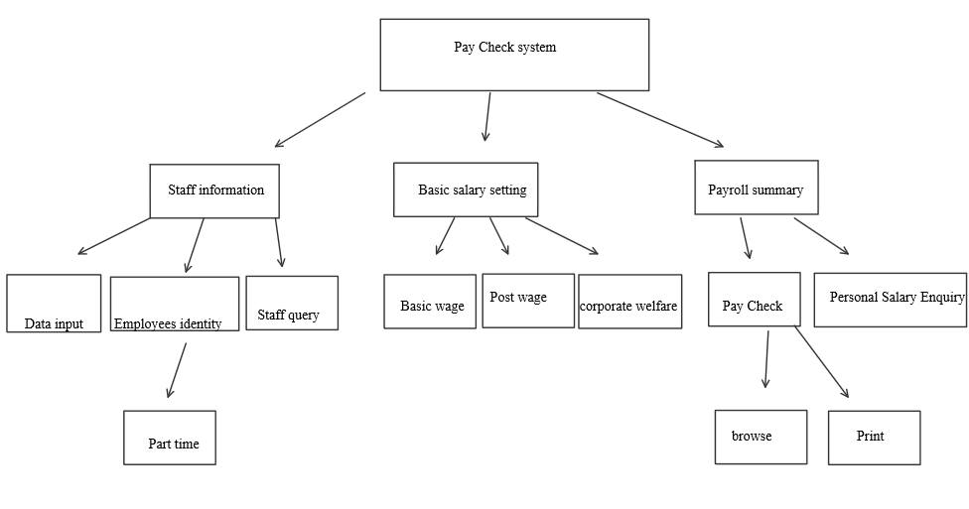

PayCheck System:

