John Robinson Project 1 part 1 Wind Chill

* Test Plan

|  |  |  |  |  |
| --- | --- | --- | --- | --- |
| Cases | Input | Expected Output | Actual Output | Pass/Fail? |
| Case 1 | Enter the temperature: 5.3  Enter the wind speed: 6 | The wind chill index is: -5.56707 | The wind chill index is: -5.56707 | Y |
| Case 2 | Enter the temperature: 41  Enter the wind speed: 2 | The wind chill index is: 40.86173 | The wind chill index is: 40.86173 | Y |
| Case 3 | Enter the temperature: 42  Enter the wind speed: 2 | Please reenter the temperature and windspeed as you entered something not specified  Enter the temperature in Fahrenheit between -58°F and 41°F: | Please reenter the temperature and windspeed as you entered something not specified  Enter the temperature in Fahrenheit between -58°F and 41°F: | Y |
| Case 4 | Enter the temperature: 41  Enter the wind speed: 1 | Please reenter the temperature and windspeed as you entered something not specified  Enter the temperature in Fahrenheit between -58°F and 41°F: | Please reenter the temperature and windspeed as you entered something not specified  Enter the temperature in Fahrenheit between -58°F and 41°F: | Y |

* Test Plan screenshots

Case 1.

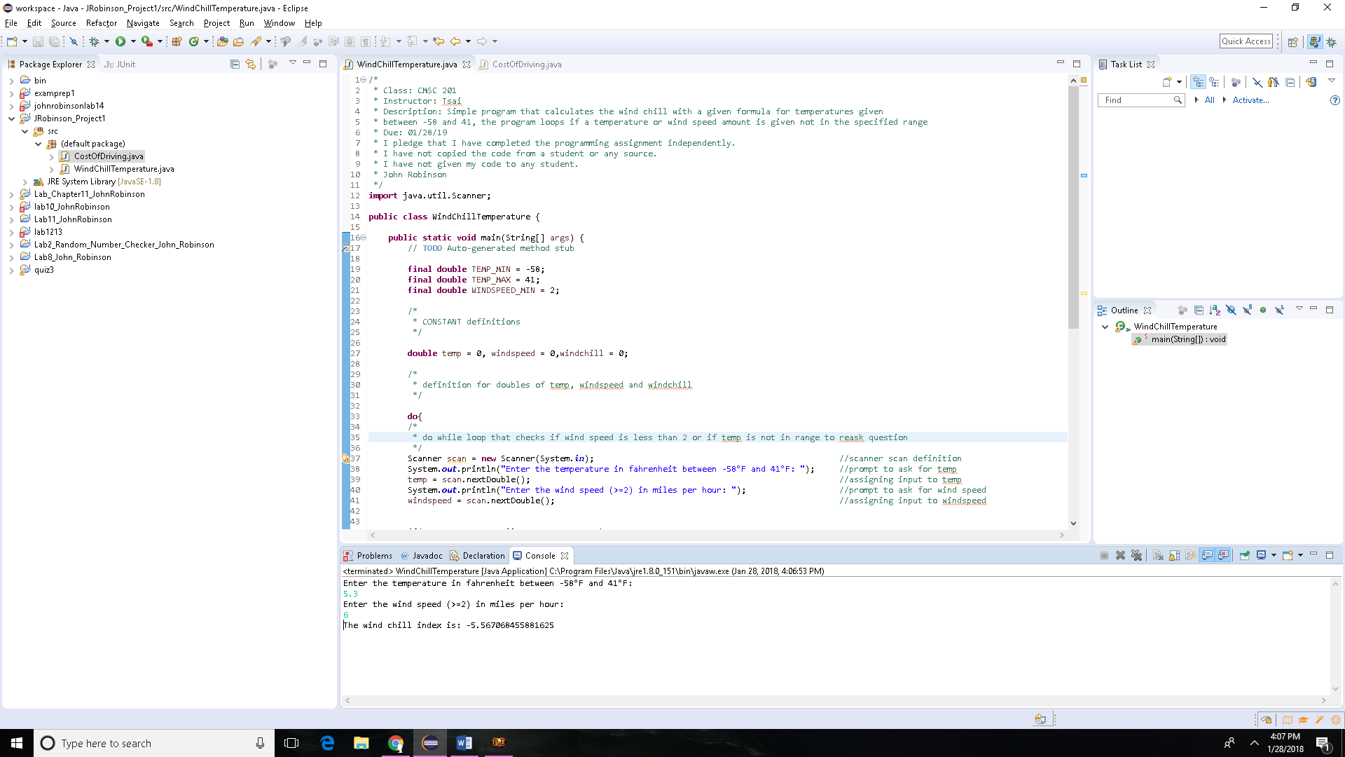

Case 2.

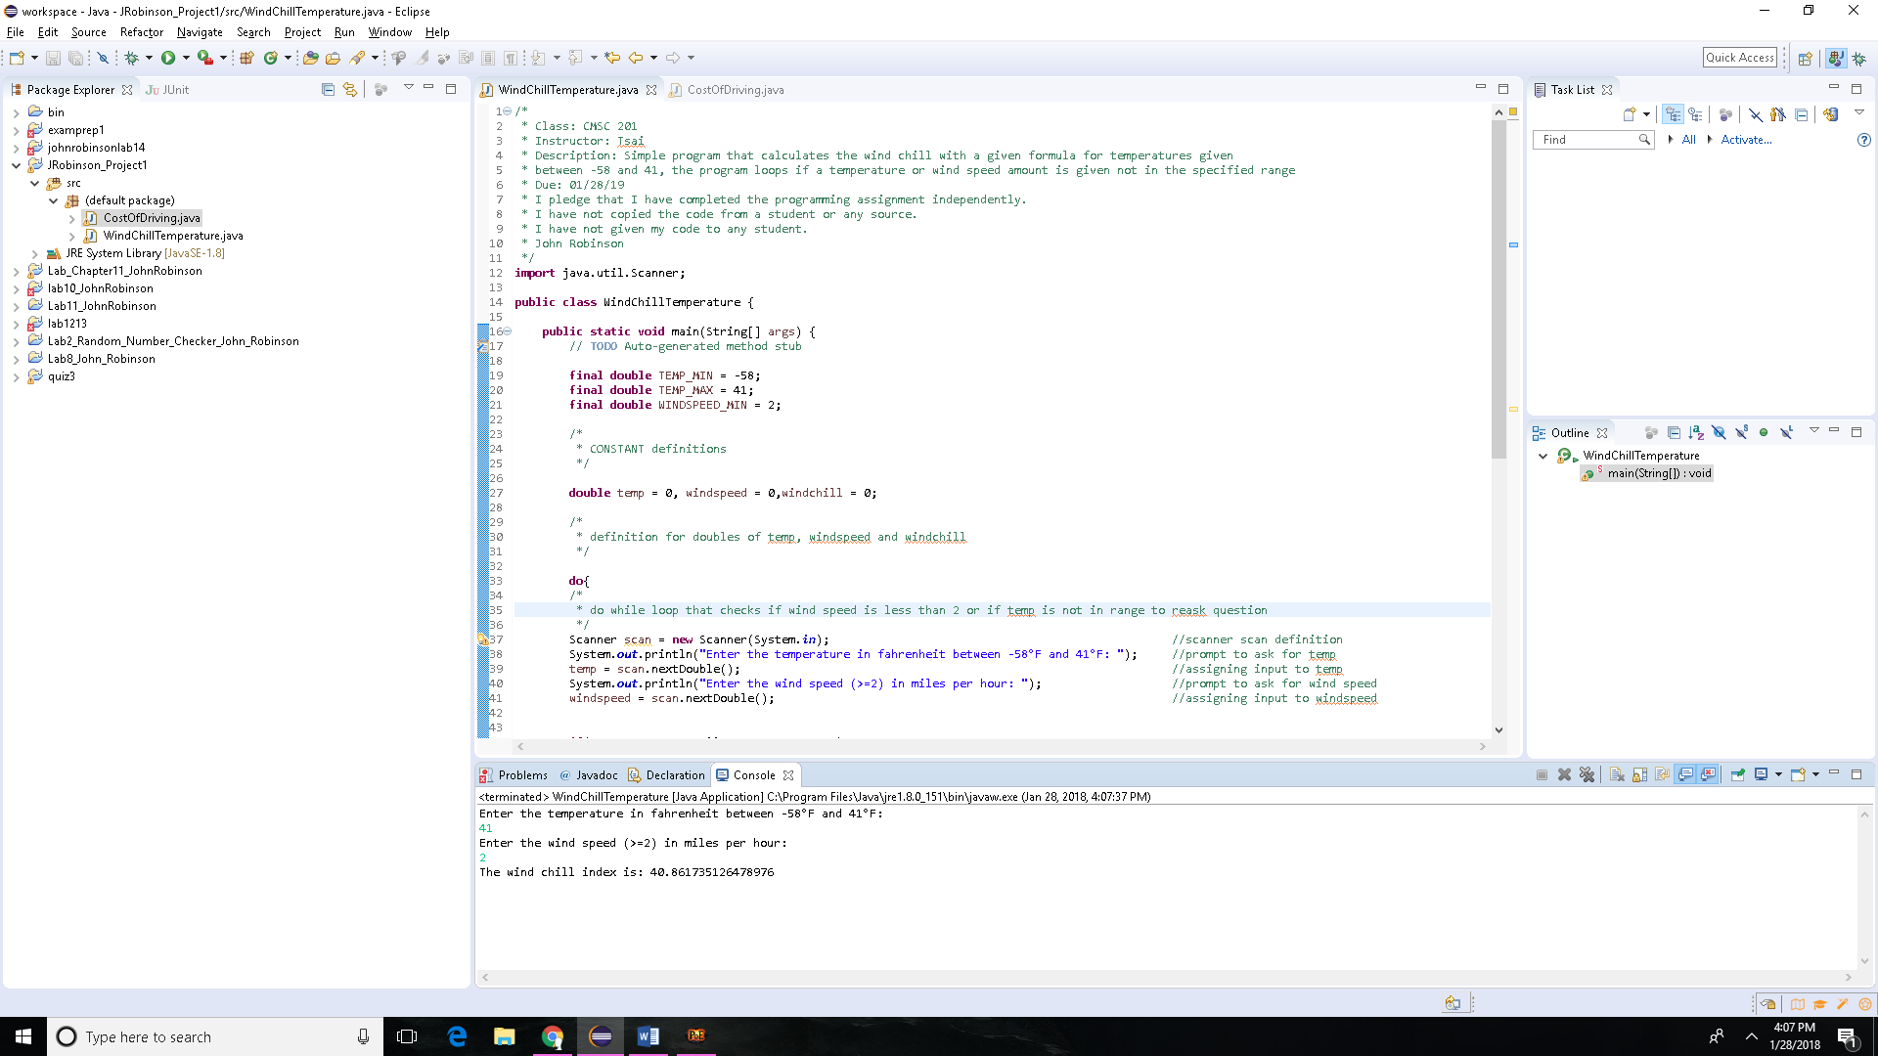

Case 3.

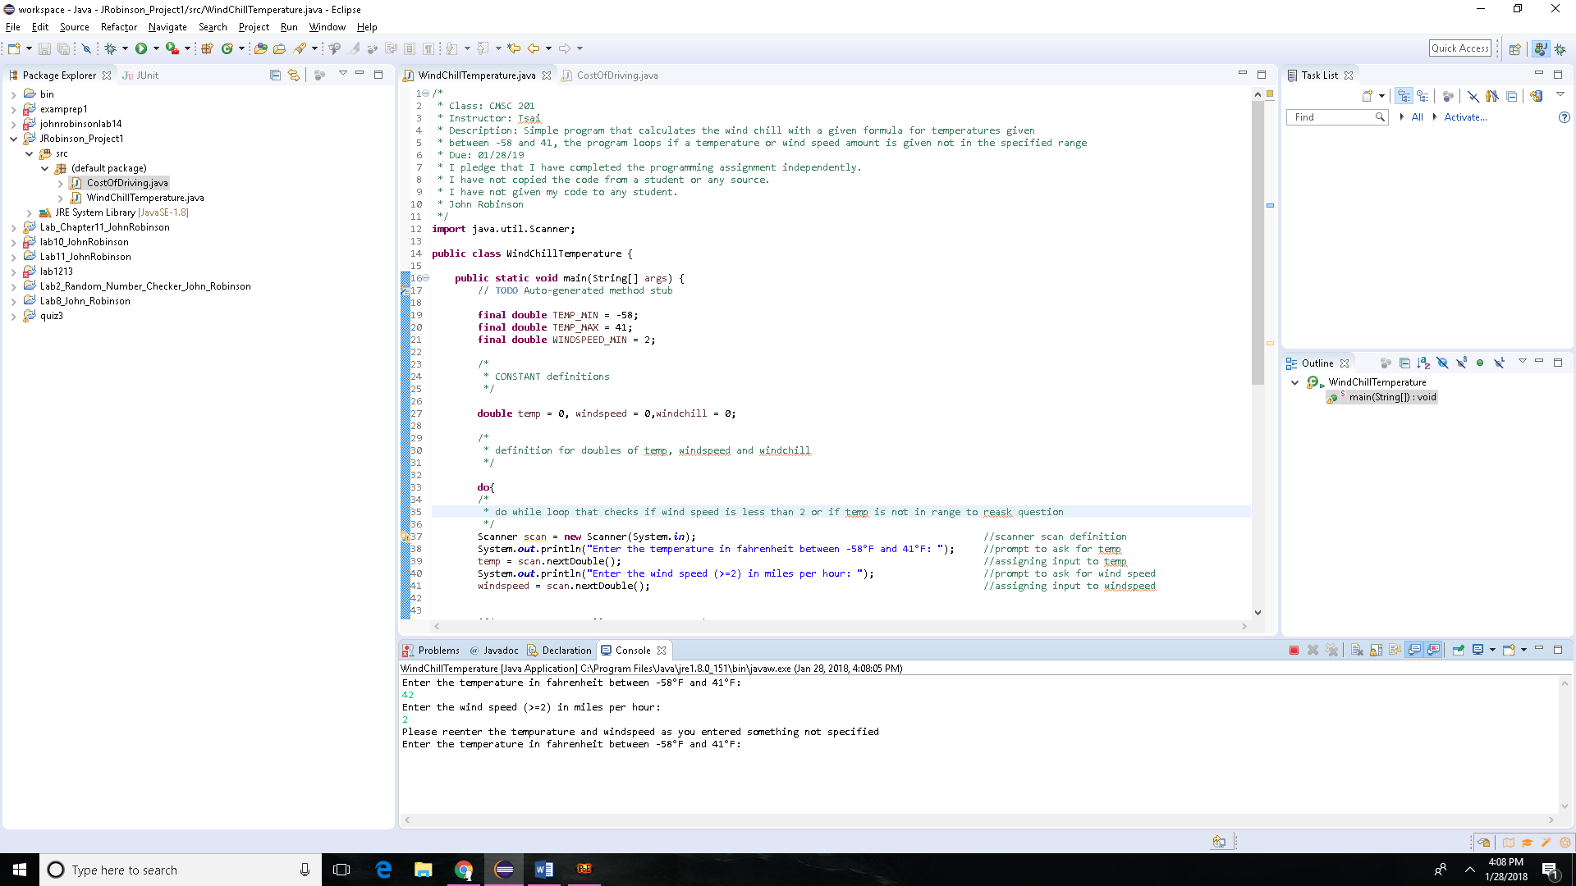

Case 4.

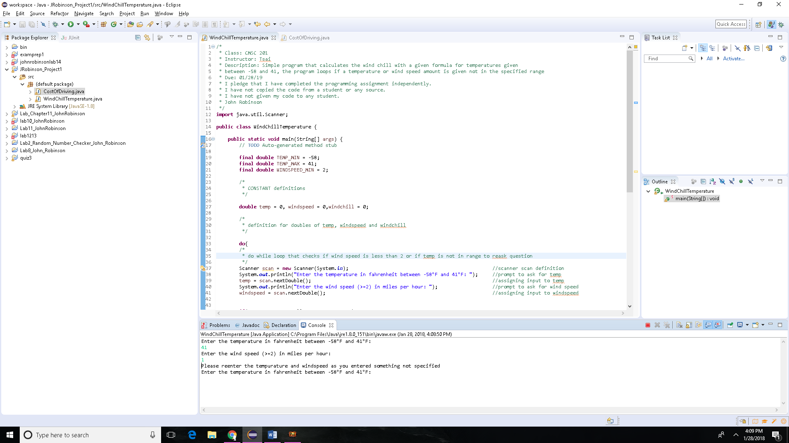

* UML Diagram

|  |
| --- |
| Wind Chill Temperature |
| +TEMP_MIN: final double  +TEMP_MAX: final double  +WINDSPEED_MIN: final double  +temp: double  +windspeed: double  +windchill: double |
| +WindChillTemperature: void |

* Pseudo Code:

1. Define and declare 3 CONST variables
   1. TEMP_MIN = -58
   2. TEMP_MAX = 41
   3. WINDSPEED_MIN = 2
2. Create a scanner to receive output from user from the keyboard
3. Declare 3 double variables
   1. Temp
   2. Windspeed
   3. Windchill
4. Prompt the user to enter the temp and windspeed
5. Receive and store the input
6. An if statement condition to check if the user input was within CONST and a second one to check if the second user input was larger than the windspeed CONST.
7. Do while loop to repeat the process if the user inputted incorrectly.
8. Calculation for windchill: windchill = 35.74 + 0.6215 * temp - 35.75 * Math.*pow*(windspeed, 0.16) + 0.4275 * temp * Math.*pow*(windspeed, 0.16);
9. Output for windchill

* Source Code:

/*

* Class: CMSC 201

* Instructor: Tsai

* Description: Simple program that calculates the wind chill with a given formula for temperatures given

* between -58 and 41, the program loops if a temperature or wind speed amount is given not in the specified range

* Due: 01/28/19

* I pledge that I have completed the programming assignment independently.

* I have not copied the code from a student or any source.

* I have not given my code to any student.

* John Robinson

*/

**import** java.util.Scanner;

**public** **class** WindChillTemperature {

**public** **static** **void** main(String[] args) {

// **TODO** Auto-generated method stub

**final** **double** TEMP_MIN = -58;

**final** **double** TEMP_MAX = 41;

**final** **double** WINDSPEED_MIN = 2;

/*

* CONSTANT definitions

*/

**double** temp = 0, windspeed = 0,windchill = 0;

/*

* definition for doubles of temp, windspeed and windchill

*/

**do**{

/*

* do while loop that checks if wind speed is less than 2 or if temp is not in range to reask question

*/

Scanner scan = **new** Scanner(System.***in***); //scanner scan definition

System.***out***.println("Enter the temperature in fahrenheit between -58°F and 41°F: "); //prompt to ask for temp

temp = scan.nextDouble(); //assigning input to temp

System.***out***.println("Enter the wind speed (>=2) in miles per hour: "); //prompt to ask for wind speed

windspeed = scan.nextDouble(); //assigning input to windspeed

**if**(temp >= TEMP_MIN && temp <= TEMP_MAX)

{

/*

* if statement that checks for range of temp between -58 and 41

*/

**if**(windspeed >= WINDSPEED_MIN)

{

windchill = 35.74 + 0.6215 * temp - 35.75 * Math.*pow*(windspeed, 0.16) + 0.4275 * temp * Math.*pow*(windspeed, 0.16);

}

/*

*if statement that checks if windspeed is greater than 2 and if it is calculate the windchill with above formula

*/

**else**

{

System.***out***.println("Please reenter the tempurature and windspeed as you entered something not specified");

}

}

**else**

{

System.***out***.println("Please reenter the tempurature and windspeed as you entered something not specified");

}

/*

* else statement to prompt user to reenter information if was not in the specified range.

*/

}**while**(windspeed < WINDSPEED_MIN || temp < TEMP_MIN || temp > TEMP_MAX);

System.***out***.println("The wind chill index is: " + windchill); //outputs the windchill

}

}

* Lessons Learned:

I learned how to use the scanner function as well as the variable definition in java and Math.pow() along with several other java commands. Also the importance of constants.

**Check List:**

|  |  |  |  |
| --- | --- | --- | --- |
| **#** |  | **Y/N** | **Comments** |
|  | **Source java files** |  |  |
|  | **Compressed files:** |  |  |
|  | FirstInitialLastName_Project1_Moss.zip |  |  |
|  | FirstInitialLastName_Project1_doc.zip |  |  |
|  | **Program compiles** |  |  |
|  | **Program runs with desired outputs related to a Test Plan** |  |  |
|  | **Checklist is completed and included in the Documentation** |  |  |
|  | **Documentation file:** |  |  |
|  | **Comprehensive Test Plan** |  |  |
|  | **Screenshots based on Test Plan** |  |  |
|  | **UML Diagram** |  |  |
|  | **Algorithms/Pseudocode** |  |  |
|  | **FlowChart** |  |  |
|  | **Lessons Learned** |  |  |

* Flow Chart

Ouput windchill

windchill = 35.74 + 0.6215 * temp - 35.75 * Math.*pow*(windspeed, 0.16) + 0.4275 * temp * Math.*pow*(windspeed, 0.16)

Do while loop wind speed < 2 || temp < -58 || temp > 41

If wind speed >= 2

If temp >= -58 && temp <= 41

end

User input for temp and wind speed

Start