John Robinson

Test Plan

|  |  |  |  |  |
| --- | --- | --- | --- | --- |
| Cases | Input | Expected Output | Actual Output | Pass/Fail? |
| Case 1 | Enter Year(eg 2012): 2017  Enter Month(eg 1-12): 1  Enter the Day of the Month(eg 1-31): 27 | Day of the Week is: Friday | Day of the Week is: Friday | Y |
| Case 2 | Enter Year(eg 2012): 1995  Enter Month(eg 1-12): 2  Enter the Day of the Month(eg 1-31): 25 | Day of the Week is: Wednesday | Day of the Week is: Wednesday | Y |
| Case 3 | Enter Year(eg 2012): 1  Enter Month(eg 1-12): 12  Enter the Day of the Month(eg 1-31): 31 | Day of the Week is: Wednesday | Day of the Week is: Wednesday | Y |
| Case 4 | Enter Year(eg 2012): 2012  Enter Month(eg 1-12): 50 | Invalid Entry | Invalid Entry | Y |

Test Plan Screenshots

Case 1

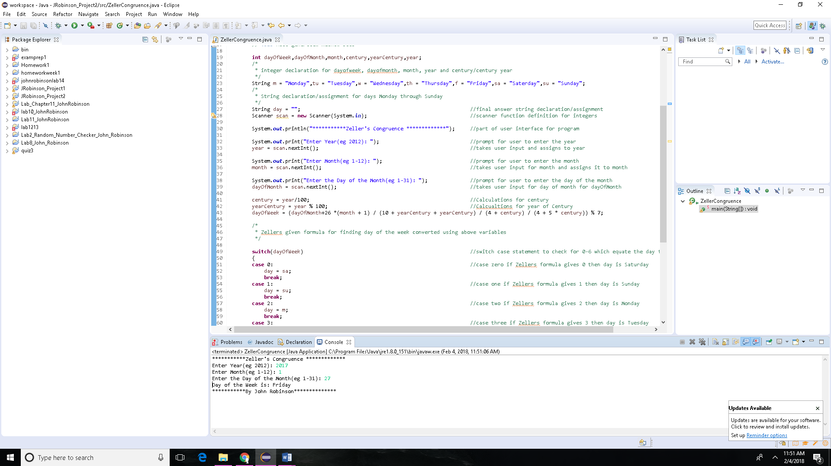

Case 2

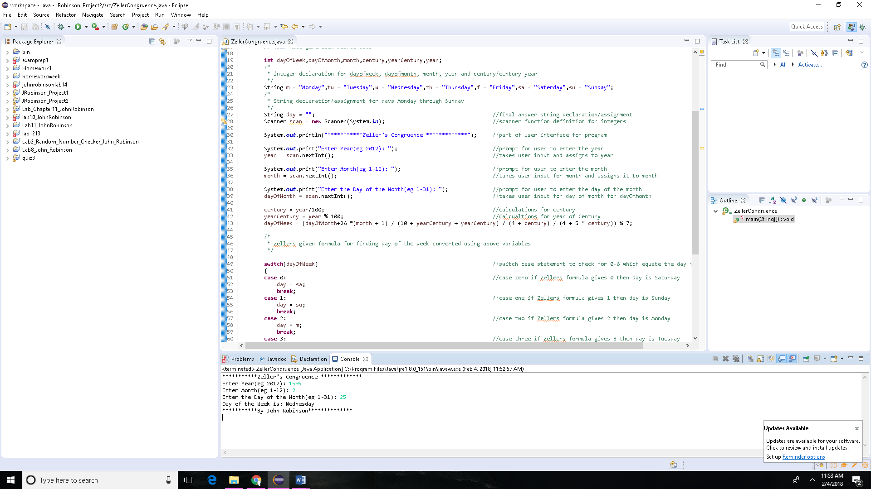

Case 3

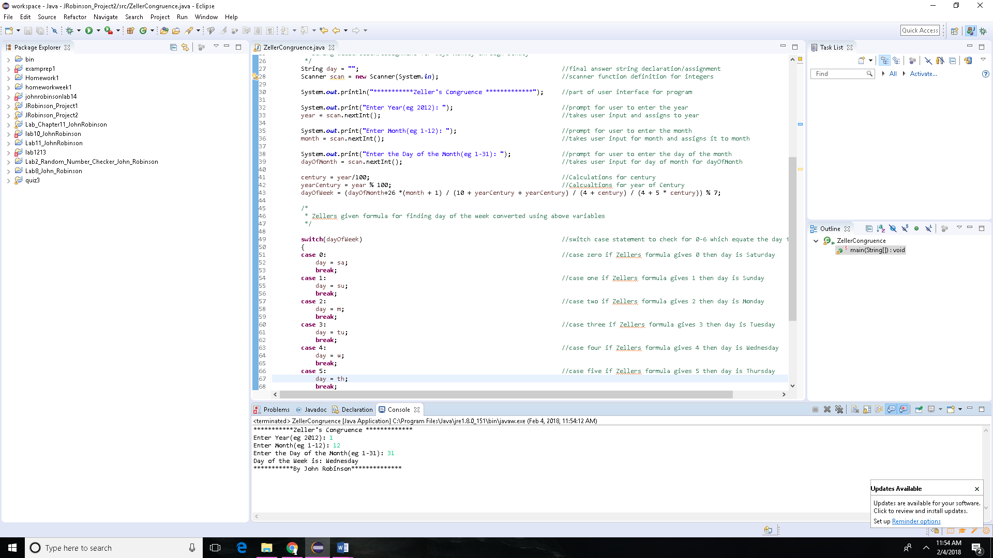

Case 4

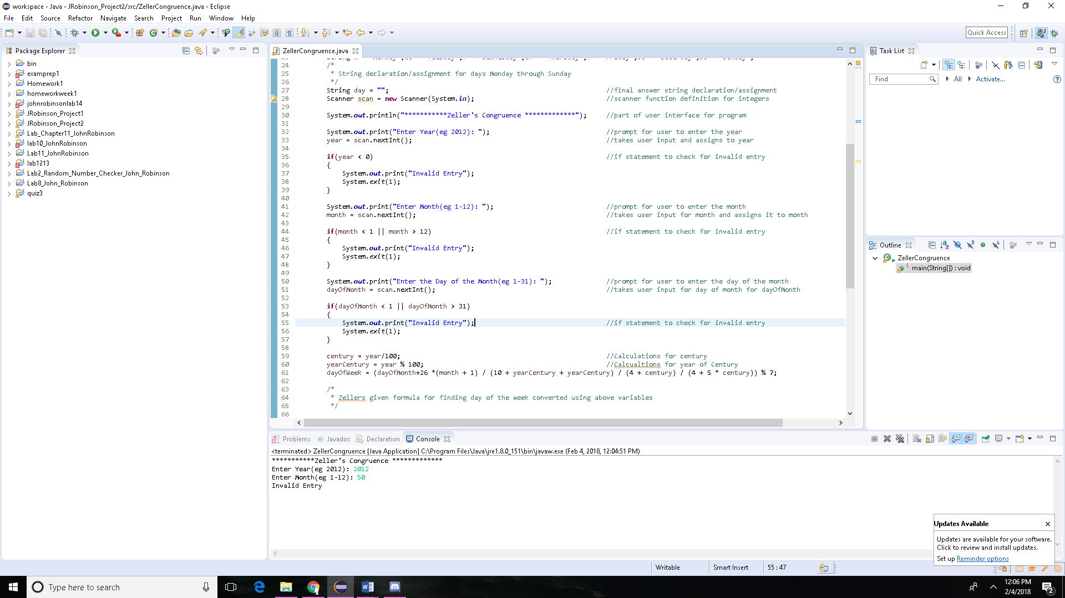

UML Diagram

|  |
| --- |
| ZellerCongruence |
| +dayOfWeek: int  +dayOfMonth: int  +month: int  +century: int  +yearCentury: int  +year: int  +m: String  +tu: String  +w: String  +th: String  +f: String  +sa: String  +sun: String  +day: String; |
| +ZellerCongruence: void |

Pseudo Code:

1. Declare the vales for dayOfWeek,dayOfMonth,month,century,yearCentury,year
2. Declare and assign the values for
   1. m = "Monday",tu = "Tuesday",w = "Wednesday",th = "Thursday",f = "Friday",sa = "Saterday",su = "Sunday"
3. declare and assign String day for the final answer
4. define the scanner function for further use: Scanner scan = **new** Scanner(System.***in***);
5. User entry for year, month and day of month
6. If statements to check for invalid entry
7. Calculations for century and yearcentury
   1. century = year/100
   2. yearCentury = year % 100
8. Calculation for Zellers formula
   1. dayOfWeek = (dayOfMonth+26 *(month + 1) / (10 + yearCentury + yearCentury) / (4 + century) / (4 + 5 * century)) % 7
9. switch case block that takes day of week answer and assigns day String to an above String using numbers 0-6 for the day of the week
10. final answer displayed

Source Code:

**import** java.util.Scanner;

**public** **class** ZellerCongruence {

**public** **static** **void** main(String[] args) {

// **TODO** Auto-generated method stub

**int** dayOfWeek,dayOfMonth,month,century,yearCentury,year;

/*

* integer declaration for dayofweek, dayofmonth, month, year and century/century year

*/

String m = "Monday",tu = "Tuesday",w = "Wednesday",th = "Thursday",f = "Friday",sa = "Saterday",su = "Sunday";

/*

* String declaration/assignment for days Monday through Sunday

*/

String day = ""; //final answer string declaration/assignment

Scanner scan = **new** Scanner(System.***in***); //scanner function definition for integers

System.***out***.println("***********Zeller's Congruence *************"); //part of user interface for program

System.***out***.print("Enter Year(eg 2012): "); //prompt for user to enter the year

year = scan.nextInt(); //takes user input and assigns to year

**if**(year < 0) //if statement to check for invalid entry

{

System.***out***.print("Invalid Entry");

System.*exit*(1);

}

System.***out***.print("Enter Month(eg 1-12): "); //prompt for user to enter the month

month = scan.nextInt(); //takes user input for month and assigns it to month

**if**(month < 1 || month > 12) //if statement to check for invalid entry

{

System.***out***.print("Invalid Entry");

System.*exit*(1);

}

System.***out***.print("Enter the Day of the Month(eg 1-31): "); //prompt for user to enter the day of the month

dayOfMonth = scan.nextInt(); //takes user input for day of month for dayOfMonth

**if**(dayOfMonth < 1 || dayOfMonth > 31)

{

System.***out***.print("Invalid Entry"); //if statement to check for invalid entry

System.*exit*(1);

}

century = year/100; //Calculations for century

yearCentury = year % 100; //Calcualtions for year of Century

dayOfWeek = (dayOfMonth+26 *(month + 1) / (10 + yearCentury + yearCentury) / (4 + century) / (4 + 5 * century)) % 7;

/*

* Zellers given formula for finding day of the week converted using above variables

*/

**switch**(dayOfWeek) //switch case statement to check for 0-6 which equate the day from the number

{

**case** 0: //case zero if Zellers formula gives 0 then day is Saturday

day = sa;

**break**;

**case** 1: //case one if Zellers formula gives 1 then day is Sunday

day = su;

**break**;

**case** 2: //case two if Zellers formula gives 2 then day is Monday

day = m;

**break**;

**case** 3: //case three if Zellers formula gives 3 then day is Tuesday

day = tu;

**break**;

**case** 4: //case four if Zellers formula gives 4 then day is Wednesday

day = w;

**break**;

**case** 5: //case five if Zellers formula gives 5 then day is Thursday

day = th;

**break**;

**case** 6: //case six if Zellers formula gives 6 then day is Friday

day = f;

**break**;

**default**: //switch case default if invalid entry is encountered

System.***out***.print("Invalid Entry");

System.*exit*(1);

}

System.***out***.println("Day of the Week is: " + day); //final display of day of the week

System.***out***.println("***********By John Robinson**************"); //aesthetic to show author of program

}

}

**Check List:**

|  |  |  |  |
| --- | --- | --- | --- |
| **#** |  | **Y/N** | **Comments** |
|  | **Source java files** |  |  |
|  | **Compressed files:** |  |  |
|  | FirstInitialLastName_Project1_Moss.zip |  |  |
|  | FirstInitialLastName_Project1_doc.zip |  |  |
|  | **Program compiles** |  |  |
|  | **Program runs with desired outputs related to a Test Plan** |  |  |
|  | **Checklist is completed and included in the Documentation** |  |  |
|  | **Documentation file:** |  |  |
|  | **Comprehensive Test Plan** |  |  |
|  | **Screenshots based on Test Plan** |  |  |
|  | **UML Diagram** |  |  |
|  | **Algorithms/Pseudocode** |  |  |
|  | **FlowChart** |  |  |
|  | **Lessons Learned** |  |  |