FINC 310 INSTRUCTOR GUIDE
Teaching the P&G Financial Story
A flexible 2-4 hour classroom plan for financial concepts, AI-assisted Python, verification, and student presentations.
Audience | FINC 310 students after or during Chapters 1-8
Core version | 120 minutes: concepts, four visuals, AI prompt, and verification demo
Lab version | 180 minutes: core plus guided Python/AI work and audit challenge
Full version | 240 minutes: lab plus team presentations and peer critique
Files | Student workbook, 10-K, student assignment, classroom deck, rubric, and solution package
Evidence before elegance. A chart is not finished until it reconciles.

Instructional Premise
Treat AI as a junior analyst whose work must be independently verified, not as an answer key.
The class moves from source evidence to finance meaning, then to code and verification. Students first learn what the four visuals mean and which accounting identities constrain them. Only then do they use AI to draft code. This sequence keeps the financial model in charge of the technology.
Communication job: By the end, students should be able to build and defend a reproducible P&G financial story because they can connect audited statements to formulas, visual encodings, code, and verification evidence.

Design principle | Classroom implication
Evidence before output | Open the 10-K and workbook before showing code.
Meaning before syntax | Explain the finance job of each function before reviewing Python details.
Checks before charts | A failed identity stops export; students do not 'fix' a chart by hiding a residual.
Roles without silos | Teams distribute labor, but oral questions enforce whole-team understanding.
AI with accountability | Prompt history, REM comments, corrections, and verification are graded evidence.

1. Learning Outcomes and Course Alignment
Outcome | Student evidence | Chapter connection
Explain value creation beyond accounting profit. | Connect net income, FCF, risk, and shareholder value. | Ch. 1
Use public-company information responsibly. | Trace metrics to the audited 10-K and standardized workbook. | Ch. 2
Link statements, taxes, NOPAT, NOWC, and FCF. | Reconcile the Sankey and FCF waterfall. | Ch. 3
Analyze profitability, efficiency, leverage, and growth. | Interpret common-size margins, trend CAGRs, and DuPont. | Ch. 4
Reason across time. | Use four CAGR intervals and connect future FCF to present value. | Ch. 5
Recognize financing sensitivity. | Place interest after EBIT and discuss rate/leverage effects. | Ch. 6
Adopt a creditor perspective. | Explain cash generation, coverage, leverage, and default implications. | Ch. 7
Distinguish return from risk. | Explain why leverage magnifies ROE and financial risk. | Ch. 8
Control AI-assisted analysis. | Audit sources, formulas, code, visuals, and interpretations. | Across course

2. Instructor Preparation

Before class
- Post PG_Student_Group_Assignment_Complete.docx, PG_FinancialStory_Student.xlsx, the FY2025 annual report, requirements.txt, and the grading rubric.
- Keep the instructor workbook, solution manual, solution Python, and finished visuals unpublished unless you plan to reveal them during class.
- Run the solution program against the student workbook and confirm the six sanity checks pass.
- Open the classroom deck in Presenter View so timing and facilitation notes remain visible to you.
- Decide whether students will install Python locally, use a managed lab, or watch a live demo and complete coding outside class.
- Form teams of approximately six and assign roles before the lab segment.
- Prepare a backup folder containing the verified output images in case local Python installation fails.

Room and technology
Need | Preferred setup | Fallback
Display | Projector with 16:9 PowerPoint and Presenter View. | PDF/printed slide thumbnails.
Student devices | One laptop per team with Python and Excel. | Instructor demo plus paper audit activities.
AI access | Approved AI tool capable of handling prompt text and code. | Provide a printed AI draft for critique.
Files | One shared folder per team. | USB or LMS download package.
Submission | One group upload plus individual oral checks. | Exit ticket plus later group upload.

Student prework
- Read the 00_ReadMe worksheet and inspect the 01_Input Metric_ID structure.
- Bring the student assignment and workbook to class.
- Install packages with: python -m pip install -r requirements.txt.
- Write a one-sentence prediction: Will P&G's EPS growth be faster or slower than revenue growth, and why?

3. Master 240-Minute Run of Show
Minutes | Slides | Learning move | Student evidence
0-10 | 1-4 | Open with the earnings-versus-sales question; reveal the four-lens dashboard. | Initial prediction and one question.
10-25 | 5-8 | Orient teams to the assignment, roles, source hierarchy, and story map. | Role assignments and source trace.
25-50 | 9-12 | Teach income-statement flow; run the Sankey classification/reconciliation activity. | Balanced node and classification correction.
50-80 | 13-18 | Contrast profit and cash; build the FCF bridge; diagnose the CapEx sign error. | Correct sign logic and residual explanation.
80-90 | Break | Pause and reset. | None.
90-110 | 19-22 | Teach multi-year trend, four-interval CAGR, and dual-axis risk. | Growth-gap hypothesis.
110-135 | 23-26 | Teach DuPont, average balances, and leverage risk. | Factor interpretation and direct-ROE check.
135-155 | 27-30 | Frame AI as junior analyst; unpack prompt structure and REM documentation. | Team prompt revision.
155-180 | 31-34 | Walk through input, model, sign, and sanity-check code architecture. | Annotated code trace.
180-205 | 35-37 | Run the four-layer verification lab and document a human correction. | Verification log and correction statement.
205-235 | 38-41 | Team presentations and peer critique using the accuracy-first rubric. | Five-minute story and one peer question.
235-240 | 42-43 | Launch next steps and collect exit tickets. | One formula, one check, one risk.

4. Compression Paths for 2 or 3 Hours

120-minute core class
Minutes | Focus | Slides and cuts
0-15 | Case, outcomes, assignment, and source | 1-8; shorten role discussion.
15-35 | Sankey concept and audit | 9-12; complete one node live.
35-60 | FCF bridge and sign error | 13-18; emphasize three FCF definitions.
60-65 | Micro-break | Pause.
65-80 | Five-year trend | 19-22; one-minute pair discussion.
80-95 | DuPont | 23-26; focus on averages and leverage.
95-115 | AI prompt, REM, code, and checks | 27-36; demo rather than team lab.
115-120 | Exit ticket | 43; assign 37-42 as outside work.

180-minute lab class
- Use the first 135 minutes of the master plan through DuPont.
- Use 35 minutes for AI prompt, REM, and annotated code (slides 27-34).
- Use the final 10 minutes for verification setup and an exit ticket; presentations occur next class or by recorded submission.
- If students already know Chapters 3-4 well, reduce the concepts segment to 105 minutes and reserve 55 minutes for hands-on coding and verification.

5. Facilitation Guide by Module

Opening and source orientation - Slides 1-8
- Ask: 'Can EPS grow faster than sales without strong revenue growth?' Record two competing explanations before revealing numbers.
- Show the dashboard only long enough to create questions. Do not explain each visual yet.
- Open the annual report's Consolidated Statements of Earnings and have students locate net sales, operating income, net earnings, and diluted EPS.
- Emphasize that public markets depend on credible information; the 10-K is evidence, not decoration.
- Assign roles and state that roles divide labor but not accountability.
Check for understanding: Ask one student to trace $84,284M from the 10-K to Metric_ID NET_SALES in 01_Input and then to a chart label.

Income statement Sankey - Slides 9-12
- Build the statement in four identities before showing the finished Sankey.
- Ask students to calculate each major item as a percentage of net sales. Translate the result into cents per sales dollar.
- Point out that a Sankey is constrained by conservation: every source node must balance.
- Use the interest-expense classification error to test whether students understand EBIT rather than merely reading labels.
- Ask why consolidated net earnings and earnings attributable to P&G differ by $91M and why numerator/denominator consistency matters.
Expected insight: Product cost absorbs 48.8% of sales, SG&A 26.9%, EBIT is 24.3%, and consolidated net earnings are 19.1% of sales.

Free cash flow waterfall - Slides 13-18
- Begin with the conceptual contrast: income statement profit includes accrual accounting; FCF asks what cash remains after operating investment.
- Build NOPAT, operating NOWC, change in NOWC, and textbook FCF sequentially.
- Then introduce cash FCF from the cash flow statement and treat the $822.23M residual as a bridge to explain.
- Finally reveal the $562M Tax Act payment add-back and require the non-GAAP label.
- Demonstrate the double-negative CapEx bug and ask students to predict the direction of error before calculating it.
Expected insight: Textbook FCF is $14.866B, cash FCF is $14.044B, and P&G adjusted FCF is $14.606B. Similar totals do not make the definitions interchangeable.

Five-year trend - Slides 19-22
- Have students count the spaces between FY2021 and FY2025: there are four compounding intervals.
- Discuss why a dual-axis chart can exaggerate or minimize co-movement through arbitrary axis bounds.
- Ask teams to generate at least three possible explanations for EPS growing faster than sales, then classify each as supported, plausible, or untested.
- Keep GAAP diluted EPS distinct from core or adjusted EPS.
Expected insight: Sales CAGR is 2.58%; diluted EPS CAGR is 4.30%. The chart supports a growth gap, not a single proven cause.

DuPont ROE - Slides 23-26
- Write ROE as three factors before inserting any numbers.
- Use average assets and equity because sales and earnings measure a full period while the balance sheet is a point-in-time snapshot.
- Interpret the 19.06% margin, 0.681x turnover, and 2.408x equity multiplier separately.
- Avoid declaring one factor 'the cause' of ROE without qualification; say margin supports ROE and leverage magnifies it while turnover is relatively modest.
- Connect leverage to Chapter 7 creditor concerns and Chapter 8 risk-return tradeoffs.
Expected insight: 0.1906 x 0.6808 x 2.4076 = 0.3124, matching direct ROE of 16,065 / 51,421.5 = 31.24%.

AI, code, and verification - Slides 27-37
- Ask students what a junior analyst should be told before beginning: approved data, definitions, outputs, constraints, and failure behavior.
- Reveal the model prompt and identify each control. Have teams add one missing or stronger control.
- Clarify that REM comments are auditable documentation, not hidden chain-of-thought.
- Walk the architecture in financial order: load -> model -> check -> visualize -> export.
- At every code slide, ask two questions: What finance job does this block perform? How could it fail silently?
- Use the four-layer verification model: source, formula, program, visual, plus interpretation as the narrative layer.
- Require a meaningful correction such as removing a fixed row, correcting a sign, improving validation, clarifying a label, or preventing a misleading axis.

6. Activity Instructions and Answer Keys

Activity 1 - Sankey classification audit
Prompt: A draft subtracts interest expense with SG&A before calculating EBIT. Is the chart acceptable? Correct the sequence and state the effect on EBIT.
Answer: No. Interest expense is non-operating in this statement and belongs after EBIT. Moving it before EBIT understates operating income and destroys the meaning of the EBIT node.

Activity 2 - CapEx sign bug
Prompt: The workbook stores CapEx as -3,773. AI writes FCF = NOPAT + D&A - raw_capex - delta_nowc. Diagnose the error.
Answer: Subtracting raw_capex subtracts a negative and adds $3,773M. Convert to a positive magnitude once with abs(), then subtract it once. Alternatively preserve the negative sign and add raw_capex, but document the convention consistently.

Activity 3 - Growth-gap claims
Prompt: EPS CAGR exceeds sales CAGR. Which explanations are facts, plausible hypotheses, or unsupported claims?
Statement | Classification | Teaching point
EPS CAGR was 4.30% and sales CAGR was 2.58%. | Fact | Directly calculated from consistent GAAP values.
Margins, taxes, impairment charges, or share count may explain the gap. | Plausible hypothesis | Requires supporting analysis before claiming causation.
P&G's brands became stronger every year. | Unsupported | The chart does not measure brand strength.
EPS growth proves value creation. | Incomplete | Value also depends on cash flow, timing, risk, and required return.

Activity 4 - DuPont strength and risk
Prompt: Which factor supports P&G's ROE, which factor constrains it, and what risk is visible?
Answer: The 19.06% profit margin strongly supports ROE. The 0.681x asset turnover is comparatively modest. The 2.408x equity multiplier magnifies the product to 31.24% and signals financial leverage, which can magnify downside as well as upside.

Activity 5 - Visual verification
Give teams a chart that is numerically correct but uses a truncated axis, mismatched widths, vague units, or colors that imply a false classification. Ask them to write a correction request to the AI.
Strong correction prompt: Keep the verified values unchanged. Start the sales axis at zero, label both y-axes and units, use width-proportional Sankey flows from the displayed dollar amounts, and distinguish GAAP from non-GAAP measures in the title and note.

7. Live AI/Python Demonstration Script
- Open the prompt and underline the data lock: use the supplied workbook; do not invent replacements.
- Underline the output contract: four PNGs, one dashboard, one CSV, one executable program.
- Underline the failure contract: validate inputs and stop when an identity fails.
- Ask AI to draft only load_metrics() first. Inspect its dependence on header names, sheet names, row numbers, and missing values.
- Ask AI to list all hard-coded numbers and justify each. Remove any hard-coded financial statement value.
- Add build_model() one formula family at a time. Test signs after CapEx and interest logic.
- Add sanity_checks() before any plotting function. Intentionally change NET_SALES by $10M and demonstrate that export stops.
- Restore the verified input, run the program, and compare the CSV to PG_Sanity_Checks.csv.
- Inspect one chart for visual truth: axis bounds, width proportionality, units, fiscal year, and GAAP/non-GAAP labels.
- Record a human correction and ask a student to explain the revised block without AI assistance.
python -m pip install -r requirements.txt
python pg_financial_story.py --workbook PG_FinancialStory_Student.xlsx --output PG_Output

8. Assessment Plan
When | Assessment | Evidence | Response
Opening | Prediction | Reason EPS may differ from sales. | Surface prior knowledge; do not grade accuracy.
After Sankey | Node audit | One balanced identity and classification. | Correct EBIT/non-operating confusion immediately.
After FCF | Sign check | Correct CapEx logic and residual explanation. | Rebuild the formula if students rely on memorized signs.
After trend | Claim sorting | Fact vs hypothesis vs unsupported claim. | Require evidence language.
After DuPont | Factor interpretation | Strength, constraint, and risk. | Tie leverage to Chapters 7-8.
AI lab | Code trace | Input -> formula -> check -> chart label. | Ask a different team member to explain each link.
End | Exit ticket | One formula, one check, one risk. | Use gaps to plan the next class.
Submission | 100-point rubric | Files, checks, interpretation, presentation, oral questions. | Adjust individual score if understanding is not demonstrated.

9. Common Misconceptions and Instructor Responses
Misconception | Diagnostic question | Instructor response
Net income equals cash generated. | Where do D&A, CapEx, and working capital enter? | Contrast accrual earnings with operating and investing cash flows.
All FCF definitions should match. | What is the starting point and definition of each measure? | Require labels and reconciliation instead of forced equality.
Negative NOWC is automatically bad. | How do supplier terms and customer collection affect NOWC? | Focus on business model and change, not sign alone.
Five years means five CAGR periods. | How many spaces are between FY2021 and FY2025? | Count four compounding intervals.
High ROE always means excellent operations. | What happens when the equity multiplier rises? | Separate profitability, efficiency, and leverage.
A PASS cell proves correctness. | Who verified the expected value and formula? | A check is only as good as its independent construction.
AI-generated code is self-explanatory. | Can you trace one label to the workbook? | Require code annotation and oral explanation.
A beautiful chart is a truthful chart. | Could axis or width choices mislead? | Audit visual encoding separately from numerical accuracy.

10. Technical Troubleshooting
Symptom | Likely cause | Resolution
ModuleNotFoundError | Packages not installed in the active Python environment. | Run python -m pip install -r requirements.txt using the same python command used to run the script.
Workbook not found | Personal absolute path or wrong working folder. | Use relative paths/arguments and run from the submission folder.
Missing expected columns | Wrong header row, renamed sheet, or edited headers. | Restore 01_Input structure and read with header=4.
Missing metric/year | Blank or renamed Metric_ID or wrong year. | Validate the exact ID and fiscal-year column; do not replace with zero.
FCF is too high | Negative CapEx subtracted twice. | Use one documented sign convention.
DuPont does not equal direct ROE | Mixed net income/equity definitions or ending balances. | Use consolidated earnings and average total equity consistently.
Chart saves but labels are wrong | Hard-coded label text or units. | Build labels from the model dictionary and test them.
Excel shows stale formulas | Workbook formula cache not recalculated. | Open and calculate in Excel, or compute required values in Python from 01_Input.

11. Inclusion, Access, and Participation
- Allow teams to combine roles based on size, but rotate who reports during class so technical labor is not isolated in one student.
- Provide formulas and chart descriptions in text, not color alone. Require labels and patterns sufficient for grayscale review.
- Offer a paper-based verification pathway if a student device fails; finance learning should continue even when installation does not.
- Share the student assignment before class so students can preview vocabulary and code architecture.
- Use structured turn-taking in group reports: data, finance concept, code control, and limitation should be voiced by different members.
- Evaluate understanding through explanation and traceability, not typing speed or prior programming experience.

12. Presentation and Debrief Protocol
- Limit each team to five minutes and five content slides.
- Require one thesis, one evidence point from each visual, one AI correction, and one caveat.
- After each presentation, randomly choose a member for one code/formula question and another for one interpretation question.
- Peer listeners record one verified strength and one question about evidence or limitation.
- Close by comparing how teams framed the same audited facts differently without changing the numbers.
Debrief question: What did the AI make faster, and what responsibility did it not remove?

Appendix A - Slide Map
Slides | Section | Instructor emphasis
1-4 | Opening | Question, outcomes, dashboard, four lenses.
5-8 | Assignment setup | Deliverables, roles, source evidence, story workflow.
9-12 | Sankey | Income statement identities, visual meaning, audit activity.
13-18 | FCF | Profit vs cash, definitions, formula bridge, residual, sign error.
19-22 | Trend | Five-year view, CAGR intervals, dual-axis interpretation.
23-26 | DuPont | Three factors, averages, leverage, audit activity.
27-30 | AI prompt and REM | Junior analyst framing, prompt controls, auditable documentation.
31-34 | Annotated code | Architecture, inputs, signs, calculations, stop conditions.
35-37 | Verification | Five layers, six checks, documented human correction.
38-41 | Synthesis and assessment | Executive story, deliverables, presentation, rubric.
42-43 | Work session and close | Team checkpoints and exit ticket.

Appendix B - Verified Benchmarks
Benchmark | Expected value
FY2025 net sales | $84,284M
FY2025 operating income (EBIT) | $20,451M
FY2025 net earnings | $16,065M
FY2025 cash flow from operations | $17,817M
FY2025 capital expenditures | $3,773M magnitude
Textbook FCF | $14,866.23M
Cash FCF | $14,044M
P&G adjusted FCF | $14,606M, non-GAAP
Sales CAGR | 2.58%
GAAP diluted EPS CAGR | 4.30%
Simplified DuPont ROE | 31.24%

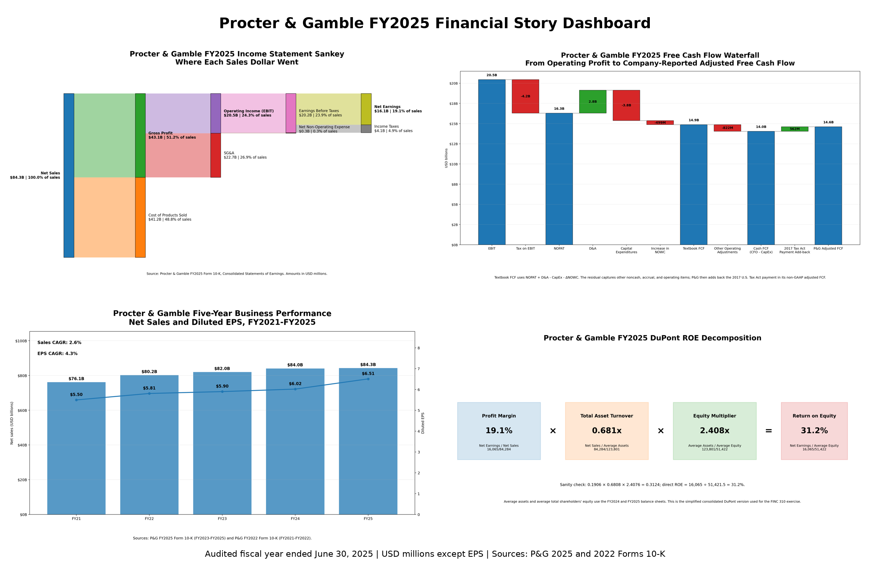
Verified instructor dashboard. Sources: P&G FY2025 and FY2022 Forms 10-K; figures in the supplied package.

