***Light-induced critical resetting of the human clock***

*General idea/goal:*

We want to be able to perform "critical" phase shifting - force the oscillator close to the critical point, then reset it from there simply because the phases are condensed.

*Approach:*

Use model predictive control to do it, figure out the amplitude response curve, and hit the oscillator where the amp response is negative to drive it to the critical point.

*Results thus far:*

(i) Amplitude and phase response curves for the Kronauer model.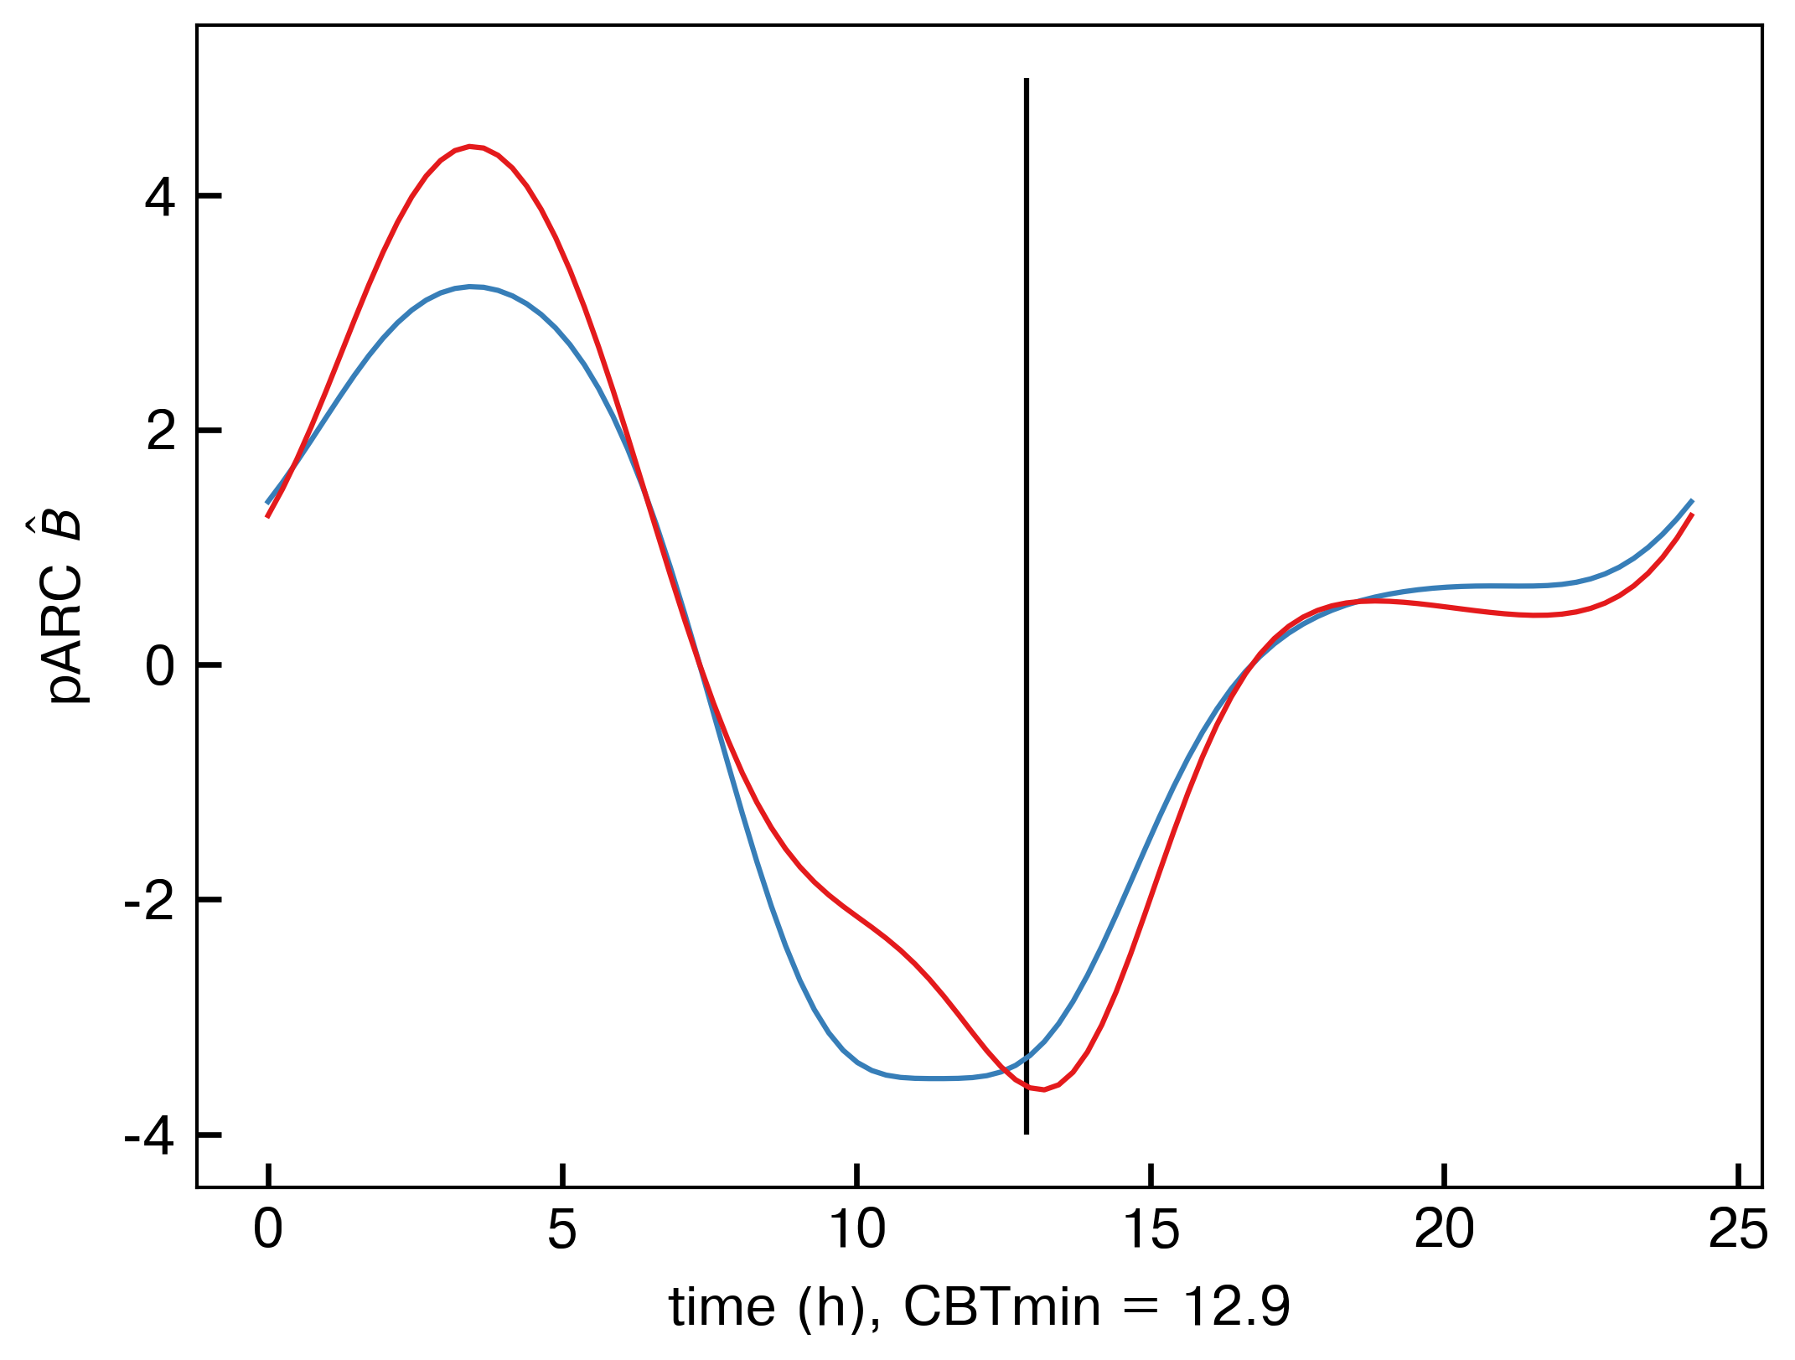

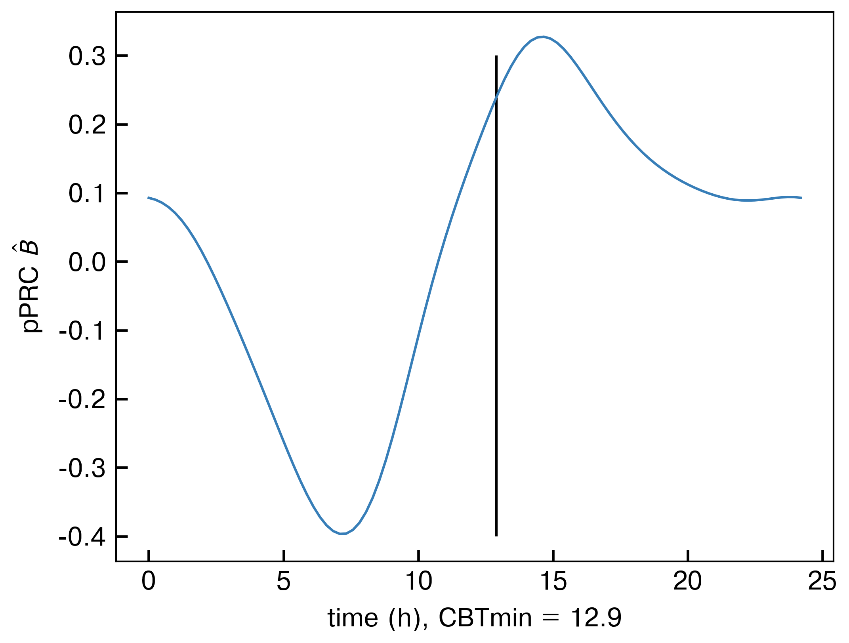

These plots are the PRC (left) and ARC (right, for each state) for an infinitesimal perturbation to \hat B. Because \hat B is the route by which light enters the model, this is the parameter we would use to formulate the control. Notably, a pulse centered at CBTmin (the line) would indeed reduce the amplitude of the oscillator if it consistently hit that area. Note: all this is for tau = 24.2h. An example of this is shown:

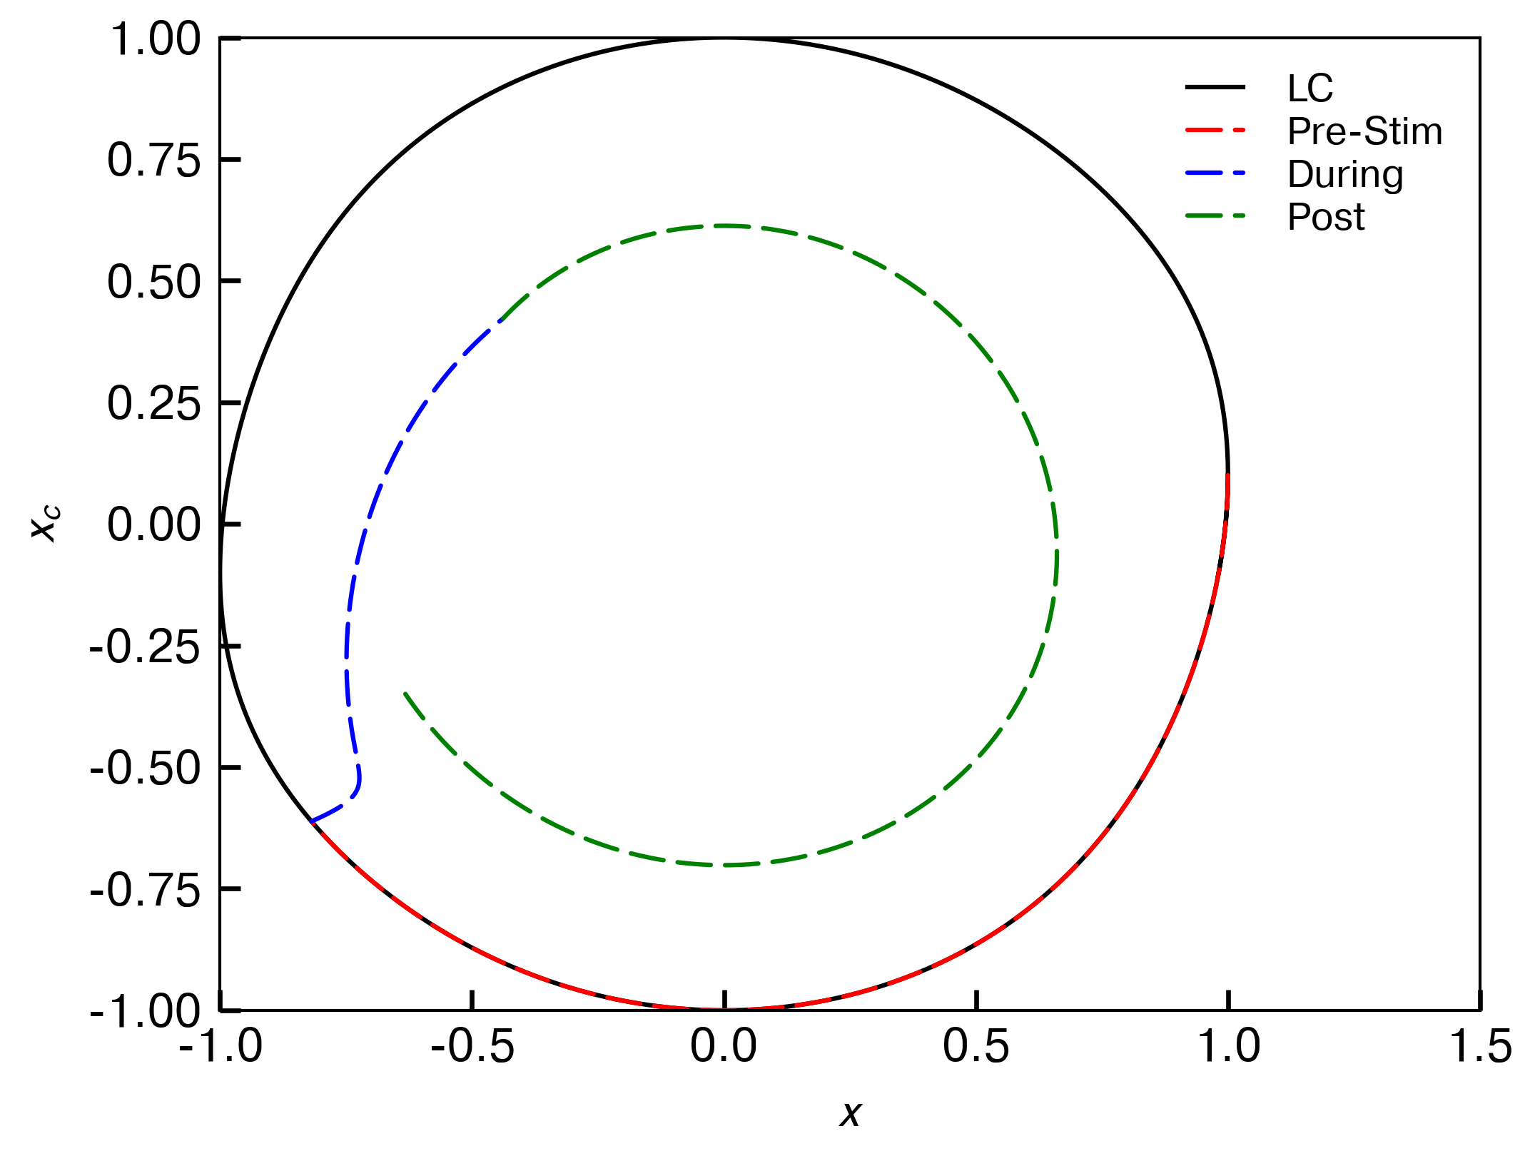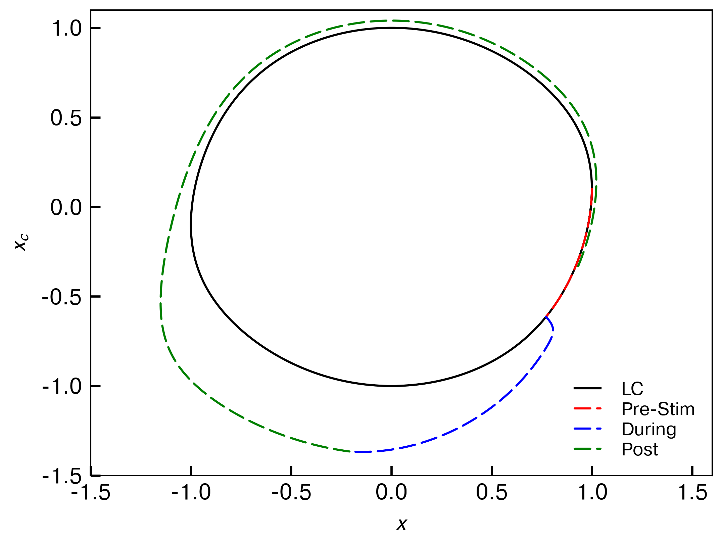

On the left is light pulse from 10-15. This clearly pushes the clock inside the limit cycle. On the right is stimulation from 3-5. This increases the amplitude, in both cases consistent with the ARC. I am to this point ignoring the PRC because the original three-pulse experiment was phase-agnostic: the pulses were 24h apart.

(ii) Recapitulation of the three-pulse experiment and testing for varying period

The purpose of the three-pulse experiment was to get a “type-0” reset, which we are calling “critical” because in reality it is close to the critical point and there are ways to get a type 0 without getting close to the critical point. The phases there are very close in phase space, so you can easily jump between phases. Here, I'm recreating the three-pulse experiment to see if we get near the critical point. To do this, I apply the first pulse from 10.4-15.4h, and then repeat every 24h. (We don't know exactly what the threshold for a critical reset is, but nevertheless it is some closeness to the critical point.) If only 25% of individuals critical reset in the study, it's possible that different periods/phase responses are causing the light to be imprecisely timed. So, in short: changing the period between 24.6 and 23.8 and recreating the three-pulse experiment.

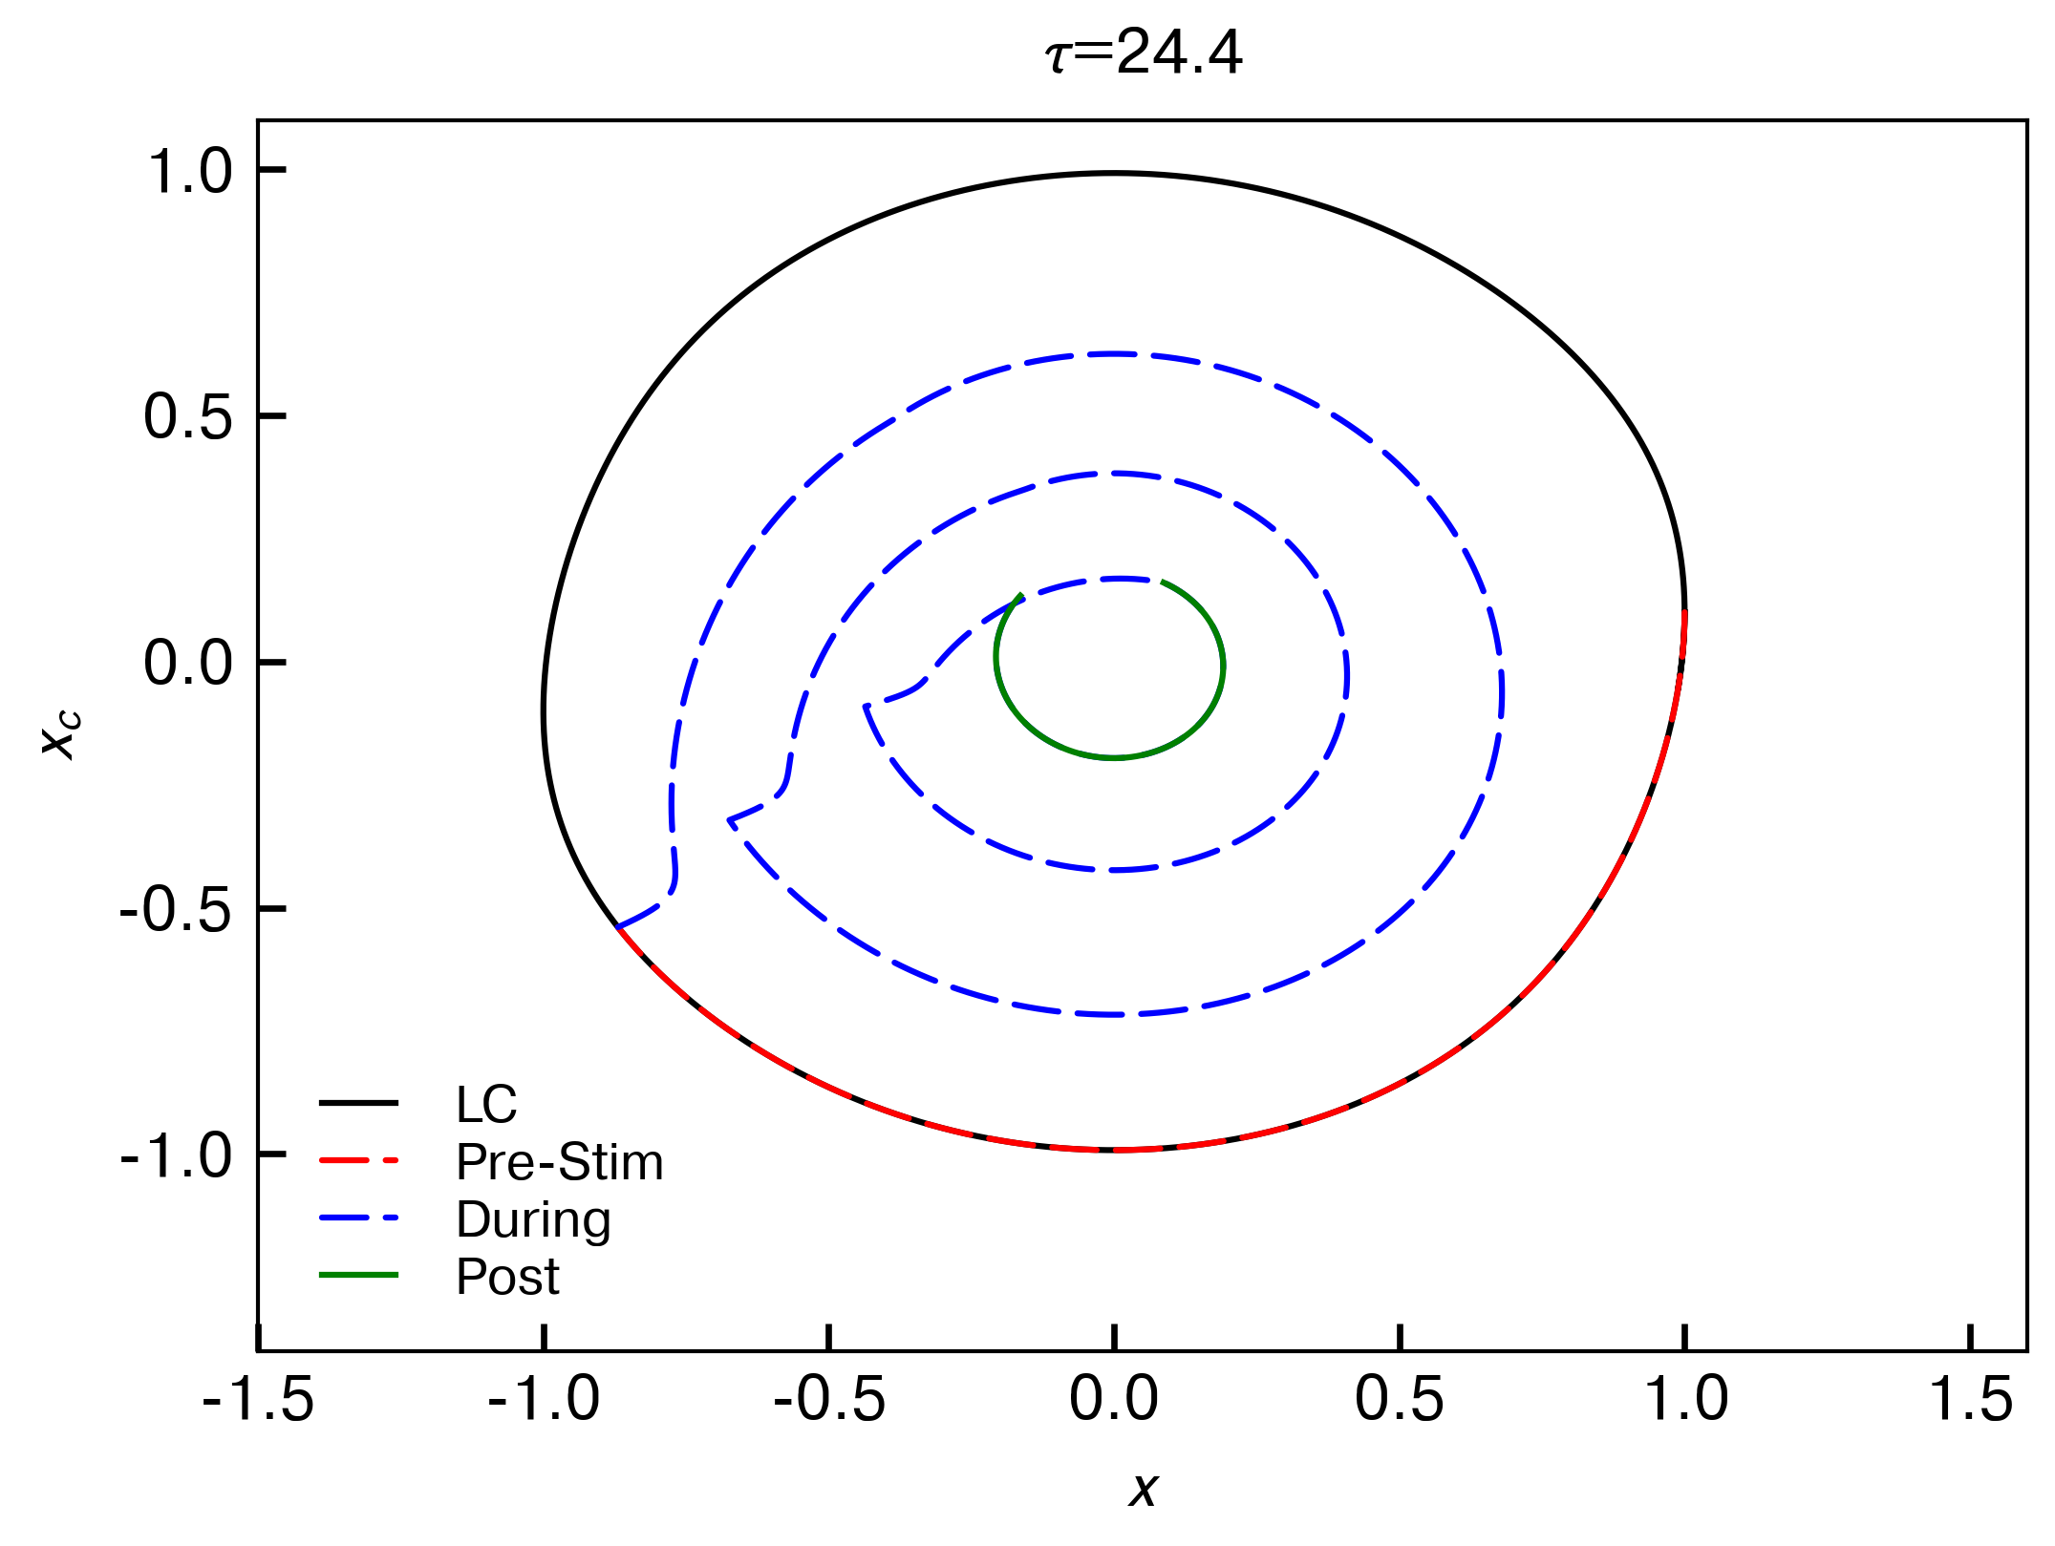

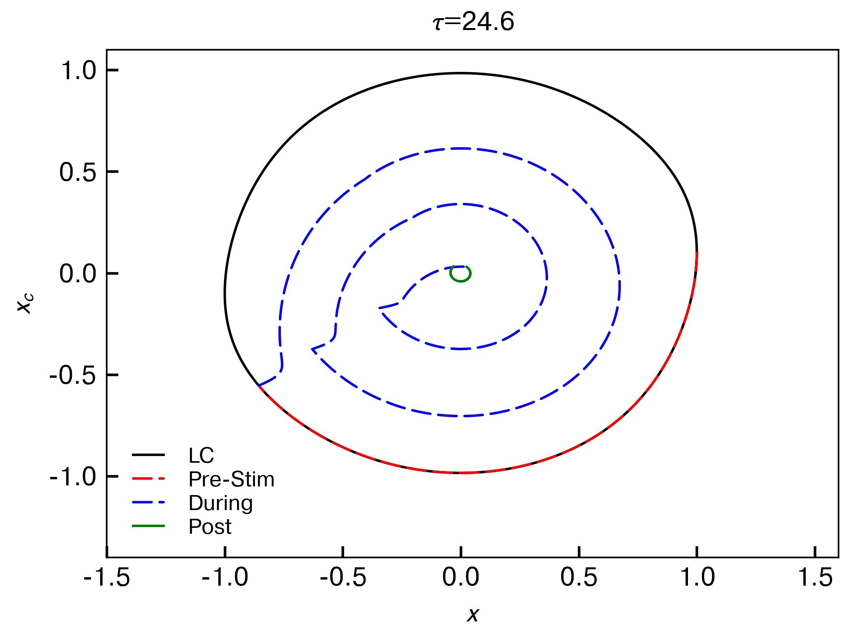

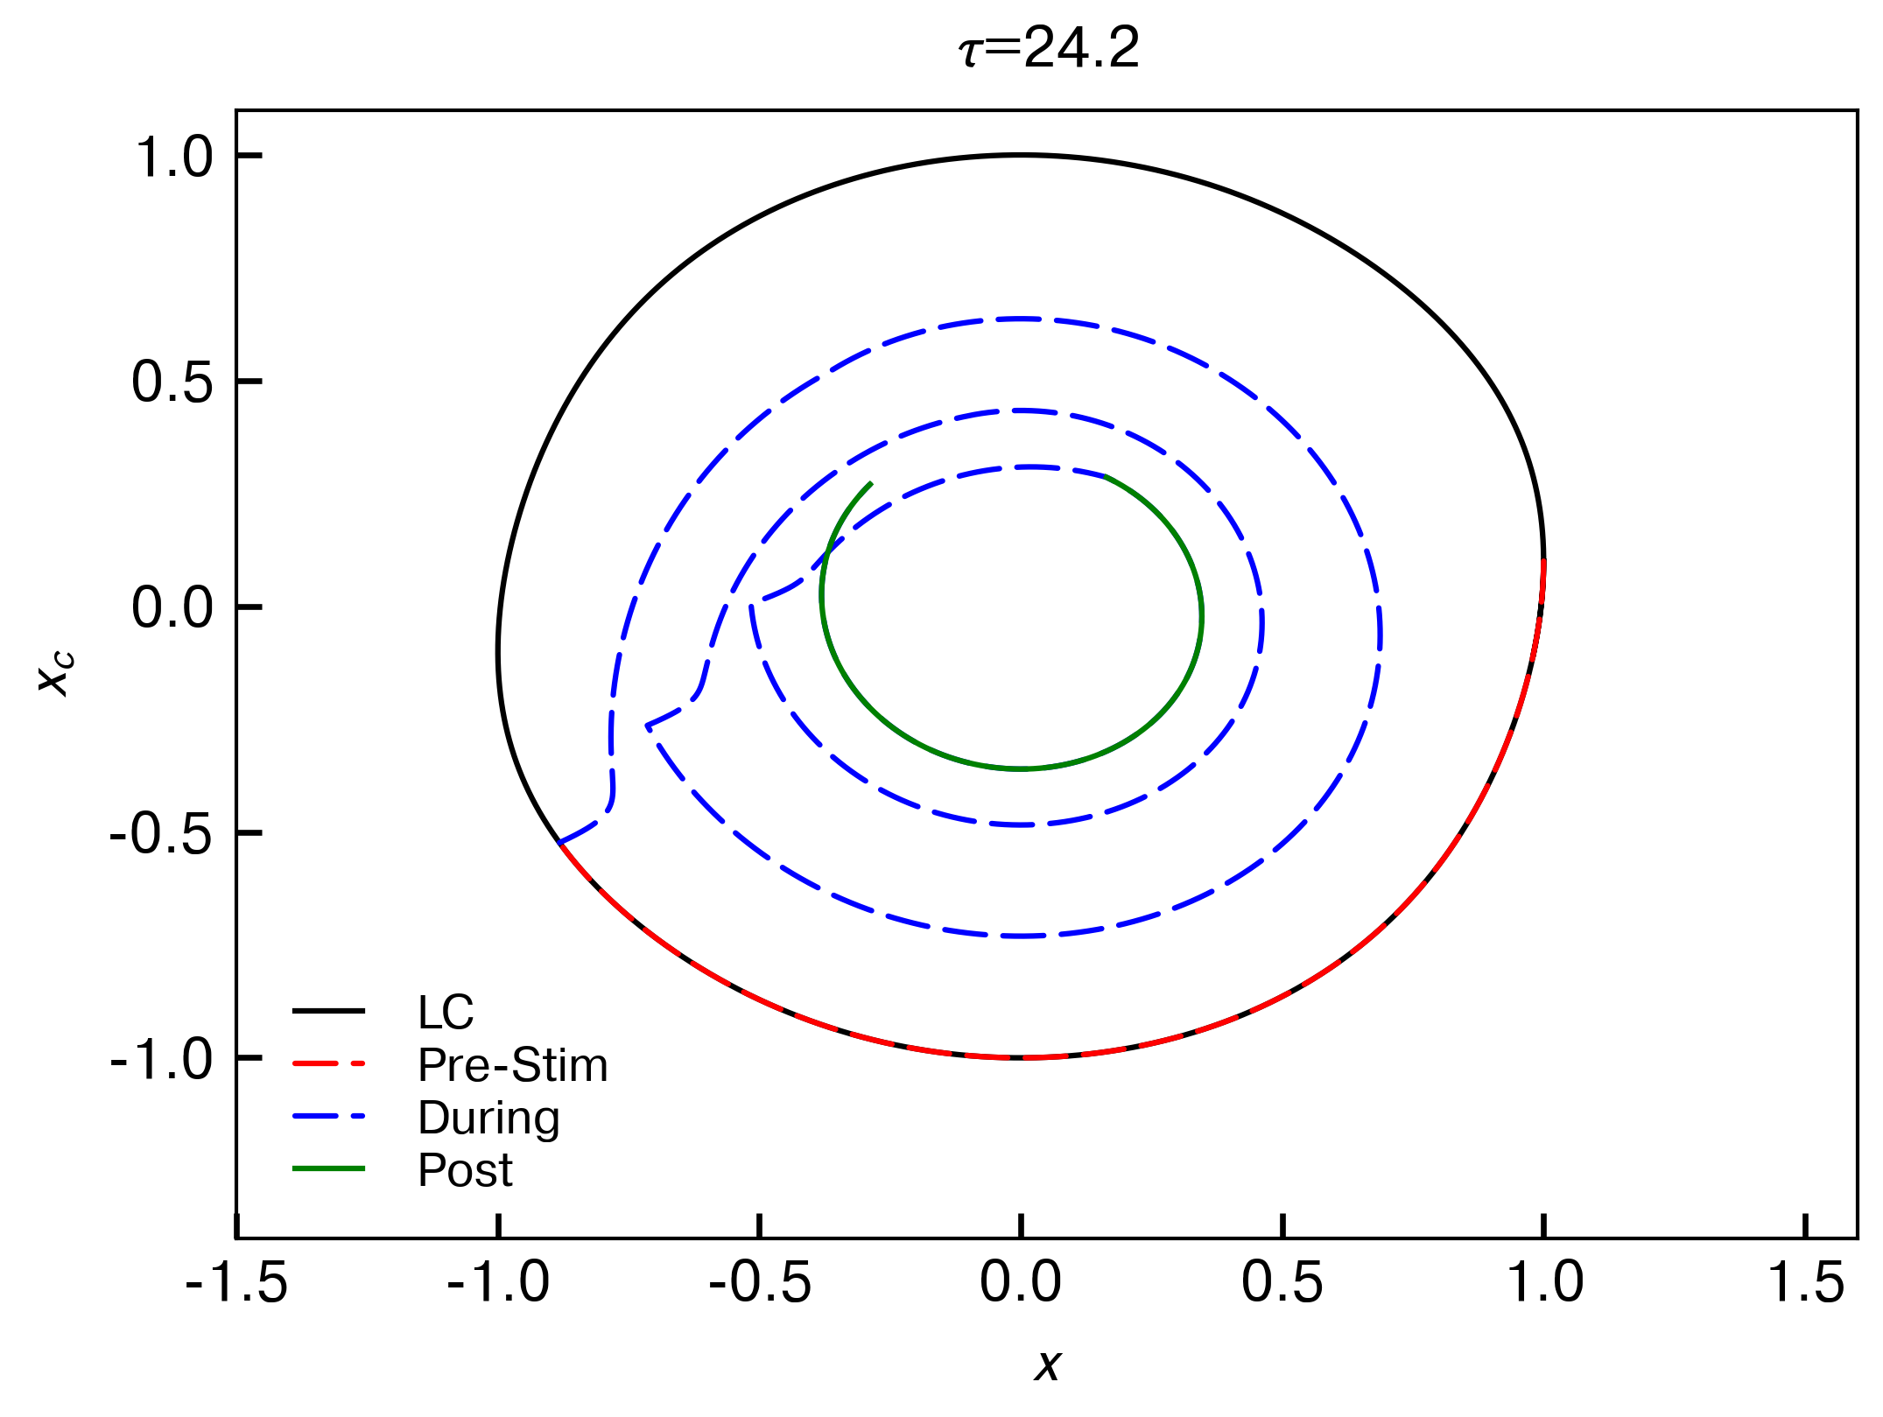

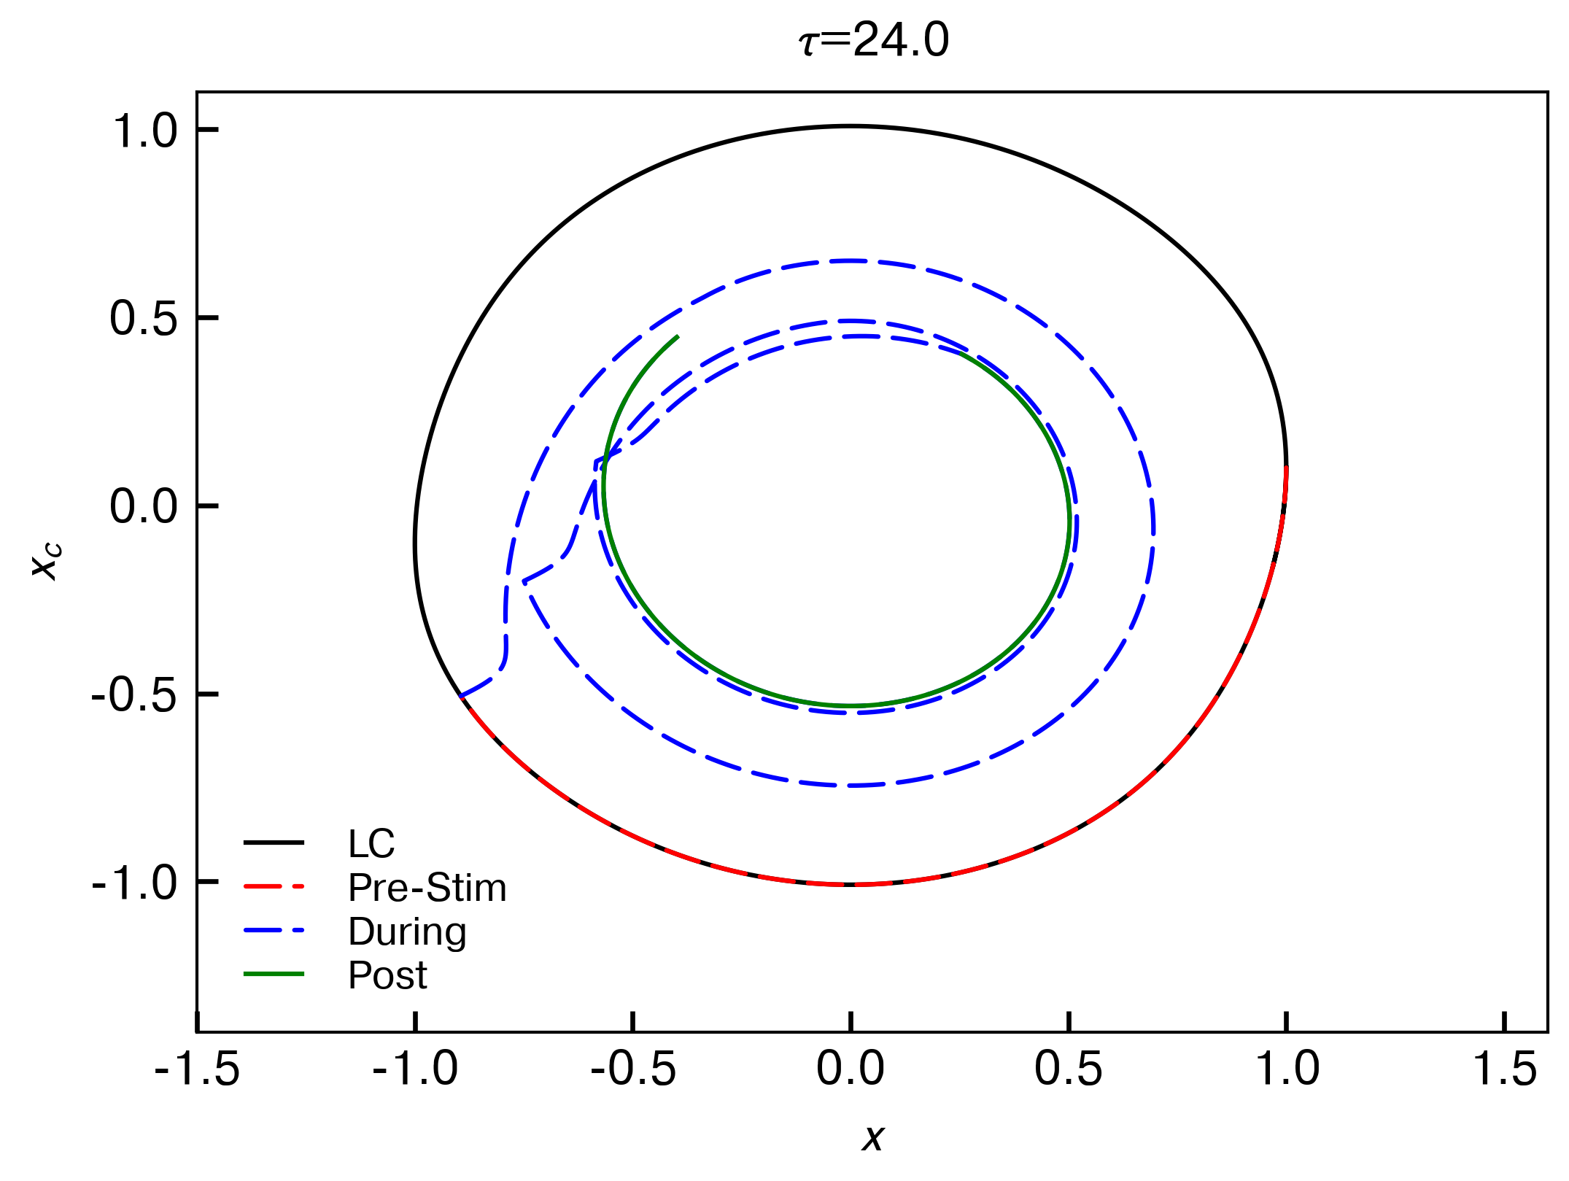

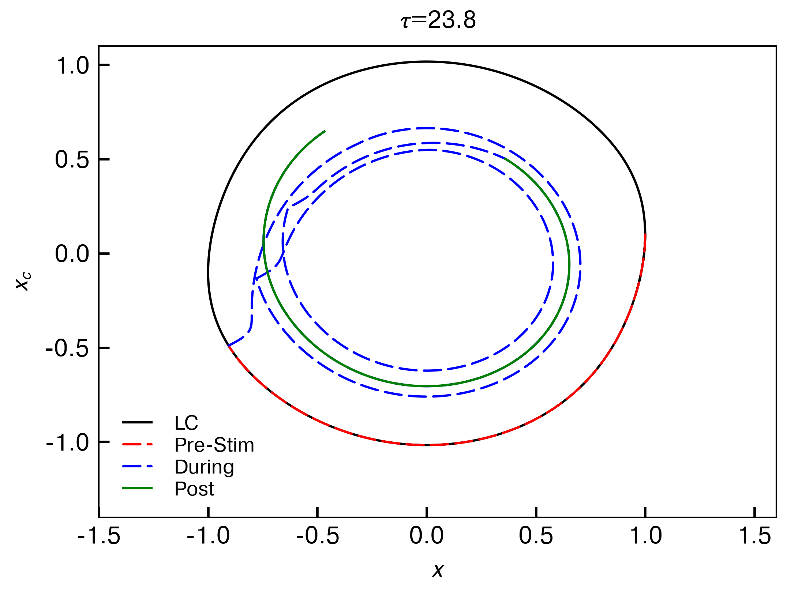

Why would a shorter period lead to a less precise critical reset? This is possibly because of the shape of the PRC. Each cycle, the phase is advancing slightly (due to shorter period), and therefore the PRC is hit in the positive region (top of this doc), advancing it further.

A similar idea holds for periods > 24.6h, where the delay is exacerbated. So, we're aiming for a pretty sensitive region completely blind. To see this, I plotted the distance to the singularity at the end of the final pulse for each period:

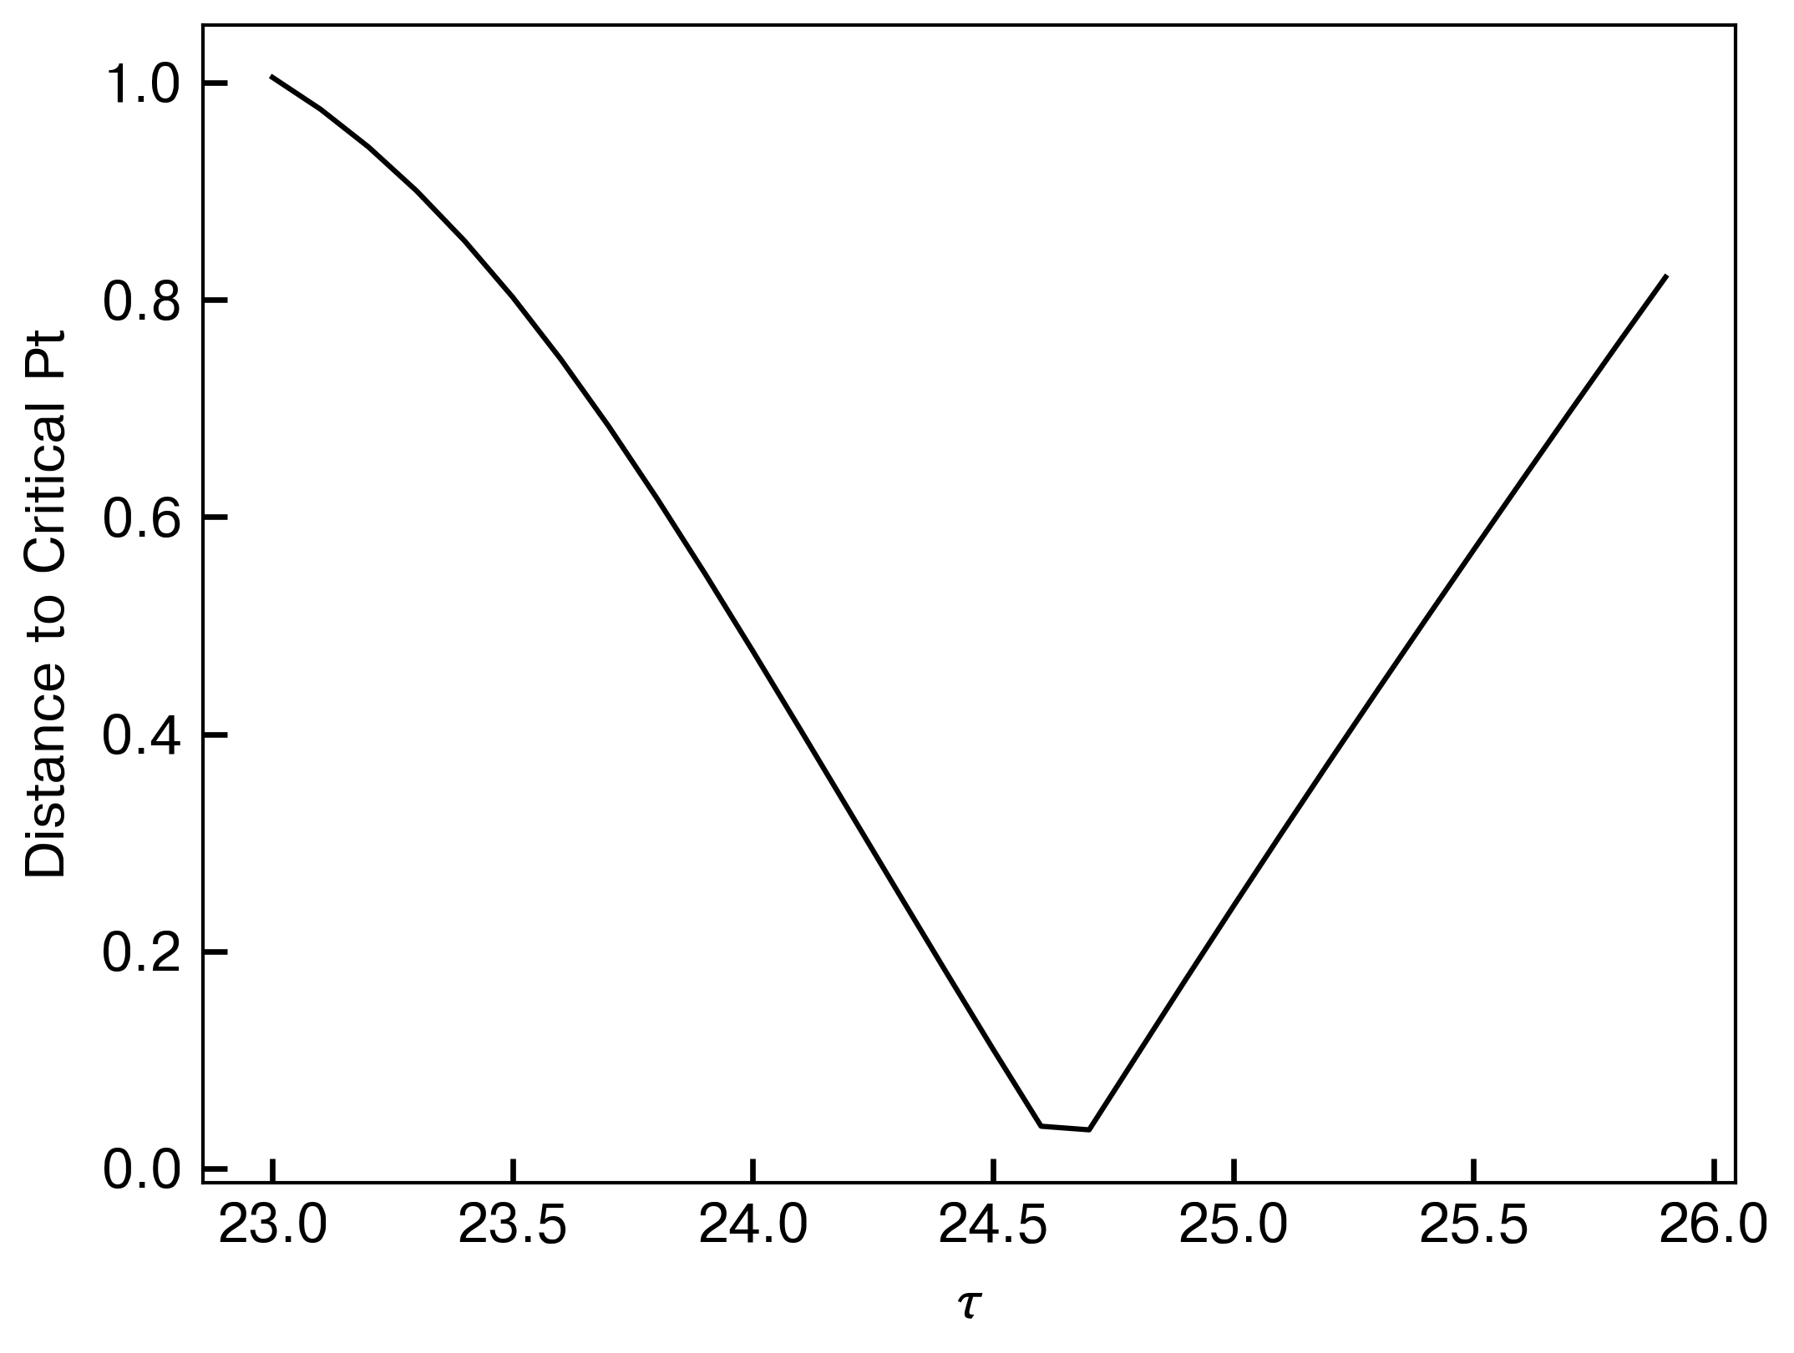

So only a narrow range of periods allows this to work in an open-loop (no feedback) fashion, which might explain the limited number of subjects who attained the critical reset.

(iii) Correction of timing using feedback control

Here I compare two protocols: the “shooting blind” protocol where the first pulse is at 10.4h (CBTmin) and each is 24h after, and the “targeted” protocol where the light starts when it reaches a certain phase (2.66 radians in each cycle, since that's what 10.4h corresponds to). This is extremely simple but may allow better critical resetting. I'll try this for periods of 24.6, 24.2, 23.8 hours. Left is dynamic plot showing the three states (light input is the nearly-square wave), right is the same limit cycle plots as above.

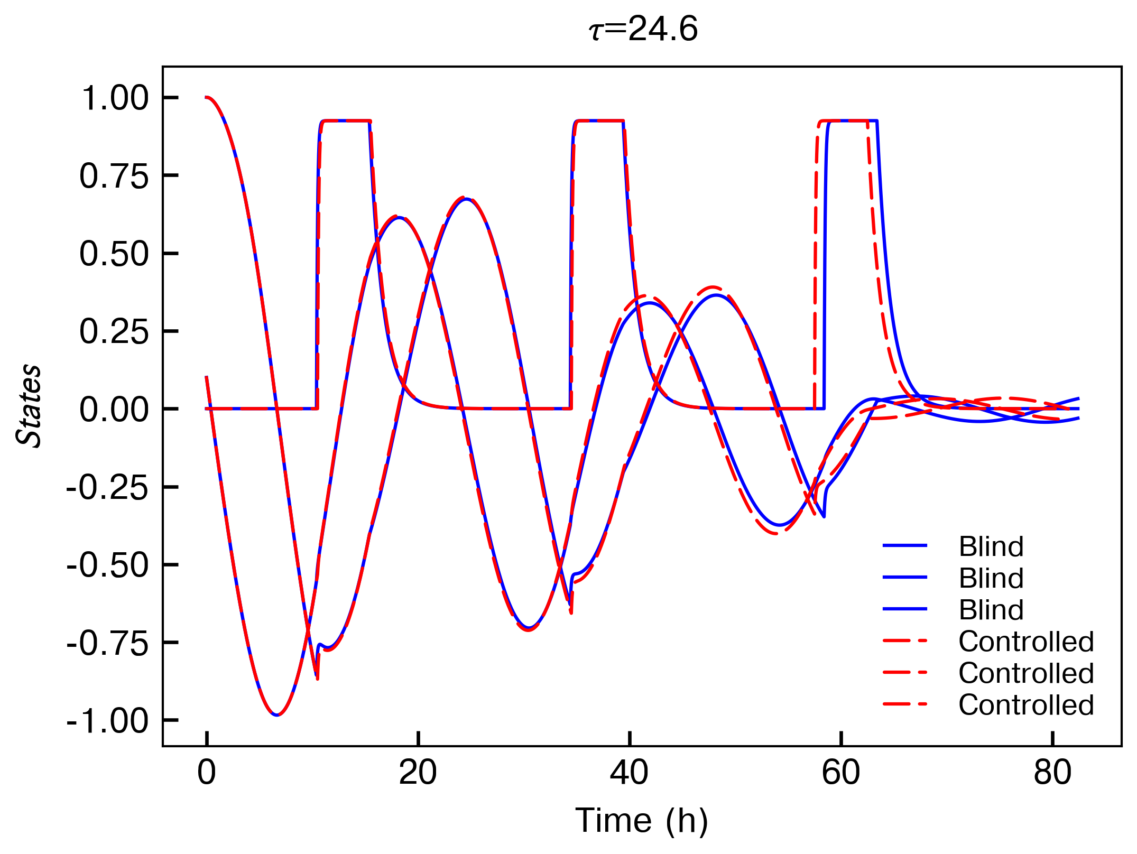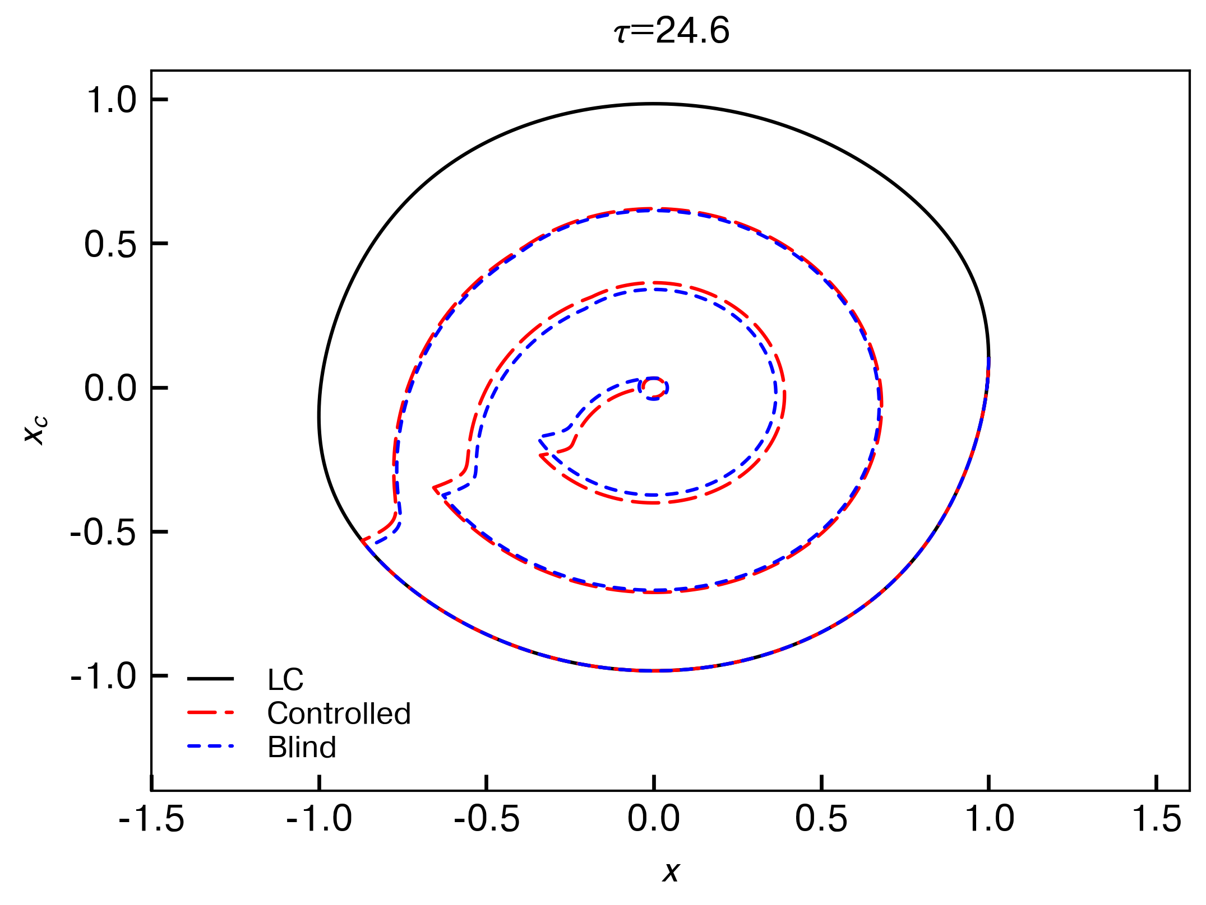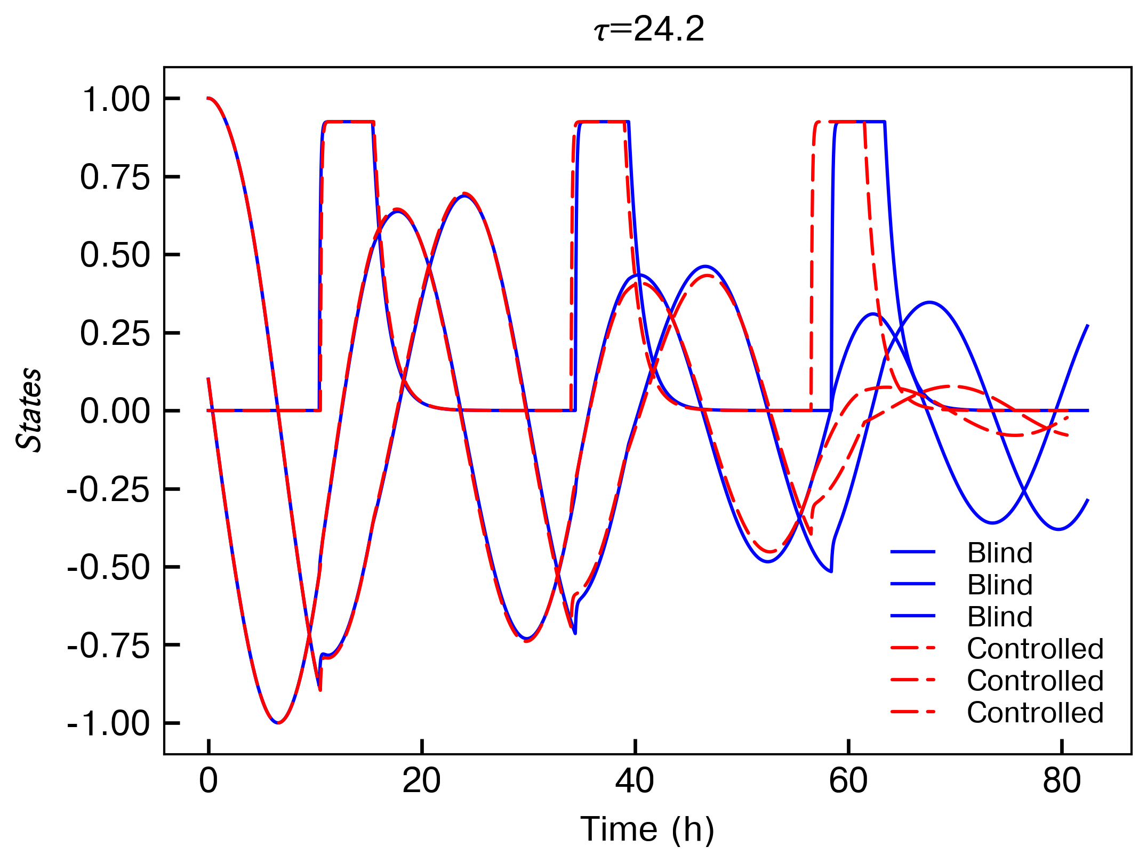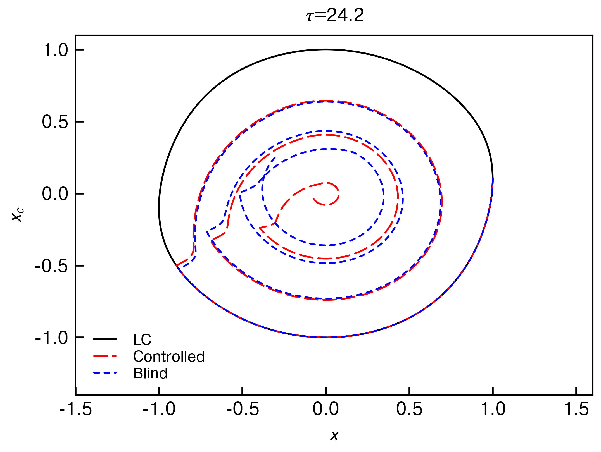

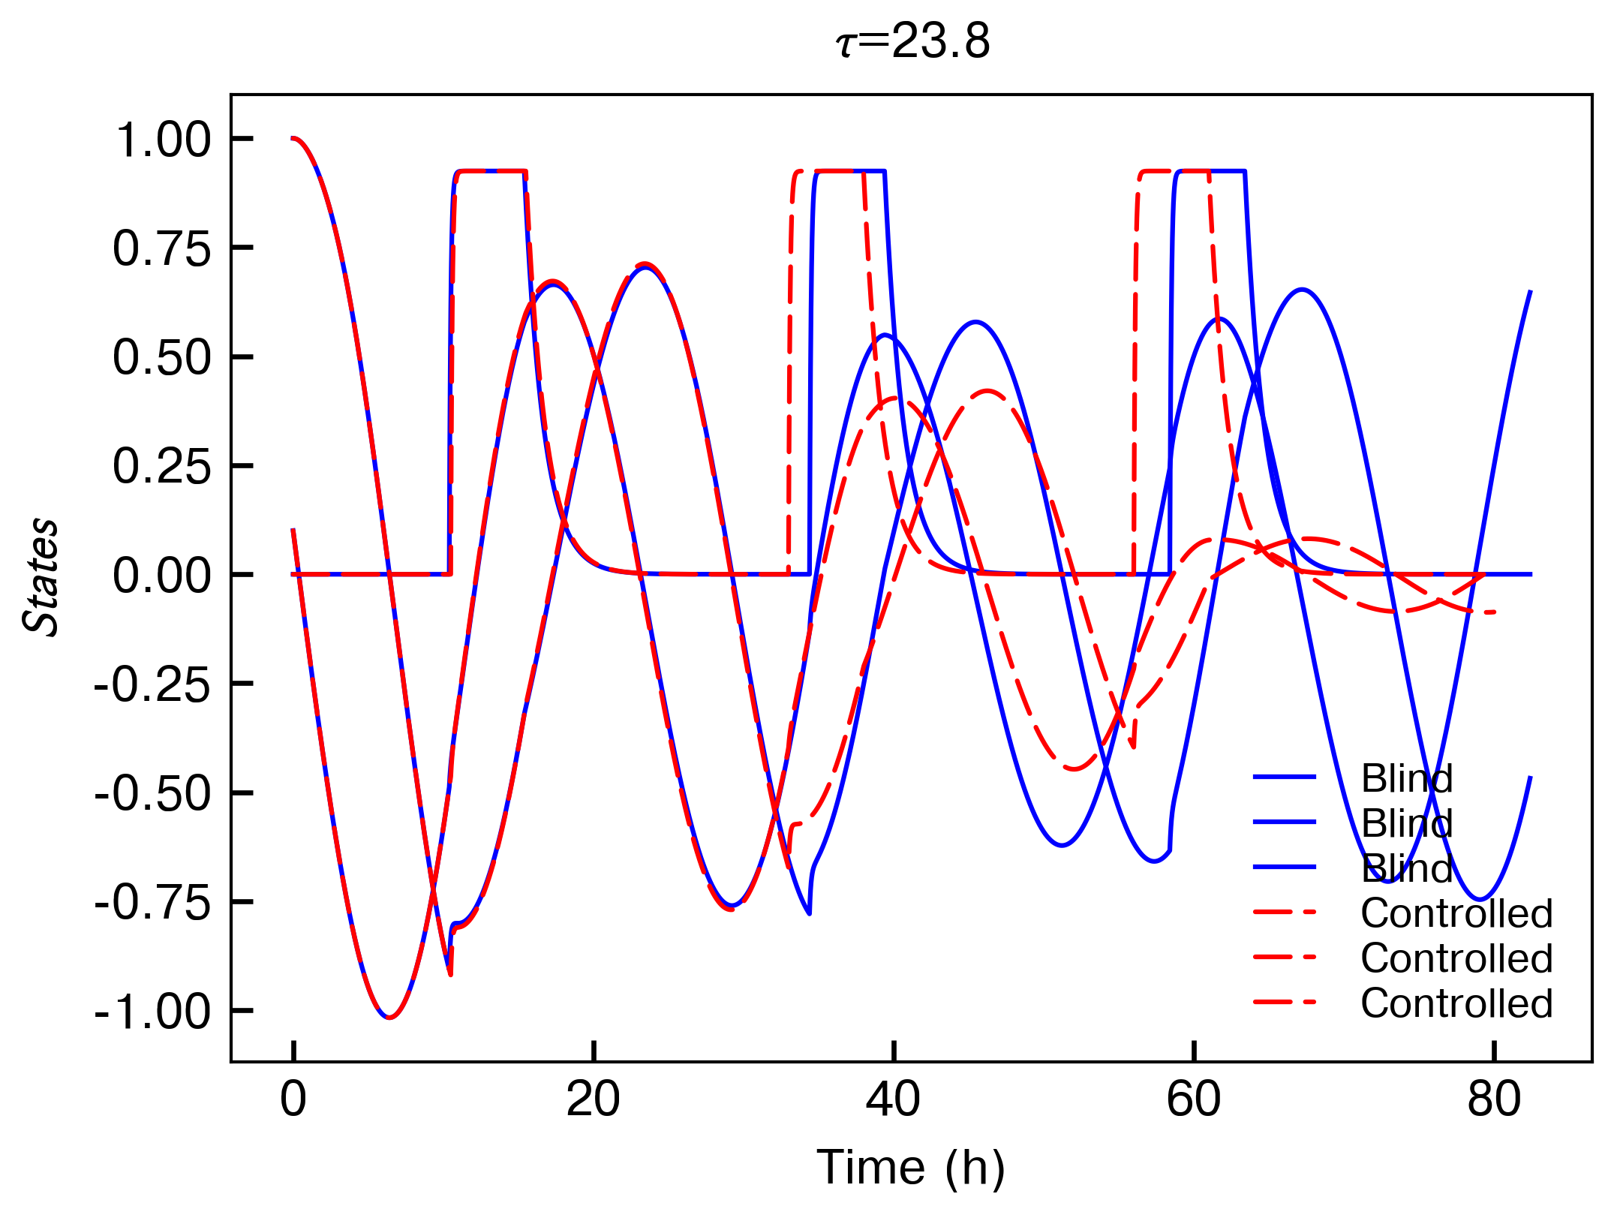

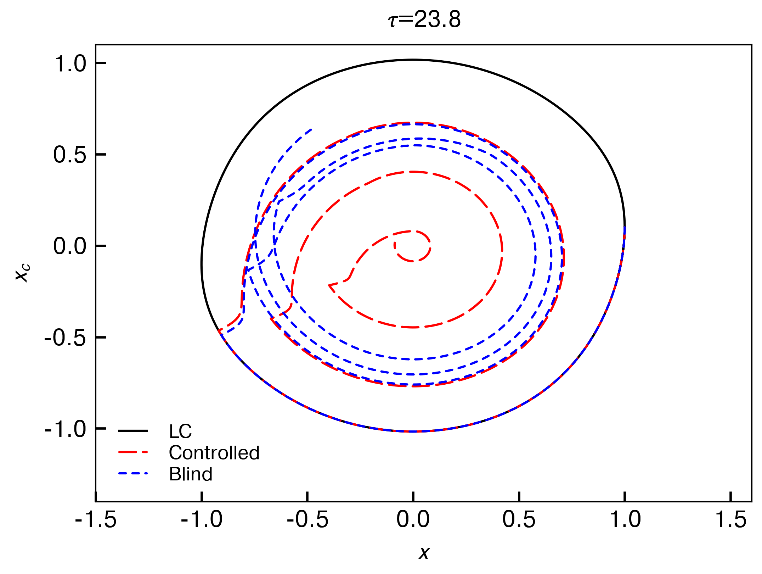

So, in all cases this formulation seems to be at least as good as the blind method. I'll plot the final distance as a function of period now for all of these to compare.

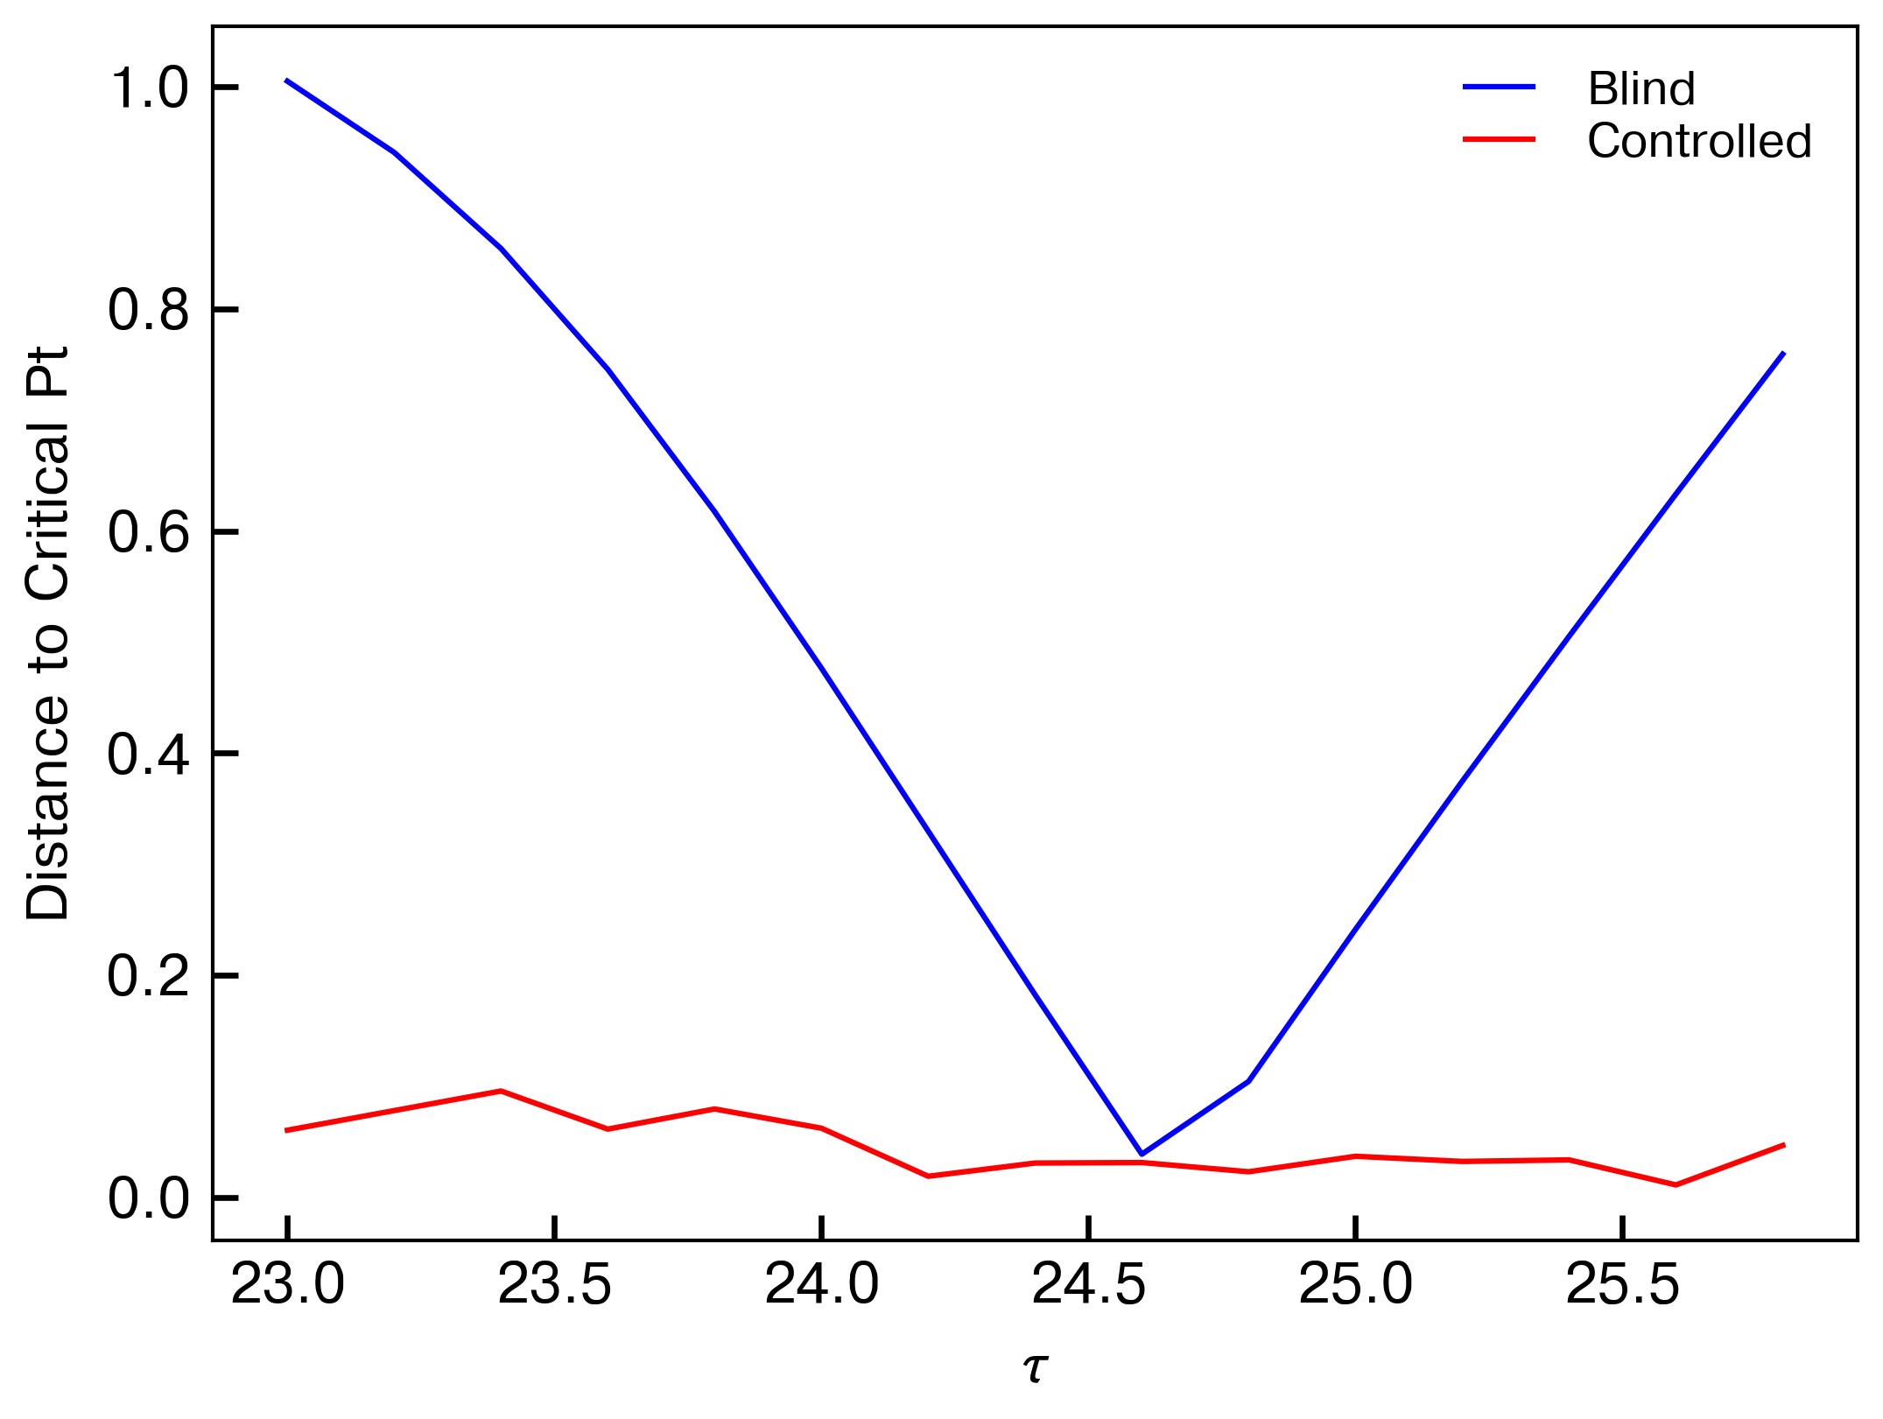

So it looks like we can get pretty good performance for all taus using this event-triggered control method.

**SUMMARY (and possible points for paper):**

**- inter-individual variability in human period explains the inability to consistently achieve a critical resetting in clinical settings**

**- this is caused by hitting different regions of the PRC and due to the sensitivity that you incur by trying to hit that part**

**- timing the pulse based on tau or (even better) feedback control allows a critical resetting to occur**

**- this also allows shorter pulses than 6h to get the critical reset (data not shown here) so long as the timing is good**

**- even an imprecise phase estimate allows the critical resetting (note: have not yet proven this, but could be as easy as saying “we need to be within x hours to hit it)**

**- this could be useful for phase shifting the human clock more aggressively**