DScaler 5 Emerging Design

Abstract
This document is an attempt to prompt discussion about the direction and design of the open source project DScaler. The document will outline the way functionality is to be split up and how the various parts are expected to interact with one another. The design process is intended to be shared and open although it is not yet clear how this will be handled.

The reader is assumed to be familiar with the DScaler 4 and DirectShow graphs.

Version Information
Name | Date | Version | Description
John Adcock | 15 Apr 03 | 0.1 | Initial Version

Introduction
The open source application DScaler has reached the point at which a major redesign seems like the only way for the project to grow and importantly for it to continue to meet the main needs and desires of its own developers.

DScaler’s direct hardware access in particular is a major drain on precious developer time as the number of slightly different capture cards is very large. Some of the core design decisions in the original project are also increasingly under pressure especially the use of the whole of the CPU for handling timing issues.

The improved smoothness now possible with DirectShow (demonstrated by the Holo3d application and the recent improved understanding of the reasons behind video jitter as shown by the reclock filter) mean that DirectShow can be considered as a suitable platform for developing a high quality video playback system.

Recent changes to MPEG decoders now allow the playback stream for DVDs to be accessed. This should allow real-time film mode detection on digital sources on powerful enough machines.

Vision
Create an architecture for a unifying Home Theater application.

Requirements

General Video
Allow playback of all video files, streams, devices.

DScaler quality processing applied to all SDTVresolution sources.

Full aspect ratio control of all sources with sensible defaults applied where no information is available.

Architecture to support processing plug-ins for video.

PVR and time-shifting should be allowed for in the design.

Processing of non YUY2 data streams should be supported.

Screen saver

General Audio
Provide for digital and analog input.

Allow for by channel adjustable audio delay.

Architecture to support processing plug-ins for audio.

User Interface
For primary tasks user interface to be simple to use and controllable with DVD style remote.

For infrequent setup tasks any UI model is acceptable.

Control of the application should be possible though a self-describing control interface.

Control applications should be able to request notification of events.

There may be a requirement for the application to control or be an uPnP application.

Sources
The application should support multiple sources.

Sources should, where possible, build on existing drivers and services.

Development
Where possible the tools required to build the application should be free (as in beer as least).

The application should be broken down into separate parts that can be worked on in parallel.

Non-windows specific code should be cross platform compatible where possible.

Application should be scriptable to allow for minor customisations to be handled by expert end-users.

Overall Structure
A rough outline of the structure is shown below. Each component will be explained in some detail below.
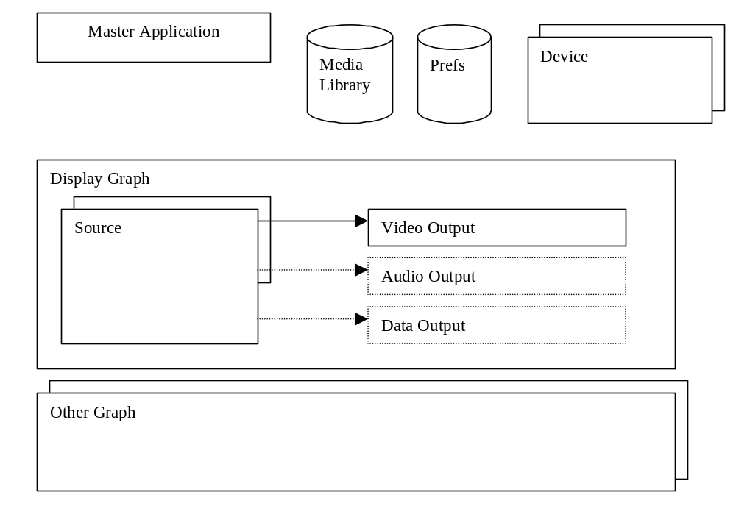

Master Application
The master application responds to events, commands etc and organises the main GUI and all the devices and graphs. It will map the available functions to uPnP so that we are controllable from other machines and will also present a COM (or .NET) interface for local control.

Media Library
Based strongly on the uPnP Content Directory see http://www.upnp.org/download/ContentDirectory 1.0.prtad.pdf . This will be implemented as a service such that there will be one instance per network. It will be accessable via uPnP methods. We may need to do a local (non-uPnP) cut down version for single machine use. It may be possible to leverage the Windows media player library and this should be investigated further but I would expect that we will have to do a lot of things ourselves. The media library will have an implied structure which will be represented to the user via the UI. Some example media items follow.

Analogue TV Channel
Would be stored as the name of the channel and possibly a picture. There will also be enough information to allow tuning to this channel on all supported devices. So if you have a VCR then the only information would be the channel number on the VCR, if you use the tuner card then the frequency and format will be required.

Digital TV Channel
Would be stored as the name of the channel and possibly a picture. There will also be enough information to allow tuning to this channel on all supported devices. So if you have a STB then the only information would be the channel number on the VCR, if you use a BDA tuner card then a complete persisted TuneRequest object will be stored.

Album
All the usual metadata with a picture

Picture Album
A playlist of picture or patterns with maybe some commentary.

Preferences
We will need a local database of preferences and settings. This may need to be fairly large and should probably not be and ini file and certainly not the registry. Preferences should be such that they can be set globally or by media (this will be the equivalent of per channel settings)

Device
A device will correspond to a physical box, PC card or another uPnP deviceon the network. They will be represented as objects that have any number of inputs and ouputs as well as a description of any settings and methods they may have. It’s probably best to work through some examples.
All devices will expose an interface similar to http://www.upnp.org/download/ConnectionManager 1.0.pdf

Video Capture Card
A standard capture card will be exposed as something that can accept one of a TV frequency, composite video, s-video and output analog sound, and YUY2 PCI video. It will support settings for brightness etc

Sound Card
A simple sound card will be exposed as three devices, an input device accepting analog audio and producing PCM PCI audio, an output device taking PCM PCI audio and producing analog output and a mixer device.

Set Top Box
Might be modelled as a device outputting analog video. How should we control external devices.

Display Graph
A single DirectShow graph that contains a VMR 9 renderer that displays any video being played back and also has the main GUI alpha blended in

Source
The set of DirectShow filters that must be built to decode a given source. The code to build the graph should be pretty simple, may even be in an external text file format a bit like ZoomPlayer

Video Output
Accepts and processes decoded video formats. Film detection, optional deinterlacing and noise filters go in here.

Audio Output
Accpects all decoded audio formats and performs processing e.g. Delays, bass management.

Data Output
How should we handle teletext and CC. There is already some DirectShow support but it is weak.

Other Graph
For an external video source we will want to process audio separately. Also things like PVR functions may require us to keep multiple non-display graphs running in separate threads.

Main User Interface
I see this as being a DVD style menu based heavily around the structure imposed by the Media Library.

Setup User Interface
The behind the scenes view will probably be very similar to the current Dscaler settings dialog, a generic settings changer with specific dialogs where appropriate.

External User Interfaces
Can be anything you want hopefully. Control should be via uPnP or via some other wndows specific method.

