Climate report
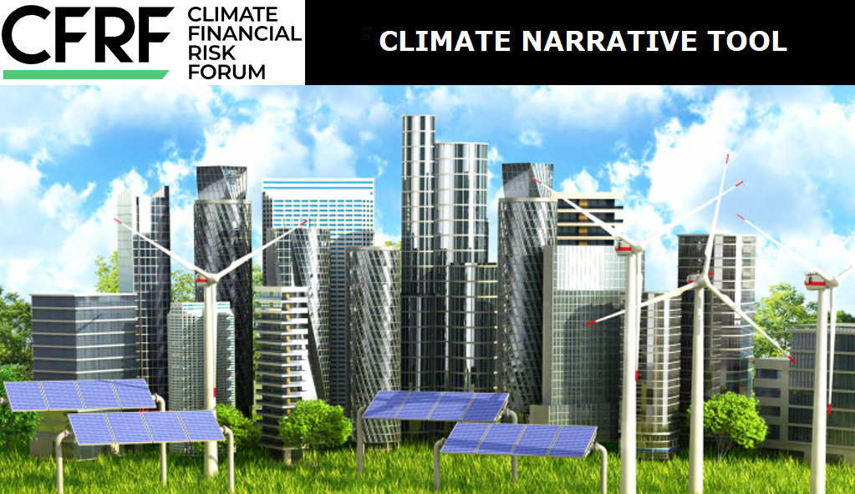

• Disclaimer
• Introduction to the Executive Summary and the long form Report
• Introduction to the Sector or Liability Report
• Executive summary
– NGFS Orderly Scenarios
– NGFS Disorderly Scenarios
– NGFS Hot House World Scenarios
• NGFS Orderly Scenarios
– Key assumptions and parameters
– Agriculture Sector
• NGFS Disorderly Scenarios
– Key assumptions and parameters
– Agriculture Sector
• NGFS Hot House World Scenarios
– Key physical assumptions and parameters
– Agriculture Sector
• References
– Agriculture Sector

Disclaimer
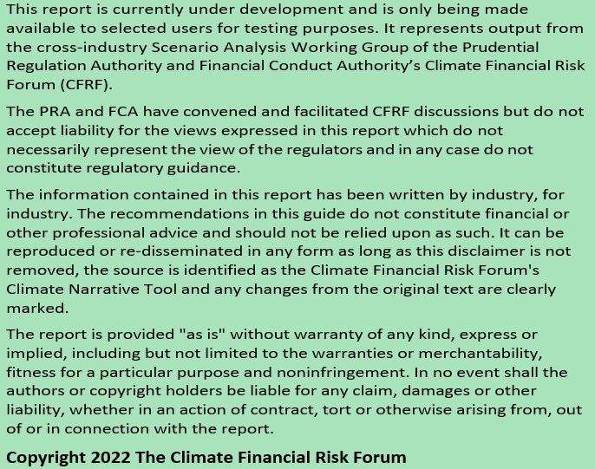

Introduction to the Executive Summary and the long form Report
This report summarises the relevant climate-related risks and opportunities for a firm based on the materiality of exposures to different lending exposure types, underwriting classes, asset classes, and economic sectors selected. These narratives are based on the NGFS scenarios which were updated in June 2021.

Introduction to the Sector or Liability Report
This report provides a stand-alone description for a selected underwriting class or economic sector for a particular NGFS scenario. These narratives are based on the NGFS scenarios which were updated in June 2021.

How can the report be used?
The information provided by the CFRF Online Scenario Analysis Narrative Tool and its associated reports aims to help firms start to better understand their potential financial exposures to climate change. This information could help them to start considering climate-related risks and opportunities within their governance, strategy, risk management and reporting under the Task Force on Climate-Related Financial Disclosures’ (TCFD) recommendations. The information provided could also encourage a more in-depth scenario analysis exercise to better understand the associated impact and support decision making. However, the observations in this report do not constitute financial or other professional advice and should not be relied upon as such.

Limitations
There are a number of uncertainties and limitations associated with the tool; for example: The tool is not updated on an ongoing basis. It draws heavily on the NGFS scenarios (updated in June 2021). The results are in turn underpinned by a single energy systems model (REMIND)which makes particular assumptions about long-term technology pathways that are of course highly uncertain.
This tool may be useful for climate reporting and risk assessments. However, a limitation for those seeking to embed climate-related risks and opportunities into their risk management framework and investment decision making is that it does not specify a baseline related directly to what is priced into assets today. It also does not allow for meaningful variation in the implementation of climate policies across geographies and sectors, nor alternative technology pathways.
For example, the Orderly Below 2°C scenario generates a common carbon price for the global power and transportation sectors, as well as between, say EU and US and China. Similarly, the tool does not provide a mechanism to really test how financial exposures may differ if the very solar PV friendly technology pathways of the REMIND model do not come to pass. Relaxing these policy and technology universality assumptions will naturally generate quite different assessments of the climate exposures of different financial securities and assets.
There are many potential ways to incorporate more plausible policy pathways and a wider range of technology pathways into climate scenario analyses. One of these has been designed by abrdn in partnership with Planetrics. This approach creates scenarios that allow for climate policy objectives to vary across the major emitting regions and sectors. It also allows for the interaction between these plausible policy variations and alternative technology pathways to be explored. All financial impairment estimates are then calculated relative to a baseline assessment of what is priced into assets at any given point in time.
This framework also has the virtue of filling in some of the ‘probability mass’ that sits between transition-heavy scenarios that are strongly or weakly aligned with the objectives of the Paris Agreement and those that are dominated by physical risks.

What is next?
The Centre for Greening Finance and Investment have agreed to house the tool on their IT platform. The tool will be released publically in Q2 2022 after further testing.
During the remainder of 2022, the Climate Financial Risk Forum Scenario Analysis Working Group will continue to collect feedback from users and will update the tool to enhance content and reflect the latest NGFS scenarios in Q1 2023.

Executive summary

NGFS Orderly Scenarios
The Orderly transition risk scenarios could result in a gradual reduction in CO2 emissions and an increase in the carbon price. The investments in energy efficiency and low carbon technologies are projected to increase (e.g. annual investment in low carbon increases from ~750 billion USD to between ~2 trillion USD and ~3 trillion USD by 2030). Global mean temperatures are projected to increase across the world by 1.6°C to 1.7°C, compared to pre-industrial levels, by 2050.
These scenarios could lead to chronic changes in living conditions affecting health, labour productivity (a decrease in labour productivity due to the reduced capacity of the human body to perform physical labour under hot and humid climate conditions), agriculture, ecosystems, and sea-level rise. It can also further change the frequency and severity of weather events such as heatwaves, droughts, wildfires, tropical cyclones, and flooding. The total cumulative relative GDP impact is estimated to be between -1.5% and -2.5% by 2050.

Agriculture Sector
The Agriculture sector continues to expand to feed and supply agricultural energy products to a growing global population. It contributes to 23% of anthropogenic emissions, exposing its producers and financiers to emerging climate related transition risks through public policies, consumer demand shifts and technological evolutions.
By 2050, the Orderly transition risk scenarios driven by societal change, national energy strategies, and carbon legislation, are likely to have a significant impact on the agriculture sector. Agricultural value chains face material climate transition risk exposure due to their emissions intensity and reliance on land. A potential expansion of land protection policies and carbon payments made to preserve and expand forests could reduce land available for agriculture.
These scenarios could also lead to a limited relative reduction in GDP growth and could result in changes in the rate of growth in demand for the agriculture sector, although the impact is likely to be limited due to inelastic demand for food products.

NGFS Disorderly Scenarios
In the Divergent Net Zero scenario the reduction in CO2 emissions starts to occur earlier and as a result is more gradual, and carbon prices rise at a smoother rate. The investments in energy efficiency and low carbon technologies are projected to increase (e.g. annual investment in low carbon technologies increases from ~750 billion USD to ~3 trillion USD by 2050). Global mean temperatures are projected to increase across the world by 1.6°C to 1.8°C, compared to pre-industrial levels, by 2050.
The Disorderly transition risk scenarios could lead to chronic changes in living conditions affecting health, labour productivity (a decrease in labour productivity due to the reduced capacity of the human body to perform physical labour under hot and humid climate conditions), agriculture, ecosystems, and sea-level rise. It can also further change the frequency and severity of weather events such as heatwaves, droughts, wildfires, tropical cyclones, and flooding. The total cumulative relative GDP impact is estimated to be between -4.2% and -4.8% by 2050.

Agriculture Sector
The Agriculture sector continues to expand to feed and supply agricultural energy products to a growing global population. It contributes to 23% of anthropogenic emissions, exposing its producers and financiers to emerging climate related transition risks through public policies, consumer demand shifts and technological evolutions.
By 2050, in the Delayed transition risk scenario, late policy action enables a “fossil recovery” out of the economic crisis brought about by COVID-19. CO2 emissions increase until 2030, before sharply decreasing after 2030 to compensate for the inaction beforehand. In the Divergent scenario there is a more immediate but divergent reduction in CO2 emissions. These scenarios are likely to have a significant impact on agriculture sector. Agricultural value chains face material climate transition risk exposure due to their emissions intensity and reliance on land. Under these scenarios, the expansion of land protection policies and carbon payments made to preserve and expand forests could reduce land available for agriculture.
These scenarios could also lead to a reduction in GDP growth. This could result in changes in the rate of growth in demand for the agriculture sector, although the impact is likely to be limited due to inelastic demand for food products.

NGFS Hot House World Scenarios
In the Hot House World scenarios CO2 emissions do not decrease and carbon prices to not increase sufficiently to prevent significant temperature rises resulting in high physical risk. In these scenarios global mean temperatures are projected to increase across the world by ~2°C compared to pre-industrial levels, by 2050.
This could lead to a significant chronic change in living conditions affecting health, labour productivity (a decrease in labour productivity due to the reduced capacity of the human body to perform physical labour under hot and humid climate conditions), agriculture, ecosystems, and sea-level rise. It can also change the frequency and severity of weather events such as heatwaves, droughts, wildfires, tropical cyclones, and flooding. The total cumulative relative GDP impact is estimated to be between -2.8% and -4.8% by 2050.

Agriculture Sector
The Agriculture sector is also exposed to physical risk. Chronic effects (e.g. raised sea-levels and mean temperatures) and acute effects due to changes to frequency and severity of weather events such as heatwaves, wildfires, tropical cyclones, and flooding are adding to pressures on global agricultural and food systems and could lead to severe disruption to agricultural production which could impact the profitability for some companies in long-run. Whilst the agriculture sector is used to responding to and managing changing weather conditions, in the high physical risk scenario, climate change and global warming could increase weather variations. This could lead to increasing disruption to agriculture sector which could impact profitability.
Adverse impacts on world GDP from physical risks are assumed in the scenarios and these scale with the rise in temperatures in the scenarios over time. The high physical risk scenarios could therefore also lead to a significant GDP impact which could negatively impact demand for agriculture, although the impact is likely to be limited due to inelastic demand for food products.

NGFS Orderly Scenarios
These Orderly transition risk scenarios assume that effective policy changes are introduced in a timely manner.
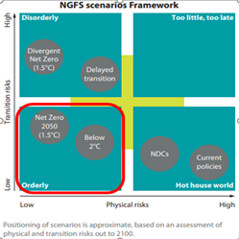
Source: NGFS Climate Scenarios, June2021
The NGFS have defined two orderly scenarios:
• Net Zero 2050 limits global warming to 1.5°C through stringent climate policies and innovation, reaching global Net Zero CO2 emissions around 2050. Some jurisdictions such as the US, EU and Japan reach Net Zero for all GHGs.
• Below 2°C gradually increases the stringency of climate policies, giving a 67% chance of limiting global warming to below 2°C.

Key assumptions and parameters
In these scenarios the reduction in CO2 emissions occurs gradually. This is achieved by an immediate and smooth policy reaction decarbonising the energy supply, accelerating electrification and switching to low-carbon fuels in industry, transport and buildings, deploying bioenergy with carbon capture and storage and increasing afforestation.
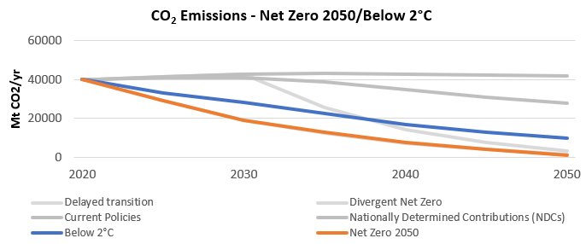
Source: IIASA NGFS Scenario Explorer
The price of carbon is higher in a Net Zero 2050 scenario compared to a Below 2°C scenario, this is due to more rigorous targets of limiting global warming to a maximum of 1.5°C set in the Net Zero 2050 scenario. In both the scenarios the gradual but significant rise in emission prices gives rise to transition risk.
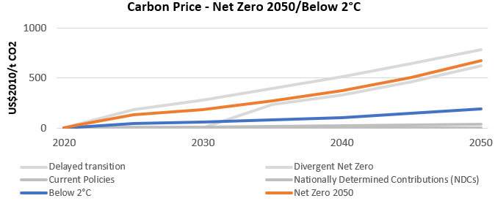
Source: IIASA NGFS Scenario Explorer. Carbon prices are weighted global averages.
The investments in energy efficiency and low carbon technologies are projected to increase in Orderly transition risk scenarios. These are expected to be higher in a Net Zero 2050 scenario compared to a Below 2°C scenario. Overall, firms could be required to readjust their capital expenditure in line with these trends; developing more efficient and less carbon intensive products and services in order to adhere to carbon pricing policies. The technologies that result from these investments could also adjust asset valuations of relatively older technology. Annual investment in energy efficiency increases from ~200 billion USD (inflation adjusted to 2010 baseline) to between ~500 billion USD and ~750 billion USD by 2050, whilst annual investment in low carbon technologies increases from ~750 billion USD to between ~2.5 trillion USD and ~3 trillion USD by 2050.
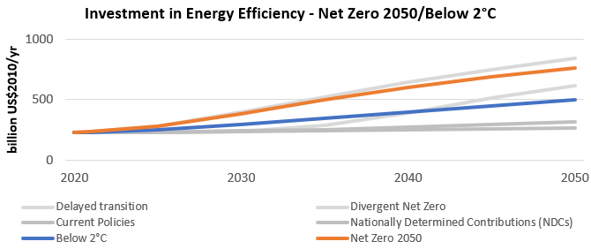
Source: IIASA NGFS Scenario Explorer.
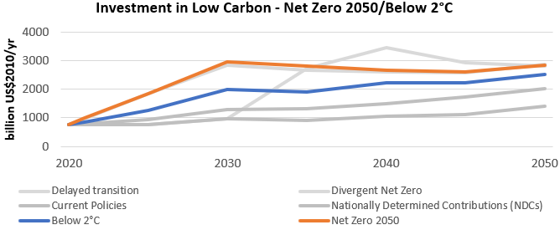
Source: IIASA NGFS Scenario Explorer.
Observed climate change has already increased global mean temperatures above 1.2°C, compared to pre-industrial levels, and both the global land area and the global population annually exposed to river flood, crop failure, tropical cyclones, wildfire, drought and heatwaves has more than doubled. (See Kaufman, D. et al. (2020)).
The increasing concentrations of carbon dioxide, methane and nitrous oxide in the atmosphere are unprecedented in at least the last 800,000 years and are extremely likely to have been the dominant cause of warming since the mid-20th century. In these scenarios global mean temperatures are projected to increase across the world by 1.6°C to 1.7°C, compared to pre-industrial levels by 2050, with land warming faster than oceans and high latitudes experiencing higher warming giving rise to low physical risk.
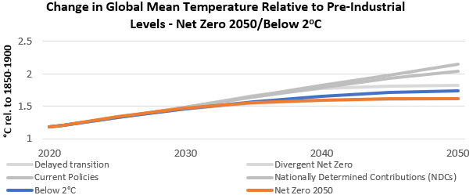
Source: IIASA NGFS Scenario Explorer, NGFS Scenario Data IAM outputs v2.2 REMIND-MAgPIE 2.1-4.2 model
These changes could lead to chronic changes in living conditions affecting health, labour productivity, agriculture, ecosystems, and sea-level rise. It can also further change the frequency and severity of weather events such as heatwaves, droughts, wildfires, tropical cyclones, and flooding. For example, in the Net Zero 2050 scenario, we could see the following:
• A decrease in labour productivity due to the reduced capacity of the human body to perform physical labour under hot and humid climate conditions.
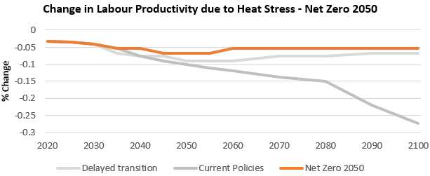
Source: Climate Impact Explorer.
• The annual economic damages from river floods are projected to increase, peaking at a ~140% increase over a 1986-2006 reference period around 2050, and remaining ~120% above the reference period thereafter. Annual economic damages from tropical cyclones are also projected to increase, but to a lesser extent; ~10% above reference period levels from 2030 onwards.
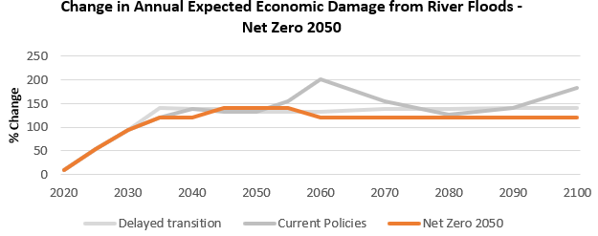
Source: Climate Impact Explorer.
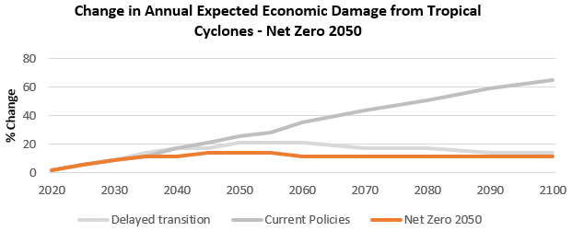
Source: Climate Impact Explorer.
In these scenarios the total cumulative relative GDP impact is estimated to be between -1.5% and-2.5% by 2050. World GDP losses from physical risks scale with the rise in temperatures in the scenarios over time. GDP impacts from transition risk are slightly positive in the Net Zero 2050 scenario as negative impacts on demand from higher carbon prices and energy costs are more than offset by the recycling of carbon tax revenues into government investment and lower employment taxes.
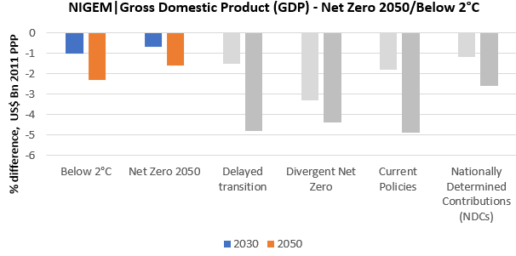
Source: IIASA NGFS Scenario Explorer, NGFS Scenario Data NIGEM v2.0 NiGEM NGFS v1.21 model
Overall, these are relatively optimistic scenarios as both transition and physical risks are limited. Any policies that are either introduced or changed are assumed to take place efficiently with little variation between countries and sectors. Similarly, the development and deployment of alternative technologies are expected to take place without significant difficulty. For example, the availability of Carbon dioxide removal technologies which involves removing carbon from the atmosphere through increasing forest cover and soil sequestration or growing crops for bioenergy doesn’t pose a significant challenge in either orderly scenario.
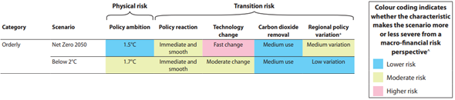
Source: NGFS Climate Scenarios, June2021

Agriculture Sector
The Agriculture sector can be split into crop production and animal production.
Industries in the Crop Production subsector grow crops mainly for food and fibre. This subsector comprises establishments such as farms, orchards, groves, greenhouses, and nurseries, primarily engaged in growing crops, plants, vines, or trees and their seeds. The industries in this subsector are grouped by similarity of production activity, the length of growing season, degree of crop rotation, extent of input specialization, labour requirements and capital demands.
The production process is typically completed when the raw product or commodity grown reaches the “farm gate” for market, that is, at the point of first sale or price determination. Within the subsector, the NAICS classifies establishments to a specific industry when a product or industry family of products (i.e., oilseed and grain farming, vegetable and melon farming, fruit and tree nut farming) account for one-half or more of the establishment’s agricultural production.
Industries in the Animal Production and Aquaculture subsector raise or fatten animals for the sale of animals or animal products and/or raise aquatic plants and animals in controlled or selected aquatic environments for the sale of aquatic plants, animals, or their products. The subsector includes establishments, such as ranches, farms, and feedlots primarily engaged in keeping, grazing, breeding, or feeding animals. These animals are kept for the products they produce or for eventual sale. The industries in this subsector are grouped by important factors, such as suitable grazing or pastureland, specialized buildings, type of equipment and the amount and types of labour required.
Establishments are classified to the Animal Production and Aquaculture subsector when animal production (i.e., value of animals for market) accounts for one-half or more of the establishment’s total agricultural production. ### Agriculture Sector — Orderly transition — Summary
The Agriculture sector continues to expand to feed and supply agricultural energy products to a growing global population. It contributes to 23% of anthropogenic emissions, exposing its producers and financiers to emerging climate related transition risks through public policies, consumer demand shifts and technological evolutions.
By 2050, the Orderly transition risk scenarios driven by societal change, national energy strategies, and carbon legislation, are likely to have a significant impact on the agriculture sector. Agricultural value chains face material climate transition risk exposure due to their emissions intensity and reliance on land. A potential expansion of land protection policies and carbon payments made to preserve and expand forests could reduce land available for agriculture.
These scenarios could also lead to a limited relative reduction in GDP growth and could result in changes in the rate of growth in demand for the agriculture sector, although the impact is likely to be limited due to inelastic demand for food products.

Agriculture Sector — Orderly transition — Details
The changes in food and bioenergy demand, emission pricing or taxes, consumer preferences and land use restrictions could potentially result in one or more of the following financial impacts, for example:
• Revenue growth in line with global demand and commodity prices.
• Rising production costs due to higher input costs and GHG emissions costs.
• Increase in capital expenditures as farms need to invest in research and development and deployment of new technologies and farming approaches necessary for long-term productivity growth
• More write-offs of assets as expansion of land protection policies to preserve and expand forests could reduce land available for agriculture.
Agricultural producers can benefit from expanding markets but face greater risks of stranded assets, geographic growth constraints, and rising production costs in the face of new emissions costs, land use restrictions, and necessary productivity improvements.
The sector has very high GHG emissions as farm and livestock productions and activities are emissions intensive. The total demand could continue to increase in the Orderly transition risk scenarios, however growth in demand for food production is limited.
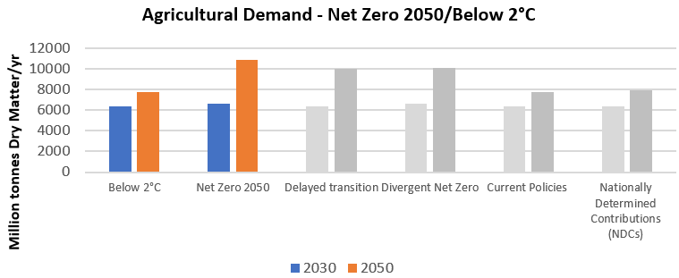
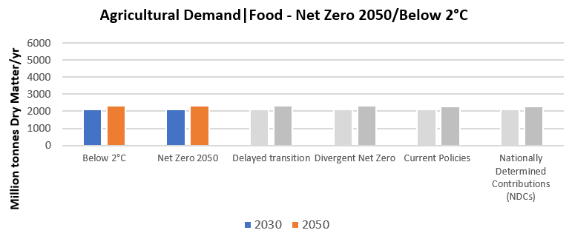
Source: IIASA NGFS Climate Scenarios Database.
As the use of bioenergy increases, by 2050, approx. 30% of total agricultural production in the Net Zero 2050 scenario and around 12% in the Below 2°C scenario could be consumed for energy generation.
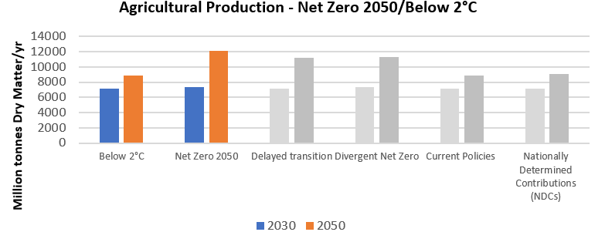
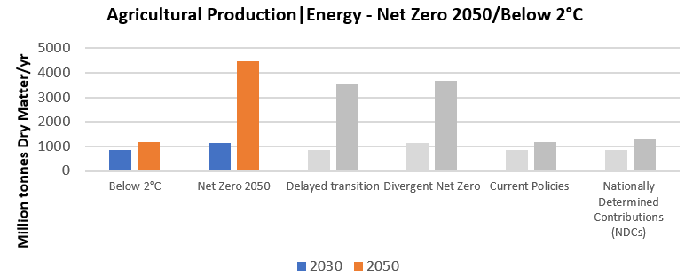
Source: IIASA NGFS Climate Scenarios Database.
Agricultural sector is key driver of forest loss, and due to forest conservation and preservation policies, availability of agricultural land reduces, limiting the growth of agricultural land cover. However, technological innovations in yields and productivity increase land use efficiency, allowing agriculture production to continue to increase with the rising demand of food and energy due to population growth. By 2050, agricultural land could increase by around 60 to 100 million hectares and forest cover could increase by around 160 million hectares in the Net Zero 2050 scenario and could remain unchanged in the Below 2°C scenario.
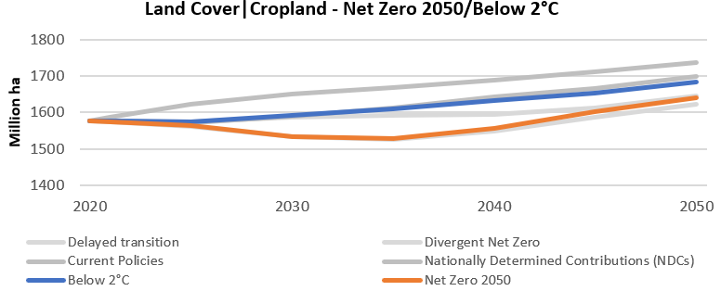
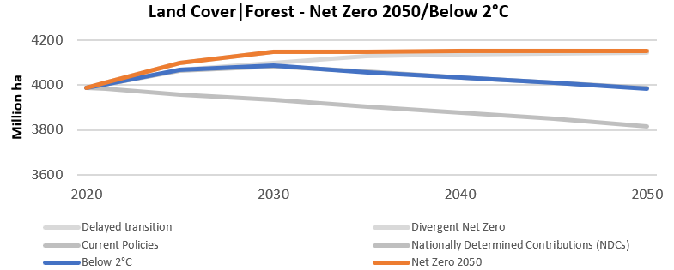
Source: IIASA NGFS Climate Scenarios Database.
The operational and production costs of firms could increase as they need to make necessary investments for technological upgrades and due to increases in carbon taxes. But producers should be able to pass the higher input costs to consumers due to inelastic demand of food and increasing usage of clean bioenergy and biofuels.
Despite these material risks, agricultural companies and investors can also derive significant opportunities from climate transitions. By investing in sustainable intensification, regenerative agriculture, and diversifying revenue streams, forward-looking agricultural companies could see their net value and profitability rise under transitions.

Agriculture Sector — Low physical risk — Summary
The Agriculture sector is also exposed to physical risk. Chronic effects (e.g. raised sea-levels and mean temperatures) and acute effects due to changes to frequency and severity of weather events such as heatwaves, wildfires, tropical cyclones, and flooding are adding to pressures on global agricultural and food systems and could lead to severe disruption to agricultural production which could impact the profitability for some companies in long-run.
In the low physical risk scenario, climate change and global warming could increase weather variations. This could lead to increasing disruption to agriculture sector which could impact profitability.

Agriculture Sector — Low physical risk — Details
The following examples illustrate how the agriculture sector could be impacted in a low physical risk scenario:
Chronic Impacts
• Increase in sea-level rise and flooding, may lead to substantial losses in crop and livestock production in low-lying agricultural areas and may contribute to waterlogging and soil erosion. Wetter weather could threaten agricultural production by adversely affecting crop yields.
• Higher average temperatures could have an impact on production, this could vary across the regions. Warmer, drier climate in already arid regions, such as North Africa, may have a negative impact on production, whereas production in colder and wetter areas, such as Northern and Western regions in the UK, may benefit from warm conditions.
Acute Impacts
• Changing rainfall patterns, reduced availability of water for irrigation could threaten agricultural production, particularly in areas where water supplies are already under pressure. Drier soil conditions could reduce growth of crops, pasture and trees. Extended or repeated period of droughts may cause death of younger tress reducing forest productivity.
• Increased frequency and intensity of Wildfires, Cyclones or Storms could cause significant damage to forests and disrupts the natural ecosystems that has been developed around the forests.
Physical risks could affect the range and quality of the ecosystem services that agriculture and forestry not only provide, but also rely on. These include climate control, flood regulation, biodiversity, pollination and nutrient cycling. The agriculture and forestry sectors have already adapted to change by introducing new genotypes, varieties, breeds and management practices. In a low physical risk scenario, there could be a need for more anticipatory adaptation measures.

NGFS Disorderly Scenarios
These Delayed/Divergent transition risk scenarios assume the introduction of effective policy change is Delayed or Divergent across countries and sectors.
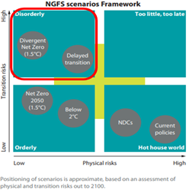
Source: NGFS Climate Scenarios, June2021
The NGFS have provided two Disorderly scenarios:
• Divergent Net Zero reaches Net Zero globally around 2050 but with higher costs in the short-term due to divergent policies being adopted across sectors leading to inefficiencies and a quicker phase out of oil use.
• Delayed transition assumes annual emissions do not decrease until 2030. Strong policies are needed to limit warming to below 2°C by 2050. CO2 removal is limited.

Key assumptions and parameters
In the Delayed transition scenario, late policy action enables a “fossil recovery” out of the economic crisis brought about by COVID-19, which results in emissions increasing until 2030. Policies drive a sharp decrease in CO2 emissions after 2030 to compensate for the inaction beforehand. In the Divergent Net Zero scenario the reduction in CO2 emissions starts to occur earlier and as a result is more gradual.
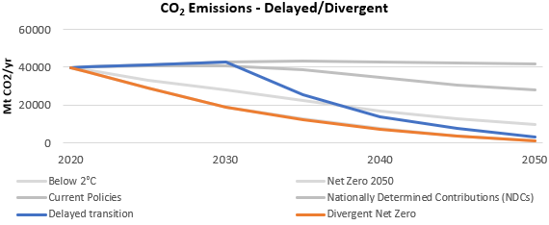
Source: IIASA NGFS Scenario Explorer.
In the Delayed transition scenario, late policy reaction enables a “fossil recovery” out of the economic crisis, which delays the increase of carbon prices until 2030, compared to the Divergent Net Zero scenario where carbon prices rise at a smoother rate because while there are varied policies implemented across countries and sectors these measures have been put in place earlier. In both the scenarios disorderly policy action results in transition risk.
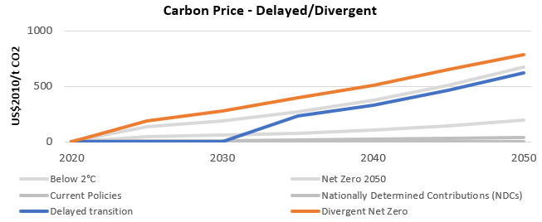
Source: IIASA NGFS Scenario Explorer. Carbon prices are weighted global averages.
The investments in energy efficiency and low carbon technologies are projected to increase in Disorderly transition risk scenarios. These are expected to be higher in a Divergent compared to a Delayed scenario. Overall, firms could be required to readjust their capital expenditure in line with these trends; developing more efficient and less carbon intensive products and services in order to adhere to carbon pricing policies. The technologies that result from these investments could also adjust asset valuations of relatively older technology. Annual investment in energy efficiency increases from around 200 billion USD (inflation adjusted to 2010 baseline) to between 600 billion USD and 850 billion USD by 2050, whilst annual investment in low carbon increases from ~750 billion USD to ~3 trillion USD by 2050.
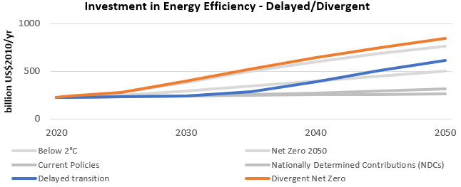
Source: IIASA NGFS Scenario Explorer.
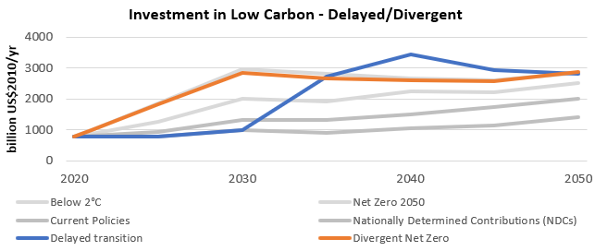
Source: IIASA NGFS Scenario Explorer.
Observed climate change has already increased global mean temperatures above 1.2°C, compared to pre-industrial levels, and both the global land area and the global population annually exposed to river flood, crop failure, tropical cyclones, wildfire, drought and heatwaves has already more than doubled (See Kaufman, D. et al. (2020).). The increasing concentrations of carbon dioxide, methane and nitrous oxide in the atmosphere are unprecedented in at least the last 800,000 years and are extremely likely to have been the dominant cause of warming since the mid-20th century. In these scenarios global mean temperatures are projected to increase across the world by 1.6°C to 1.8°C, above pre-industrial levels, by 2050 with land warming faster than oceans and high latitudes experiencing higher warming.
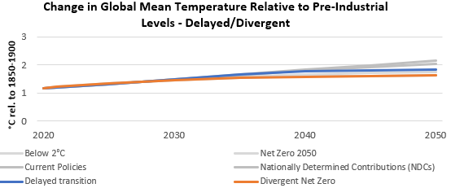
Source: IIASA NGFS Scenario Explorer, NGFS Scenario Data IAM outputs v2.2 REMIND-MAgPIE 2.1-4.2 model
These changes could lead to chronic changes in living conditions affecting health, labour productivity, agriculture, ecosystems, and sea-level rise. It can also further change the frequency and severity of weather events such as heatwaves, droughts, wildfires, tropical cyclones, and flooding. For example, in the delayed transition risk scenario we could see the following:
• A decrease in labour productivity due to the reduced capacity of the human body to perform physical labour under hot and humid climate conditions.
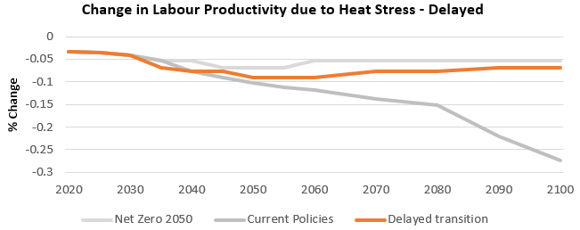
Source: Climate Impact Explorer.
• The annual economic damages from river floods are projected to increase, peaking at a ~140% over a 1986-2006 reference period around 2035, and remaining around this level thereafter. Annual economic damages from tropical cyclones are also projected to increase, but to a lesser extent; peaking at ~20% above reference period levels around 2050.
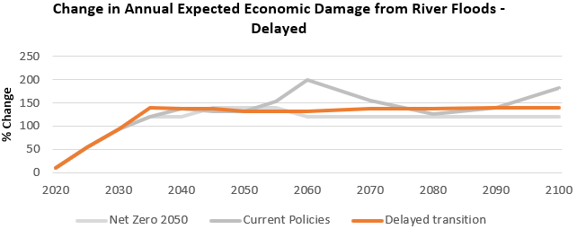
Source: Climate Impact Explorer.
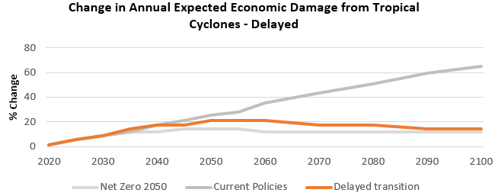
Source: Climate Impact Explorer.
In these scenarios the total cumulative relative GDP impact is estimated to be between -4.2% and -4.8% by 2050. World GDP losses from physical risks scale with the rise in temperatures in the scenarios over time. World GDP impacts from Disorderly transition risks are negative as the speed of the transition combines with investment uncertainty and affects consumption and investment. In these scenarios, there is a large mix of physical and transition risks in 2050.
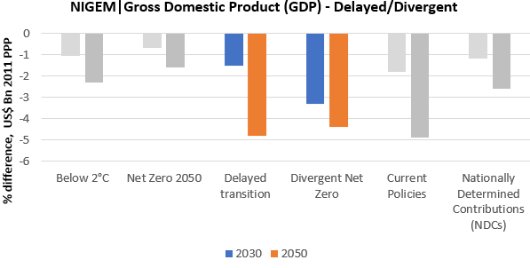
Source: IIASA NGFS Scenario Explorer, NGFS Scenario Data NIGEM v2.0 NiGEM NGFS v1.21 model
Overall, the Delayed transition scenario leaves a limited timeframe for countries, companies and the population to adapt to climate change. The Divergent Net Zero scenario will imply a higher cost to reach Net Zero by 2050 due to divergent policies.
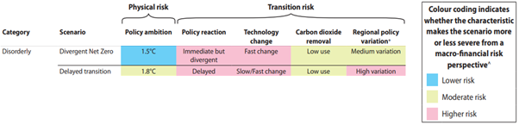
Source: NGFS Climate Scenarios, June2021

Agriculture Sector
The Agriculture sector can be split into crop production and animal production.
Industries in the Crop Production subsector grow crops mainly for food and fibre. This subsector comprises establishments such as farms, orchards, groves, greenhouses, and nurseries, primarily engaged in growing crops, plants, vines, or trees and their seeds. The industries in this subsector are grouped by similarity of production activity, the length of growing season, degree of crop rotation, extent of input specialization, labour requirements and capital demands.
The production process is typically completed when the raw product or commodity grown reaches the “farm gate” for market, that is, at the point of first sale or price determination. Within the subsector, the NAICS classifies establishments to a specific industry when a product or industry family of products (i.e., oilseed and grain farming, vegetable and melon farming, fruit and tree nut farming) account for one-half or more of the establishment’s agricultural production.
Industries in the Animal Production and Aquaculture subsector raise or fatten animals for the sale of animals or animal products and/or raise aquatic plants and animals in controlled or selected aquatic environments for the sale of aquatic plants, animals, or their products. The subsector includes establishments, such as ranches, farms, and feedlots primarily engaged in keeping, grazing, breeding, or feeding animals. These animals are kept for the products they produce or for eventual sale. The industries in this subsector are grouped by important factors, such as suitable grazing or pastureland, specialized buildings, type of equipment and the amount and types of labour required.
Establishments are classified to the Animal Production and Aquaculture subsector when animal production (i.e., value of animals for market) accounts for one-half or more of the establishment’s total agricultural production. ### Agriculture Sector — Disorderly transition — Summary
The Agriculture sector continues to expand to feed and supply agricultural energy products to a growing global population. It contributes to 23% of anthropogenic emissions, exposing its producers and financiers to emerging climate related transition risks through public policies, consumer demand shifts and technological evolutions.
By 2050, in the Delayed transition risk scenario, late policy action enables a “fossil recovery” out of the economic crisis brought about by COVID-19. CO2 emissions increase until 2030, before sharply decreasing after 2030 to compensate for the inaction beforehand. In the Divergent scenario there is a more immediate but divergent reduction in CO2 emissions. These scenarios are likely to have a significant impact on agriculture sector. Agricultural value chains face material climate transition risk exposure due to their emissions intensity and reliance on land. Under these scenarios, the expansion of land protection policies and carbon payments made to preserve and expand forests could reduce land available for agriculture.
These scenarios could also lead to a reduction in GDP growth. This could result in changes in the rate of growth in demand for the agriculture sector, although the impact is likely to be limited due to inelastic demand for food products.

Agriculture Sector — Disorderly transition — Details
The changes in food and bioenergy demand, emission pricing or taxes, consumer preferences and land use restrictions could potentially result in one or more of the following financial impacts:
• Revenue growth due to rising global demand and commodity prices.
• Rising production costs due to higher input costs and GHG emissions costs
• Increase in capital expenditures as farms need to invest in research and development and deployment of new technologies necessary for long-term productivity growth
• More write-offs of assets as expansion of land protection policies to preserve and expand forests could reduce land available for agriculture.
Agricultural producers can benefit from expanding markets but face greater risks of stranded assets, geographic growth constraints, and rising production costs in the face of new emissions costs, land use restrictions, and necessary productivity improvements.
The sector has very high GHG emissions as farm and livestock productions and activities are emission intensive. The total demand could continue to increase in the Disorderly transition risk scenarios, however growth in demand for food production is limited.
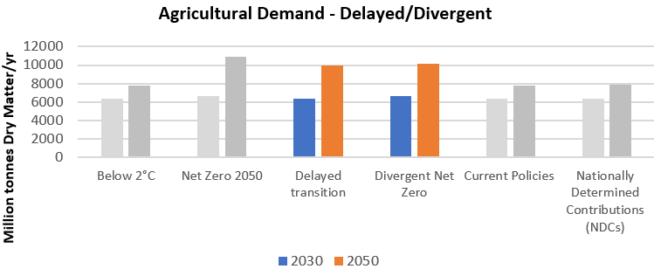
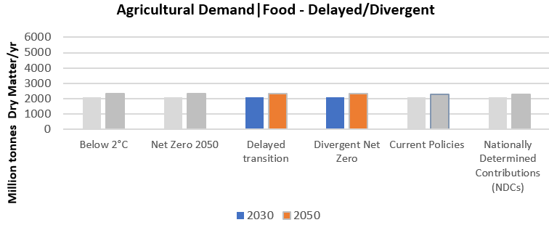
Source: IIASA NGFS Climate Scenarios Database.
As the use of bioenergy increases, by 2050, just over 40% of total agricultural production (in both Delayed Transition and Divergent Net Zero scenarios) are consumed for energy generation.
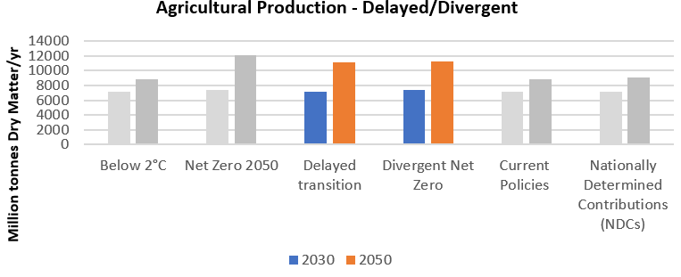
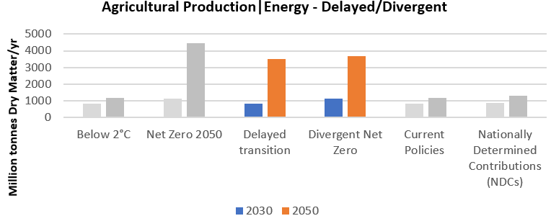
Source: IIASA NGFS Climate Scenarios Database.
Agricultural sector is key driver of forest loss, and due to forest conservation and preservation policies, availability of agricultural land reduces, limiting the growth of agricultural land cover. However, technological innovations in yields and productivity increase land use efficiency, allowing agriculture production to continue to increase with the rising demand of food and energy due to population growth. By 2050, agricultural land could increase by around 45 to 70 million hectares and forest cover could increase by around 160 million hectares.
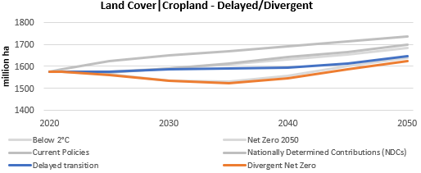
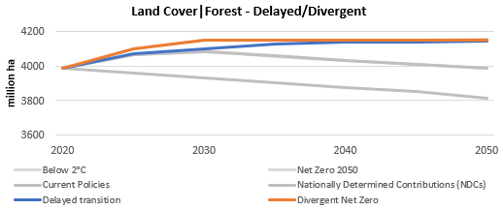
Source: IIASA NGFS Climate Scenarios Database.
The operational and production costs of firms could increase as they need to make necessary investments for technological upgrades and increase in carbon taxes. But producers should be able to pass the higher input costs to consumers due to inelastic demand of food and increasing usage of clean bioenergy and biofuels.
Despite these material risks, agricultural companies and investors can also derive significant opportunities from climate transitions. By investing in sustainable intensification, regenerative agriculture, and diversifying revenue streams, forward-looking agricultural companies could see their net value and profitability rise under transitions.

Agriculture Sector — Low physical risk — Summary
The Agriculture sector is also exposed to physical risk. Chronic effects (e.g. raised sea-levels and mean temperatures) and acute effects due to changes to frequency and severity of weather events such as heatwaves, wildfires, tropical cyclones, and flooding are adding to pressures on global agricultural and food systems and could lead to severe disruption to agricultural production which could impact the profitability for some companies in long-run.
In the low physical risk scenario, climate change and global warming could increase weather variations. This could lead to increasing disruption to agriculture sector which could impact profitability.

Agriculture Sector — Low physical risk — Details
The following examples illustrate how the agriculture sector could be impacted in a low physical risk scenario:
Chronic Impacts
• Increase in sea-level rise and flooding, may lead to substantial losses in crop and livestock production in low-lying agricultural areas and may contribute to waterlogging and soil erosion. Wetter weather could threaten agricultural production by adversely affecting crop yields.
• Higher average temperatures could have an impact on production, this could vary across the regions. Warmer, drier climate in already arid regions, such as North Africa, may have a negative impact on production, whereas production in colder and wetter areas, such as Northern and Western regions in the UK, may benefit from warm conditions.
Acute Impacts
• Changing rainfall patterns, reduced availability of water for irrigation could threaten agricultural production, particularly in areas where water supplies are already under pressure. Drier soil conditions could reduce growth of crops, pasture and trees. Extended or repeated period of droughts may cause death of younger tress reducing forest productivity.
• Increased frequency and intensity of Wildfires, Cyclones or Storms could cause significant damage to forests and disrupts the natural ecosystems that has been developed around the forests.
Physical risks could affect the range and quality of the ecosystem services that agriculture and forestry not only provide, but also rely on. These include climate control, flood regulation, biodiversity, pollination and nutrient cycling. The agriculture and forestry sectors have already adapted to change by introducing new genotypes, varieties, breeds and management practices. In a low physical risk scenario, there could be a need for more anticipatory adaptation measures.

NGFS Hot House World Scenarios
These scenarios assume that some climate policies are implemented in some jurisdictions, but globally efforts are insufficient to halt significant global warming leading to high physical risk.
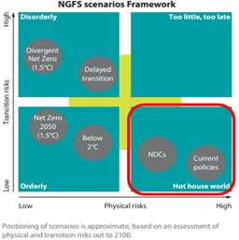
Source: NGFS Climate Scenarios, June2021
The NGFS have provided two hot house world scenarios:
• Nationally Determined Contributions (NDCs) includes all pledged policies even if not yet implemented.
• Current Policies assumes that only currently implemented policies are preserved, leading to high physical risk.

Key physical assumptions and parameters
In these scenarios CO2 emissions do not decrease sufficiently to prevent significant temperature rises resulting in high physical risk.
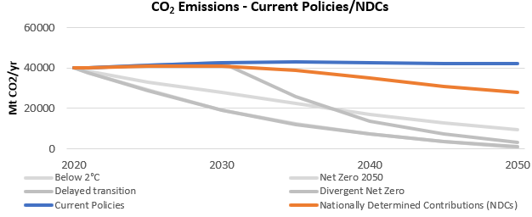
Source: IIASA NGFS Scenario Explorer.
Carbon price is a measure of overall policy intensity. Emission prices are sensitive to the timing of policy implementation. With none or relatively small additions to current policy, these scenarios have low carbon prices throughout. Therefore, transition risk is not relevant for these scenarios.
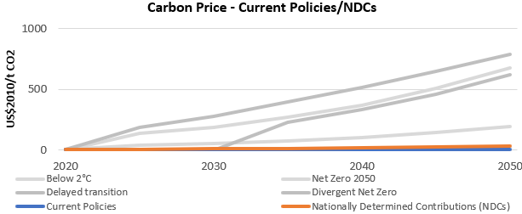
The investments in energy efficiency and low carbon technologies are projected to increase in Hot House scenarios. Annual investment in energy efficiency increases from around 200 billion USD (inflation adjusted to 2010 baseline) to between 250 billion USD and 350 billion USD by 2050, whilst annual investment in low carbon increases from ~750 billion USD to below ~2 trillion USD by 2050. However this increase is relatively small compared to other scenarios.
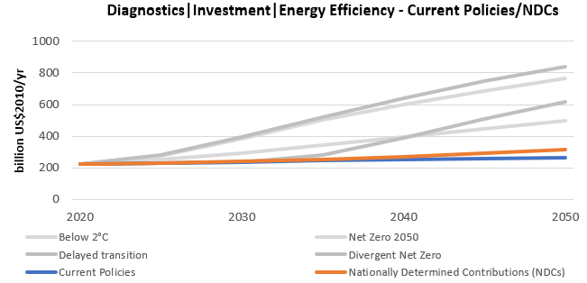
Source: IIASA NGFS Scenario Explorer.
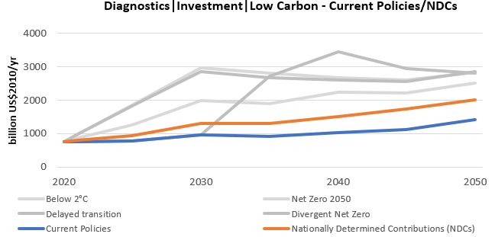
Source: IIASA NGFS Scenario Explorer.
The increasing concentrations of carbon dioxide, methane and nitrous oxide in the atmosphere are unprecedented in at least the last 800,000 years and are extremely likely to have been the dominant cause of warming since the mid-20th century. Observed climate change of 1.2°C, compared to pre-industrial levels, has already more than doubled both the global land area and the global population annually exposed to river flood, crop failure, tropical cyclones, wildfire, drought and heatwaves. In these scenarios global mean temperatures are projected to increase across the world by ~2°C, compared to pre-industrial levels, by 2050, with land warming faster than oceans and high latitudes experiencing higher warming.
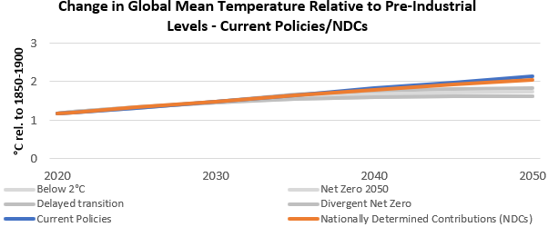
Source: IIASA NGFS Scenario Explorer, NGFS Scenario Data IAM outputs v2.2 REMIND-MAgPIE 2.1-4.2 model
These changes could lead to chronic changes in living conditions affecting health, labour productivity, agriculture, ecosystems, and sea-level rise. It can also change the frequency and severity of weather events such as heatwaves, droughts, wildfires, tropical cyclones, and flooding. For example, in the Current Policies scenario we could see the following:
• A decrease in labour productivity due to the reduced capacity of the human body to perform physical labour under hot and humid climate conditions.
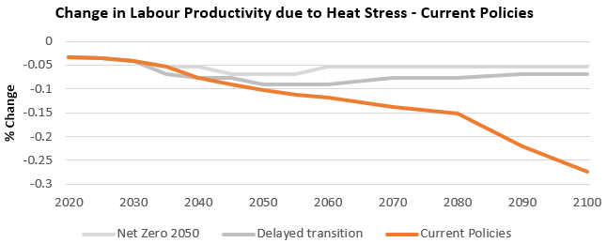
Source: Climate Impact Explorer.
• The annual economic damages from river floods are projected to increase, peaking at a ~200% increase over a 1986-2006 reference period around 2060. Annual economic damages from tropical cyclones are also projected to increase, but to a lesser extent; ~65% above reference period levels by the end of the century.
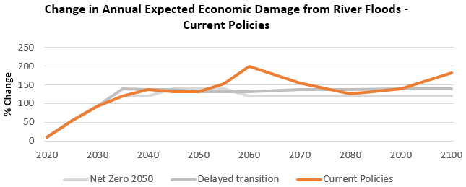
Source: Climate Impact Explorer.
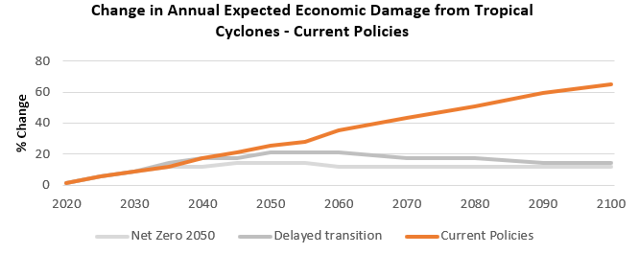
Source: Climate Impact Explorer.
In these scenarios the total cumulative relative GDP impact is estimated to be between -2.8% and -4.8% by 2050. World GDP losses from physical risks scale with the rise in temperatures in the scenarios over time.
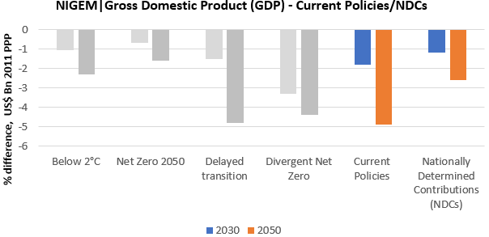
Source: IIASA NGFS Scenario Explorer, NGFS Scenario Data NIGEM v2.0 NiGEM NGFS v1.21 model
Overall, these scenarios result in high physical risk including irreversible impacts like sea-level rise. Transition risks are not relevant in these scenarios as only policies that are already implemented or pledged are in place.
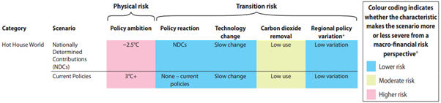
Source: NGFS Climate Scenarios, June2021

Agriculture Sector
The Agriculture sector can be split into crop production and animal production.
Industries in the Crop Production subsector grow crops mainly for food and fibre. This subsector comprises establishments such as farms, orchards, groves, greenhouses, and nurseries, primarily engaged in growing crops, plants, vines, or trees and their seeds. The industries in this subsector are grouped by similarity of production activity, the length of growing season, degree of crop rotation, extent of input specialization, labour requirements and capital demands.
The production process is typically completed when the raw product or commodity grown reaches the “farm gate” for market, that is, at the point of first sale or price determination. Within the subsector, the NAICS classifies establishments to a specific industry when a product or industry family of products (i.e., oilseed and grain farming, vegetable and melon farming, fruit and tree nut farming) account for one-half or more of the establishment’s agricultural production.
Industries in the Animal Production and Aquaculture subsector raise or fatten animals for the sale of animals or animal products and/or raise aquatic plants and animals in controlled or selected aquatic environments for the sale of aquatic plants, animals, or their products. The subsector includes establishments, such as ranches, farms, and feedlots primarily engaged in keeping, grazing, breeding, or feeding animals. These animals are kept for the products they produce or for eventual sale. The industries in this subsector are grouped by important factors, such as suitable grazing or pastureland, specialized buildings, type of equipment and the amount and types of labour required.
Establishments are classified to the Animal Production and Aquaculture subsector when animal production (i.e., value of animals for market) accounts for one-half or more of the establishment’s total agricultural production. ### Agriculture Sector — High physical risk — Summary
The Agriculture sector is also exposed to physical risk. Chronic effects (e.g. raised sea-levels and mean temperatures) and acute effects due to changes to frequency and severity of weather events such as heatwaves, wildfires, tropical cyclones, and flooding are adding to pressures on global agricultural and food systems and could lead to severe disruption to agricultural production which could impact the profitability for some companies in long-run. Whilst the agriculture sector is used to responding to and managing changing weather conditions, in the high physical risk scenario, climate change and global warming could increase weather variations. This could lead to increasing disruption to agriculture sector which could impact profitability.
Adverse impacts on world GDP from physical risks are assumed in the scenarios and these scale with the rise in temperatures in the scenarios over time. The high physical risk scenarios could therefore also lead to a significant GDP impact which could negatively impact demand for agriculture, although the impact is likely to be limited due to inelastic demand for food products.

Agriculture Sector — High physical risk — Details
The following examples illustrate how the Agriculture sector could be impacted in a high physical risk scenario:
Chronic Impacts
• Increase in sea-level rise, may lead to substantial losses in crop and livestock production in low-lying agricultural areas and may contribute to waterlogging and soil erosion. Wetter weather could threaten agricultural production by adversely affecting crop yields.
• Higher average temperatures could have an impact on production, this could vary across the regions. Warmer, drier climates in tropical regions may have a negative impact on production where production in colder and wetter areas may benefit from warm conditions.
Acute Impacts
• Changing rainfall patterns, reduced availability of water for irrigation could threaten agricultural production, particularly in areas where water supplies are already under pressure. Drier soil conditions could reduce growth of crops, pasture and trees. Extended or repeated period of droughts may cause death of younger tress reducing forest productivity.
• Increased frequency and intensity of Wildfires, Cyclones or Storms could cause significant damage to forests and disrupts the natural ecosystems that has been developed around the forests.
Significantly slowed GDP growth could impact demand for agriculture through its effect on individuals’ disposable income. The impact on food products is likely to be low due to inelastic demand, but demand for bioenergy could see growth partially offset.
Physical risks could affect the range and quality of the ecosystem services that agriculture and forestry not only provide, but also rely on. These include climate control, flood regulation, biodiversity, pollination and nutrient cycling. The agriculture and forestry sectors have already adapted to change by introducing new genotypes, varieties, breeds and management practices. In a high physical risk scenario, there could be a need for more anticipatory adaptation measures.

References

Agriculture Sector
• How will African farmers adjust to changing patterns of precipitation? - McKinsey, May 2020
• Agriculture and Forestry Climate Change Impacts - Living With Environmental Change, Report Card 2016
• NAICS Code 11
• SIC Code A

