COMP7402 Assignment 1 Testing and Analysis
John Agapeyev A00928238

Table of Contents
Testing 1
Analysis 4

Testing
The one-shot nature of the application limits the possible testing of the executable.
Running without a filename displays a prompt requesting a filename, before exiting the application.

Running against war and peace, we can see the following frequency graph being generated
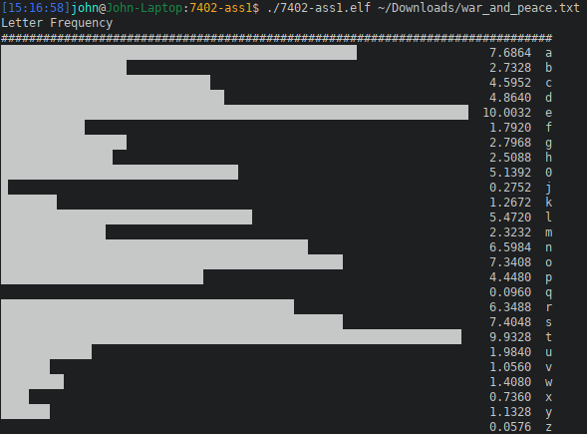

The application then immediately prints out the encrypted letter frequency. As we can see, the frequencies are intact, and simply shifted over.
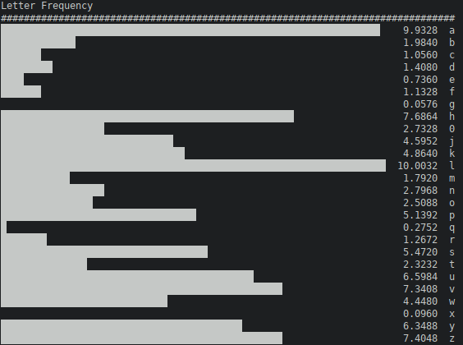
Lastly, the application prints out the individual letter probabilities across the set of all keys, the most likely key, and the top 6 corresponding letters that are a result of applying that key.
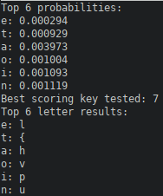

Running the application against the full text of Alice in Wonderland shows a similar result, corroborating the earlier results.
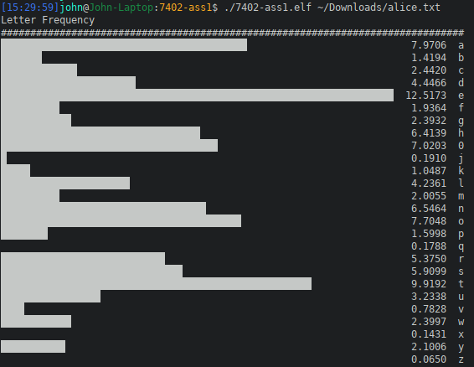

Analysis
The standard frequency analysis on the plaintext shows that it follows the general frequency pattern found in the english language. After applying the caesar cipher to the plaintext, we can see that the relative frequencies are intact, but are not longer applied to their expected letters. In fact, all the frequencies are shifted over by a constant amount. With some trivial analysis, it is easy to determine the key used, simply by comparing the frequencies against the letters that hold them. For example, the letter ‘e’ has the highest frequency in the English language. By analyzing a ciphertext, one can trivially test that the highest frequency found is the ciphertext equivalent to ‘e’, and then a simple subtraction would provide the most likely key. This is a ciphertext-only attack with trivial complexity. An exhaustive search of the key space is also trivial with computers. By scoring texts by weighting their count of english letters, as well as the relative frequency of those letters, we can perform a simple max score search to determine the key used, again, without any knowledge of the plaintext. As part of this analysis, I print the overall letter probabilities of the top 6 characters across the keyspace. This is obtained by multiplying their letter frequencies by 1/25, representing the total keyspace. This can help determine what sort of patterns should be expected, since it covers the entire message and keyspace.

