COMP7402 Assignment 1 Design
John Agapeyev A00928238

Table of Contents
State Machine 1
Pseudocode 2
Init 2
Read File 2
Calculate Frequencies 2
Caesar Cipher 2
Graph 3

State Machine

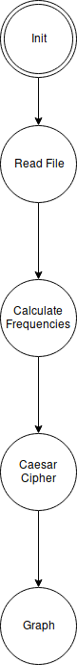

Pseudocode

Init
- Initialize static memory buffers
- Check command line arguments
- If arguments does not contain a filename, print help text and exit the application
- goto READ FILE state

Read File
- Open file from filename
- If file fails to open, print error and exit the application
- Read the total file size
- Use the total file size to read the entire contents of the file in a single operation
- goto CALCULATE FREQUENCIES state

Calculate Frequencies
- Iterate through every character in the buffer
- Increment the counter for each alphabetic letter that is encountered
- Divide each letter count by the total size of the text
- Store the initial plaintext frequencies in a buffer
- goto CAESAR CIPHER state

Caesar Cipher
- Iterate through every character in the plaintext
- Offset the character by the key
- If the resulting value is not a character, make its value wrap around starting back at ‘a’
- Calculate the ciphertext frequencies as above
- goto GRAPH state

Graph
- Write both plaintext and ciphertext letter probabilities into a bar chart
- Print the top 6 character probabilities in the ciphertext
- Exit the application

