COMP7402 Assignment 2 Testing
John Agapeyev A00928238

Table of Contents
Testing 1

Testing
- Running with no arguments

- Running with a single argument

- Running with an invalid file path
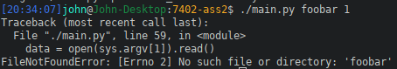

- Running with invalid key size

- Running with non-integer key size
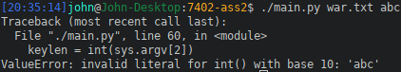

- Running with key size larger than the plaintext

- Running with valid input
