COMP7402 Assignment 2 Design
John Agapeyev A00928238

Table of Contents
State Machine 1
Pseudocode 2
Init 2
Encrypt 2
Brute Force 2
Show Best Key 2

State Machine
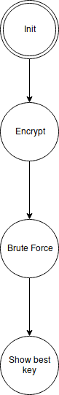

Pseudocode

Init
- Read command arguments
- Validate argument format
- Open plaintext file
- Convert key length to integer
- goto ENCRYPT state

Encrypt
- Read plaintext file
- Encrypt it with transposition cipher according to key length
- goto BRUTE FORCE state

Brute Force
- Loop from 1 up to the length of the ciphertext
- For each potential keysize, decrypt the ciphertext with said key
- Check the number of correctly spelled words
- Select the key with the most number of correctly spelled words
- goto SHOW BEST KEY state

Show Best Key
- Decrypt the ciphertext with the best performing key
- Print the resulting plaintext along with the key
- Exit the application

