COMP7402 Assignment 3 Testing
John Agapeyev A00928238

Table of Contents
Testing 1

Testing
- Running with no arguments

- Running with a not enough arguments

- Running with an invalid file path
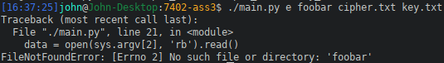
- Running with existing output file
- Running with existing key file
- Decrypting with invalid key size

- Encrypt with valid input
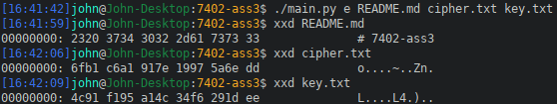
- Decrypt with valid input
