COMP7402 Assignment 3 Design
John Agapeyev A00928238

Table of Contents
State Machine 1
Pseudocode 2
Init 2
Read Files 2
Encrypt 2
Write Files 2

State Machine
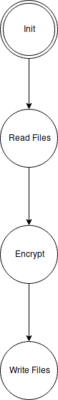

Pseudocode

Init
- Read command arguments
- Validate argument format
- Set mode of operation based on arguments
- goto READ FILES state

Read Files
- Read input file into buffer
- If application is in decrypt mode, read key file into buffer
- If application is in encrypt mode, generate key with CSPRNG with length equal to plaintext
- goto ENCRYPT state

Encrypt
- For every byte of the message
  - Xor the message byte against the corresponding key byte
  - Write the output byte to the buffer
- goto WRITE FILES state

Write Files
- Open the output file
- If the application is in encrypt mode, open the key file
- Write the resulting cipher output to the output file
- If the application is in encrypt mode, write the key data to the key file
- Exit the application

