7612-Assignment 1 Design
John Agapeyev A00928238

Table of Contents
State Machine 2
Pseudocode 3
Prompt User 3
Read User String 3
Convert ASCII to Binary 3
Bounds Check 3
Switch 3
Case 4
Convert Binary to ASCII 4
Exit 4

State Machine
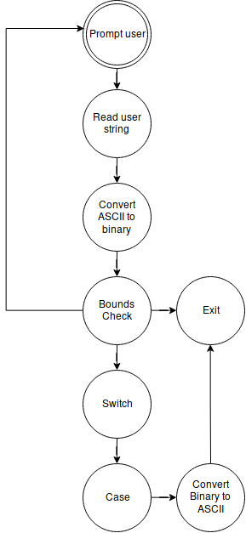

Pseudocode

Prompt User
- Write to standard out with appropriate prompt for given variable
- goto READ USER STRING state

Read User String
- Read user input string into buffer
- goto CONVERT ASCII TO BINARY state

Convert ASCII to Binary
- For every byte in the string in reverse order
  - If character is the negative sign, negate result, and goto BOUNDS CHECK state
  - Take char & 0xf
  - Multiply value by 10 * byte position
  - Add to result
- goto BOUNDS CHECK state

Bounds Check
- If input number is less than zero, or greater than 65535, goto EXIT state
- If all input variables have been received, goto SWITCH state
- Else, goto PROMPT USER state

Switch
- Increment index value
- If index is equal to zero, set case to zero, and goto CASE state
- If index is equal to one, set case to one, and goto CASE state
- If index is equal to two, set case to two, and goto CASE state
- If index is equal to three, set case to three, and goto CASE state
- Else, set case to default, and goto CASE state

Case
- Write string according to selected case
- If case is default, goto EXIT state
- Else, calculate intermediate value according to case
- goto CONVERT BINARY TO ASCII state

Convert Binary to ASCII
- If number is negative, write negative sign, and negate value
- Divide number by ten thousand
- If result is non-zero, write it to buffer and increment counter
- Divide number by one thousand
- If result is non-zero, write it to buffer and increment counter
- Divide number by one hundred
- If result is non-zero, write it to buffer and increment counter
- Divide number by ten
- If result is non-zero, write it to buffer and increment counter
- Write ones digit value to buffer, and increment counter
- Write newline character to buffer, and increment counter
- Write buffer to standard out using the last counter number of bytes
- goto EXIT state

Exit
- Exit the application

