8506 Assignment 1 Testing
John Agapeyev A00928238
Table of Contents
Notes 1
Tests 2

Notes
All inputs are run through identical functions. So while there might be 4 user input values, only 1 needs to be tested for validity, since they all are run through the same checks.
Also, due to a bug in the requirements, it is impossible to run the first switch case statement. The index value being switched on is incremented before the switch takes place. As such, a value of zero is incremented to one, and a value of negative one is rejected as out of range. Therefore, there is no possible code path where the user input can be equal to zero at the time of the switch statement.

Tests
Test case | What does it test | Expected result | Actual Result
a | Handling of non-numeric characters | Program exits | 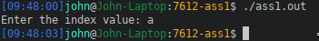
-1 | Handling of negative numbers | Program exits | 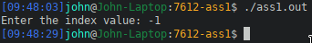
0 | Minimum range value | Program continues as expected | 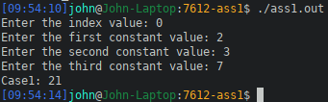
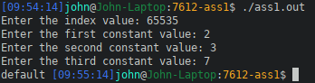  65535 | Maximum range value | Program continues as expected
65536 | Handling of values over maximum range | Program exits | 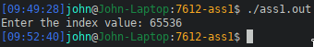
9f | Handling a mix of valid and invalid characters | Program exits | 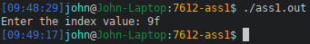
! | Handling of non-alphanumeric characters | Program exits | 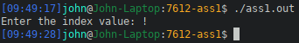
1 | Handling of second case | Program continues as expected | 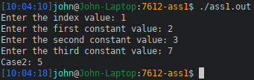
2 | Handling of third case | 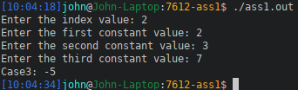  Program continues as expected

