COMP8505 Assignment 3 Testing
John Agapeyev A00928238

Test case | What does it test | Expected result | Screenshot
No userspace application | Bad setup | Application fails to load
No server application | Bad setup | Application fails to load
Bad shell command | Shell command parsing | Shell responds with error
Bad module command | Module command parsing | Module responds with error
Open invalid port | Module command parsing | Module responds with error
Close C2 port | Module command parsing | Module responds with error
Open port | Normal Execution | Port is now open
Close port | Normal Execution | Port is now closed
Clear port status | Normal Execution | Previously open/closed are reset
Run shell command | Normal Execution | 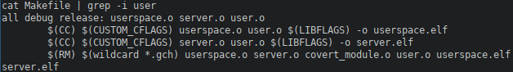  Shell executes command and responds with results

