COMP 8505 Assignment 4 Design
John Agapeyev A00928238

Table of Contents
State Machine 3
Pseudocode 4
Init 4
Get Local Addresses 4
Get Remote Addresses 4
Spoof ARP 4
Spoof DNS 4

State Machine
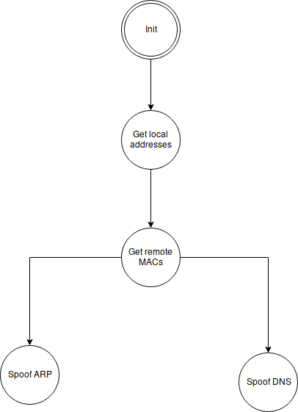

Pseudocode

Init
- Initialize memory buffers
- Ensure application was run with root privileges
- Create packet socket
- goto GET LOCAL ADDRESSES state

Get Local Addresses
- Perform system calls to obtain:
  - Ipv4 address
  - Ipv6 address
  - MAC address
  - Interface index
- goto GET REMOTE ADDRESSES state

Get Remote Addresses
- Ping both the target and gateway machines
- Read from the packet socket for either the incoming or outgoing packet
- Read the mac address of the machine from the ethernet header that was read by the socket
- In one thread, goto SPOOF ARP state
- In another thread, goto SPOOF DNS state

Spoof ARP
- Craft an arp packet that associates the designated IP with the local mac address
- Send this crafted packet to the target once per second
- Repeat until application termination

Spoof DNS
- Read for outgoing DNS packets
- Craft a DNS response packet that associates the queried domain name with the attacker’s IP address
- Send the crafted DNS response back to the victim
- Repeat until program termination

