COMP 8505 Assignment 4 Testing
John Agapeyev A00928238

Foreward
The nature of the DNS spoofer results in zero user interaction, so no testing can be performed on input parsing. All data is gathered through a combination of system calls and packet parsing. The only input data is hardcoded in the form of the interface name, and the target IP addresses. Of note, a valid IP that cannot be ARP-spoofed (one that is on a different subnet), will simply result in the application doing nothing besides sending spoofed arp packets which are ignored.

Invalid interface name
Input used: Interface name was an invalid string
Result:
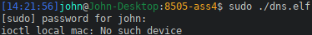

Invalid Target/Gateway IP address
Input used: Target IP address was an invalid string
Result:
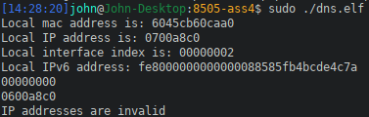

Successful Run
Input used: Valid interface name and valid IP addresses
Application output:
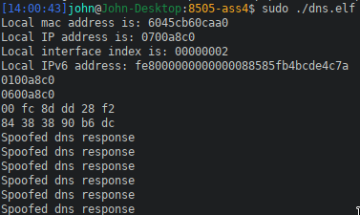

Spoofed DNS packet contents:
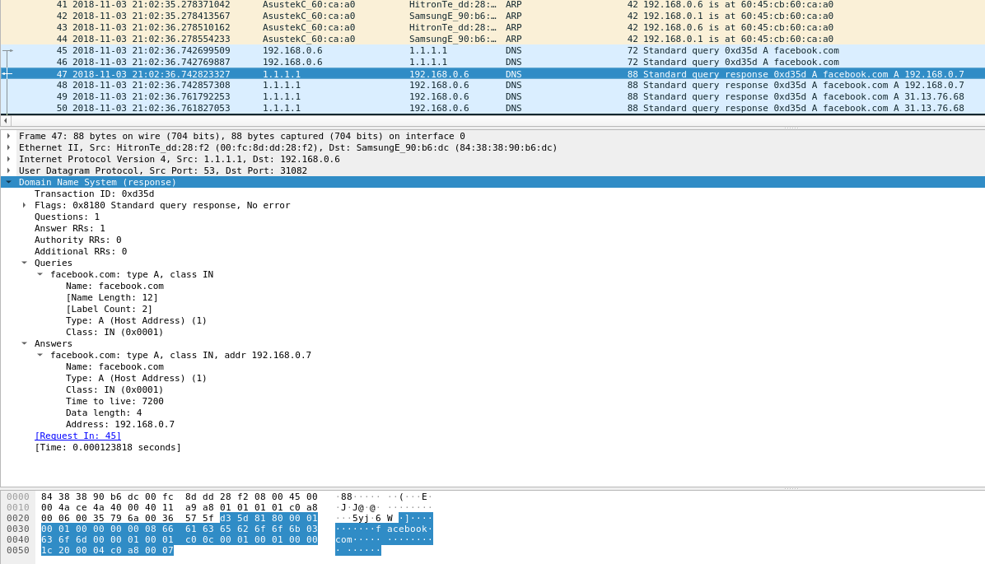

DNS response result:

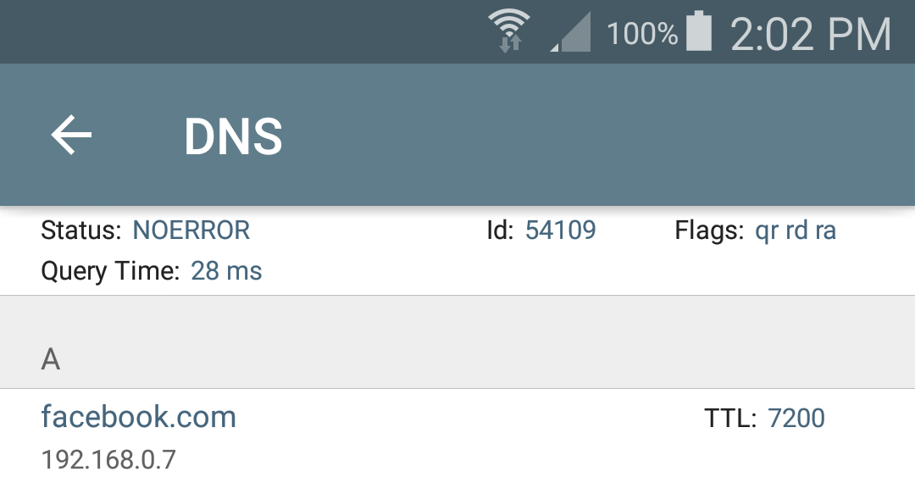
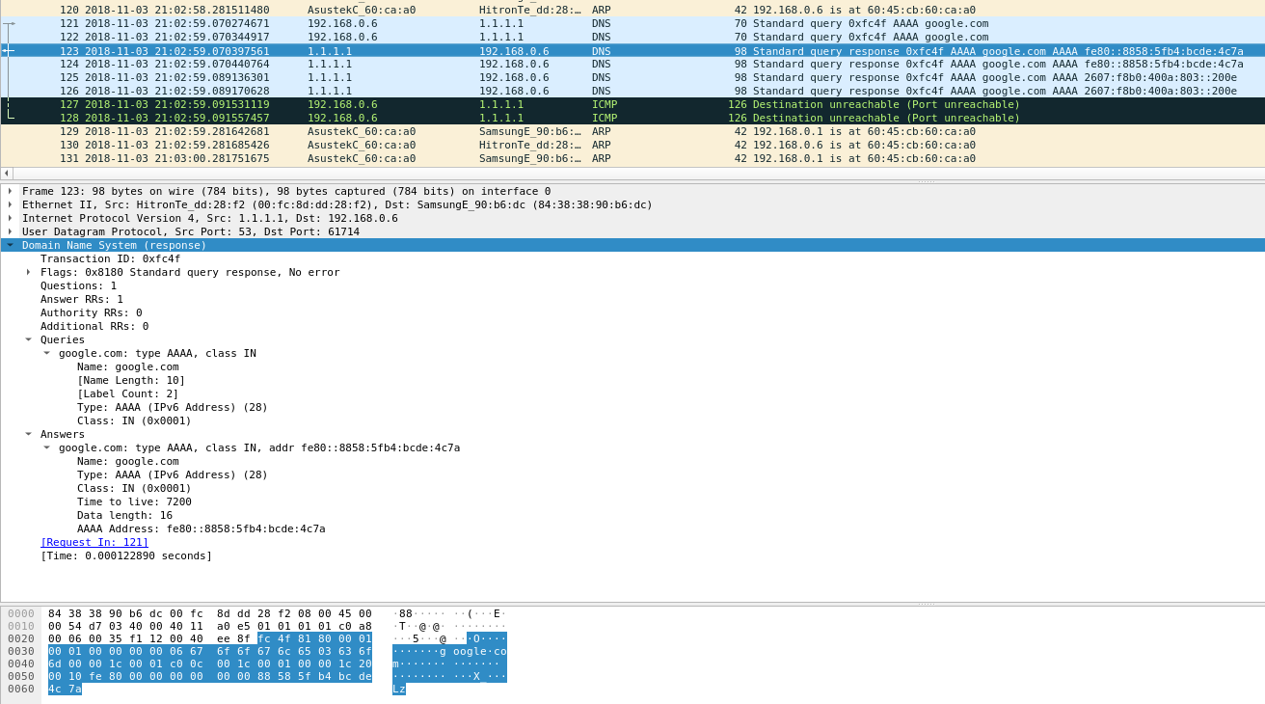
Ipv6 Spoofed response:

Ipv6 result:
