COMP 8505 Final Design
John Agapeyev A00928238

Table of Contents
State Machine 1
Pseudocode 1
Userspace 1
Init Userspace 1
Wait for module connections 1
Connect to server 2
Wait for data 2
Execute shell 2
Forward data 2
Module 2
Init module 2
Run netfilter hook 2
Run Keylogger 3
Read command 3
Execute command 3
Send response 3
Server 3
Init server 3
Read user input 4
Send input 4
Read incoming data 4
Print received data 4

State Machine
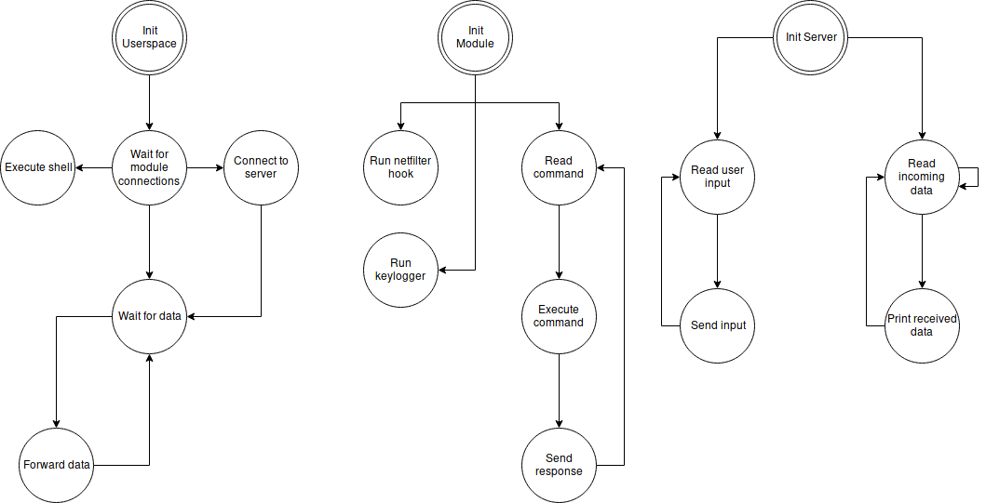

Pseudocode

Userspace

Init Userspace
- Daemonize process
- Initialize local and remote sockets
- Set local sockets to listen for incoming connections
- goto WAIT FOR MODULE CONNECTIONS state

Wait for module connections
- Wait for incoming connections to local sockets by the kernel module
- Accept incoming connections
- In one thread, goto CONNECT TO SERVER state
- In another thread, goto EXECUTE SHELL state
- In the other threads, goto WAIT FOR DATA state

Connect to server
- Connect to server using hardcoded IP and port
- Initialize TLS connection with server
- goto WAIT FOR DATA state

Wait for data
- Wait for data on respective socket
- When data is received:
  - Indicate destination, and goto FORWARD DATA state

Execute shell
- Daemonize process
- Connect to local socket
- Duplicate connected local socket as standard streams
- Execute shell process using the socket as the default streams

Forward data
- Forward received data to either the kernel module, the shell, or the server, depending on where the data came from, and where its intended destination is.
- Goto WAIT FOR DATA state

Module

Init module
- Register netfilter hooks
- Register keylogger hook
- Allocate buffers
- Start command parsing thread and goto READ COMMAND state

Run netfilter hook
- Parse incoming or outgoing packet
- If port is on closed port list, drop the packet
- If port is on the open port list, queue the packet for userspace

Run Keylogger
- Perform table lookup to convert keycode into human-readable string
- Store string in global variable
- Schedule network send using global data in a process context

Read command
- Read data from local socket
- Parse command for proper formatting and length
- goto EXECUTE COMMAND state

Execute command
- Execute command received from userspace
- If command is ill-formed, set reponse as an error message
- else, set confirmation message as reponse
- goto SEND REPONSE state

Send response
- Send response message back over the local socket to the userspace application

Server

Init server
- Initialize listening socket
- Set standard input and output to non-buffered
- Wait for incoming connection on listening socket
- When a connection is received, accept it and goto READ INCOMING DATA state
- In a seperate thread, goto READ USER INPUT

Read user input
- Read input from user
- goto SEND INPUT state

Send input
- Write contents of user input buffer to TLS connection
- goto READ USER INPUT

Read incoming data
- Read incoming data from TLS socket
- If data is status message or shell output: goto PRINT DATA state
- If data is keystroke, write it to the keystroke file
- If data is file packet, open file if no file is open, and write data to new file
- If data is file completion packet, open file is no file is open, write data, and close file
- goto READ INCOMING DATA state

Print received data
- Print contents of received data buffer to the screen
- goto READ INCOMING DATA state

