COMP8505 Final Testing
John Agapeyev A00928238

Table of Contents
Testing Data 1

Testing Data
Test input | What does it test? | Expected Outcome | Actual Outcome | Screenshot
Initial Connection | Connection to server can be established | Client connects to server | Client connects to server | 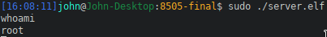
!hide 1 | Hiding arbitrary process | PID 1 will not appear in htop | 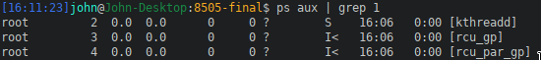  PID 1 is no longer visible
!clearp | Unhide hidden processes | PID 1 will reappear in htop | PID active in htop
!hidef <filename> | Hiding arbitrary files | File is hidden | File is hidden | 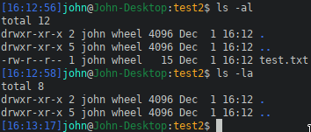
!clearf | Unhide hidden files | File is now visible | File is now visible | 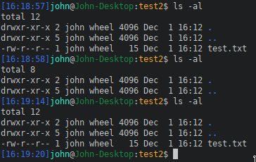
!watch . | Adding a file watch on a directory | File modifications should be detected and uploaded to the server | 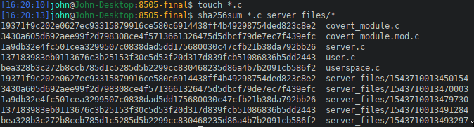  Server receives copy of all modified files
Keylogger enabled | Sending of keystroke data | Keystrokes should be recorded in file | Keystrokes are recorded in file on server | 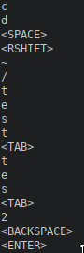
Hide PID that doesn’t exist | Detection of invalid PID values | PID will be rejected | PID was rejected
Hide file that doesn’t exist | Detection of invalid file paths | Path will be rejected | Path was rejected | 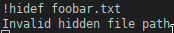
!kill | Testing of killswitch functionality | Implant will be closed and removed | Implant is no longer active
ls | Testing valid shell command | Shell will respond with ls results | Server receives valid ls shell results | 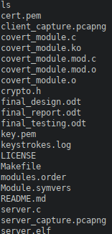
foobar | Testing invalid shell command | Shell will respond with error message | Server receives shell error message
!open 12345 | Opening port on victim | Server receives confirmation port is open | Confirmation message received
!open foobar | Opening invalid port | Server receives error message | Server receives error message
!close 12345 | Closing port on victim | Server receives confirmation of closed port | Server receives confirmation message | 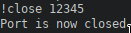
!close foobar | Closing invalid port | Server receives error message | Error message received
!close 443 | Closing C2 port | Server receives error message | Error message received
!clear | Clearing all port settings | Server receives confirmation of port clearing | Status message received
!foo | Invalid special command | Implant responds with error message | Error message received

